Lesson 23: Surface Area

Classwork

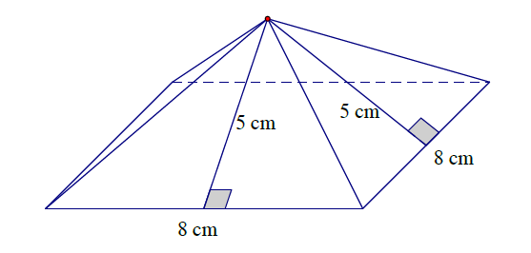Opening Exercise

Calculate the surface area of the square pyramid.

Example 1

* 1. 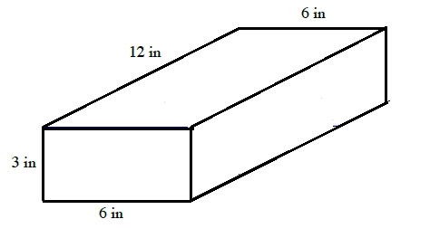Calculate the surface area of the rectangular prism.
  2. 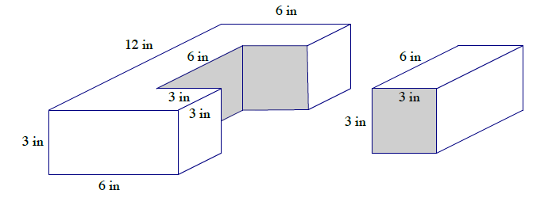Imagine that a piece of the rectangular prism is removed. Determine the surface area of both pieces.
  3. How is the surface area in part (a) related to the surface area in part (b)?

Exercises 1–5

Determine the surface area of the right prisms.

1. 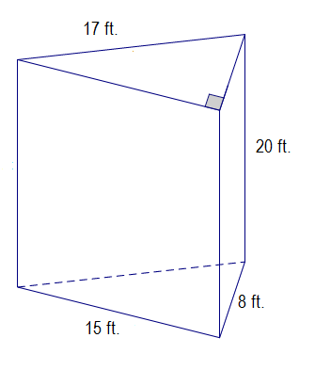
2. 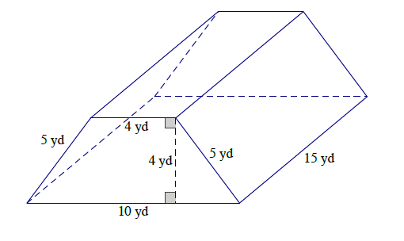
3. 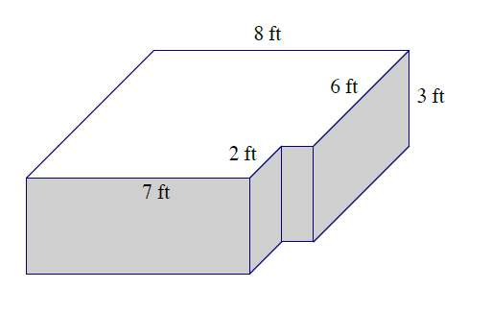
4. 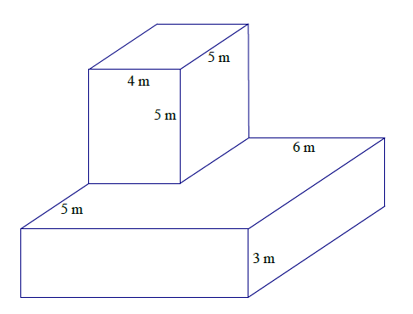
5. 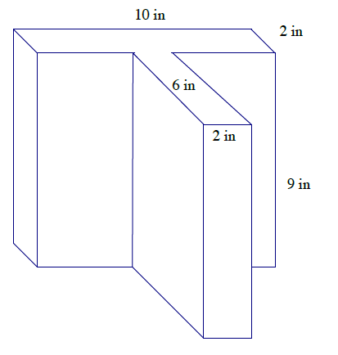

Problem Set

Determine the surface area of the figures.

|  |  |
| --- | --- |
| 1. | 2. |
| 3. | 4. |
| 5. |  |