Lesson 23: Surface Area

Student Outcomes
- Students determine the surface area of three-dimensional figures, including both composite figures and those missing sections.

Lesson Notes
This lesson is an extension of the work done on surface area in Module 5 of Grade 6 (Lessons 15–19) as well as Module 3 of Grade 7 (Lessons 21–22).
Scaffolding:
Encourage students that are struggling to draw a net of the figure to help them determine the surface area.
Classwork
Opening Exercise (5 minutes)
Opening Exercise
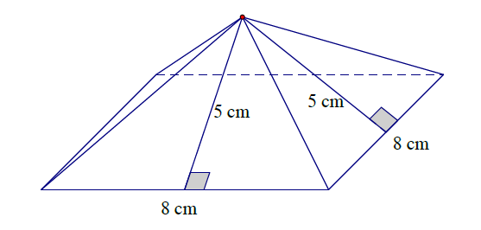
Calculate the surface area of the square pyramid.
Area of the square base: $s^{2}$
$$= (8 cm)^{2} \\ = 64 cm^{2}$$
Area of the triangular lateral sides: $\frac{1}{2} bh$
$$= \frac{1}{2} (8 cm)(5 cm) \\ = 20 cm^{2}$$
There are four lateral sides. So the area of all $4$ triangles is $80 cm^{2}$.
MP.1
Surface Area:
$$\left(8 cm∙8 cm\right)+4\left(\frac{1}{2}\left(8 cm∙5 cm\right)\right)=64 cm^{2} + 80 cm^{2} \\ =144 cm^{2}$$

- Explain the process you used to determine the surface area of the pyramid.
  - Answers will vary. Students may have drawn a net or determined the area of each side without the net. Emphasize how each method determines the area of the sides and then adds them together.
- The surface area of a pyramid is the union of its base region and all its lateral faces.
- Explain how $\left(8 cm∙8 cm\right)+4\left(\frac{1}{2}\left(8 cm∙5 cm\right)\right)$ represents the surface area.
  - The area of the square with side lengths of $8 cm$ is represented by $\left(8 cm∙8 cm\right)$, and the area of the four lateral faces with base lengths of $8 cm$ and heights of $5 cm$ is represented by $4\left(\frac{1}{2}\left(8 cm∙5 cm\right)\right)$.
- Would this method work for any prism or pyramid?
MP.1
  - Answers will vary. Students should come to the conclusion that calculating the area of each lateral face will determine the surface area even if the areas are determined in different orders, by using a formula or net, or any other method.

Example 1 (10 minutes)
Students find the surface area of the rectangular prism. Then students will determine the surface area of the rectangular prism when it is broken into two separate pieces. Finally, students will compare the surface areas before and after the split.
Scaffolding:
Students may benefit from a physical demonstration of this, perhaps using base ten blocks.
Example 1
  - Calculate the surface area of the rectangular prism.
Surface Area:
$$2\left(3 in. ×6 in.\right)+ 2\left(3 in. ×12 in.\right)+ 2\left(6 in. ×12 in.\right)$$
$$= 2(18 {in}^{2}) + 2(36 {in}^{2}) + 2(72 {in}^{2})$$
$$= 36 {in}^{2}+72 {in}^{2}+144 {in}^{2}$$
$$=252 {in}^{2}$$
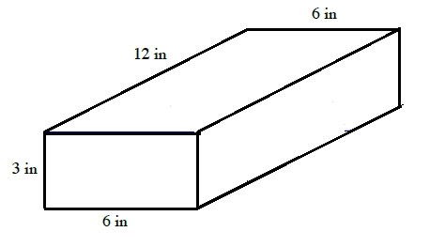

Have students predict in writing or in discussion with a partner whether or not the sum of the two surface areas in part (b) will be the same as the surface area in part (a).
MP.3

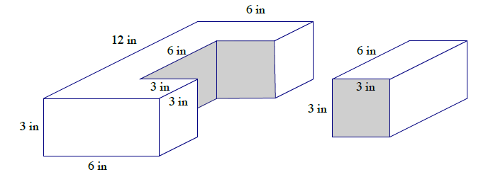
  - Imagine that a piece of the rectangular prism is removed. Determine the surface area of both pieces.

The surface area of the shape on the left: The surface area of the shape on the right:
Area for front and back sides: |  |  |  | $$2 (3 in. × 6 in.)$$  $$= 2\left(18 {in}^{2}\right)= 36{ in}^{2}$$ | Area for front and back sides: |  |  | $$2(3 in. × 3 in.)$$  $$= 2\left(9 {in}^{2}\right)= 18 in^{2}$$
Area seen from left and right: |  |  |  | $$2(3 in. × 12 in.)$$  $$= 2\left(36 in^{2}\right)= 72 {in}^{2}$$ | Area for left and right sides: |  | $$2(3 in. × 6 in.)$$  $$= 2\left(18 in^{2}\right)= 36 in^{2}$$
Area of extra sides: |  | $$2(3 in. × 3 in.)$$  $$= 2\left(9 {in}^{2}\right)= 18 in^{2}$$ |  |  | Area for top and bottom: |  | $$2(3 in. × 6 in.)$$  $$= 2\left(18 in^{2}\right)= 36 in^{2}$$
Area of top and bottom: |  |  | $$2(6 in. × 12) - 2(6 in. × 3 in.)$$  $$= 2\left(72 in^{2}\right)- 2\left(18{ in}^{2}\right)$$  $$= 144 in^{2}- 36 {in}^{2} = 108 {in}^{2}$$ |  | Surface area: | $$8 {in}^{2}+ 36 {in}^{2} + 36 {in}^{2}$$  $$= 90 {in}^{2}$$
Surface area: | $$36 {in}^{2} + 72 {in}^{2} + 18 {in}^{2} + 108 {in}^{2}$$  $$= 234{ in.}^{2}$$
- How did you determine the surface area of the shape on the left?
  - I was able to calculate the area of the sides that are rectangles using length times width. For the two bases that are C-shaped, I used the area of the original top and bottom and subtracted the piece that was taken off.

  - How is the surface area in part (a) related to the surface area in part (b)?
If I add the surface area of both figures, I will get more than the surface area of the original shape.
$$234 {in}^{2} + 90 {in}^{2} =324 {in}^{2}$$
$$324 {in}^{2}-252 {in}^{2} = 72 {in}^{2}$$
$72 in^{2}$ is twice the area of the region where the two pieces fit together.
There are $72$ more square inches when the prisms are separated.

Exercises 1–5 (18 minutes)
Exercises 1–5
Determine the surface area of the right prisms.
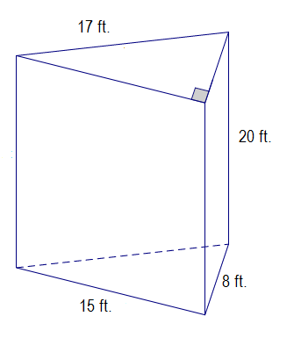
Area of top and bottom: | $2 \left(\frac{1}{2} \left(15 ft. ×8 ft.\right)\right)=$  $15 ft. ×8 ft.=120 {ft}^{2}$
Area for front: | $15 ft. ×20 ft. =300$ ${ft}^{2}$
Area that can be seen from left: | $$17 ft. ×20 ft. =340 {ft}^{2}$$
Area that can be seen from right: | $$8 ft. ×20 ft. =160 {ft}^{2}$$

Surface area: $120 {ft}^{2}+300 {ft}^{2}+340 {ft}^{2}+160 {ft}^{2}= 920 {ft}^{2}$
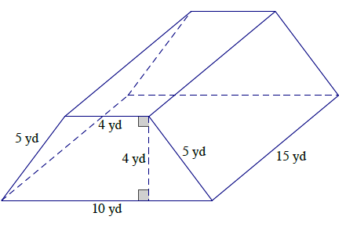

Area of front and back: | $2\left(\frac{1}{2}\left(10 yd.+ 4 yd.\right)4yd.\right)=$  $$14 yd. ×4 yd.=56{ yd}^{2}$$
Area of top: | $$4 yd. ×15 yd. =60 {yd}^{2}$$

Area that can be seen from left and right: | $$2\left(5 yd. ×15 yd.\right)=$$  $$2(75 {yd.}^{2})=150 {yd}^{2}$$
Area of bottom: | $$10 yd. × 15 yd. = 150 {yd}^{2}$$

Surface area: $56 {yd}^{2}+ 60 {yd}^{2}+150 {yd}^{2} +150 {yd}^{2}=416$ ${yd}^{2}$

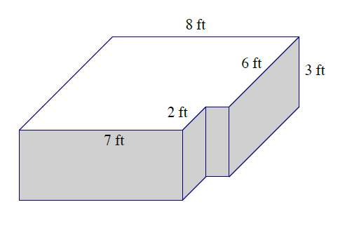
Area of top and bottom: | $$2 \left(\left(8 ft. ×6 ft.\right)+\left(7 ft×2 ft.\right)\right)$$  $$= 2\left(48 {ft}^{2}+14 {ft}^{2}\right)$$  $$= 2\left(62 {ft}^{2}\right)=124 {ft}^{2}$$
Area for back: | $$8 ft. ×3 ft. =24 {ft}^{2}$$
Area for front: | $7 ft. ×3 ft. =21$ ${ft}^{2}$
Area of corner cut out: | $$(2 ft. ×3 ft.)+\left(1 ft. ×3 ft.\right)=9 {ft}^{2}$$
Area of right side: | $$6 ft. ×3 ft. =18 {ft}^{2}$$
Area of left side: | $8 ft. ×3 ft. =24$ ${ft}^{2}$

Surface area: $124 {ft}^{2}+24 {ft}^{2}+21 {ft}^{2}+9 {ft}^{2}+18 {ft}^{2}+24 {ft}^{2}= 220 {ft}^{2}$

Surface area of top prism:
Area of top: | $$4 m × 5 m = 20 m^{2}$$
Area of front and back sides: | $$2\left(4 m × 5 m\right)= 40m^{2}$$
Area of left and right sides: | $$2\left(5 m × 5 m\right)= 50 m^{2}$$
Surface area of bottom prism:
Area of top: | $$10 m × 10 m- 20 m^{2} = 80 m^{2}$$
Area of bottom: | $$10 m × 10 m = 100 m^{2}$$
Area of front and back sides: | $$2\left(10 m × 3 m\right)= 60 m^{2}$$
Area of left and right sides: | $$2\left(10 m × 3 m\right)= 60 m^{2}$$

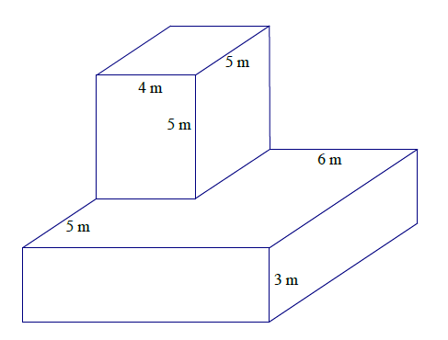
Surface area: $110 m^{2}+ 300 m^{2} = 410 m^{2}$

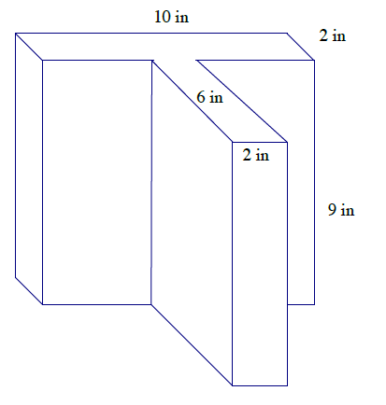
Area of top and bottom faces: |  | $$2\left(10 in. ×2 in.\right)+ 2\left(6 in. ×2 in.\right)$$  $$= 40 {in}^{2} + 24 {in}^{2} \\ = 64 {in}^{2}$$
Area of lateral faces: | $$2\left(9 in. ×2 in.\right)+ 2\left(6 in. ×9 in.\right)$$  $$= 36 {in}^{2} + 108 {in}^{2}+2\left(10 in. ×9 in.\right)$$  $$= 324 {in}^{2}$$
Surface area: | $$64 {in}^{2}+ 144 {in}^{2}+ 180 {in}^{2}= 388 {in}^{2}$$

Closing (2 minutes)
- Describe the process you use to find the surface area of shapes that are composite figures or that are missing sections.
- To determine the surface area of a right prism, find the area of each lateral face and the two base faces, then add the areas of all the faces together.

Exit Ticket (10 minutes)
Name Date
Lesson 23: Surface Area

Exit Ticket

Determine and explain how to find the surface area of the following right prisms.
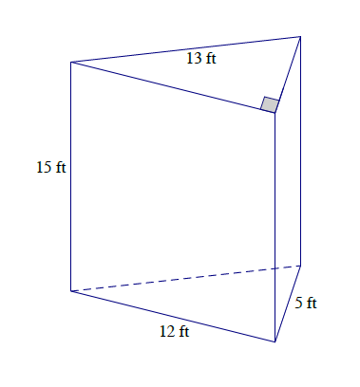
1.

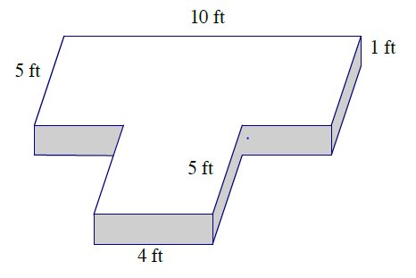
2.

Exit Ticket Sample Solutions

Determine and explain how to find the surface area of the following right prisms.
Area of top and bottom: | $$2 \left(\frac{1}{2} \left(12 ft. ×5 ft.\right)\right)$$  $$= 12 ft. ×5 ft. \\ = 60 {ft}^{2}$$
Area of front: | $$12 ft. ×15 ft.$$  $=180$ ${ft}^{2}$
Area seen from left: | $$13 ft. ×15 ft.$$  $$= 195 {ft}^{2}$$
Area seen from right: | $$5 ft. ×15 ft.$$  $$= 75 {ft}^{2}$$
Surface Area: | $$60 {ft}^{2} + 180 {ft}^{2} + 195 {ft}^{2} + 75 {ft}^{2}$$  $$= 510 {ft}^{2}$$

To find the surface area of the triangular prism, I must sum the areas of two triangles (the bases that are equal in area) and the areas of three different sized rectangles.

Area of front and back: | $$2\left(10ft. ×1 ft.\right)=20 {ft}^{2}$$
Area of sides: | $$2\left(10 ft. ×1 ft.\right)= 20{ ft}^{2}$$
Area of top and bottom: | $$2\left(10 ft. ×5 ft.\right)+2\left( 4 ft. ×5 ft.\right)$$  $$= 100 {ft}^{2}+40 {ft}^{2}$$  $= 140 {ft}^{2}$
Surface Area: | $$20 {ft}^{2}+20 {ft}^{2}+140 {ft}^{2}$$  $$= 180 {ft}^{2}$$

To find the surface area of the prism, I must sum the composite area of the bases with rectangular areas of the sides of the prism.

Problem Set Sample Solutions

Determine the surface area of the figures.
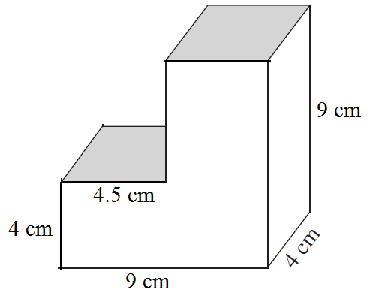
Area of top and bottom: | $$2\left(9 cm × 4 cm\right)= 72 {cm}^{2}$$
Area of left and right sides: | $$2\left(4 cm × 9 cm\right)= 72 {cm}^{2}$$
Area of front and back: | $$2\left(9 cm × 4 cm\right)+ 2\left(4.5 cm × 5 cm\right)$$  $= 117$ ${cm}^{2}$

Surface area: $72{ cm}^{2} + 72 {cm}^{2} + 117 {cm}^{2} = 261 {cm}^{2}$
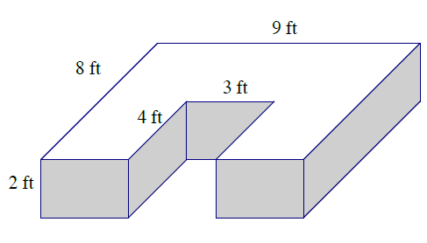
Area of front and back: | $$2\left(9 ft × 2 ft\right)= 36 {ft}^{2}$$
Area of sides: | $$2\left(8 ft × 2 ft\right)= 32 {ft}^{2}$$
Area of top and bottom: | $$2\left(9 ft × 8 ft\right)- 2\left( 4 ft × 3 ft\right)$$  $$= 144{ ft}^{2}- 24 {ft}^{2}$$  $= 120 {ft}^{2}$

Surface area: $36 {ft}^{2} + 32 {ft}^{2}+ 120 {ft}^{2}=188 {ft}^{2}$
Surface Area of Top Prism:
Area of top: |  | $$8 in. ×6 in.=48 {in}^{2}$$
Area of front and back sides: |  | $$2\left(6 in.×8 in.\right)=96{in}^{2}$$
Area of left and right sides: |  | $$2\left(8 in. ×8 in.\right)=128 {in}^{2}$$
Surface Area of Bottom Prism:
Area of top: | $$16 in. ×16 in.- 48 {in}^{2} =208 {in}^{2}$$
Area of bottom: | $$16 in. ×16 in. =256 {in}^{2}$$
Area of front and back sides: | $$2\left(16 in. ×4 in.\right)=128{ in}^{2}$$
Area of left and right sides: | $$2\left(16 in. ×4 in.\right)=128{ in}^{2}$$

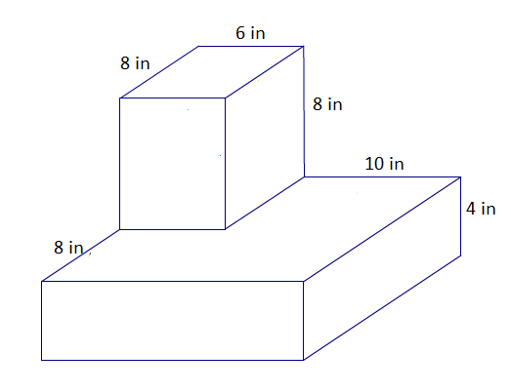

Surface area: $272 {in}^{2}+ 720 {in}^{2} =992 {in}^{2}$

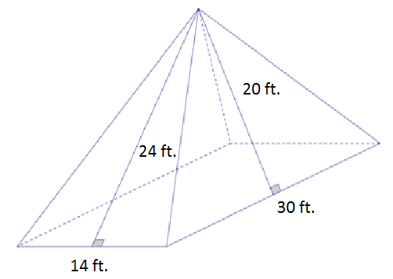
Area of the rectangle base: | $$14 ft. × 30 ft.=420 {ft}^{2}$$
Area of the triangular lateral sides:
Area of front and back: | $$\frac{1}{2} bh$$  $$=2\left(\frac{1}{2} \left(14 ft.\right)\left(24 ft.\right)\right)$$  $$= 336 {ft}^{2}$$

Area that can be seen from left and right: | $$\frac{1}{2}bh$$  $$=2\left(\frac{1}{2}\left(30 ft.\right)\left(20 ft.\right)\right)$$  $$=600 {ft}^{2}$$

Surface area: $420 {ft}^{2}+336{ ft}^{2 }+600 {ft}^{2} = 1356 {ft}^{2}$
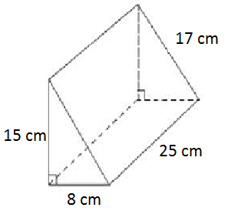
Area of front and back: | $$2 \left(\frac{1}{2} \left(8 cm × 15 cm\right)\right)$$  $$= 8 cm × 15 cm$$  $$= 120 {cm}^{2}$$
Area of bottom: | $$8 cm× 25 cm$$  $=200$ ${cm}^{2}$
Area that can be seen from left side: | $$25 cm × 15 cm$$  $$= 375 {cm}^{2}$$
Area that can be seen from right side: | $$25 cm × 17 cm$$  $$= 425 {cm}^{2}$$

Surface area: $120 {cm}^{2} + 200 {cm}^{2} + 375 {cm}^{2} + 425 {cm}^{2} = 1,120 {cm}^{2}$

