Lesson 22: Area Problems with Circular Regions

Classwork
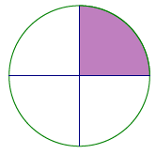
Example 1
  - The circle to the right has a diameter of $12$ cm. Calculate the area of the shaded region.

  - Sasha, Barry, and Kyra wrote three different expressions for the area of the shaded region. Describe what each student was thinking about the problem based on their expression.
Sasha’s expression: $\frac{1}{4}π(6^{2})$

Barry’s expression: $π\left(6^{2}\right)-\frac{3}{4} π(6^{2})$

Kyra’s expression:$\frac{1}{2}\left(\frac{1}{2}π\left(6^{2}\right)\right)$

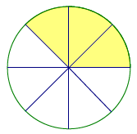
Exercise 1
$$12 ft.$$
- Find the area of the shaded region of the circle to the right.

- Explain how the expression you used represents the area of the shaded region.

Exercise 2
Calculate the area of the figure below that consists of a rectangle and two quarter circles, each with the same radius. Leave your answer in terms of pi.
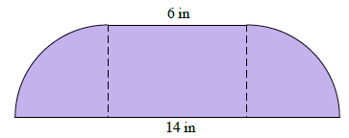

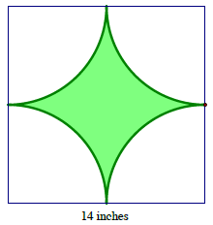
Example 2
The square in this figure has a side length of $14$ inches. The radius of the quarter circle is $7$ inches.
- Estimate the shaded area.

- What is the exact area of the shaded region?

- What is the approximate area using $π≈\frac{22}{7}$?

Exercise 3
The vertices $A$ and $B$ of rectangle $ABCD$ are centers of circles each with a radius of $5$ inches.
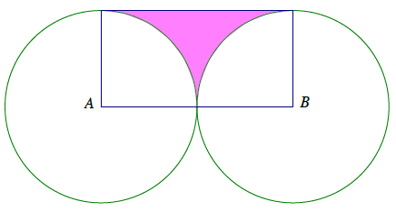
  - Find the exact area of the shaded region.

  - Find the approximate area using $π≈\frac{22}{7}$.

  - Find the area to the nearest hundredth using your $π$ key on your calculator.

Exercise 4
The diameter of the circle is $12$ in. Write and explain a numerical expression that represents the area.
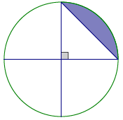

Problem Set

- A circle with center $O$ has an area of $96$ in². Find the area of the shaded region.
Peyton’s Solution | Monte’s Solution
$$A=\frac{1}{3}\left(96\right) {in}^{2}=32 {in}^{2}$$ | $$A=\frac{96}{120} {in}^{2}=0.8 {in}^{2}$$
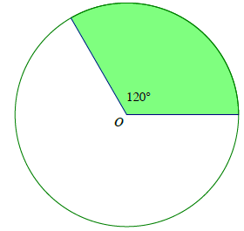

- The following region is bounded by the arcs of two quarter circles each with a radius of $4$ cm and by line segments $6$cm in length. The region on the right shows a rectangle with dimensions $4$ cm by $6$cm. Show that both shaded regions have equal areas.
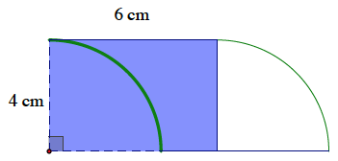
6 cm
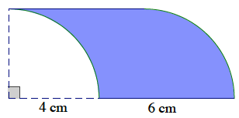

4 cm

- A square is inscribed in a paper disc (i.e., a circular piece of paper) with a radius of $8$ cm. The paper disc is red on the front and white on the back. Two edges of the square are folded over. Write and explain a numerical expression that represents the area of the figure. Then find the area of the figure.

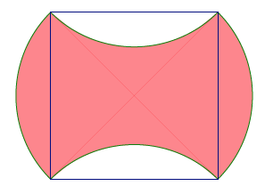

- The diameters of four half circles are sides of a square with a side length of $7$ cm.
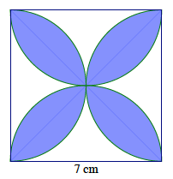

  - Find the exact area of the shaded region.
  - Find the approximate area using $π≈\frac{22}{7}$.
  - Find the area using the $π$ button on your calculator and rounding to the nearest thousandth.

- A square with a side length of $14$inches is shown below, along with a quarter circle (with a side of the square as its radius) and two half circles (with diameters that are sides of the square). Write and explain a numerical expression that represents the area of the figure.
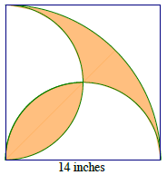

- Three circles have centers on segment $AB$. The diameters of the circles are in the ratio $3:2:1$. If the area of the largest circle is $36$ ft², find the area inside the largest circle but outside the smaller two circles.

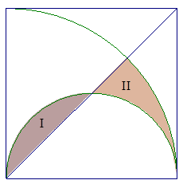
- A square with a side length of $4$ ft. is shown, along with a diagonal, a quarter circle (with a side of the square as its radius), and a half-circle (with a side of the square as its diameter). Find the exact, combined area of regions $I$ and $II$.

