Lesson 22: Area Problems with Circular Regions

Student Outcomes
- Students determine the area of composite figures and of missing regions using composition and decomposition of polygons.

Lesson Notes
Students learned how to calculate the area of circles previously in Grade 7. They apply this knowledge in order to calculate the area of composite shapes throughout this lesson. The problems become progressively more challenging. It is important to remind students that they have all the necessary knowledge and skills for every one of these problems.

Classwork
Example 1 (5 minutes)
Allow students time to struggle through the following question. Use the bullet points to lead a discussion to review the problem.
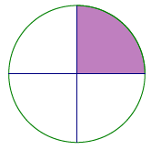
Example 1
  - The circle to the right has a diameter of $12$cm. Calculate the area of the shaded region.

Scaffolding:
- Place a prominent visual display in the classroom of a circle and related key relationships (formulas for circumference, area, etc.).

Circumference $=2πr=πd$
Area $=πr^{2}$
$$r$$
- What information do we need to calculate the area?
  - We need the radius of the circle and the shaded fraction of the circle.
- What is the radius of the circle? How do you know?
MP.1
  - The radius of the circle is $6 cm$ since the length of the radius is half the length of the diameter.
- Now that we know the radius, how can we find the area of the shaded region?
  - Find the area of one quarter of the circle because the circle is divided into four identical parts and only one part is shaded.
- Choose a method discussed, and calculate the area of the shaded region.
  - $A_{quarter circle}=\frac{1}{4}πr^{2}$
  - The area in cm²
$$\frac{1}{4}π{\left(6\right)}^{2}=9π≈28.27$$
  - The area of the shaded region is about $28.27$cm²
  - Sasha, Barry, and Kyra wrote three different expressions for the area of the shaded region. Describe what each student was thinking about the problem based on their expression.
Sasha’s expression: $\frac{1}{4}π(6^{2})$
Sasha’s expression gets directly to the shaded area as it represents a quarter of the area of the whole circle.
Barry’s expression: $π\left(6^{2}\right)-\frac{3}{4} π(6^{2})$
Barry’s expression shows the area of the whole circle minus the unshaded area of the circle or three-quarters of the area of the circle.
Kyra’s expression: $\frac{1}{2}\left(\frac{1}{2}π\left(6^{2}\right)\right)$
Kyra’s expression arrives at the shaded area by taking half the area of the whole circle, which is half of the circle, and taking half of that area, which leaves a quarter of the area of the whole circle.

Exercise 1 (5 minutes)
Exercise 1
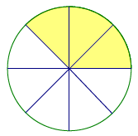
- Find the area of the shaded region of the circle to the right.
$$12 ft.$$
$$A=\frac{3}{8}πr^{2} \\ A=\frac{3}{8}\left(π\right){\left(12\right)}^{2} ft^{2} \\ A=54π ft^{2} \\ A≈169.65 ft^{2}$$
The shaded area of the circle is approximately $169.65$ft².

- Explain how the expression you used represents the area of the shaded region.
The expression $\frac{3}{8}\left(π\right){\left(12\right)}^{2}$ takes the area of a whole circle with a radius of $12$ ft., which is just the portion that reads $\left(π\right){\left(12\right)}^{2}$, and then multiplies that by $\frac{3}{8}$. The shaded region is just three out of eight equal pieces of the circle.

Exercise 2 (7 minutes)

Exercise 2
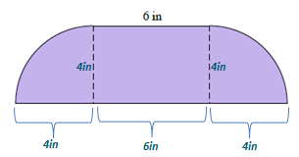
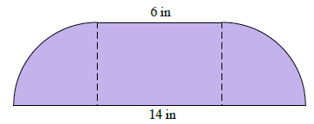
Calculate the area of the figure below that consists of a rectangle and two quarter circles, each with the same radius. Leave your answer in terms of pi.

$$A_{rectangle}=l∙w \\ A=6∙4 {in}^{2} \\ A=24 {in}^{2}$$  The area of the rectangle is $24$in². | $$A_{half circle}=\frac{1}{2}πr^{2} \\ A=\frac{1}{2}\left(π\right)(4)^{2} {in}^{2} \\ A=8π {in}^{2}$$  The area of the two quarter circles, or one semicircle, is $8π$ in².
The area of the entire figure is $A=\left(24+8π\right)in^{2}$.

Example 2 (7 minutes)
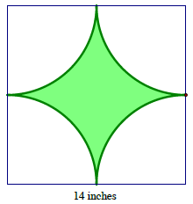
Example 2
The square in this figure has a side length of $14$ inches. The radius of the quarter circle is $7$ inches.
- Estimate the shaded area.
- What is the exact area of the shaded region?
- What is the approximate area using $π≈\frac{22}{7}$?
MP.1

- Describe a strategy to find the area of the shaded region.
  - Find the area of the entire square, and subtract the area of the unshaded region because the unshaded region is four quarter circles of equal radius or a whole circle.
- What is the difference between parts (b) and (c) in Example 2?
  - Part (b) asks for the exact area, which means the answer must be left in terms of pi; part (c) asks for the approximate area, which means the answer must be rounded off.
- How would you estimate the shaded area?
  - Responses will vary. One possible response might be that the shaded area looks approximately one-quarter the area of the entire square, roughly$\frac{1}{4}(14$ in.$)^{2}=49$in².
- What is the area of the square?
  - $A=14∙14$in²$=196$ in²
  - The area of the square is$196$ in².
- What is the area of each quarter circle?
  - $A=\frac{π}{4}r^{2}=\frac{π}{4}(7)^{2}$ in² $=\frac{49π}{4}$ in²
The area of each quarter circle is$\frac{49π}{4}$ in².
MP.1
The area of the entire unshaded region, or all four quarter circles, is$49π$ in².
- What is the exact area of the shaded region?
  - $A=196$in² $- 49π$ in²
The area of the shaded region is $(196-49π)$ in².
- What is the approximate area using $π≈\frac{22}{7}$?
  - $A=196$in²$-\left(\frac{22}{7}\right){\left(7\right)}^{2}$in²
$=\left(196-154\right)$ in²
$=42$in²
  - The area of the shaded region is $42$in².

Exercise 3 (7 minutes)
Exercise 3
The vertices $A$ and $B$ of rectangle $ABCD$ are centers of circles each with a radius of $5$ inches.
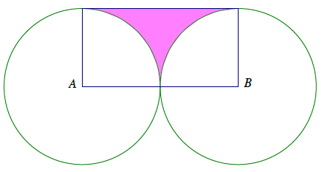
  - Find the exact area of the shaded region.
$$A_{rectangle}=10∙5 {in}^{2}=50 {in}^{2}$$
$A_{semicircle}=\frac{1}{2}π({5)}^{2} {in}^{2}$
$A_{semicircle}=\frac{25π}{2}$ ${in}^{2}$
$A_{shaded area}=\left(50-\frac{25π}{2}\right) {in}^{2}$

  - Find the approximate area using $π≈\frac{22}{7}$.
$A_{shaded area}=\left(50-\frac{25π}{2}\right){ in}^{2}$
$A_{shaded area}≈\left(50-\frac{25}{2}\left(\frac{22}{7}\right)\right) {in}^{2}$
$A_{shaded area}≈\left(50-\frac{275}{7}\right)$ ${in}^{2}$
$A_{shaded area}≈10\frac{5}{7} {in}^{2}$
The area of the shaded region in the figure is approximately $10\frac{5}{7} in^{2}$.

  - Find the area to the nearest hundredth using your $π$ key on your calculator.
$A_{shaded area}=\left(50-\frac{25π}{2}\right) {in}^{2}$
$A_{shaded area}≈10.73 {in}^{2}$
The area of the shaded region in the figure is approximately $0.73$ $in^{2}$.

Exercise 4 (5 minutes)
Exercise 4
The diameter of the circle is $12$ in. Write and explain a numerical expression that represents the area.
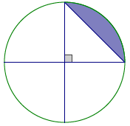

$$A_{shaded}=A_{quarter circle}-A_{triangle}$$
$A_{shaded}=\frac{π}{4}(6)^{2} {in}^{2}-\frac{1}{2}(6∙6){ in}^{2}$
$A_{shaded}=\left(9π-18\right) {in}^{2}$
The expression represents the area of one quarter of the entire circle less the area of the right triangle, whose legs are formed by radii of the circle.

Closing (2 minutes)
- In calculating composite figures with circular regions, it is important to identify relevant geometric areas; for example, identify relevant rectangles or squares that are part of a figure with a circular region.
- Next, determine which areas should be subtracted or added based on their positions in the diagram.
- Be sure to note whether a question asks for the exact or approximate area.

Exit Ticket (7 minutes)

Name Date
Lesson 22: Area Problems with Circular Regions

Exit Ticket

A circle with a $10$ cm radius is cut into a half circle and two quarter circles. The three circular arcs bound the region below.
- Write and explain a numerical expression that represents the area.
- Then find the area of the figure.
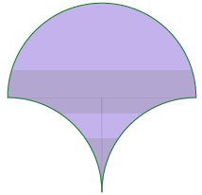

Exit Ticket Sample Solutions

A circle with a $10$ cm radius is cut into a half circle and two quarter circles. The three circular arcs bound the region below.
- Write and explain a numerical expression that represents the area.
- Then find the area of the figure.

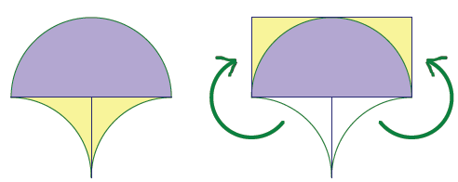
- Numeric expression 1 for the area:
$10$cm$∙20$cm
The expression for the area represents the region when it is cut into three pieces and rearranged to make a complete rectangle as shown.
Numeric expression 2 for the area: $\left(50π\right)$ cm² $+ \left(200-50π\right)$ cm²
The expression for the area is calculated as is; in other words, finding the area of the semicircle in the top portion of the figure, and then the area of the carved out regions in the bottom portion of the figure.

- The area of the figure is $200$cm².

Problem Set Sample Solutions

- A circle with center $O$ has an area of $96$ in². Find the area of the shaded region.
Peyton’s Solution | Monte’s Solution
$$A=\frac{1}{3}\left(96\right) {in}^{2}=32 {in}^{2}$$ | $$A=\frac{96}{120} {in}^{2}=0.8 {in}^{2}$$
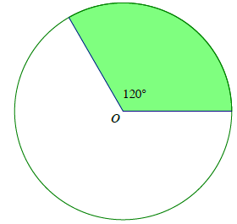

Which person solved the problem correctly? Explain your reasoning.
Peyton solved the problem correctly because he correctly identified the shaded region as one third of the area of the entire circle. The shaded region represents $\frac{1}{3}$ of the circle because $120°$ is one third of$360°$. To find the area of the shaded region, one -third of the area of the entire circle, $96$ in², must be calculated, which is what Peyton did to get his solution.

- The following region is bounded by the arcs of two quarter circles each with a radius of $4$ cm and by line segments $6$cm in length. The region on the right shows a rectangle with dimensions $4$ cm by $6$cm. Show that both shaded regions have equal areas.
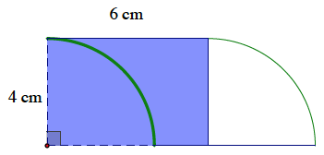
6 cm
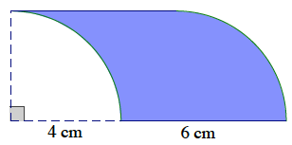
4 cm

$$A=\left(\left(4 cm∙6 cm\right)-\frac{1}{4}π{\left(4 cm\right)}^{2}\right)+\frac{1}{4}π{\left(4 cm\right)}^{2}$$ | $$A=4 cm∙6 cm$$
$$A=24 {cm}^{2}$$ | $$A=24 {cm}^{2}$$

- A square is inscribed in a paper disc (i.e., a circular piece of paper) with a radius of $8$ cm. The paper disc is red on the front and white on the back. Two edges of the square are folded over. Write and explain a numerical expression that represents the area of the figure. Then find the area of the figure.
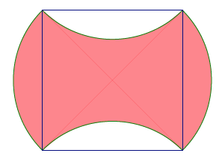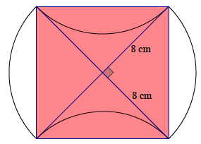

Numeric expression for the area: $4\left(\frac{1}{2}∙8∙8\right)$ cm²
The shaded (red) area is the same as the area of the square. The radius is $8$ cm, which is the length of one leg of each of the four, equal-sized right triangles within the square. Thus, we find the area of one triangle and multiply by $4$.
The area of the shaded region is $128$ cm².

- The diameters of four half circles are sides of a square with a side length of $7$ cm.
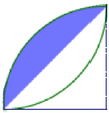
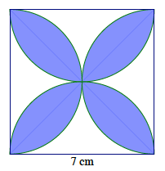
Figure 2
(Not drawn to scale)

3.5 cm
Figure 1
3.5 cm

  - Find the exact area of the shaded region.
Figure 2 isolates one quarter of Figure 1. The shaded area in Figure 2 can be found as follows:
Shaded area $=$ Area of the quarter circle $-$ Area of the isosceles right triangle
Shaded area:
$$\left(\frac{π}{4}{\left(\frac{7}{2}\right)}^{2}\right){cm}^{2}-\left(\frac{1}{2}∙\frac{7}{2}∙\frac{7}{2}\right){cm}^{2}=\left(\frac{49π}{16}-\frac{49}{8}\right) {cm}^{2} \\ =\frac{49}{16}\left(π-2\right){cm}^{2}$$
The area of the shaded region is $\frac{49}{16}\left(π-2\right)$ cm². There are $8$such regions in the figure, so we multiply this answer by $8$:
Total shaded area:
$$8\left(\frac{49}{16}\left(π-2\right)\right)=\frac{49}{2}\left(π-2\right)=\frac{49π}{2}-49$$
The exact area of the shaded region is $\frac{49π}{2}-49$cm².

  - Find the approximate area using $π≈\frac{22}{7}$.
$$A_{total shaded}=\frac{49}{2}\left(\frac{22}{7}-2\right){cm}^{2} \\ A_{total shaded}=\left(77-49\right){ cm}^{2} \\ A_{total shaded}=28 {cm}^{2}$$
The approximate area of the shaded region is $28$ cm².

  - Find the area using the $π$ button on your calculator and rounding to the nearest thousandth.
$A_{total shaded}=\frac{49}{2}\left(π-2\right)$ cm²
$A_{total shaded}=27.969$cm²
The approximate area of the shaded region is $27.969$ cm².

- A square with a side length of $14$inches is shown below, along with a quarter circle (with a side of the square as its radius) and two half circles (with diameters that are sides of the square). Write and explain a numerical expression that represents the area of the figure.

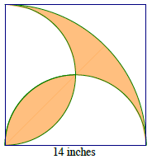
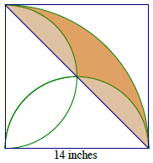

Figure 1
Figure 2

Numeric expression for the area: $\frac{1}{4}π{(14)}^{2} in^{2}$ $-\left(\frac{1}{2}∙14∙14\right) in^{2}$
The shaded area in Figure 1 is the same as the shaded area in Figure 2. This area can be found by subtracting the area of the right triangle with leg lengths $14$ in. from the area of the quarter circle with radius $14$ in.
$$\frac{1}{4}π{\left(14\right)}^{2} {in}^{2}-\left(\frac{1}{2}∙14∙14\right){ in}^{2}=\left(49π-98\right) {in}^{2}$$
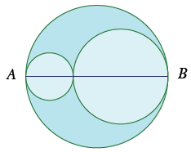
- Three circles have centers on segment $AB$. The diameters of the circles are in the ratio $3:2:1$. If the area of the largest circle is $36$ ft², find the area inside the largest circle but outside the smaller two circles.
Since all three circles are scale drawings of each other, the ratio of the areas of the circles is $9:4:1.$ This ratio provides a means to find the areas of the two smaller circles.
Area of medium-sized circle in ft²:  $$\frac{9}{4}=\frac{36}{x} \\ x=16$$  The area of the medium-sized circle is $16$ ft². | Area of small-sized circle ft²:  $$\frac{9}{1}=\frac{36}{y} \\ y=4$$  The area of the small-sized circle is $4$ft².
Area inside largest circle but outside smaller two circles is
$A=\left(36-16-4\right)$ ft²$A=16$ft²
The area inside the largest circle but outside the smaller two circles is $16$ ft².

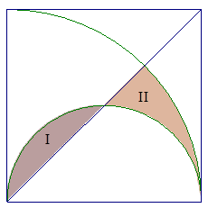
- A square with a side length of $4$ ft. is shown, along with a diagonal, a quarter circle (with a side of the square as its radius), and a half-circle (with a side of the square as its diameter). Find the exact, combined area of regions $I$ and $II$.

The area of $I$ is the same as the area of $III$ in the following diagram.
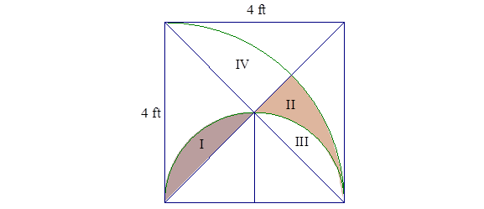
Since the area of $I$ is the same as the area of $III$, we need to find the combined area of $II$ and $III$. The combined area of $II$ and $III$ is half the area of $II$, $III$, and $IV$. The area of $II$, $III$, and $IV$ is the area of the quarter circle minus the area of the triangle.
$A_{II and III}=\frac{1}{2}\left(\frac{16π}{4}-\frac{4 ⋅ 4}{2}\right)$ ft²$A_{II and III}=\left(2π-4\right)$ ft²
The combined area of$I$ and $II$ is $\left(2π-4\right)$ft².

