Lesson 21: Mathematical Area Problems

Classwork
Opening Exercise
Patty is interested in expanding her backyard garden. Currently, the garden plot has a length of $4$ ft. and a width of $3$ ft.
  - What is the current area of the garden?

Patty plans on extending the length of the plot by $3$ ft. and the width by $2$ ft.
  - What will the new dimensions of the garden be? What will the new area of the garden be?

  - Draw a diagram that shows the change in dimension and area of Patty’s garden as she expands it. The diagram should show the original garden as well as the expanded garden.

  - Based on your diagram, can the area of the garden be found in a way other than by multiplying the length by the width?

  - Based on your diagram, how would the area of the original garden change if only the length increased by $3$ ft.? By how much would the area increase?

  - How would the area of the original garden change if only the width increased by $2$ft.? By how much would the area increase?

  - Complete the following table with the numeric expression, area, and increase in area for each change in the dimensions of the garden.
Dimensions of the garden | Numeric expression for the area of the garden |  |  | Area of the garden | Increase in area of the garden
Original garden with length of $4$ ft. and width of $3$ ft.
The original garden with length extended by $3$ ft. and width extended by $2$ ft.
The original garden with only the length extended by $3$ ft.
The original garden with only the width extended by $2$ ft.

  - Will the increase in both the length and width by $3$ ft. and $2$ ft., respectively, mean that the original area will increase strictly by the areas found in parts (e) and (f)? If the area is increasing by more than the areas found in parts (e) and (f), explain what accounts for the additional increase.

Example 1
Examine the change in dimension and area of the following square as it increases by $2$units from a side length of $4$units to a new side length of $6$units. Observe the way the area is calculated for the new square. The lengths are given in units, and the areas of the rectangles and squares are given in units².

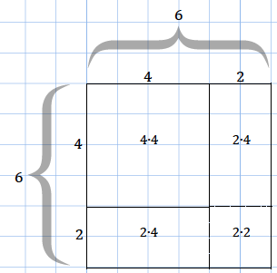

  - Based on the example above, draw a diagram for a square with side length of $3$units that is increasing by $2$units. Show the area calculation for the larger square in the same way as in the example.

  - Draw a diagram for a square with side length of $5$ units that is increased by$3$ units. Show the area calculation for the larger square in the same way as in the example.

  - Generalize the pattern for the area calculation of a square that has an increase in dimension. Let the side length of the original square be $a$ units and the increase in length be by $b$ units to the length and width. Use the diagram below to guide your work.
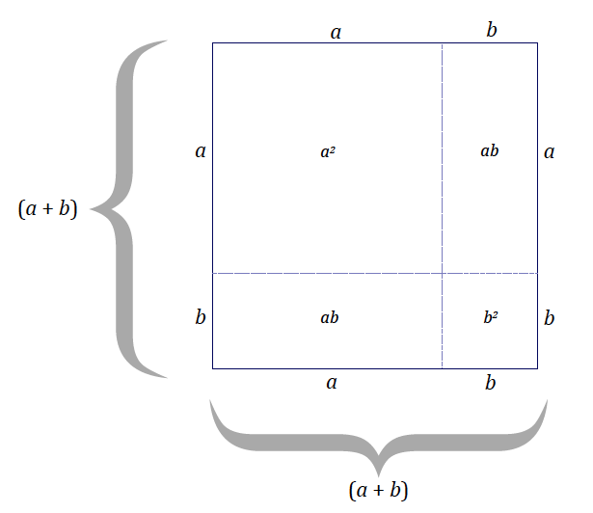

Example 2
Bobby draws a square that is $10$units by $10$units. He increases the length by $x$ units and the width by $2$units.
  - Draw a diagram that models this scenario.

  - Assume the area of the large rectangle is $156$ units². Find the value of $x$.

Example 3
The dimensions of a square with side length $x$ units are increased. In this figure the indicated lengths are given in units, and the indicated areas are given in units².
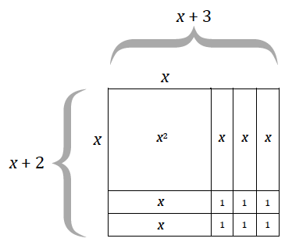

  - What are the dimensions of the large rectangle in the figure?

  - Use the expressions in your response from part (a) to write an equation for the area of the large rectangle, where $A$ represents area.

  - Use the areas of the sections within the diagram to express the area of the large rectangle.

  - What can be concluded from parts (b) and (c)?

  - Explain how the expressions $(x+2)(x+3)$ and $x^{2}+3x+2x+6$ differ within the context of the area of the figure.

Problem Set
- A square with side length $a$ units is decreased by $b$ units in both length and width.
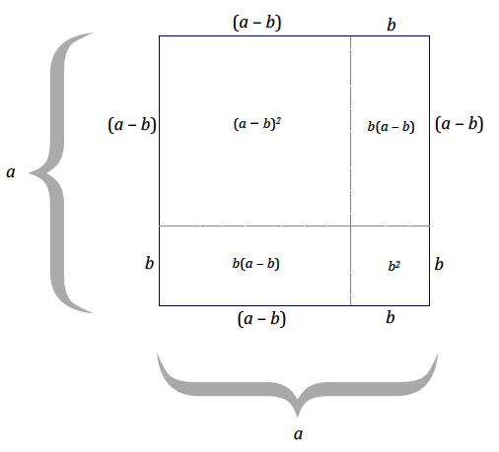
Use the diagram to express ${(a-b)}^{2}$ in terms of the other $a^{2}$, $ab$, and$b^{2}$ by filling in the blanks below:
$${\left(a-b\right)}^{2}=a^{2}-b\left(a-b\right)-b\left(a-b\right)-b^{2} \\ =a^{2}-_____+_____-_____+_____- b^{2} \\ =a^{2}-2ab+_____-b^{2} \\ =_____________________________________$$

- In Example 3(c) we generalized that ${(a+b)}^{2}=a^{2}+2ab+b^{2}.$ Use these results to evaluate the following expressions by writing $1,001=1,000+1$, etc.:
  - Evaluate ${101}^{2}$
  - Evaluate ${1,001}^{2}$
  - Evaluate ${21}^{2}$

- Use the results of Problem Set 1 to evaluate ${999}^{2}$ by writing $999=1,000-1$.

- The figures below show that $8^{2}-5^{2}$ is equal to $(8-5)(8+5)$.

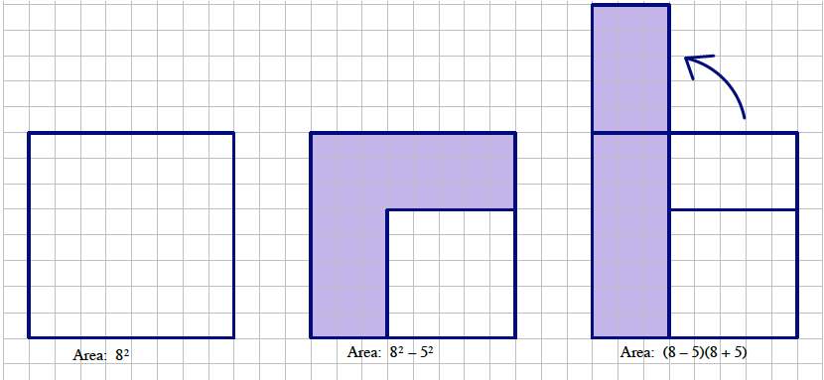
  - Create a drawing to show that $a^{2}-b^{2}=(a-b)(a+b)$.
  - Use the result in part (a), $a^{2}-b^{2}=(a-b)(a+b)$, to explain why:
    - ${35}^{2}-5^{2}=(30)(40)$
    - ${21}^{2}-{18}^{2}=\left(3\right)\left(39\right)$
    - ${104}^{2}-{63}^{2}=\left(41\right)\left(167\right)$
  - Use the fact that ${35}^{2}=\left(30\right)\left(40\right)+5^{2}=1,225$ to create a way to mentally square any two digit number ending in “$5$.”

- Create an area model for each product. Use the area model to write an equivalent expression that represents the area.
  - $\left(x+1\right) \left(x+4\right)=$
  - $\left(x+5\right)\left(x+2\right)=$
  - Based on the context of the area model, how do the expressions provided in parts (a) and (b) differ from the equivalent expression answers you found for each?

- Use the distributive property to multiply the following expressions:
  - $(2+6)(2+4)$
  - $\left(x+6\right)\left(x+4\right)$; draw a figure that models this multiplication problem.
  - $\left(10+7\right)\left(10+7\right)$
  - $(a+7)(a+7)$
  - $(5-3)(5+3)$
  - $\left(x-3\right)\left(x+3\right)$

