|  |
| --- |
|  |

Lesson 21: Mathematical Area Problems

Student Outcomes

* Students use the area properties to justify the repeated use of the distributive property to expand the product of linear expressions.

Lesson Notes

In Lesson 21, students use area models to make an explicit connection between area and algebraic expressions. The lesson opens with a numeric example of a rectangle (a garden) expanding in both dimensions. Students calculate the area of the garden as if it expands in a single dimension, once just in length and then in width, and observe how the areas change with each change in dimension. Similar changes are then made to a square. Students record the areas of several squares with expanded side lengths, eventually generalizing the pattern of areas to the expansion of (MP.2 and 8). This generalization is reinforced through the repeated use of the distributive property, which clarifies the link between the terms of the algebraic expression and the sections of area in each expanded figure.

Classwork

Opening Exercise (7 minutes)

The objective of the lesson is to generalize a formula for the area of rectangles that result from adding to the length and width. Using visuals and concrete (numerical) examples throughout the lesson will help students make this generalization.

**Opening Exercise**

**Patty is interested in expanding her backyard garden. Currently, the garden plot has a length of ft. and a width of ft.**

* 1. **What is the current area of the garden?**

*Scaffolding:*

Use the following visual as needed.

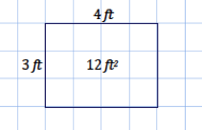

**The garden has an area of ft2.**

**Patty plans on extending the length of the plot by ft. and the width by ft.**

* 1. **What will the new dimensions of the garden be? What will the new area of the garden be?**

**The new dimensions of the garden are ft. by ft., and it has an area of ft2.**

In part (c), students are asked to draw a plan of the expanded garden and quantify how the area increases. Allow students time to find a way to show this. Share out student responses; if none are able to produce a valid response, share the diagram below.

* 1. **Draw a diagram that shows the change in dimension and area of Patty’s garden as she expands it. The diagram should show the original garden as well as the expanded garden.**

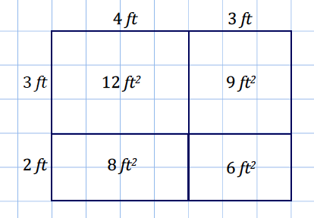

* 1. **Based on your diagram, can the area of the garden be found in a way other than by multiplying the length by the width?**

**The area can be found by taking the sum of the smaller sections of areas.**

* 1. **Based on your diagram, how would the area of the original garden change if *only* the length increased by ft.? By how much would the area increase?**

**The area of the garden would increase by ft2.**

* 1. **How would the area of the original garden change if *only* the width increased by ft.? By how much would the area increase?**

**The area of the garden would increase by ft2.**

* 1. **Complete the following table with the numeric expression, area, and increase in area for each change in the dimensions of the garden.**

|  |  |  |  |  |  |
| --- | --- | --- | --- | --- | --- |
| Dimensions of the garden | Numeric expression for the area of the garden | | | Area of the garden | Increase in area of the garden |
| Original garden with length of ft. and width of ft. | ft. |  | ft. | **ft2** |  |
| The original garden with length extended by ft. and width extended by ft. | ft. |  | ft. | **ft2** | **ft2** |
| The original garden with only the length extended by ft. | ft. |  | ft. | **ft2** | **ft2** |
| The original garden with only the width extended by ft. | ft. |  | ft. | **ft2** | **ft2** |

* 1. **Will the increase in both the length and width by ft. and ft., respectively, mean that the original area will increase strictly by the areas found in parts (e) and (f)? If the area is increasing by more than the areas found in parts (e) and (f), explain what accounts for the additional increase.**

**The area of the garden increases not only by ft2 and ft2, but also by an additional ft2. This additional ft2 is the corresponding area formed by the ft. and ft. extensions in both dimensions (length and width); that is, this area results from not just an extension in the length or just the width but because the extensions occurred in both length and width.**

Example 1 (8 minutes)

Students increase the dimensions of several squares and observe the pattern that emerges from each area model.

**Example 1**

**Examine the change in dimension and area of the following square as it increases by units from a side length of units to a new side length of units. Observe the way the area is calculated for the new square. The lengths are given in units, and the areas of the rectangles and squares are given in units2.**

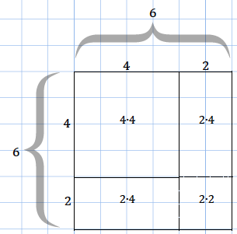

**Area of the by square**  **units2 units2 units2 units2 units2**

**The area of the by square can be calculated either by multiplying its sides represented by or by adding the areas of the subsections, represented by** ,**, and .**

MP.2

&

MP.8

* 1. **Based on the example above, draw a diagram for a square with side length of units that is increasing by units. Show the area calculation for the larger square in the same way as in the example.**

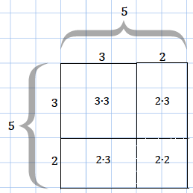

**Area of the by square**  **units2**  **units2 units2 units2 units2**

**The area of the by square can be calculated either by multiplying its sides represented by or by adding the areas of the subsections, represented by** ,**, and .**

* 1. **Draw a diagram for a square with side length of units that is increased by units. Show the area calculation for the larger square in the same way as in the example.**

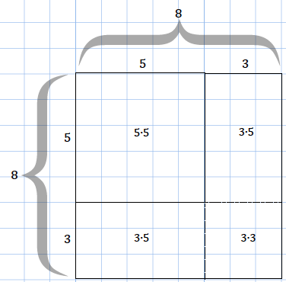

**Area of the by square**  **units2**  **units2 units2 units2 units2**

**The area of the by square can be calculated either by multiplying its sides represented by or by adding the areas of the subsections, represented by** , **, and .**

MP.2

&

MP.8

* 1. **Generalize the pattern for the area calculation of a square that has an increase in dimension. Let the side length of the original square be units and the increase in length be by units to the length and width. Use the diagram below to guide your work.**

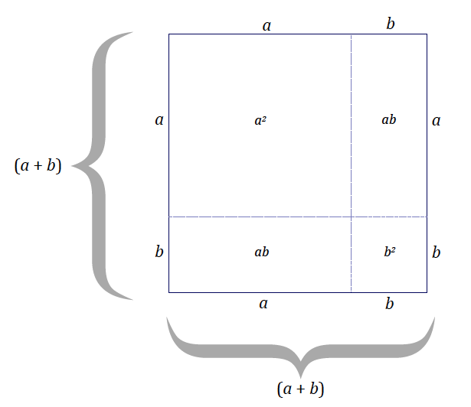

**Area of the by square**  **units2 units2**

**The area of the square with side length is equal to the sum of the areas of the subsections. Describing the area as units2 is a way to state the area in terms of the dimensions of the figure, whereas describing the area as**  **units2 is a way to state the area in terms of the sum of the areas of the sections formed by the extension of units in each dimension.**

Show how the distributive property can be used to rewrite the expression :

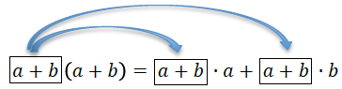





Example 2 (5 minutes)

Students model an increase of one dimension of a square by an unknown amount. Students may hesitate with how to draw this. Instruct them to select an extension length of their choice and label it so that the reader recognizes the length is an unknown quantity.

Example 2

Bobby draws a square that is units by units. He increases the length by units and the width by units.

* 1. **Draw a diagram that models this scenario.**

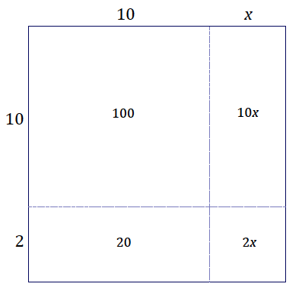

* 1. **Assume the area of the large rectangle is units2. Find the value of .**

Example 3 (7 minutes)

In Example 3, students model an increase in dimensions of a square with side length units, where the increase in the length is different than the increase in the width.

Example 3

The dimensions of a square with side length units are increased. In this figure the indicated lengths are given in units, and the indicated areas are given in units2.

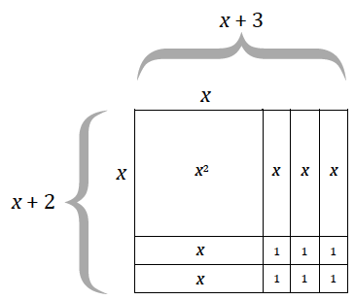

* 1. **What are the dimensions of the large rectangle in the figure?**

**The length (or width) is units, and the width (or length) is units.**

* 1. **Use the expressions in your response from part (a) to write an equation for the area of the large rectangle, where represents area.**

**units2**

* 1. **Use the areas of the sections within the diagram to express the area of the large rectangle.**

**units2**

* 1. **What can be concluded from parts (b) and (c)?**
  2. **Explain how the expressions and differ within the context of the area of the figure.**

MP.2

***The expression shows the area is equal to the quantity the length increased by times the quantity the width increased by . The expression shows the area as the sum of four sections of the expanded rectangle.***

**Discussion (12 minutes)**

* Even though the context of the area calculation only makes sense for positive values of , what happens if you substitute a negative number into the equation you stated in part (d) of Example 3? (Hint: Try some values.) Is the resulting number sentence true? Why?

Teachers should give students time to try a few negative values for in the equation . Encourage students to try small numbers (less than one) and large numbers (greater than 100). Conclusion: the equation becomes a true number sentence for all values in the equation.

* The resulting number sentence is true for negative values of because of the distributive property. The area properties explain why the equation is true for positive values of , but the distributive property holds for both positive and negative values of .
* Show how the distributive property can be used to rewrite the expression from Example 3, , as . Explain how each step relates back to the area calculation you did above when is positive.
* Think of as a single number and distribute it over .

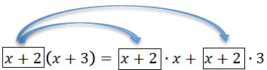

(This step is equivalent to relating the area of the entire rectangle to the areas of each of the two corresponding rectangles in the diagram above.)

* Distribute the over and distribute the over the :

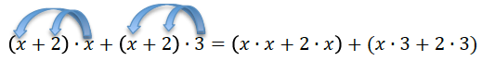

(This step is equivalent to relating the area of the entire rectangle to the areas of each of the two corresponding rectangles in the diagram above.)

* Collecting like terms gives us the right-hand side of the equation displayed in the Example 2(d), showing that the two expressions are equivalent both by area properties (when is positive) and by the properties of operations.



Closing (1 minute)

* The properties of area, because they are limited to positive numbers for lengths and areas, are not as robust as properties of operations, but the area properties do support why the properties of operations are true.

Exit Ticket (5 minutes)

Name Date

Lesson 21: Mathematical Area Problems

Exit Ticket

1. Create an area model to represent this product: .
2. Write two different expressions that represent the area.
3. Explain how each expression represents different information about the situation.
4. Show that the two expressions are equal using the distributive property.

Exit Ticket Sample Solutions

1. Create an area model to represent this product: .

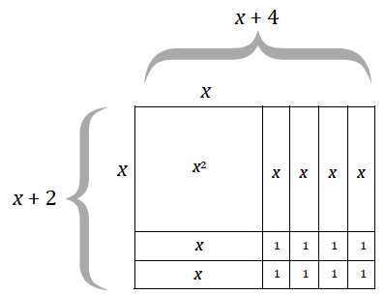

1. Write two different expressions that represent the area.

and

1. Explain how each expression represents different information about the situation.

The expression shows the area is equal to the quantity of the length increased by times the quantity of the width increased by . The expression shows the area as the sum of four sections of the expanded rectangle.

1. Show that the two expressions are equal using the distributive property.

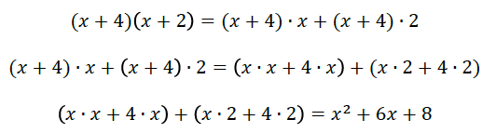

Problem Set Sample Solutions

1. A square with side length units is decreased by units in both length and width.

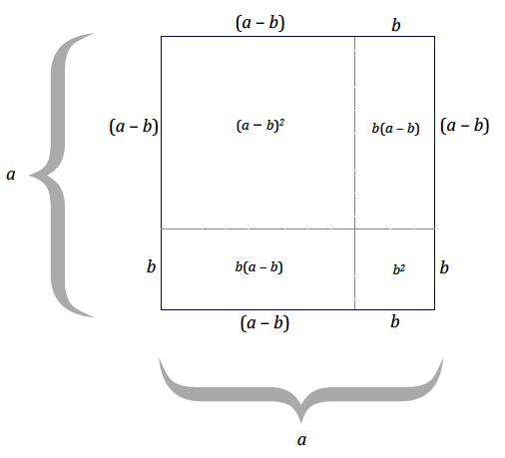

Use the diagram to express in terms of the other ,, and by filling in the blanks below:

1. In Example 3(c) we generalized that Use these results to evaluate the following expressions by writing , etc.:
   1. Evaluate
   2. Evaluate
   3. Evaluate
2. Use the results of Problem Set 1 to evaluate by writing .
3. The figures below show that is equal to .

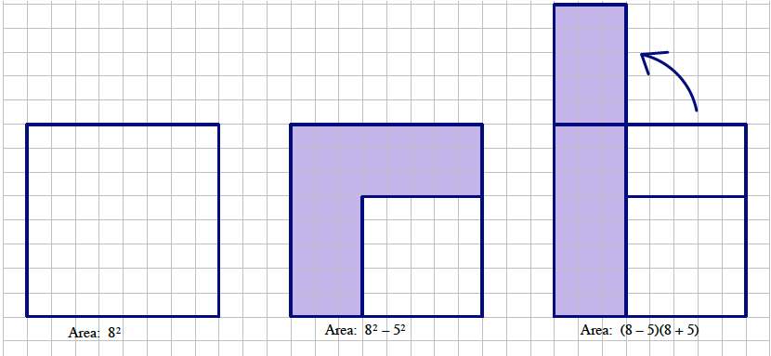

* 1. Create a drawing to show that .

Macintosh HD:Users:wright:Desktop:David's:CCSS:Area&SufaceArea:Pics:Area101.pdf

* 1. Use the result in part (a), , to explain why:
  2. Use the fact that to create a way to mentally square any two digit number ending in “.”

In general, if the first digit is , then the first digit(s) are and the last two digits are .

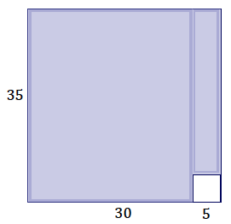 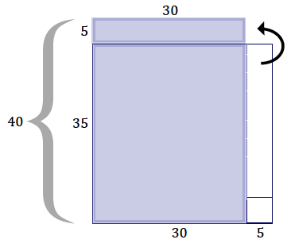

1. Create an area model for each product. Use the area model to write an equivalent expression that represents the area.
2. 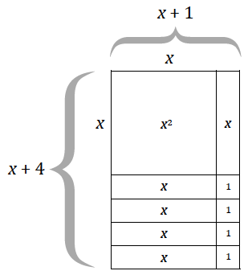
3. 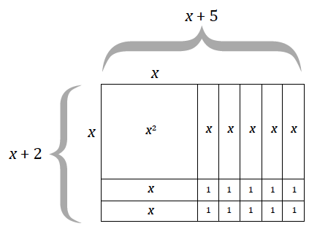
4. Based on the context of the area model, how do the expressions provided in parts (a) and (b) differ from the equivalent expression answers you found for each?

The expression provided in each question shows the area as a length times width product or as the product of two expanded lengths. Each equivalent expression shows the area as the sum of the sections of the expanded rectangle.

1. Use the distributive property to multiply the following expressions:
   1. draw a figure that models this multiplication problem.

