Lesson 20: Real-World Area Problems

Classwork
Opening
Find the area of each shape based on the provided measurements. Explain how you found each area.
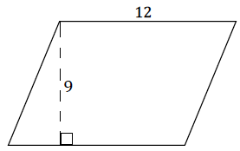
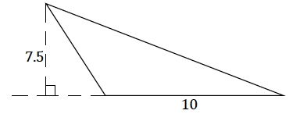

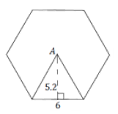
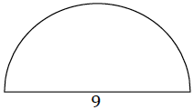

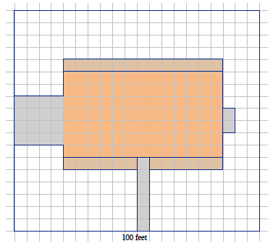
Example 1
A landscape company wants to plant lawn seed. A $20$ lb. bag of lawn seed will cover up to$420$ sq. ft. of grass and costs $\$49.98$ plus the $8\%$ sales tax. A scale drawing of a rectangular yard is given. The length of the longest side is $100$ft. The house, driveway, sidewalk, garden areas, and utility pad are shaded. The unshaded area has been prepared for planting grass. How many $20$ lb. bags of lawn seed should be ordered, and what is the cost?

Exercise 1
A landscape contractor looks at a scale drawing of a yard and estimates that the area of the home and garage is the same as the area of a rectangle that is $100$ ft.$× 35$ft. The contractor comes up with $5,500$ft². How close is this estimate?

Example 2
Ten dartboard targets are being painted as shown in the following figure. The radius of the smallest circle is $3$in. and each successive, larger circle is $3$in. more in radius than the circle before it. A “tester” can of red and of white paint is purchased to paint the target. Each $8$oz. can of paint covers $16$ ft². Is there enough paint of each color to create all ten targets?

Problem Set

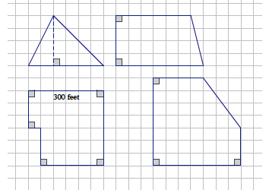
- A farmer has four pieces of unfenced land as shown below in the scale drawing where the dimensions of one side are given. The farmer trades all of the land and $\$10,000$ for $8$ acres of similar land that is fenced. If one acre is equal to$43,560$ft², how much per square foot for the extra land did the farmer pay rounded to the nearest cent?

- An ordinance was passed that required farmers to put a fence around their property. The least expensive fences cost $\$10$ for each foot. Did the farmer save money by moving the farm?
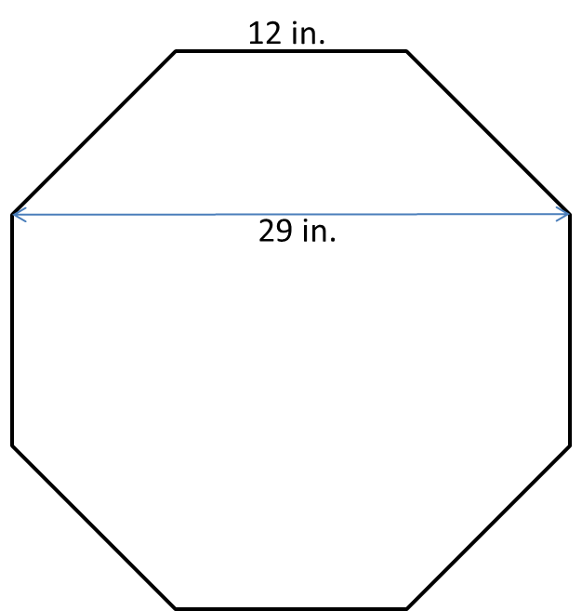
- A stop sign is an octagon (i.e., a polygon with eight sides) with eight equal sides and eight equal angles. The dimensions of the octagon are given. One side of the stop sign is to be painted red. If Timmy has enough paint to paint$500$ft², can he paint $100$ stop signs? Explain your answer.

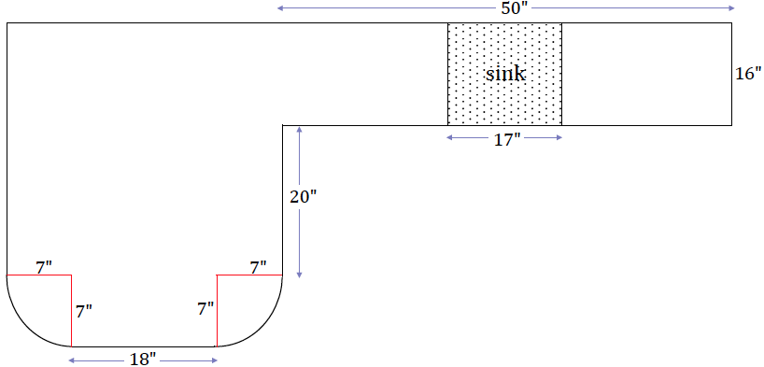
- The Smith family is renovating a few aspects of their home. The following diagram is of a new kitchen countertop. Approximately how many square feet of counter space is there?

- In addition to the kitchen renovation, the Smiths’ are laying down new carpet. Everything but closets, bathrooms, and the kitchen will have new carpet. How much carpeting must be purchased for the home?

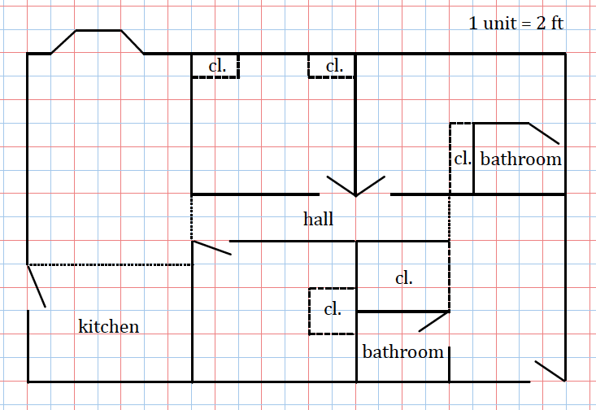

- Jamie wants to wrap a rectangular sheet of paper completely around cans that are $8\frac{1}{2}$ in. high and $4$ in. in diameter. She can buy a roll of paper that is $8\frac{1}{2}$ in. wide and $60$ ft. long. How many cans will this much paper wrap?

