175
Lesson 20: Real-World Area Problems

Student Outcomes
- Students determine the area of composite figures in real-life contextual situations using composition and decomposition of polygons and circular regions.

Lesson Notes
Students apply their understanding of the area of polygons and circular regions to real-world contexts.

Classwork
Opening Exercise (8 minutes)
Opening Exercise
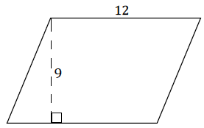
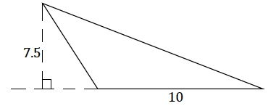
Find the area of each shape based on the provided measurements. Explain how you found each area.

Triangular Region, half base times height.  $area=\frac{1}{2}∙10 units∙7.5 units$  $$=37.5 {units}^{2}$$ | Parallelogram, base times height.  $area=12 units∙9 units$  $$=108 {units}^{2}$$
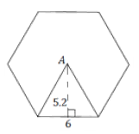
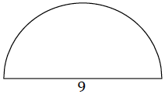

Regular Hexagon, area of the shown triangle times six for the six triangles that fit into the hexagon.  $$area=6\left(\frac{1}{2}⋅6 units⋅5.2 units\right)$$  $=93.6 {units}^{2}$ | Semi-circle, half the area of a circle with the same radius.  $$area=\frac{π}{2} {(4.5)}^{2} {units}^{2}$$  $=10.125π {units}^{2}$  $≈31.81 {units}^{2}$

Example 1 (10 minutes)
Students should first attempt this question without assistance. Once students have had time to work on their own, lead the class through a discussion using the following prompts according to student need.
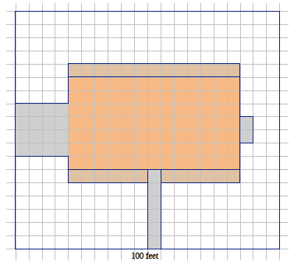
Example 1
A landscape company wants to plant lawn seed. A $20$ lb. bag of lawn seed will cover up to $420$ sq. ft. of grass and costs $\$49.98$ plus the $8\%$ sales tax. A scale drawing of a rectangular yard is given. The length of the longest side is $100$ ft. The house, driveway, sidewalk, garden areas, and utility pad are shaded. The unshaded area has been prepared for planting grass. How many $20$ lb. bags of lawn seed should be ordered, and what is the cost?
$$A_{1}$$
$$A_{3}$$
$$A_{2}$$
$$A_{4}$$
$$A_{6}$$
$$A_{5}$$
$$A_{7}$$

- The following calculations demonstrate how to find the area of the lawn by subtracting the area of the home from the area of the entire yard.
- Non-grassy sections in the map of the yard and their areas.
  - $A_{1}=4 units∙4 units=16 {units}^{2}$
Scaffolding:
- An alternative image with fewer regions is provided after the initial solution.
  - $A_{2}=1 units∙13 units=13 {units}^{2}$
  - $A_{3}=7 units∙13 units=91 {units}^{2}$
  - $A_{4}=1 units∙6 units=6 {units}^{2}$
  - $A_{5}=6 units∙1 units=6 {units}^{2}$
  - $A_{6}=1 units∙6 units=6 {units}^{2}$
  - $A_{7}=2 units∙1 units=2 {units}^{2}$
- What is the total area of the non-grassy sections?
  - $A_{1}+A_{2}{ + A}_{3}+A_{4}+A_{5}+A_{6}+A_{7}= 16 {units}^{2}+ 13 {units}^{2}+ 91 {units}^{2}+ 6 {units}^{2}+ 6 {units}^{2}+ 6 {units}^{2}+ 2 {units}^{2}=140 {units}^{2}$
- What is the area of the grassy section of the yard?
  - Subtract the area of the non-grassy sections from the area of the yard.
$$A=\left(20 units∙18 units\right)-140 {units}^{2}=220 {units}^{2}$$
- What is the scale factor of the map of the yard?
  - The scale of the map is $5$ ft. for every one unit and $25$ ft² for every $1$unit².
- What is the grassy area in square feet?
  - $220⋅25=5,500$
- If one $20$ lb. bag covers $420$ square feet, write a numerical expression for the number of bags needed to cover the grass in the yard. Explain your expression.
MP.2
  - Grassy area $÷$ area that one bag of seed covers
  - $5,500÷420$
- How many bags are needed to cover the grass in the yard?
  - $5,500÷420≈13.1$
MP.2
  - It will take $14$ bags to seed the yard.
- What is the final cost of seeding the yard?
  - $1.08⋅14⋅\$49.98≈\$755.70$
  - Final cost with sales tax is $\$755.70$
- Encourage students to write or state an explanation for how they solved the problem.
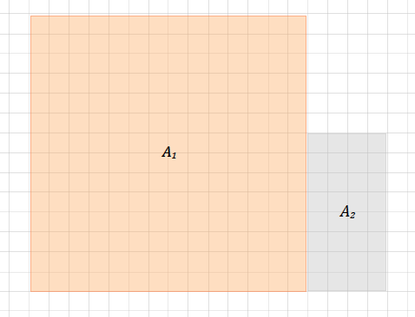
Alternative image of property:
$100$ft.

- Non-grassy sections in the map of the yard and their areas.
  - $A_{1}=14 units∙14 units=196 {units}^{2}$
  - $A_{2}=4 units∙8 units=32 {units}^{2}$
- What is the total area of the non-grassy sections?
  - $A_{1}+A_{2}= 196 {units}^{2}+ 32 {units}^{2}=228 {units}^{2}$
- What is the area of the grassy section of the yard?
  - Subtract the area of the non-grassy sections from the area of the yard.
  - $A=\left(20 units∙15 units\right)-228 {units}^{2}=72 {units}^{2}$
- What is the scale factor of the map of the yard?
  - The scale of the map is $5$ft. for every one unit and $25$ft² for every $1$unit².
- What is the grassy area in square feet?
  - $72⋅25=1,800$
- If one $20$ lb. bag covers $420$ square feet, write a numerical expression for the number of bags needed to cover the grass in the yard. Explain your expression.
  - Grassy area $÷$ area that one bag of seed covers
MP.2
  - $1,800÷420$
- How many bags are needed to cover the grass in the yard?
  - $1,800÷420≈4.3$
  - It will take $5$ bags to seed the yard.
- What is the final cost of seeding the yard?
  - $1.08⋅5⋅\$49.98≈\$269.89$
  - Final cost with sales tax is $\$269.89$.
Exercise 1 (6 minutes)
Exercise 1
A landscape contractor looks at a scale drawing of a yard and estimates that the area of the home and garage is the same as the area of a rectangle that is $100$ft. $× 35$ ft. The contractor comes up with $5,500$ ft². How close is this estimate?
The entire yard (home and garage) has an area of$100$ft. $×35$ft. $=3,500$ft². The contractor’s estimate is$5,500$ ft². He is $2,000$ ft² over the actual area, which is quite a bit more ($2,000$ ft² is roughly $57\%$ of the actual area).

Example 2 (10 minutes)
Example 2
$$C_{1}$$
$$C_{2}$$
$$C_{3}$$
$$C_{4}$$
Ten dartboard targets are being painted as shown in the following figure. The radius of the smallest circle is $3$in. and each successive, larger circle is $3$ in. more in radius than the circle before it. A “tester” can of red and of white paint is purchased to paint the target. Each $8$ oz. can of paint covers $16$ ft². Is there enough paint of each color to create all ten targets?
Let each circle be labeled as in the diagram.
Radius of $C_{1}$ is $3$ in.; area of $C_{1}$ is $9π$in².
Radius of $C_{2}$ is $6$in.; area of $C_{2}$ is $36π$ in².
Radius of $C_{3}$ is $9$ in.; area of $C_{3}$ is $81π$ in².
Radius of $C_{4}$ is $12$ in.; area of $C_{4}$ is $144π$ in².

- Write a numerical expression that represents the area painted red. Explain how your expression represents the situation.
MP.2
&
MP.7
  - The area of red and white paint in square inches is found by finding the area between circles of the target board:
  - Red paint: $(144π$in²$- 81π$ in²$)+(36π$in²$- 9π$in²$)$
  - White paint: $(81π$ in²$- 36π$ in²$)+ 9π$in²
The following calculations demonstrate how to find the area of red and white paint in the target.
Target area painted red
The area between $C_{4}$ and $C_{3}$: $144π$in²$- 81π$ in²$=63π$ in²
The area between $C_{2}$ and $C_{1}$: $36π$ in² $- 9π$in² $=27π$ in²
Area painted red in one target: $63π$ in²$+27π$in²$=90π$ in²; approximately $282.7$ in²
Area of red paint for one target in sq. ft.: $282.7 {in}^{2}\left(\frac{1 {ft}^{2}}{144 {in}^{2}}\right)≈1.96 {ft}^{2}$
Area to be painted red for ten targets in sq. ft.: $1.96$ft²$× 10=19.6$ft²

Target area painted white
The area between $C_{3}$ and $C_{2}$: $81π$in²$-36π$in²$=45π$ in²
The area of $C_{1}$: $9π$in²
Area painted white in one target: $45π$ in²$+9π$ in²$=54π$in²; approximately$169.6$in²
Area of white paint for one target sq. ft.: $169.6 {in}^{2}\left(\frac{1 {ft}^{2}}{144 {in}^{2}}\right)≈1.18 {ft}^{2}$
Area of white paint needed for ten targets in sq. ft.: $1.18$ ft²$× 10=11.8$ft²
There is not enough red paint in one tester can of paint to complete all ten targets; however, there is enough white paint in one tester can of paint for all ten targets.

Closing (2 minutes)
- What is a useful strategy when tackling area problems with real-world context?
  - Decompose drawings into familiar polygons and circular regions, and identify all relevant measurements.
  - Pay attention to the unit needed in a response to each question.

Exit Ticket (9 minutes)
Name Date
Lesson 20: Real-World Area Problems

Exit Ticket

A homeowner called in a painter to paint bedroom walls and ceiling. The bedroom is $18$ft. long, $12$ ft. wide, and $8$ ft. high. The room has two doors each $3$ ft. by $7$ ft. and three windows each $3$ ft. by $5$ ft. The doors and windows do not have to be painted. A gallon of paint can cover $300$ ft². A hired painter claims he will need $4$ gal. Show that the estimate is too high.

Exit Ticket Sample Solutions

A homeowner called in a painter to paint bedroom walls and ceiling. The bedroom is $18$ft. long, $12$ ft. wide, and $8$ ft. high. The room has two doors each $3$ ft. by $7$ ft. and three windows each $3$ ft. by $5$ ft. The doors and windows do not have to be painted. A gallon of paint can cover $300$ ft². A hired painter claims he will need $4$ gal. Show that the estimate is too high.
Area of 2 walls: $2(18$ft. $∙8$ft.$)=288$ ft²
Area of remaining 2 walls: $2(12$ ft. $∙8$ft.$)=192$ ft²
Area of ceiling: $18$ft. $∙12$ ft. $=216$ ft²
Area of 2 doors: $2(3$ ft. $∙7$ft$.)=42$ft²
Area of 3 windows $3(3$ft. $∙5$ft$.)=45$ft²
Area to be painted: $(288$ ft² $+ 192$ ft² $+ 216$ ft² $)-(42$ft² $+ 45$ ft² $)=609$ft²
Gallons of paint needed: $609÷300=2.03$ The painter will need a little more than $2$ gal.
The painter’s estimate for how much paint is necessary was too high.

Problem Set Sample Solutions

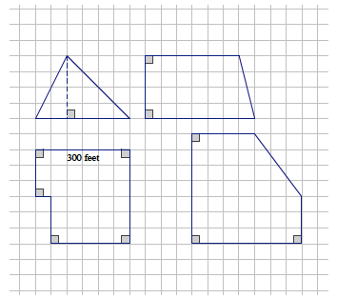
- A farmer has four pieces of unfenced land as shown below in the scale drawing where the dimensions of one side are given. The farmer trades all of the land and $\$10,000$ for $8$ acres of similar land that is fenced. If one acre is equal to$43,560$ ft², how much per square foot for the extra land did the farmer pay rounded to the nearest cent?
$$A_{1}$$
$$A_{2}$$
$$A_{3}$$
$$A_{4}$$

$A_{1}=\frac{1}{2}\left(6 units∙4 units\right)=12 {units}^{2}$
$A_{2}=\frac{1}{2}\left(6 units+7 units\right)(4 units)=26 {units}^{2}$
$$A_{3}=\left(3 units∙6 units\right)+\left(3 units∙5 units\right)=33 {units}^{2}$$
$A_{4}=\left(4 units∙7 units\right)+\left(3 units∙3 units\right)+\frac{1}{2}\left(3 units∙4 units\right)=43 {units}^{2}$
The sum of the farmer’s four pieces of land:
$$A_{1}+A_{2}{ + A}_{3}+A_{4}=12{ units}^{2}+26 {units}^{2}+33 {units}^{2}+43 {units}^{2}=114 {units}^{2}$$
The sum of the farmer’s four pieces of land in sq. ft.:
$6$units$= 300$ ft. divide each side by $6$
$1$unit$=50$ft. and $1$ unit² $=2,500$ ft²
$$114⋅2,500=285,000$$
The total area of the farmer's four pieces of land: $285,000$ft².
The sum of the farmer’s four pieces of land in acres:
$285,000÷43,560≈6.54$
The farmer’s four pieces of land total about $6.54$ acres.
Extra land purchased with $\$10,000$: $8$acres$- 6.54$acres$=1.46$acres
Extra land in square feet:
$$1.46 acres \left(\frac{43,560 {ft}^{2}}{1 acre}\right)≈63,597.6 {ft}^{2}$$
Price per square foot for extra land:
$$\left(\frac{ \$10,000}{63,597.6 {ft}^{2}}\right)≈\$0.16$$

- An ordinance was passed that required farmers to put a fence around their property. The least expensive fences cost $\$10$ for each foot. Did the farmer save money by moving the farm?
At $\$10$ for each foot, $\$10,000$ would purchase $1,000$ feet of fencing. The perimeter of the third piece of land (labeled $A_{3}$) has perimeter $1,200$ ft. So it would have cost over$\$10,000$ just to fence that piece of property. The farmer did save money by moving the farm.

- A stop sign is an octagon (i.e., a polygon with eight sides) with eight equal sides and eight equal angles. The dimensions of the octagon are given. One side of the stop sign is to be painted red. If Timmy has enough paint to paint$500$ ft², can he paint $100$ stop signs? Explain your answer.
area of top trapezoid$=\frac{1}{2}(12$ in.$+ 29$ in.$)(8.5$ in.$)=174.25$in²
area of middle rectangle $=12$in.$∙ 29$in.$=348$in²
area of bottom trapezoid $=\frac{1}{2}(12$ in.$+ 29$ in.$)(8.5$in.$)=174.25$in²
Total area of stop sign in square inches:
$A_{1}+A_{2}{ + A}_{3}=174.25$ in² $+ 348$ in² $+ 174.25$in² $=696.5$ in²
Total area of stop sign in square feet:
$696.5 {in}^{2} \left(\frac{1 {ft}^{2}}{144 {in}^{2}}\right)≈4.84 {ft}^{2}$
Yes, the area of one stop sign is less than $5$ft²$(4.84$ ft²$)$. Therefore, $100$ stop signs would be less than $500$ft².
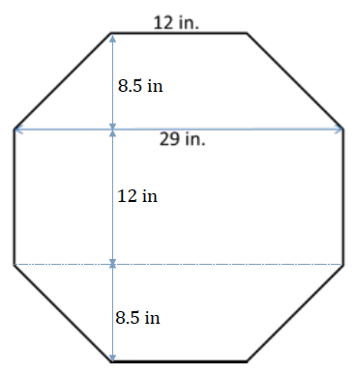
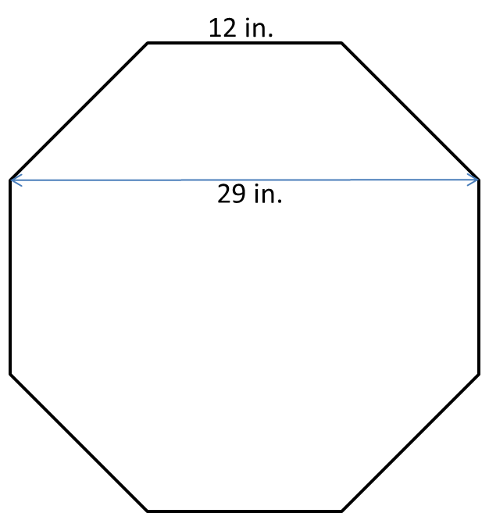
$$A_{1}$$
$$A_{2}$$
$$A_{3}$$

- The Smith family is renovating a few aspects of their home. The following diagram is of a new kitchen countertop. Approximately how many square feet of counter space is there?
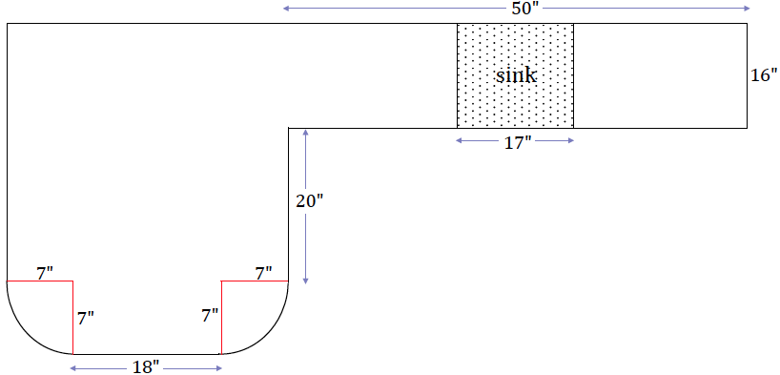
$$A_{1}$$
$$A_{2}$$

$$A_{3}$$
$$A_{1}=\left(20 in.+16 in.\right)\left(18 in.+14 in.\right)=1,152 {in}^{2} \\ A_{2}=\left(18 in.∙7 in.\right)+\frac{1}{2}\left(49π {in}^{2}\right) \\ ≈(126 {in}^{2}+77 {in}^{2}) \\ =203 {in}^{2} \\ A_{3}=\left(50 in.∙16 in.\right)-(17 in.∙16 in.)=528 {in}^{2}$$

Total area of counter space in square inches:
$$A_{1}+A_{2}{ + A}_{3}≈1,152{ in}^{2}+203 {in}^{2}+528 {in}^{2} \\ A_{1}+A_{2}{ + A}_{3}≈1,883 {in}^{2}$$

Total area of counter-space in square feet:
$$1,883 {in}^{2} \left(\frac{1 {ft}^{2}}{144 {in}^{2}}\right)≈13.1 {ft}^{2}$$
There is approximately $13.1$ ft² of counter space.

- In addition to the kitchen renovation, the Smiths’ are laying down new carpet. Everything but closets, bathrooms, and the kitchen will have new carpet. How much carpeting must be purchased for the home?
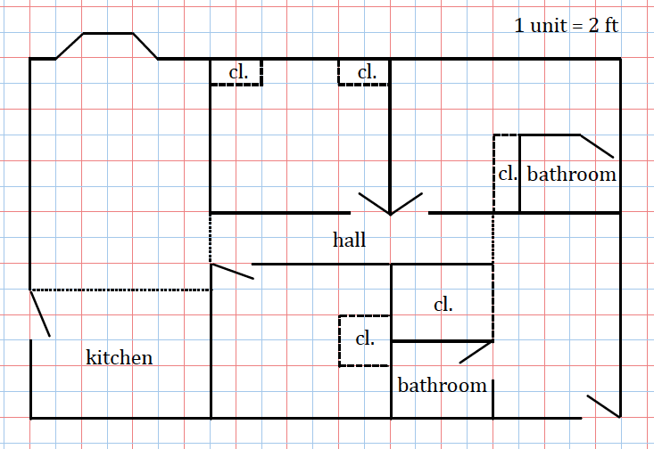
$$A_{1}$$
$$A_{2}$$
$$A_{5}$$
$$A_{3}$$
$$A_{4}$$
$$A_{6}$$

$$A_{1}=\left(9 units∙7 units\right)+3 {units}^{2}=66 {units}^{2}$$
$$A_{2}=\left(6 units∙7 units\right)-4 {units}^{2}=38 {units}^{2}$$
$$A_{3}=\left(6 units∙7 units\right)-4 {units}^{2}=38 {units}^{2}$$
$$A_{4}=2 units∙11 units=22 {units}^{2}$$
$$A_{5}=\left(5 units∙3 units\right)+(4 units∙6 units)=39 {units}^{2}$$
$$A_{6}=5 units∙8 units=40 {units}^{2}$$

Total area that needs carpeting:
$$A_{1}+A_{2}{ + A}_{3}+A_{4}+A_{5}+A_{6}=66 {units}^{2}+38 {units}^{2}+38 {units}^{2}+22 {units}^{2}+39 {units}^{2}+40 {units}^{2} \\ =243 {units}^{2}$$

Scale factor: $1 unit=2 ft.$; $1 {unit}^{2}=4 {ft}^{2}$.
Total area that needs carpeting in square feet:
$$243 {units}^{2}\left(\frac{4 {ft}^{2}}{1 {unit}^{2}}\right)=972 {ft}^{2}$$

- Jamie wants to wrap a rectangular sheet of paper completely around cans that are $8\frac{1}{2}$ in. high and $4$ in. in diameter. She can buy a roll of paper that is $8\frac{1}{2}$ in. wide and$60$ ft. long. How many cans will this much paper wrap?
$4$ inch diameter cans have a circumference of $4π$ in., approximately $12.57$ in. $60$ft. is the same as $720$in.;
$720$ in. $÷12.57$ in. is approximately $57.3$ in., so this paper will cover $57$ cans.

