Lesson 19: Understanding Three-Dimensional Figures

Classwork
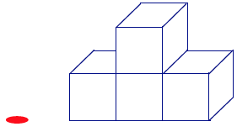
Example 1
If slices parallel to the tabletop (with height a whole number of units from the tabletop) were taken of this figure, then what would each slice look like?

Example 2
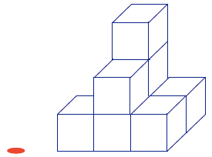
If slices parallel to the tabletop were taken of this figure, then what would each slice look like?

Exercise 1
Based on the level slices you determined in Example 2, how many unit cubes are in the figure?

Exercise 2
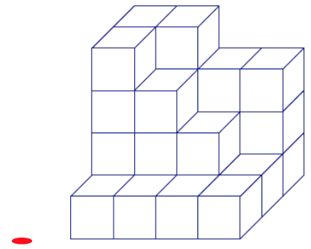
  - If slices parallel to the tabletop were taken of this figure, then what would each slice look like?

  - Given the level slices in the figure, how many unit cubes are in the figure?

Example 3
Given the level slices in the figure, how many unit cubes are in the figure?
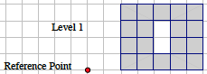 | 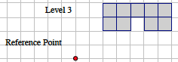
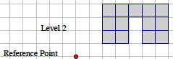 | 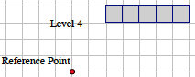

Exercise 3
Sketch your own three dimensional figure made from cubes and the slices of your figure. Explain how the slices relate to the figure.

Problem Set

In the given three-dimensional figures, unit cubes are stacked exactly on top of each other on a tabletop. Each block is either visible or below a visible block.

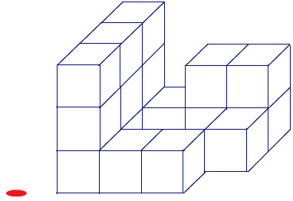
  - The following three-dimensional figure is built on a tabletop. If slices parallel to the tabletop are taken of this figure, then what would each slice look like?
  - Given the level slices in the figure, how many cubes are in the figure?

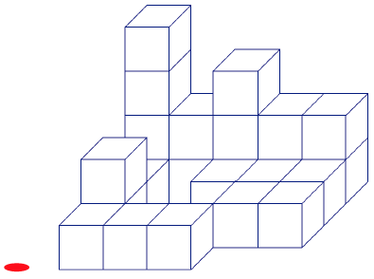
  - The following three-dimensional figure is built on a tabletop. If slices parallel to the tabletop are taken of this figure, then what would each slice look like?
  - Given the level slices in the figure, how many cubes are in the figure?

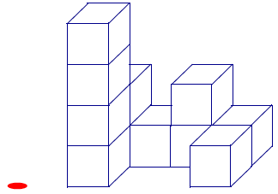
  - The following three-dimensional figure is built on a tabletop. If slices parallel to the tabletop are taken of this figure, then what would each slice look like?
  - Given the level slices in the figure, how many cubes are in the figure?

- John says that we should be including the Level 0 slice when mapping slices. Naya disagrees, saying it is correct to start counting cubes from the Level 1 slice. Who is right?

- Draw a three-dimensional figure made from cubes so that each successive layer further away from the tabletop has one less cube than the layer below it. Use a minimum of three layers. Then draw the slices and explain the connection between the two.

