Lesson 19: Understanding Three-Dimensional Figures

Student Outcomes
- Students describe three-dimensional figures built from cubes by looking at horizontal slicing planes.

Lesson Notes
In Grade 10 geometry, students will study the link between the volume of a figure and its slices and in doing so consider a whole figure in slices versus any given slice as studied in Grade 7. In Lesson 19, students take an easy approach to thinking of a figure in slices. We say easy since each slice is made up of several cubes and is thereby not a stretch to visualize, or for that matter, to build. In this lesson, students examine figures built out of unit cubes. A one-unit grid is placed on a table. Cubes are fit into the squares on the grid and then stacked on top of each other to make a three-dimensional figure; the figure in Example 1 is one such example. Slices are made at each level of the figure so that each slice is actually between layers of cubes. Students learn to map the figure layer by layer, much like creating a blueprint for each floor of a building. Students are able to deconstruct a figure, mapping each slice on a grid to determine the number of cubes in the figure. Students are also able to do the reverse and construct a three-dimensional figure from a map of each horizontal slice of the figure. The use of unit cubes and a square unit grid is useful in this lesson; another idea is to provide graph paper to draw the levels of each figure on.

Classwork
Example 1 (10 minutes)
Scaffolding:
Consider using unit cubes and grid paper throughout the examples. As an alternative, have students build the figures in the examples using the net for a cube at the end of the module.
Students are to imagine each three-dimensional figure as a figure built on a tabletop. Each horizontal slice of the figure is to be mapped onto grid paper where each $1×1$ cell represents the base of a unit cube. Level $n$ means the slicing plane is $n$ units above the tabletop. This means, Level 0 ($0$ units above the tabletop) is the level of the tabletop, while Level 1 is one unit above the tabletop. Recall that a slice is the intersection of the solid with the slicing plane. This means that the slice at Level 0 and the slice at Level 1 will always be the same. This is also why there is a slice at Level 3, even though it is the “top” of the figure; a horizontal plane at that level would still intersect with the figure.
In the map of each slice, there should be a reference point that remains in the same position (i.e., the reference points are all exactly on top or below each other), regardless of which slice the map is for. In Example 1, the reference point is marked for students. Reference points should also be marked in the image of the three-dimensional figure so that any reader can correctly compare the point of view of the three-dimensional figure to the slices.

Example 1
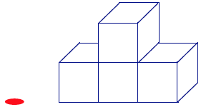
If slices parallel to the tabletop (with height a whole number of units from the
tabletop) were taken of this figure, then what would each slice look like?
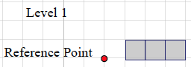
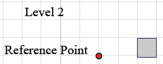 | 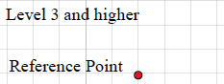

Example 2 (7 minutes)
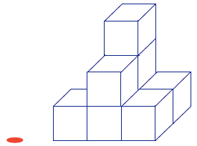
Example 2
If slices parallel to the tabletop were taken of this figure, then what would each slice look like?

MP.7
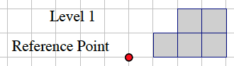 | 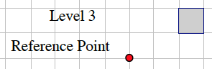
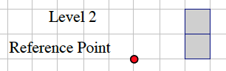 | 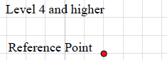

- Check in with students for each level in the example. Pull the whole class together if discussion is needed. Remind students that this perspective of the three-dimensional solid allows a full view of two of four “sides” of the figure.

Exercise 1 (5 minutes)
Exercise 1
Based on the level slices you determined in Example 2, how many unit cubes are in the figure?
The number of unit cubes can be determined by counting the shaded squares in Levels 1–3.
Level 1: five shaded squares; there are four cubes between Level 0 and Level 1.
Level 2: two shaded squares; there are two cubes between Level 1 and Level 2.
Level 3: one shaded square; there are six cubes between Level 2 and Level 3.
The total number of cubes in the solid is $8$.

Exercise 2 (7 minutes)
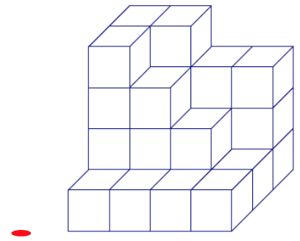
Exercise 2
  - If slices parallel to the tabletop were taken of this figure, then
what would each slice look like?

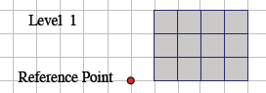
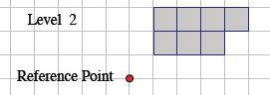 | 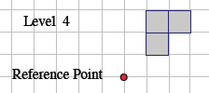
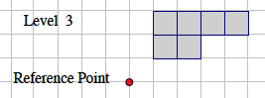 | 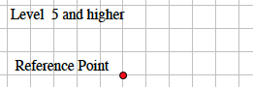

  - Given the level slices in the figure, how many unit cubes are in the figure?
The number of unit cubes can be determined by counting the shaded squares in Levels 1–4.
Level 1: There are $12$ cubes between Level 0 and Level 1.
Level 2: There are seven cubes between Level 1 and Level 2.
Level 3: There are six cubes between Level 2 and Level 3.
Level 4: There are three cubes between Level 3 and Level 4.
The total number of cubes in the solid is $28$.

Example 3 (7 minutes)
Example 3
Given the level slices in the figure, how many unit cubes are in the figure?
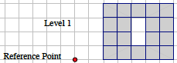 | 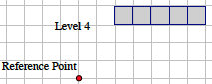
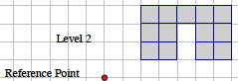
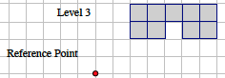
The number of unit cubes can be determined by counting the shaded squares in Levels 1–4.
Level $1$: There are $18$ cubes between Level $0$ and Level$1$.
Level $2$: There are $13$ cubes between Level $1$ and Level$2$.
Level $3$: There are nine cubes between Level $2$ and Level$3$.
Level $4$: There are five cubes between Level $3$ and Level$4$.
The total number of cubes in the solid is $45$.

Exercise 3 (optional)
Exercise 3
MP.6
&
MP.7
Sketch your own three dimensional figure made from cubes and the slices of your figure. Explain how the slices relate to the figure.
Responses will vary.

Closing (1 minutes)
- We take a different perspective of three-dimensional figures built from unit cubes by examining the horizontal whole-unit slices. The slices allow a way to count the number of unit cubes in the figure, which is particularly useful when the figure is layered in a way so that many cubes are hidden from view.

Exit Ticket (6 minutes)
Name Date
Lesson 19: Understanding Three-Dimensional Figures

Exit Ticket
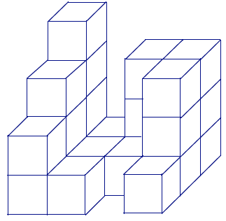
- The following three-dimensional figure is built on a tabletop. If slices parallel to the tabletop are taken of this figure, then what would each slice look like?

- Given the level slices in the figure, how many cubes are in the figure?

Exit Ticket Sample Solutions

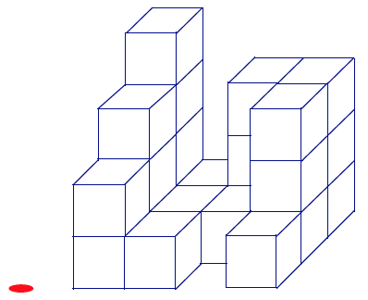
- The following three-dimensional figure is built on a tabletop. If slices
parallel to the tabletop are taken of this figure, then what would each
slice look like?

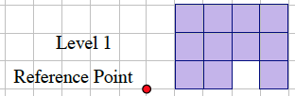
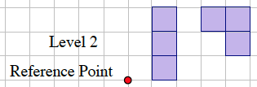 | 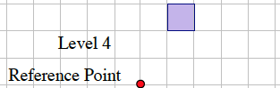
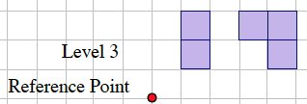 | 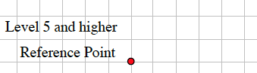

- Given the level slices in the figure, how many cubes are in the figure?
The number of unit cubes can be determined by counting the shaded squares in Levels 1–4.
Level 1: There are $11$ cubes between Level 0 and Level 1.
Level 2: There are six cubes between Level 1 and Level 2.
Level 3: There are five cubes between Level 2 and Level 3.
Level 4: There is one cube between Level 3 and Level 4.
The total number of cubes in the solid is $23$.

Problem Set Sample Solutions
In the given three-dimensional figures, unit cubes are stacked exactly on top of each other on a tabletop. Each block is either visible or below a visible block.

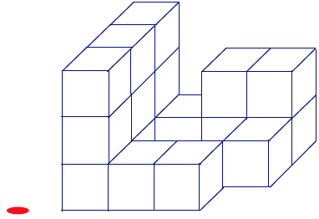
  - The following three-dimensional figure is built on a tabletop. If slices parallel to the tabletop are taken of this figure, then what would each slice look like?

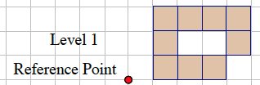 | 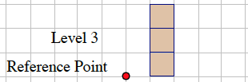
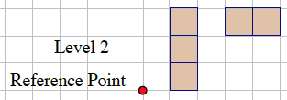 | 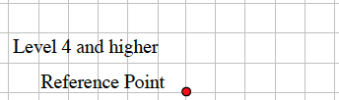

  - Given the level slices in the figure, how many cubes are in the figure?
The number of unit cubes can be determined by counting the shaded squares in Levels 1–3.
Level 1: There are nine cubes between Level 0 and Level 1.
Level 2: There are five cubes between Level 1 and Level 2.
Level 3: There are three cubes between Level 2 and Level 3.
The total number of cubes in the solid is $17$.

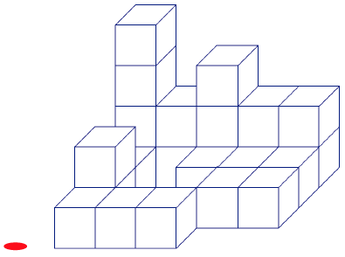
  - The following three-dimensional figure is built on a tabletop. If slices parallel to the tabletop are taken of this figure, then what would each slice look like?

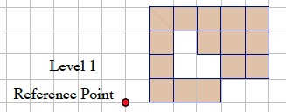 | 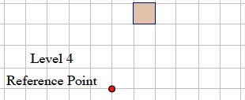
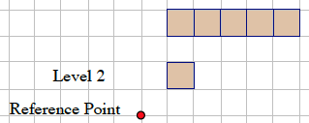 | 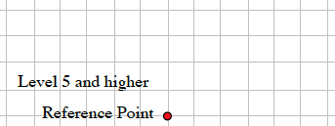
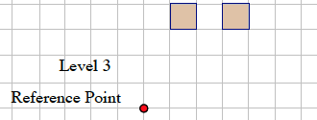

  - Given the level slices in the figure, how many cubes are in the figure?
The number of unit cubes can be determined by counting the shaded squares in Levels 1–4.
Level 1: There are fifteen cubes between Level 0 and Level 1.
Level 2: There are six cubes between Level 1 and Level 2.
Level 3: There are two cubes between Level 2 and Level 3.
Level 4: There is one cube between Level 3 and Level 4.
The total number of cubes in the solid is $24$.

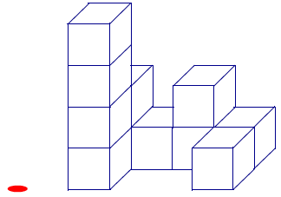
  - The following three-dimensional figure is built on a tabletop. If
slices parallel to the tabletop are taken of this figure, then what
would each slice look like?

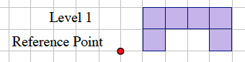
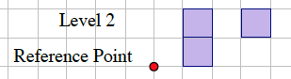 | 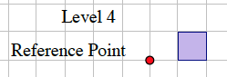
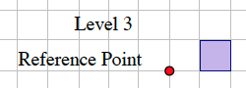 | 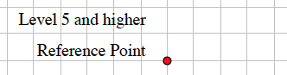

  - Given the level slices in the figure, how many cubes are in the figure?
The number of unit cubes can be determined by counting the shaded squares in Levels 1–4.
Level 1: There are six cubes between Level 0 and Level 1.
Level 2: There are three cubes between Level 1 and Level 2.
Level 3: There is one cube between Level 2 and Level 3.
Level 4: There is one cube between Level 3 and Level 4.
The total number of cubes in the solid is $11$.

- John says that we should be including the Level 0 slice when mapping slices. Naya disagrees, saying it is correct to start counting cubes from the Level 1 slice. Who is right?
Naya is right because the Level 0 slice and Level 1 slice are the tops and bottoms of the same set of cubes; counting cubes in both slices would be double counting cubes.

- Draw a three-dimensional figure made from cubes so that each successive layer further away from the tabletop has one less cube than the layer below it. Use a minimum of three layers. Then draw the slices and explain the connection between the two.
Responses will vary.

