Lesson 18: Slicing on an Angle

Classwork
Example 1
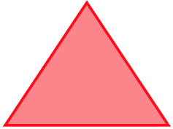
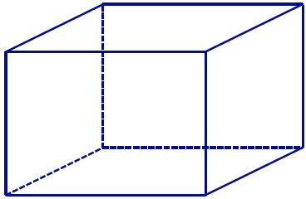
With your group, discuss whether a right rectangular prism can be sliced at an angle so that the resulting slice looks like the figure in Figure 1? If it is possible, draw an example of such a slice into the following prism.
Figure 1

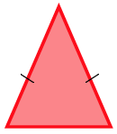
Exercise 1
Figure 2
  - With your group, discuss how to slice a right rectangular prism so that the resulting slice looks like the figure in Figure 2. Justify your reasoning.

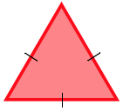
  - With your group, discuss how to slice a right rectangular prism so that the resulting slice looks like the figure in Figure 3. Justify your reasoning.
Figure 3

Example 2
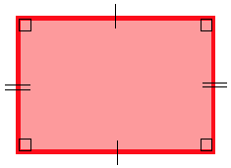
With your group, discuss whether a right rectangular prism can be sliced at an angle so that the resulting slice looks like the figure in Figure 4. If it is possible, draw an example of such a slice into the following prism.
Figure 4

Exercise 2
In Example 2, we discovered how to slice a right rectangular prism to makes the shapes of a rectangle and a parallelogram. Are there other ways to slice a right rectangular prism that result in other quadrilateral-shaped slices?

Example 3
  - Slicing a plane through a right rectangular prism so that the slice meets the three faces of the prism, the resulting slice is in the shape of a triangle; if the slice meets four faces, the resulting slice is in the shape of a quadrilateral. Is it possible to slice the prism in a way that the region formed is a pentagon (as in Figure 5)? A hexagon (as in Figure 6)? An octagon (as in Figure 7)?
Figure 5 | Figure 6 | Figure 7

  - Draw an example of a slice in a pentagon shape and a slice in a hexagon shape.

Example 4
Figure 8
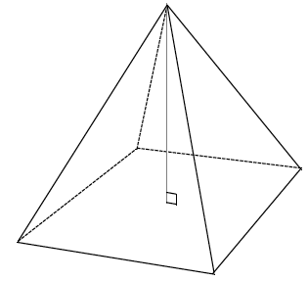
  - With your group, discuss whether a right rectangular pyramid can be sliced at an angle so that the resulting slice looks like the figure in Figure 8. If it is possible, draw an example of such a slice into the following pyramid.

  - With your group, discuss whether a right rectangular pyramid can be sliced at an angle so that the resulting slice looks like the figure in Figure 9. If it is possible, draw an example of such a slice into the pyramid above.

Figure 9
Problem Set

- Draw a slice into the right rectangular prism at an angle in the form of the provided shape, and draw each slice as a 2D shape.
Slice made in the prism Slice as a 2D shape

  - A triangle

  - A quadrilateral

  - A pentagon

  - A hexagon

- Draw slices at an angle in the form of each given shape into each right rectangular pyramid, and draw each slice as a 2D shape:
Slice made in the pyramid Slice as a 2D shape

  - A triangle

  - A quadrilateral

  - A pentagon

- Why isn’t it possible to draw a slice in the shape of a hexagon for a right rectangular pyramid?

- If the slicing plane meets every face of a right rectangular prism, then the slice is a hexagonal region. What can you say about opposite sides of the hexagon?

- Draw a right rectangular prism so that rectangles $ABCD$ and $A'B'C'D'$ are base faces. The line segments $AA'$, $BB'$, $CC^{'}$ and $DD'$ are edges of the lateral faces.
  - A slicing plane meets the prism so that vertices $A$, $B$,$C$, and $D$ lie on one side of the plane and vertices $A^{'}$, $B^{'}$, $C^{'}$, and $D'$ lie on the other side. What other information can be concluded about the slice based on its position?
  - A slicing plane meets the prism so that vertices $A$, $B$,$C$, and $B'$ are on one side of the plane and vertices $A^{'}$, $D^{'}$,$C^{'}$, and $D$ are on the other side. What other information can be concluded about the slice based on its position?

