Lesson 17: Slicing a Right Rectangular Pyramid with a Plane

Classwork

Opening

**Rectangular Pyramid:** Given a rectangular region in a plane , and a point not in , the *rectangular pyramid with base and vertex*  is the collection of all segments for any point in It can be shown that the planar region defined by a side of the base and the vertex is a triangular region, called a *lateral face*.



A rectangular region in a plane and a point not in

The rectangular pyramid will be determined by the collection of all segments for any point in ; here is shown for a total of points.

The rectangular pyramid is a solid once the collection of all segments for any point in are taken. The pyramid has a total of five faces: four lateral faces and a base.

If the vertex lies on the line perpendicular to the base at its center (the intersection of the rectangle’s diagonals), the pyramid is called a right rectangular pyramid. The example of the rectangular pyramid above is not a right rectangular pyramid, as evidenced in this image. The perpendicular from does not meet at the intersection of the diagonals of the rectangular base .



The following is an example of a right rectangular pyramid. The opposite lateral faces are identical isosceles triangles.

**Example 1**

Use the models you built to assist in a sketch of a pyramid: Though you are sketching from a model that is opaque, use dotted lines to represent the edges that cannot be seen from your perspective.

**Example 2**

Sketch a right rectangular pyramid from three vantage points: (1) from directly over the vertex, (2) facing straight on to a lateral face, and (3) from the bottom of the pyramid. Explain how each drawing shows each view of the pyramid.

Example 3

Assume the following figure is a top-down view of a rectangular pyramid. Make a reasonable sketch of any two adjacent lateral faces. What measurements must be the same between the two lateral faces? Mark the equal measurement. Justify your reasoning for your choice of equal measurements.

Example 4

* 1. A slicing plane passes through segment parallel to base of the right rectangular pyramid below. Sketch what the slice will look like into the figure. Then sketch the resulting slice as a two-dimensional figure. Students may choose how to represent the slice (e.g., drawing a 2D or 3D sketch or describing the slice in words).
  2. What shape does the slice make? What is the relationship between the slice and the rectangular base of the pyramid?

Example 5

A slice is to be made along segment perpendicular to base of the right rectangular pyramid below.

* 1. Which of the following figures shows the correct slice? Justify why each of the following figures is or is not a correct diagram of the slice.



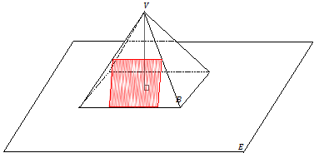

* 1. A slice is taken through the vertex of the pyramid perpendicular to the base. Sketch what the slice will look like into the figure. Then, sketch the resulting slice itself as a two-dimensional figure.



Problem Set

1. A side view of a right rectangular pyramid is given. The line segments lie in the lateral faces.
   1. For segments ,, and , sketch the resulting slice from slicing the right rectangular pyramid with a slicing plane that contains the line segment and is perpendicular to the base.
   2. For segment , sketch the resulting slice from slicing the right rectangular pyramid with a slicing plane that contains the segment and is parallel to the base.

*Note:* To challenge yourself, you can try drawing the slice into the pyramid.

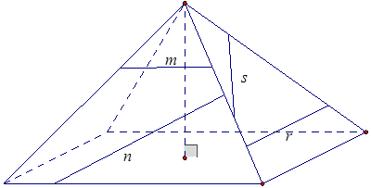

* 1. A top view of a right rectangular pyramid is given. The line segments lie in the base face. For each line segment, sketch the slice that results from slicing the right rectangular pyramid with a plane that contains the line segment and is perpendicular to the base.

