|  |
| --- |
|  |

Lesson 17: Slicing a Right Rectangular Pyramid with a Plane

Student Outcomes

* Students describe polygonal regions that result from slicing a right rectangular pyramid by a plane perpendicular to the base and by another plane parallel to the base.

Lesson Notes

In contrast to Lesson 16, Lesson 17 studies slices made to a right rectangular pyramid rather than a right rectangular prism. However, the slices will still be made perpendicular and parallel to the base. Students have had some experience with pyramids in Module 3 (Lesson 22), but it was in the context of surface area. This lesson gives students the opportunity to build pyramids from nets as they study the formal definition of pyramid. (Nets for the pyramids are provided at the end of the module.)

Classwork

Opening (10 minutes)

Have students build right rectangular pyramids from the provided nets in their groups. Once the pyramids are built, lead a discussion that elicits a student description of what a right rectangular pyramid is.

* How would you describe a pyramid?
  + *Responses will vary. Students may remark on the existence of a rectangular base, that the “sides” are isosceles triangles, and that the edges of the isosceles triangles all meet* *at a vertex.*

Then, introduce the formal definition of a *rectangular pyramid,* and use the series of images that follow to make sense of the definition.

Opening

Rectangular Pyramid: Given a rectangular region in a plane , and a point not in , the *rectangular pyramid with base and vertex*  is the collection of all segments for any point in It can be shown that the planar region defined by a side of the base and the vertex is a triangular region, called a *lateral face*.



A rectangular region in a plane and a point not in



The rectangular pyramid will be determined by the collection of all segments for any point in ; here is shown for a total of points.



The rectangular pyramid is a solid once the collection of all segments for any point in are taken. The pyramid has a total of five faces: four lateral faces and a base.

Students should understand that a rectangular pyramid is a solid figure and not a hollow shell like the pyramids they built from the nets, so the nets are not a perfect model in this sense. The collection of all segments renders the pyramid to be solid.

  
If the vertex lies on the line perpendicular to the base at its center (the intersection of the rectangle’s diagonals), the pyramid is called a *right rectangular pyramid*. The example of the rectangular pyramid above is not a right rectangular pyramid, as evidenced in this image. The perpendicular from does not meet at the intersection of the diagonals of the rectangular base .



The following image is an example of a right rectangular pyramid. The opposite lateral faces are identical isosceles triangles.

Visualizing slices made to a pyramid can be challenging. To build up to the task of taking slices of a pyramid, have students take time to sketch a pyramid from different perspectives. In Example 1, students sketch one of the models they built from any vantage point. In Example 2, students sketch a pyramid from particular vantage points.

**Example 1 (5 minutes)**

Example 1

Use the models you built to assist in a sketch of a pyramid: Though you are sketching from a model that is opaque, use dotted lines to represent the edges that cannot be seen from your perspective.

Sketches will vary; emphasize the distinction between the pyramids by asking how each must be drawn.

* Students may struggle with this example; remind them that attempting these sketches is not a test of artistic ability but rather an exercise in becoming more familiar with the structure of a pyramid. They are working towards visualizing how a plane will slice a rectangular pyramid perpendicular and parallel to its base.

Example 2 (5 minutes)

Example 2

Sketch a right rectangular pyramid from three vantage points: (1) from directly over the vertex, (2) facing straight on to a lateral face, and (3) from the bottom of the pyramid. Explain how each drawing shows each view of the pyramid.

Possible sketches:

 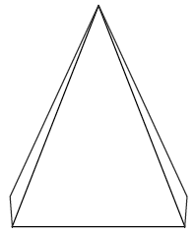 

|  |  |  |
| --- | --- | --- |
| (1) | (2) | (3) |

1. **From directly overhead, all four lateral faces are visible.**
2. **Facing a lateral face, all of the lateral face in question is visible, as well as a bit of the adjacent lateral faces. If the pyramid were transparent, I would be able to see the entire base.**
3. **From the bottom, I can see only the rectangular base.**

Example 3 (6 minutes)

  
Example 3

Assume the following figure is a top-down view of a rectangular pyramid. Make a reasonable sketch of any two adjacent lateral faces. What measurements must be the same between the two lateral faces? Mark the equal measurements. Justify your reasoning for your choice of equal measurements.



The equal sides in each triangle are the same between both triangles.



* Students may think that the heights of the triangles are equal in length, when in fact they are not unless the base is a square. The triangle with the shorter base has a height greater than that of the triangle with the longer base. An easy way of making this point is by looking at a right rectangular pyramid with rectangular base of exaggerated dimensions: a very long length in contrast to a very short width. Though students do not yet have the Pythagorean Theorem at their disposal to help them quantify the difference in heights of the lateral faces, an image should be sufficiently persuasive.

Example 4 (6 minutes)

*Scaffolding:*

As with the last lesson, understanding the slices is made easier when students are able to view and handle physical models. Consider using the figures constructed from the nets in the Opening throughout these exercises.

Remind students of the types of slices taken in Lesson 15: slices parallel to a face and slices perpendicular to a face. In this lesson, we examine slices made parallel and perpendicular to the rectangular base of the pyramid.

Example 4

* 1. A slicing plane passes through segment parallel to base of the right rectangular pyramid below. Sketch what the slice will look like into the figure. Then sketch the resulting slice as a two-dimensional figure. Students may choose how to represent the slice (e.g., drawing a 2D or 3D sketch or describing the slice in words).



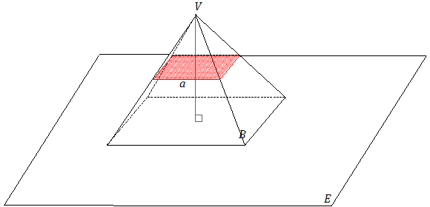 

* 1. What shape does the slice make? What is the relationship between the slice and the rectangular base of the pyramid?

The slice is a rectangle; the slice looks a lot like the rectangular base but is smaller in size.

* Students study similar figures in Grade 8, so they do not have the means to determine that a slice made parallel to the base is in fact a rectangle similar to the rectangular base. Students have, however, studied scale drawings in Module 4.
* Tell students that a slice made parallel to the base of a right rectangular pyramid is a scale drawing, a reduction, of the base. How can the scale factor be determined?
  + *The scale factor can be calculated by dividing the side length of the slice by the corresponding side length of the base.*

Example 5 (7 minutes)

Example 5

A slice is to be made along segment perpendicular to base of the right rectangular pyramid below.

* 1. Which of the following figures shows the correct slice? Justify why each of the following figures is or is not a correct diagram of the slice.



This is not a slice by a plane because there is space between the base and the lateral face. This could be a slice by a rectangle with the same width as in the figure but not a plane that extends in all directions.

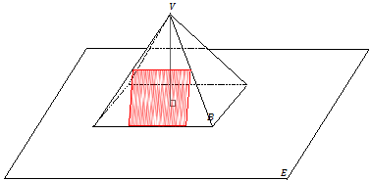

This is not a slice by a plane perpendicular to the base because the marked rectangular region is in the same plane as the lateral face in which it lays.



This is a slice made by a plane meeting the rectangular pyramid perpendicular to its base. The slice shows all the possible points at which the slicing plane would make contact with the right rectangular pyramid. The slice is in the shape of an isosceles trapezoid.

* It may help students to visualize the third figure by taking one of the model pyramids and tracing the outline of the slice. Ask students to visualize cutting along the outline and looking at what remains of the cut-open lateral face. For any slice made perpendicular to the base, ask students to visualize a plane (or say, a piece of paper) moving perpendicularly towards the base through a marked segment on a lateral face. Ask them to think about where all the points the paper would meet the pyramid.
  1. A slice is taken through the vertex of the pyramid perpendicular to the base. Sketch what the slice will look like into the figure. Then, sketch the resulting slice itself as a two-dimensional figure.

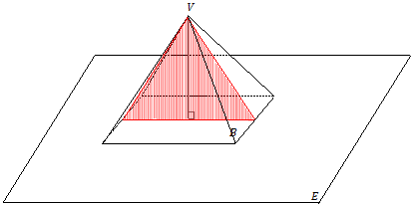

Closing (1 minute)

* How is a rectangular pyramid different from a right rectangular pyramid?
  + *The vertex of a right rectangular pyramid lies on the line perpendicular to the base at its center (the intersection of the rectangle base’s diagonals); a pyramid that is not a right rectangular pyramid will have a vertex that is not on the line perpendicular to the base at its center.*
* Students should visualize slices made perpendicular to the base of a pyramid by imagining a piece of paper passing through a given segment on a lateral face perpendicularly towards the base. Consider the outline the slice would make on the faces of the pyramid.
* Slices made parallel to the base of a right rectangular pyramid are scale drawings (i.e., reductions) of the rectangular base of the pyramid.

Exit Ticket (5 minutes)

Name Date

Lesson 17: Slicing a Right Rectangular Pyramid with Plane

Exit Ticket

Two copies of the same right rectangular pyramid are shown below. Draw in the slice perpendicular to the base and the slice parallel to the base. Then, sketch the resulting slices as two-dimensional figures.



|  |  |
| --- | --- |
| Slice Perpendicular to Base | Slice Parallel to Base |

Exit Ticket Sample Solutions

Two copies of the same right rectangular pyramid are shown below. Draw in the slice perpendicular to the base and the slice parallel to the base. Then, sketch the resulting slices as two-dimensional figures.



|  |  |
| --- | --- |
| Slice Perpendicular to Base | Slice Parallel to Base |

Problem Set Sample Solutions

1. 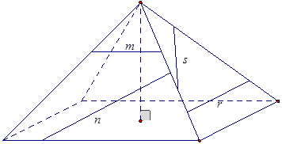A side view of a right rectangular pyramid is given. The line segments lie in the lateral faces.
   1. For segments , , and , sketch the resulting slice from slicing the right rectangular pyramid with a slicing plane that contains the line segment and is perpendicular to the base.
   2. For segment , sketch the resulting slice from slicing the right rectangular pyramid with a slicing plane that contains the segment and is parallel to the base.

*Note:* To challenge yourself, you can try drawing the slice into the pyramid.

|  |  |
| --- | --- |
|  |  |
|  |  |

Note that the diagram for the slice made through is from a perspective different from the one in the original pyramid. From the original perspective, the slice itself would not be visible and would appear as follows:



* 1. 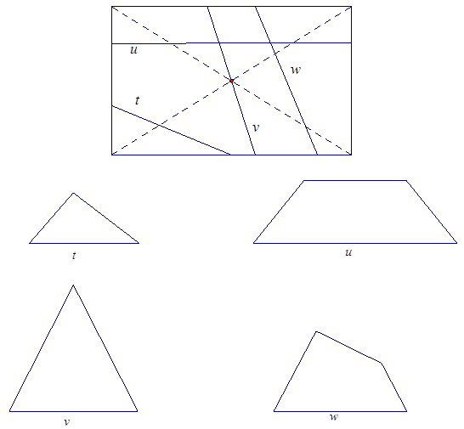A top view of a right rectangular pyramid is given. The line segments lie in the base face. For each line segment, sketch the slice that results from slicing the right rectangular pyramid with a plane that contains the line segment and is perpendicular to the base.