Lesson 16: Slicing a Right Rectangular Prism with a Plane

Classwork

**Example 1**

Figure 3. A Slice of Ball

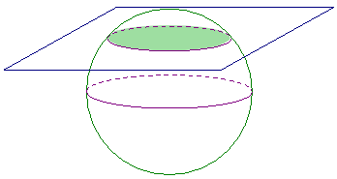

Consider a ball . Figure 3 shows one possible slice of .

* 1. What figure does the slicing plane form? Students may choose their method of representation of the slice (e.g., drawing a 2D sketch, a 3D sketch, or describing the slice in words).
  2. Will all slices that pass through be the same size? Explain your reasoning.
  3. How will the plane have to meet the ball so that the plane section consists of just one point?

**Example 2**

The right rectangular prism in Figure 4 has been sliced with a plane parallel to face . The resulting slice is a rectangular region that is identical to the parallel face.

Figure 4.

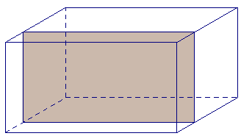

* 1. Label the vertices of the rectangular region defined by the slice as .
  2. To which other face is the slice parallel and identical?
  3. Based on what you know about right rectangular prisms, which faces must the slice be perpendicular to?

Exercise 1

Figure 5.

cm

cm

cm

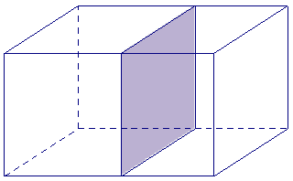

Discuss the following questions with your group.

1. The right rectangular prism in Figure 5 has been sliced with a plane parallel to face .
   1. Label the vertices of the rectangle defined by the slice as .
   2. What are the dimensions of the slice?
   3. Based on what you know about right rectangular prisms, which faces must the slice be perpendicular to?

**Example 3**

in.

in.

in.

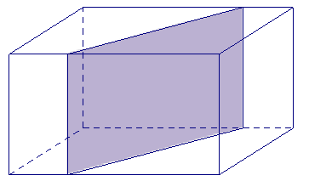

Figure 6.

The right rectangular prism in Figure 6 has been sliced with a plane perpendicular to . The resulting slice is a rectangular region with a height equal to the height of the prism.

* 1. Label the vertices of the rectangle defined by the slice as .
  2. To which other face is the slice perpendicular?
  3. What is the length of ?
  4. Joey looks at and thinks that the slice may be a parallelogram that is not a rectangle. Based on what is known about how the slice is made, can he be right? Justify your reasoning.

Exercises 2–6

In the following exercises, the points at which a slicing plane meets the edges of the right rectangular prism have been marked. Each slice is either parallel or perpendicular to a face of the prism. Use a straightedge to join the points to outline the rectangular region defined by the slice and shade in the rectangular slice.

1. A slice parallel to a face



1. A slice perpendicular to a face.



1. A slice perpendicular to a face.



In Exercises 5–6, the dimensions of the prisms have been provided. Use the dimensions to sketch the slice from each prism and provide the dimensions of each slice.

1. A slice parallel to a face.

mm

mm



mm

1. A slice perpendicular to a face.

mm

mm



mm

Problem Set

A right rectangular prism is shown along with line segments that lie in a face. For each line segment, draw and give the approximate dimensions of the slice that results when the slicing plane contains the given line segment and is perpendicular to the face that contains the line segment.

