|  |
| --- |
|  |

Lesson 16: Slicing a Right Rectangular Prism with a Plane

Student Outcomes

* Students describe rectangular regions that result from slicing a right rectangular prism by a plane perpendicular to one of the faces.

Lesson Notes

Students examine the cross sections of solid figures in the next four lessons. In Lessons 16 and 17, students examine slices made parallel or perpendicular to a face of a solid before moving to angled slices in Lesson 18. To help students visualize slices, provide them with the right rectangular prism nets included after Lesson 27 (and later, the right rectangular pyramid nets) to build and refer to as they complete the lesson.

Classwork

**Discussion (8 minutes)**

Provide context to the concept of taking slices of a solid by discussing what comes to mind when we think of “taking a slice” of something.

* In our next topic, we will be examining the slices of solid figures. What do you think of when you hear the word “slice”?
  + *Answers will vary; e.g., a slice of cake, a slice of pizza, a slice of bread, “carrot coins”, etc.*
* We want to make sure everyone thinks of “slice” in the same way. Let’s begin to narrow our idea of “slice” by deciding that the actual cut of a slice can be imagined as being done in a single motion (unlike the cuts that a wedge-shaped slice from a cylindrical cake would need or a cut that is a jagged in any way).
* Perhaps you have been in a deli or a grocery store where cured meat and cheese is often sold in slices. These are examples of a slice made by a single-motion cut. A slice of bread from a loaf of bread is another example of such a slice.
* Can you think of a non-food related example that models the concept of a slice?
  + *Answers will vary; e.g., a card from a deck of playing cards, a quarter from a roll of quarters, coasters from a stack of coasters.*
* We must further distinguish whether a slice is the physical piece that has been cut (e.g., a single “carrot coin”), or if it’s the resulting surface from the cut (i.e., the region left on the carrot by the cut). Consider demonstrating the difference with a real carrot.
* We will answer this question after a discussion about the plane.

Remind students what a plane is and how it relates to a slice.

* Recall that a plane is a building block of geometry that does not have a definition (as it is an undefinable term); rather, we know what a representation of it looks like. How would you describe a representation of a plane?
  + *A representation of a plane is a flat surface, one that extends without edges; it can be thought of as a large sheet of paper.*
* Two planes are parallel if they do not meet (Figure 1).

Figure 1. Parallel Planes

* Two planes are perpendicular if one plane contains a line that is perpendicular to the other plane (Figure 2).
* Consider a right rectangular prism. Any two opposite faces of the right rectangular prism are parallel; any two adjacent faces are perpendicular. Model parallel and perpendicular faces of rectangular prisms with the walls of a classroom or the surfaces of a tissue box.
* Since we have agreed that the motion needed to make a slice is done in one motion, we can extend that image and say that a slice is made when a plane meets a figure.

Figure 2. Perpendicular Planes

* The *plane section* of the figure with respect to the plane consists of all points where the plane meets the figure. We also call the plane section the *slice*. We call the plane the *slicing plane*.

Example 1 (5 minutes)

*Scaffolding:*

All exercises in this lesson are made more accessible when physical models are used (e.g., a ball for the sphere, a wood block, or a prism constructed from the net provided after Lesson 27 for the others). Consider showing these or providing them for students to handle as they determine what the slice would look like.

**Example 1**

**Consider a ball . Figure 3 shows one possible slice of .**

Figure 3. A Slice of Ball

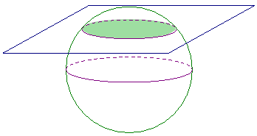

* 1. **What figure does the slicing plane form? Students may choose their method of representation of the slice (e.g., drawing a 2D sketch, a 3D sketch, or describing the slice in words).**

MP.7

**A circle (or disc)**

* 1. **Will all slices that pass through be the same size? Explain your reasoning.**

***No, different slices can result in circles of different sizes; it will depend on where the slicing plane meets the ball.***

* 1. **How will the plane have to meet the ball so that the plane section consists of just one point?**

***If you picture the ball and the plane as distinct but being brought towards each other, the plane section of just one point occurs when the plane just makes contact with the ball.***

Examples 2 and 3 highlight slices made to a rectangular prism that make the plane section parallel to a face and perpendicular to a face, respectively. Angled slices will be explored in another lesson. Point out that planar regions, such as the rectangular regions in the figures below, are parallel if the planes containing them are parallel.

Consider taking time here to build the rectangular prisms from the nets located at the end of this module. Ask students to imagine different slices that could be made perpendicular or parallel to a face and to sketch what these slices might look like.

Example 2 (5 minutes)

**Example 2**

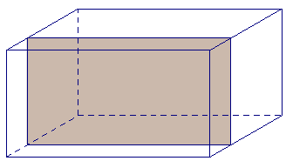

**The right rectangular prism in Figure 4 has been sliced with a plane parallel to face . The resulting slice is a rectangular region that is identical to the parallel face.**

* 1. **Label the vertices of the rectangular region defined by the slice as .**
  2. **To which other face is the slice parallel and identical?**

Figure 4

**The slice is parallel and identical to the face .**

* 1. **Based on what you know about right rectangular prisms, which faces must the slice be perpendicular to?**

**Since the slice is parallel to two faces, it will be perpendicular to whichever sides those faces are perpendicular to: the faces , , , and .**

Exercise 1 (5 minutes)

**Exercise 1**

Figure 5

cm

cm

cm

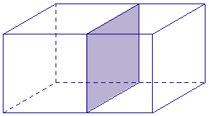

**Discuss the following questions with your group.**

1. **The right rectangular prism in Figure 5 has been sliced with a plane parallel to face .** 
   1. **Label the vertices of the rectangle defined by the slice as .**

**The slice is parallel and identical to the face .**

MP.3

* 1. **What are the dimensions of the slice?**

**cm cm**

* 1. **Based on what you know about right rectangular prisms, which faces must the slice be perpendicular to?**

**Since the slice is parallel to two faces, it will be perpendicular to whichever sides those faces are perpendicular to: the faces , , , and .**

**Example 3 (5 minutes)**

**Example 3**

Figure 6.

in.

in.

in.

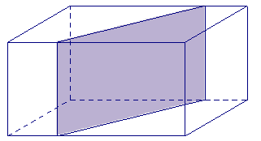

**The right rectangular prism in Figure 6 has been sliced with a plane perpendicular to . The resulting slice is a rectangular region with a height equal to the height of the prism.**

* 1. Label the vertices of the rectangle defined by the slice as **.**
  2. **To which other face is the slice perpendicular?**

**The slice is perpendicular to the face .**

* 1. **What is the length of ?**

**in.**

* 1. **Joey looks at and thinks that the slice may be a parallelogram that is not a rectangle. Based on what is known about how the slice is made, can he be right? Justify your reasoning.**

**The slice was made perpendicular to face . Then we know that the angles in the slice, angles and , formed by the slicing plane and face , are right angles. If we focus on of the slice, since it is a right angle, we know that must be perpendicular face to . lies in face , which is perpendicular to both and to , so is perpendicular to . This means that must also be perpendicular to . A similar argument can be made for of the slice, making all four angles of right angles and making a rectangle.**

Exercises 2–6 (10 minutes)

Exercises 2–6

In the following exercises, the points at which a slicing plane meets the edges of the right rectangular prism have been marked. Each slice is either parallel or perpendicular to a face of the prism. Use a straightedge to join the points to outline the rectangular region defined by the slice and shade in the rectangular slice.

1. A slice parallel to a face

 

1. A slice perpendicular to a face.



1. A slice perpendicular to a face.

 

In Exercises 5–6, the dimensions of the prisms have been provided. Use the dimensions to sketch the slice from each prism and provide the dimensions of each slice.

1. A slice parallel to a face.



mm

mm

mm

mm

mm



1. A slice perpendicular to a face.

mm

mm

mm

mm



mm

Closing (2 minutes)

* A slice, also known as a plane section, consists of all the points where the plane meets the figure.
* A slice made parallel to a face in a right rectangular prism will be parallel and identical to the face.
* A slice made perpendicular to a face in a right rectangular prism will be a rectangular region with a height equal to the height of the prism.

Exit Ticket (5 minutes)

Name Date

Lesson 16: Slicing a Right Rectangular Prism with a Plane

Exit Ticket

In the following figures, use a straightedge to join the points where a slicing plane meets with a right rectangular prism to outline the slice.

* + 1. Label the vertices of the rectangular slice .
    2. State any known dimensions of the slice.
    3. Describe two relationships slice has in relation to faces of the right rectangular prism.

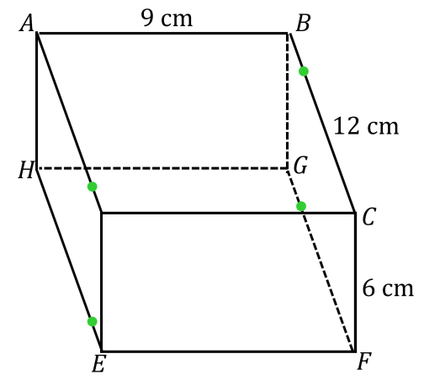

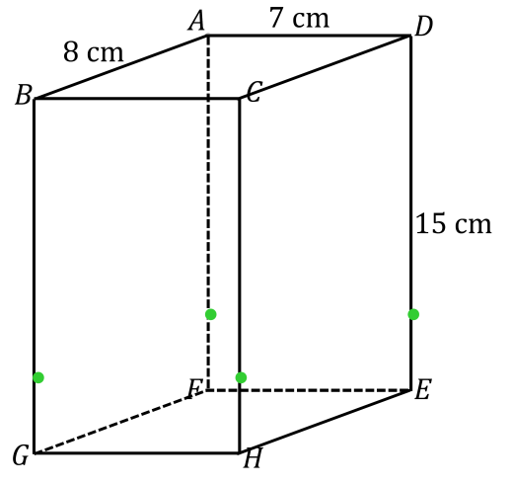

Exit Ticket Sample Solutions

In the following figures, use a straightedge to join the points where a slicing plane meets with a right rectangular prism to outline the slice.

* + 1. Label the vertices of the rectangular slice .
    2. State any known dimensions of the slice.
    3. Describe two relationships slice has in relation to faces of the right rectangular prism.

1. 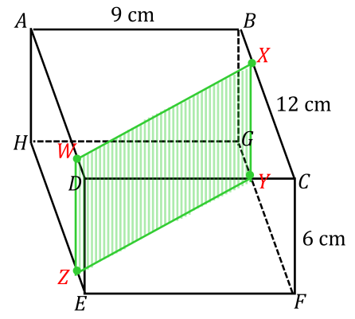

Sides and are cm in length. Slice is perpendicular to faces and .

1. 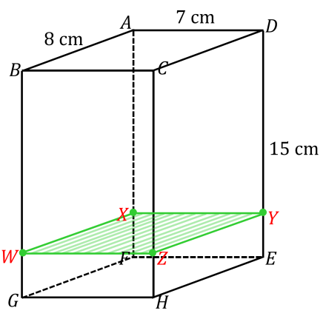

Sides and are cm in length. Sides and are cm in length. Slice is parallel to faces and and perpendicular to faces , , , and .

Note: Students are only required to state two of the relationships the slice has with the faces of the prism.

Problem Set Sample Solutions

Note: Students have not yet studied the Pythagorean Theorem; thus the answers provided for the missing length of each line segment are possible answers that are made based on rough approximations.

A right rectangular prism is shown along with line segments that lie in a face. For each line segment, draw and give the approximate dimensions of the slice that results when the slicing plane contains the given line segment and is perpendicular to the face that contains the line segment.

