Lesson 15: Using Unique Triangles to Solve Real-World and Mathematical Problems

Classwork

Example 1

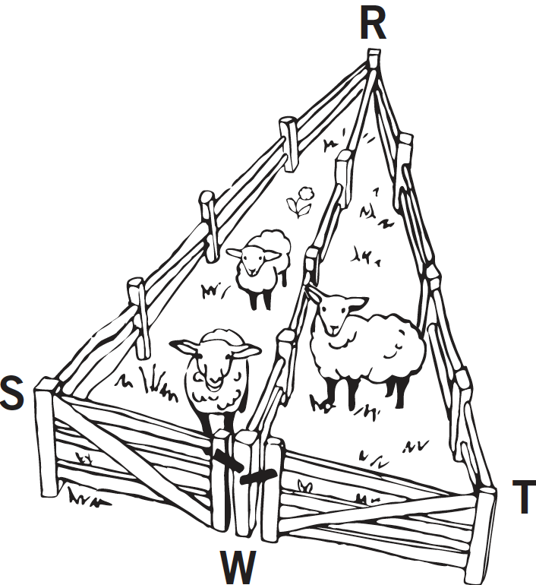A triangular fence with two equal angles, , is used to enclose some sheep. A fence is constructed inside the triangle that exactly cuts the other angle into two equal angles: . Show that the gates, represented by and , are the same width.

Example 2

In , . John says that the triangle correspondence matches two sides and the included angle and shows that . Is John correct?

 



Exercises 1–4

1. Mary puts the center of her compass at the vertex of the angle and locates points and on the sides of the angle. Next, she centers her compass at each of and to locate point . Finally, she constructs the ray . Explain why .



1. 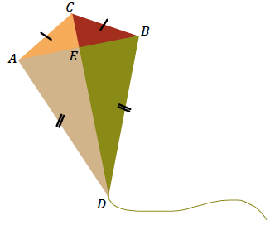Quadrilateral is a model of a kite. The diagonals and represent the sticks that help keep the kite rigid.
   1. John says that . Can you use identical triangles to show that John is correct?
   2. Jill says that the two sticks are perpendicular to each other. Use the fact that and what you know about identical triangles to show .
   3. John says that Jill’s triangle correspondence that shows the sticks are perpendicular to each other also shows that the sticks cross at the midpoint of the horizontal stick. Is John correct? Explain.
2. In , . Jill says that the triangle correspondence matches two sides and the included angle and shows that . Is Jill correct?

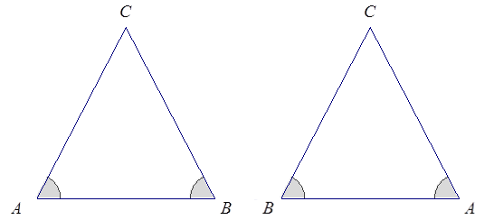



1. 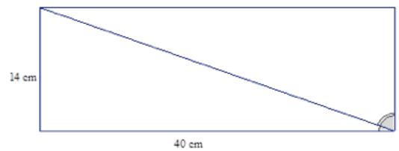Right triangular corner flags are used to mark a soccer field. The vinyl flags have a base of cm and a height of cm.
   1. Mary says that the two flags can be obtained by cutting a rectangle that is cm cm on the diagonal. Will that create two identical flags? Explain.
   2. Will measures the two non-right angles on a flag and adds the measurements together. Can you explain, without measuring the angles, why his answer is ?

Problem Set

1. Jack is asked to cut a cake into equal pieces. He first cuts it into equal fourths in the shape of rectangles, and then he cuts each rectangle along a diagonal.

Did he cut the cake into equal pieces? Explain.

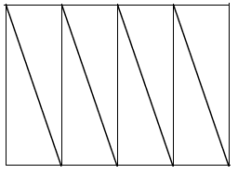

1. The bridge below, which crosses a river, is built out of two triangular supports. The point lies on segment . The beams represented by and are equal in length, and the beams represented by and are equal in length. If the supports were constructed so that and are equal in measurement, is point the midpoint of ? Explain.



1. In , . Bill says that triangle correspondence matches three equal sides and shows that . Is Bill correct?

Macintosh HD:Users:wright:Desktop:David's:CCSS:isoscelestriangle.pdf

1. In the previous problem, Jill says that triangle correspondence matches two equal sides and the included angle. This also shows that . Is Jill correct?