|  |
| --- |
|  |

Lesson 15: Using Unique Triangles to Solve Real-World and Mathematical Problems

Student Outcomes

* Students use conditions that determine a unique triangle to construct viable arguments that angle measures and lengths are equal between triangles.

Lesson Notes

In Lesson 15, students continue to apply their understanding of the conditions that determine a unique triangle. In Lesson 14, they were introduced to diagrams of triangles that had pre-existing relationships, as opposed to the diagrams in Lesson 13 that showed distinct triangles with three matching, marked parts. This added a new challenge to the task of determining whether triangles were identical because some information had to be assessed from the diagram in order to establish a condition that would determine triangles as identical. In Lesson 15, students are exposed to yet another challenge where they are asked to determine whether triangles are identical and to show how this information can lead to further conclusions about the diagram (i.e., showing why a given point must be the midpoint of a segment). Problems in this lesson are both real-world and mathematical. All problems require an explanation that logically links given knowledge, a correspondence, and a condition that determines triangles to be identical; some problems require these links to yield one more conclusion. This lesson is an opportunity to highlight Mathematical Practice 1, giving students an opportunity to build perseverance in solving problems.

Classwork

Example 1 (5 minutes)

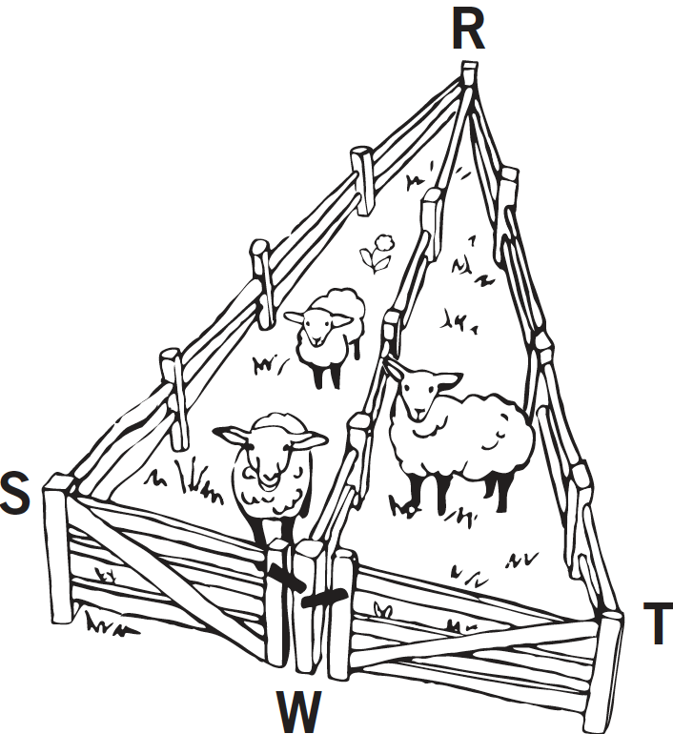  
Example 1

A triangular fence with two equal angles, , is used to enclose some sheep. A fence is constructed inside the triangle that exactly cuts the other angle into two equal angles: . Show that the gates, represented by and , are the same width.

MP.1

There is a correspondence that matches two pairs of angles of equal measurement, and , and one pair of sides of equal lengths shared side . The triangles satisfy the two angles and side opposite a given angle condition. From the correspondence, we can conclude that , or that the gates are of equal width.

**Example 2 (5 minutes)**

*Scaffolding:*

* If needed, provide a hint: Draw the segments and
* Also, provide students with compasses so that they can mimic the construction marks in the diagram.

As students work through Example 2, remind them that this question is addressed in an easier format in Grade 4, when students folded the triangle so that folded onto .

Example 2

In , . John says that the triangle correspondence matches two sides and the included angle and shows that . Is John correct?

 



We are told that . The correspondence tells us that , , and , which means is identical to by the two sides and included angle condition. From the correspondence, we can conclude that ; therefore, John is correct.

Exercises 1–4 (20 minutes)

Exercises 1–4

1. Mary puts the center of her compass at the vertex of the angle and locates points and on the sides of the angle. Next, she centers her compass at each of and to locate point . Finally, she constructs the ray . Explain why .



***Since Mary uses one compass adjustment to determine points and ,*** . Mary also uses the same compass adjustment from and to find point ; this means . Side is common to both the triangles and . Therefore, there is a correspondence that matches three pairs of equal sides, and the triangles are identical by the three sides condition. From the correspondence, we conclude that .



1. 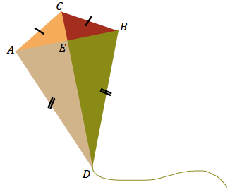Quadrilateral is a model of a kite. The diagonals and represent the sticks that help keep the kite rigid.
   1. John says that . Can you use identical triangles to show that John is correct?

From the diagram, we see that , and . is a common side to both triangles and . There is a correspondence that matches three pairs of equal sides; the two triangles are identical by the three sides condition. From the correspondence, we conclude that . John is correct.

* 1. Jill says that the two sticks are perpendicular to each other. Use the fact that and what you know about identical triangles to show .

Since we know that and , and that triangles and share a common side, , we can find a correspondence that matches two pairs of equal sides and a pair of equal, included angles. The triangles are identical by the two sides and included angle condition. We can then conclude that . Since both angles are adjacent to each other on a straight line, we also know they must sum to . We can then conclude that each angle measures .

* 1. John says that Jill’s triangle correspondence that shows the sticks are perpendicular to each other also shows that the sticks cross at the midpoint of the horizontal stick. Is John correct? Explain.

Since we have established that and are adjacent to each other, we know that . This means that is the midpoint of , by definition.

1. In , . Jill says that the triangle correspondence matches two sides and the included angle and shows that . Is Jill correct?

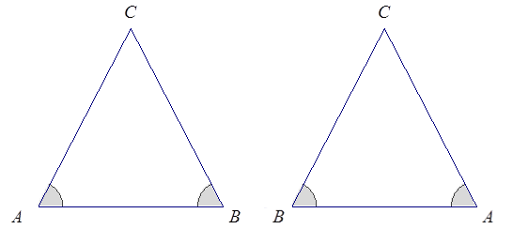



We are told that . The correspondence tells us that , , and , which means is identical to by the two angles and included side condition. From the correspondence, we can conclude that ; therefore, Jill is correct.

1. 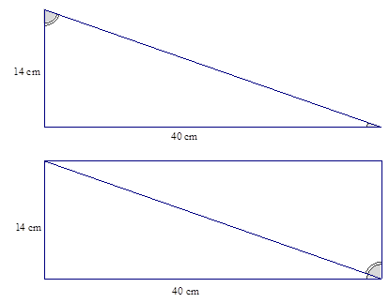Right triangular corner flags are used to mark a soccer field. The vinyl flags have a base of cm and a height of cm.
   1. Mary says that the two flags can be obtained by cutting a rectangle that is cm cm on the diagonal. Will that create two identical flags? Explain.

If the flag is to be cut from a rectangle, both triangles will have a side of length cm, a length of cm, and a right angle. There is a correspondence that matches two pairs of equal sides and an included pair of equal angles to the corner flag; the two triangles are identical to the corner flag as well as to each other.

* 1. Will measures the two non-right angles on a flag and adds the measurements together. Can you explain, without measuring the angles, why his answer is ? The two non-right angles of the flags are adjacent angles that together form one angle of the four angles of the rectangle. We know that a rectangle has four right angles, so it must be that the two non-right angles of the flag together sum to .

**Discussion (8 minutes)**

Consider a gallery walk as a means of reviewing responses to each exercise.

* Hold students accountable for providing evidence in their responses that logically progresses to a conclusion.
* Offer opportunities for students to share and compare their solution methods.

Closing (2 minutes)

* In deciding whether two triangles are identical, examine the structure of the diagram of the two triangles to look for a relationship that might reveal information about corresponding parts of the triangles. This information may determine whether the parts of the triangle satisfy a particular condition, which might determine whether the triangles are identical.
* Be sure to identify and label all known measurements and then determine if any other measurements can be established based on knowledge of geometric relationships.

Exit Ticket (5 minutes)

Name Date

Lesson 15: Using Unique Triangles to Solve Real-World and Mathematical Problems

Exit Ticket

Alice is cutting wrapping paper to size to fit a package. How should she cut the rectangular paper into two triangles to ensure that each piece of wrapping paper is the same? Use your knowledge of conditions that determine unique triangles to justify that the resulting pieces from the cut are the same.



Exit Ticket Sample Solutions

Alice is cutting wrapping paper to size to fit a package. How should she cut the rectangular paper into two triangles to ensure that each piece of wrapping paper is the same? Use your knowledge of conditions that determine unique triangles to prove that the resulting pieces from the cut are the same.



***Alice should cut along the diagonal of rectangle . Since is a rectangle, the opposite sides will be equal in length, or, and . A rectangle also has four right angles, which means a cut along the diagonal will result in each triangle with one angle. The correspondence***  matches two equal pairs of sides and an equal, included pair of angles; the triangles are identical by the two sides and included angle condition.

Problem Set Sample Solutions

1. Jack is asked to cut a cake into equal pieces. He first cuts it into equal fourths in the shape of rectangles, and then he cuts each rectangle along a diagonal.

Did he cut the cake into equal pieces? Explain.



Yes, Jack cut the cake into equal pieces. Since the first series of cuts divided the cake into equal fourths in the shape of rectangles, we know that the opposite sides of the rectangles are equal in length; that means all triangles have two sides that are equal in length to each other. Each of the triangular pieces also has one right angle because we know that rectangles have four right angles. Therefore, there is a correspondence between all triangles that matches two pairs of equal sides and an equal, non-included angle, determining identical pieces of cake.

1. The bridge below, which crosses a river, is built out of two triangular supports. The point lies on segment . The beams represented by and are equal in length, and the beams represented by and are equal in length. If the supports were constructed so that and are equal in measurement, is point the midpoint of ? Explain.



Yes, is the midpoint of . The triangles are identical by the two sides and included angle condition. The correspondence matches two pairs of equal sides and one pair of included, equal angles. Since the triangles are identical, we can use the correspondence to conclude that , which makes the midpoint, by definition.

1. In , . Bill says that triangle correspondence matches three equal sides and shows that . Is Bill correct?

Macintosh HD:Users:wright:Desktop:David's:CCSS:isoscelestriangle.pdf

We are told that . The correspondence matches three equal sides: , , and ; this means is identical to by the three sides condition. From the correspondence, we can conclude that; therefore, Bill is correct.

1. In the previous problem, Jill says that triangle correspondence matches two equal sides and the included angle. This also shows that . Is Jill correct?

We are told that . The correspondence matches two equal sides and the included angle: , , and ; this means is identical to by the two sides and included angle condition. From the correspondence, we can conclude that; therefore, Jill is correct.