Lesson 14: Checking for Identical Triangles

Classwork

In each of the following problems, determine whether the triangles are identical, not identical, or whether they are not necessarily identical; justify your reasoning. If the relationship between the two triangles yields information that establishes a condition, describe the information. If the triangles are identical, write a triangle correspondence that matches the sides and angles.

Example 1

What is the relationship between the two triangles below?

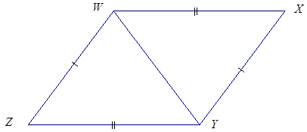

Exercises 1–2

1. Are the triangles identical? Justify your reasoning.

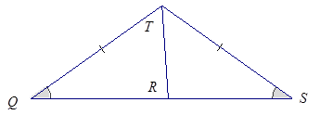

1. Are the triangles identical? Justify your reasoning.

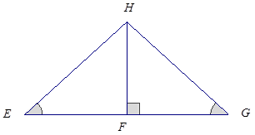

Example 2

Are the triangles identical? Justify your reasoning.



Exercises 3–8

1. Are the triangles identical? Justify your reasoning.

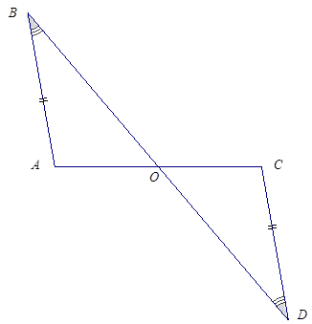

1. Are the triangles identical? Justify your reasoning.

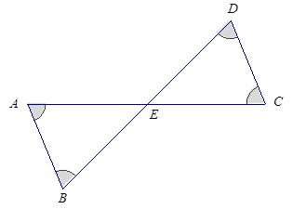

1. Are the triangles identical? Justify your reasoning.

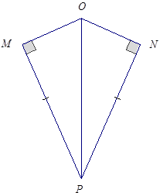

1. Are the triangles identical? Justify your reasoning.

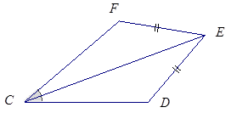

1. Are the triangles identical? Justify your reasoning.

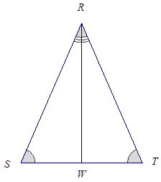

1. Create your own labeled diagram and set of criteria for a pair of triangles. Ask a neighbor to determine whether the triangles are identical based on the provided information.

Problem Set

In the following problems, determine whether the triangles are identical, not identical, or whether they are not necessarily identical; justify your reasoning. If the relationship between the two triangles yields information that establishes a condition, describe the information. If the triangles are identical, write a triangle correspondence that matches the sides and angles.

1. 
2. 
3. 
4. 
5. 
6. 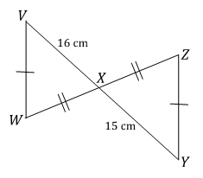

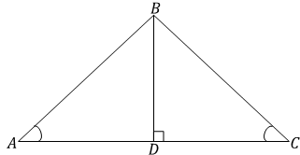

1. Are there any identical triangles in this diagram?



1. 
2. 