|  |
| --- |
|  |

Lesson 14: Checking for Identical Triangles

Student Outcomes

* Students use information such as vertical angles and common sides in the structure of triangle diagrams to establish whether conditions that determine a unique triangle exist.
* Students use conditions that determine a unique triangle to determine when two triangles are identical.
* Students construct viable arguments to explain why the given information can or cannot give a triangle correspondence between identical triangles.

Lesson Notes

In contrast to Lesson 12, where students had to examine pairs of distinct triangles, the diagrams of triangles in Lesson 13 are presented so that a relationship exists between the triangles due to the way they are positioned. They may share a common side, may be arranged in a way so that two angles from the triangles are vertical angles, and so on. Students must use the structure of each diagram in order to establish whether a condition exists that renders the triangles identical.

Classwork

**Opening (2 minutes)**

* Scan the figures in the next several problems. How are these diagrams different from the diagrams in Lesson 12?
  + *The triangles seem to be joined instead of being separated.*

MP.7

* Does this change the way you figure out whether a condition exists that determines whether the triangles are identical?
  + *You have to check the connection between the two triangles and determine if it shows whether two parts between the triangles are equal in measure.*

In each of the following problems, determine whether the triangles are identical, not identical, or whether they are not necessarily identical; justify your reasoning. If the relationship between the two triangles yields information that establishes a condition, describe the information. If the triangles are identical, write a triangle correspondence that matches the sides and angles.

Example 1 (5 minutes)

Example 1

What is the relationship between the two triangles below?



* What is the relationship between the two triangles below?
  + *The triangles share a common side.*
* Imagine that and were pulled apart and separated. Sketch the triangles separately. Based on how they were joined, what kind of tick mark should be added to each triangle?

MP.7

* + *is a common side. Since it belongs to each triangle, we should put a triple tick mark on to indicate that it is a part of equal measure in both triangles.*

 

* Are the triangles identical? How do you know?
  + *The triangles are identical by the three side condition. The correspondence that matches the three equal pairs of sides is .*

Exercises 1–2 (8 minutes)

*Scaffolding:*

As shown above, consider modeling the process of sketching the triangles as “unattached” to one another.

Exercises 1–2

1. Are the triangles identical? Justify your reasoning.

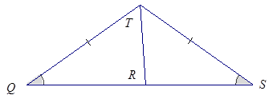

The triangles are not necessarily identical. The correspondence matches a pair of equal angles and a pair of equal sides. The correspondence also matches a common side, , to both triangles. Two sides and a non-included acute angle do not necessarily determine a unique triangle.

1. Are the triangles identical? Justify your reasoning.

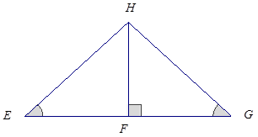

These triangles are identical by the two angles and side opposite a given angle condition. The correspondence matches two pairs of equal angles and a pair of equal sides. must be a right angle, since is a right angle, and they are both on a line. Also, is a common side to both triangles. Since both triangles have parts under the condition of the same measurement, the triangles must be identical.

Example 2 (5 minutes)

* What is the relationship between the two triangles below?
  + *The triangle is positioned so that there is a pair of vertical angles,, in the diagram.*

Example 2

Are the triangles identical? Justify your reasoning.



The triangles are identical by the two sides and the included angle condition. The correspondence matches two equal pairs of sides and a pair of equal angles, , which we know to be equal in measurement because they are vertical angles.

Exercises 3–4 (8 minutes)

Exercises 3–4

1. Are the triangles identical? Justify your reasoning.

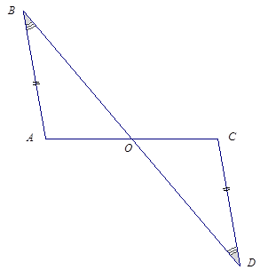

These triangles are identical by the two angles and side opposite a given angle condition. The correspondence matches the two pairs of equal angles and one pair of equal sides. There is a marked pair of equal sides and one pair of marked, equal angles. The second pair of equal angles, , are vertical angles.

1. Are the triangles identical? Justify your reasoning.

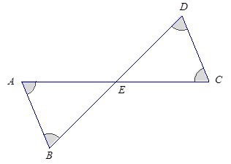

The triangles are not necessarily identical. The correspondence matches three pairs of equal angles, including the unmarked angles, and , which are equal in measurement because they are vertical angles. The triangles could have different side lengths; therefore, they are not necessarily identical.

Exercises 5–8 (10 minutes)

Exercises 5–8

1. Are the triangles identical? Justify your reasoning.

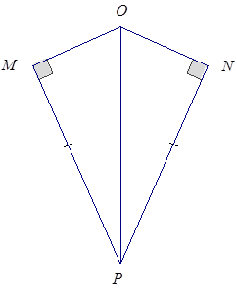

The triangles are identical by the two sides and non-included (or greater) angle condition. The correspondence matches two pairs of equal sides and one pair of equal angles. One of the two pairs of equal sides is side , which is common to both triangles.

1. Are the triangles identical? Justify your reasoning.

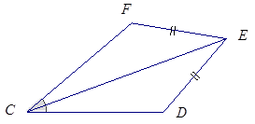

These triangles are not necessarily identical. The triangles have a pair of marked equal sides and equal angles; side is also common to both triangles. The triangles satisfy the two sides and non-included acute angle condition, which does not determine a unique triangle.

1. 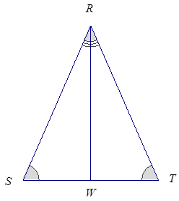Are the triangles identical? Justify your reasoning.

These triangles are identical by the two angles and a side opposite a given angle condition. The triangle correspondence matches two pairs of equal angles and one pair of equal sides. The equal pair of sides, , is common to both triangles.

1. Create your own labeled diagram and set of criteria for a pair of triangles. Ask a neighbor to determine whether the triangles are identical based on the provided information.

Answers will vary.

Closing (2 minutes)

* In deciding whether two triangles are identical, examine the structure of the diagram of the two triangles to look for a relationship that might reveal information about corresponding parts of the triangles. This information may determine whether the parts of the triangle satisfy a particular condition, which might determine whether the triangles are identical.

Exit Ticket (5 minutes)

Name Date

Lesson 14: Checking for Identical Triangles

Exit Ticket

Are triangles and identical, not identical, or not necessarily identical? Justify your reasoning. If the relationship between the two triangles yields information that establishes a condition, describe the information. If the triangles are identical, write a triangle correspondence that matches the sides and angles.



Exit Ticket Sample Solutions

Are triangles and identical, not identical, or not necessarily identical? Justify your reasoning. If the relationship between the two triangles yields information that establishes a condition, describe the information. If the triangles are identical, write a triangle correspondence that matches the sides and angles.

These triangles are identical by the two angles and side opposite a given angle condition. The triangle correspondence matches the two pairs of equal angles and one pair of equal sides condition. The pair of equal sides, , is common to both triangles.

Problem Set Sample Solutions

In the following problems, determine whether the triangles are identical, not identical, or whether they are not necessarily identical; justify your reasoning. If the relationship between the two triangles yields information that establishes a condition, describe the information. If the triangles are identical, write a triangle correspondence that matches the sides and angles.



These triangles are identical by the two sides and the included angle condition. The triangle correspondence matches two pairs of equal sides and one pair of equal angles. One of the equal pairs of sides is shared side .

1. 

These triangles are not necessarily identical. The triangles have a pair of marked, equal sides, and a pair of marked, acute, equal angles; side is also common to both triangles. The triangles satisfy the two sides and non-included acute angle condition, which does not determine a unique triangle.

1. 

These triangles are identical by the two angles and included side condition. The triangle correspondence matches the two pairs of equal angles and one pair of equal sides. One pair of equal angles is the vertical angle pair .



These triangles are not necessarily identical. A correspondence that matches up the equal pair of sides and the equal pair of vertical angles does not match the equal, marked pair of angles.



The triangles are identical by the two sides and non-included (or greater) angle condition. The correspondence matches two pairs of equal sides and one pair of equal angles. One of the two pairs of equal sides is side , which is common to both triangles.

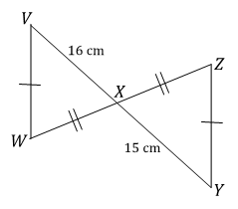

The triangles are not identical since a correspondence that matches the two marked equal pairs of sides also matches sides and , which are not equal in length.

1. 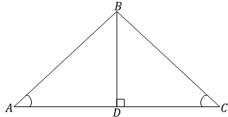

These triangles are identical by the two angles and side opposite a given angle condition. The correspondence matches the two pairs of equal angles and one pair of equal sides. The pair of equal sides is the common side, . We know must be a right angle since is a right angle, and they are both on a line and of course angles and are equal in measurement.

1. Are there any identical triangles in this diagram?

Triangles and are not necessarily identical; we only know about a single pair of equal angles in the triangles, which are vertical angles. Triangles and are also not necessarily identical. We only know about a single pair of equal angles and a side common to both triangles, which is not enough information to determine the triangles as identical or non-identical.

1. 

The triangles are not necessarily identical since there is no correspondence that matches the two marked equal pairs of sides as well as the two pairs of equal angles. One of the pairs of equal angles is the pair of vertical angles.



Triangles and are not necessarily identical. The triangles satisfy the two sides and non-included acute angle condition, which does not determine a unique triangle.