Lesson 13: Checking for Identical Triangles

Classwork
Opening Exercise
- List all the conditions that determine unique triangles:

- How are the terms identical and unique related?

In Example 1 and Exercises 1–3, two triangles are given. State whether the triangles are identical, not identical, or not necessarily identical. If possible, give the triangle conditions that explain why the triangles are identical, and write a triangle correspondence that matches the sides and angles. If the triangles are not identical, explain why. If it is not possible to definitively determine whether the triangles are identical, write “the triangles are not necessarily identical,” and explain your reasoning.

Example 1
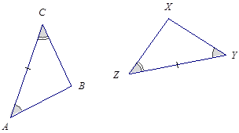

Exercises 1–3
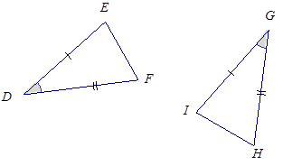

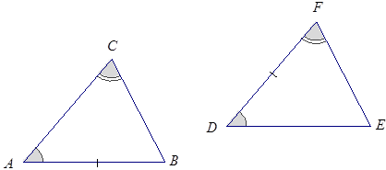

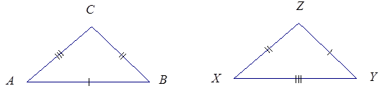

In Example 2 and Exercises 4–6, three pieces of information are given for $△ABC$ and $△XYZ$. Draw, freehand, the two triangles (do not worry about scale), and mark the given information. If the triangles are identical, give a triangle correspondence that matches equal angles and equal sides. Explain your reasoning.

Example 2
$AB=XZ$, $AC=XY$, $∠A=∠X$

Exercises 4–6
- $∠A=∠Z$, $∠B=∠Y$, $AB=YZ$

- $∠A=∠Z$, $∠B=∠Y$, $BC=XY$

- $∠A=∠Z$,$∠B=∠Y$,$BC=XZ$

Problem Set

In each of the following four problems, two triangles are given. State whether the triangles are identical, not identical, or not necessarily identical. If possible, give the triangle conditions that explain why the triangles are identical, and write a triangle correspondence that matches the sides and angles. If the triangles are not identical, explain why. If it is not possible to definitively determine whether the triangles are identical, write “the triangles are not necessarily identical,” and explain your reasoning.
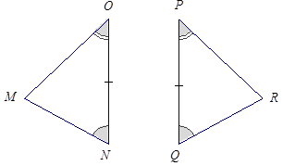

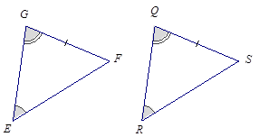

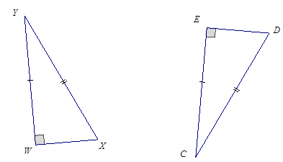

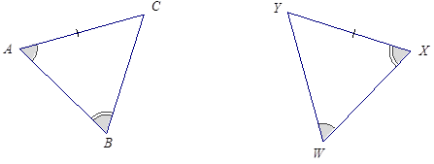

For Problems 5–8, three pieces of information are given for $△ABC$ and $△XYZ$. Draw, freehand, the two triangles (do not worry about scale), and mark the given information. If the triangles are identical, give a triangle correspondence that matches equal angles and equal sides. Explain your reasoning.
- $AB=ZY$, $BC=ZX$, $AC=YX$

- $AB=ZY$, $BC=ZX$, $∠C=∠Y$

- $AB=XZ$, $∠A=∠Z$, $∠C=∠Y$

- $AB=XY$,$AC=YZ$,$∠C=∠Z$ (Note that both angles are obtuse.)

