|  |
| --- |
|  |

Lesson 13: Checking for Identical Triangles

Student Outcomes

* Students use conditions that determine a unique triangle to determine when two triangles are identical.
* Students construct viable arguments to explain why the given information can or cannot give a triangle correspondence between identical triangles.

Lesson Notes

Lessons 13 and 14 are application lessons for Topic B. Students must look at a pair of triangles and decide whether the triangles are identical based on what they know about conditions that determine unique triangles.

Classwork

Opening Exercise (5 minutes)

Opening Exercise

* 1. List all the conditions that determine unique triangles:
* Three sides condition
* Two sides and included angle condition
* Two angles and included side condition
* Two angles and the side opposite a given angle condition
* Two sides and a non-included angle, provided the angle is or greater
* Two sides and a non-included angle, provided the side adjacent to the angle is shorter than the side opposite the angle
  1. How are the terms *identical* and *unique* related?

**When drawing a triangle under a given condition, the triangle will either be identical or non-identical to the original triangle. If only one triangle can be drawn under the condition, we say the condition determines a unique triangle. A triangle drawn under a condition that is known to determine a unique triangle will be identical to the original triangle.**

**Discussion (2 minutes)**

Students synthesize their knowledge on triangles and use what they have learned about correspondences and conditions that determine a unique triangle to explain whether each pair of triangles is identical or not. Hold students accountable for the same level of precision in their responses as the response provided in Example 1.

MP.3

&

MP.6

Follow the instructions below for Example 1 and Exercises 1–3.

In each of the following problems, two triangles are given. State whether the triangles are identical, not identical, or not necessarily identical. If possible, give the triangle conditions that explain why the triangles are identical, and write a triangle correspondence that matches the sides and angles. If the triangles are not identical, explain why. If it is not possible to definitively determine whether the triangles are identical, write “the triangles are not necessarily identical,” and explain your reasoning.

Example 1 (5 minutes)

*Scaffolding:*

For students struggling to visualize whether the triangles are identical or not, suggest that they trace one triangle, mark it with all tick and arc marks, and cut it out to try and map over the other triangle.

Example 1

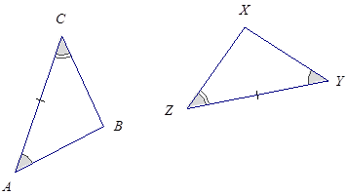

The triangles are identical by the two angles and the included side condition. The correspondence matches two pairs of angles and one pair of equal sides. Since both triangles have parts under the condition of the same measurement, the triangles must be identical.

Exercises 1–3 (12 minutes)

Exercises 1–3

1. 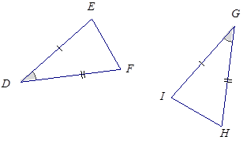

The triangles are identical by the two sides and the included angle condition. The correspondence matches two equal pairs of sides and one equal pair of angles. Since both triangles have parts under the condition of the same measurement, the triangles must be identical.

1. 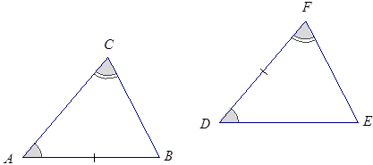

The triangles are not necessarily identical. Although the two angles in each triangle match, the marked sides do not correspond. In triangle , the marked side is not between the marked angles, whereas in , the marked side is between the marked angles.

1. 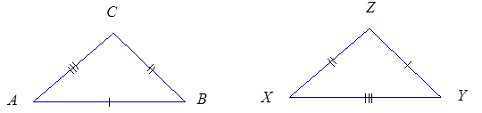

The triangles are identical by the three sides condition. The correspondence matches three equal pairs of sides. Since both triangles have the same side lengths, the triangles must be identical.

Example 2 (5 minutes)

Follow the instructions below for Example 2 and Exercises 4–6.

In Example 2 and Exercises 4–6, three pieces of information are given for and . Draw, freehand, the two triangles (do not worry about scale), and mark the given information. If the triangles are identical, give a triangle correspondence that matches equal angles and equal sides. Explain your reasoning.

Example 2

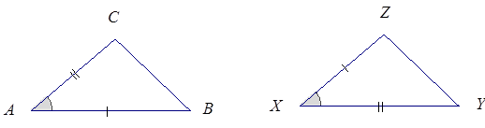,,

These triangles are identical by the two sides and included angle condition. The triangle correspondence matches two pairs of equal sides and one pair of equal, included angles. Since both triangles have parts under the condition of the same measurement, the triangles must be identical.

Note: Students need not worry about exact drawings in these questions; the objective is to recognize that the triangles’ matching parts fit the condition.

Exercises 4–6 (12 minutes)

Exercises 4–6

1. , ,

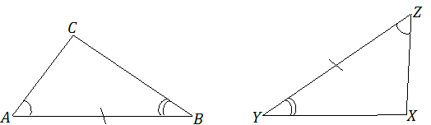

These triangles are identical by the two angles and included side condition. The triangle correspondence   
 matches two pairs of equal angles and one pair of equal, included sides. Since both triangles have parts under the condition of the same measurement, the triangles must be identical.

1. *,,*

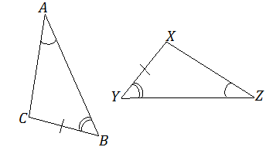

These triangles are identical by the two angles and side opposite a given angle condition. The triangle correspondence matches two pairs of equal angles and one pair of equal sides. Since both triangles have parts under the condition of the same measurement, the triangles must be identical.

1. ,,



These triangles are not necessarily identical. In , the marked side is opposite . In , the marked side is not opposite , which is equal to . Rather, it is opposite , which is equal to .

Closing (1 minutes)

* The measurement and arrangement (and correspondence) of the parts in each triangle plays a role in determining whether two triangles are identical.

Exit Ticket (5 minutes)

Name Date

Lesson 13: Checking for Identical Triangles

Exit Ticket

Angles and are equal in measure. Draw two triangles around each angle and mark parts appropriately so that the triangles are identical; use angles and as part of the chosen condition. Write a correspondence for the triangles.



Exit Ticket Sample Solutions

Angles and are equal in measure. Draw two triangles around each angle and mark parts appropriately so that the triangles are identical; use angles and as part of the chosen condition. Write a correspondence for the triangles.

***Answers will vary; students should select any condition except for the three side condition and show the appropriate correspondence for their condition on the two triangles.***

Problem Set Sample Solutions

In each of the following four problems, two triangles are given. State whether the triangles are identical, not identical, or not necessarily identical. If possible, give the triangle conditions that explain why the triangles are identical, and write a triangle correspondence that matches the sides and angles. If the triangles are not identical, explain why. If it is not possible to definitively determine whether the triangles are identical, write “the triangles are not necessarily identical,” and explain your reasoning.

1. 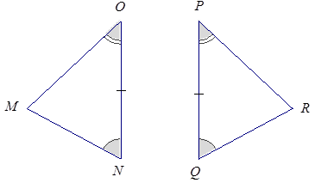

The triangles are identical by the two angles and included side condition. The correspondence matches two equal pairs of angles and one equal pair of included sides. Since both triangles have parts under the condition of the same measurement, the triangles must be identical.

1. 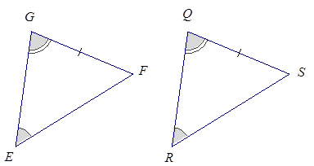

The triangles are identical by the two angles and side opposite a given angle condition. The correspondence matches two equal pairs of angles and one equal pair of sides. Since both triangles have parts under the condition of the same measurement, the triangles must be identical.

1. 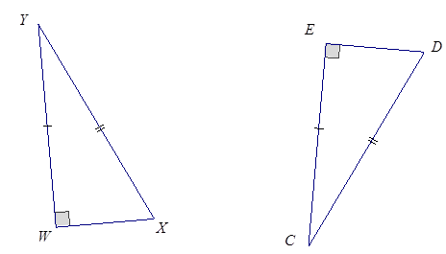

The triangles are identical by the two sides and non-included (or greater) angle condition. The correspondence matches two pairs of equal sides and one pair of equal angles. Since both triangles have parts under the condition of the same measurement, the triangles must be identical.

1. 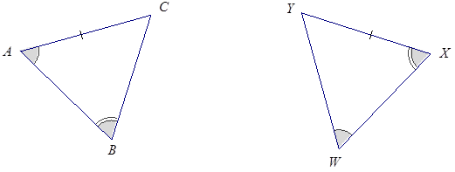

The triangles are not necessary identical by the two angles and side opposite a given angle condition. In , the marked side is adjacent to the angle marked with a single arc mark. In , the marked side is not adjacent to the angle marked with a single arc mark.

For Problems 5–8, three pieces of information are given for and . Draw, freehand, the two triangles (do not worry about scale), and mark the given information. If the triangles are identical, give a triangle correspondence that matches equal angles and equal sides. Explain your reasoning.

1. ,,

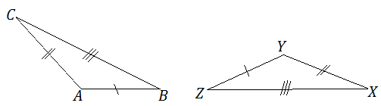

These triangles are identical by the three sides condition. The triangle correspondence matches three pairs of equal sides. Since both triangles have parts under the condition of the same measurement, the triangles must be identical.

1. ,,



These triangles are not necessarily identical. In , the marked angle is adjacent to . In , the marked angle is not adjacent to the side equal to , which is equal to side .

1. , ,



These triangles are identical by the two angles and a side opposite a given angle condition. The triangle correspondence matches two pairs of equal angles and one pair of equal sides. Since both triangles have parts under the condition of the same measurement, the triangles must be identical.

1. ,, (Note that both angles are obtuse.)



The triangles are identical by the two sides and non-included (or greater) angle condition. The correspondence matches two pairs of equal sides and one pair of equal angles. Since both triangles have parts under the condition of the same measurement, the triangles must be identical.