Lesson 12: Unique Triangles―Two Sides and a Non-Included Angle

Classwork

Exploratory Challenge

1. Use your tools to draw , provided cm, cm, and . Continue with the rest of the problem as you work on your drawing.
2. What is the relationship between the given parts of ?
3. Which parts of the triangle can be drawn without difficulty? What makes this drawing challenging?
4. A ruler and compass are instrumental in determining where is located.

* Even though the length of is unknown, extend the ray in anticipation of the intersection with .
* Draw segment with length cm away from the drawing of the triangle.
* Adjust your compass to the length of .
* Draw a circle with center and a radius equal to or cm.

1. How many intersections does the circle make with ? What does each intersection signify?
2. Complete the drawing of .
3. Did the results of your drawing differ from your prediction?
4. Now attempt to draw this triangle: Draw , provided cm, cm, and .
   1. How are these conditions different from those in Exercise 1, and do you think the criteria will determine a unique triangle?
   2. What is the relationship between the given parts of ?
   3. Describe how you will determine the position of
   4. How many intersections does the circle make with ?
   5. Complete the drawing of . How is the outcome of different from that of ?
   6. Did your results differ from your prediction?
5. Now attempt to draw this triangle: Draw , provided cm, cm, and . Use what you drew in Exercises 1 and 2 to complete the full drawing.
6. Review the conditions provided for each of the three triangles in the Exploratory Challenge, and discuss the uniqueness of the resulting drawing in each case.

Problem Set

1. In each of the triangles below, two sides and a non-included acute angle are marked. Use a compass to draw a non-identical triangle that has the same measurements as the marked angle and marked sides (look at Exercise 1, part (e) of the Exploratory Challenge as a reference). Draw the new triangle on top of the old triangle. What is true about the marked angles in each triangle that results in two non-identical triangles under this condition?
2. 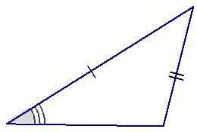
3. 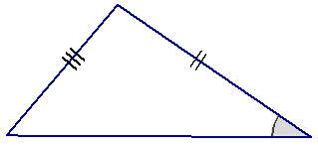

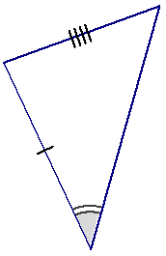

2. Sometimes two sides and a non-included angle of a triangle determine a unique triangle, even if the angle is acute. In the following two triangles, copy the marked information (i.e., two sides and a non-included acute angle), and discover which determines a unique triangle. Measure and label the marked parts.

In each triangle, how does the length of the marked side adjacent to the marked angle compare with the length of the side opposite the marked angle? Based on your drawings, specifically state when the two sides and acute non-included angle condition determines a unique triangle.



1. A sub-condition of the two sides and non-included angle is provided in each row of the following table. Decide whether the information determines a unique triangle. Answer with a “yes,” “no,” or “maybe” (for a case that may or may not determine a unique triangle).

|  |  |  |
| --- | --- | --- |
|  | Condition | Determines a Unique Triangle? |
| 1 | Two sides and a non-included angle. |  |
| 2 | Two sides and an acute, non-included angle. |  |
| 3 | Two sides and a non-included angle. |  |
| 4 | Two sides and a non-included angle, where the side adjacent to the angle is shorter than the side opposite the angle. |  |
| 5 | Two sides and a non-included angle. |  |
| 6 | Two sides and a non-included angle, where the side adjacent to the angle is longer than the side opposite the angle. |  |

1. Choose one condition from the chart in Problem 3 that does not determine a unique triangle, and explain why.
2. Choose one condition from the chart in Problem 3 that does determine a unique triangle, and explain why.