|  |
| --- |
|  |

Lesson 12: Unique Triangles—Two Sides and a Non-Included Angle

Student Outcomes

* Students understand that two sides of a triangle and an acute angle, not included between the two sides, may not determine a unique triangle.
* Students understand that two sides of a triangle and a angle (or obtuse angle), not included between the two sides, determine a unique triangle.

Lesson Notes

A triangle drawn under the condition of two sides and a non-included angle is often thought of as a condition that does not determine a unique triangle. Lesson 12 breaks this idea down by sub-condition. Students see that the sub-condition, two sides and a non-included angle, provided the non-included angle is an *acute* angle, is the only sub-condition that does not determine a unique triangle. Furthermore, there is a maximum of two possible non-identical triangles that can be drawn under this sub-condition.

Classwork

Exploratory Challenge (30 minutes)

Ask students to predict, record, and justify whether they think the provided criteria will determine a unique triangle for each set of criteria.

MP.3

Exploratory Challenge

1. Use your tools to draw , provided cm, cm, and . Continue with the rest of the problem as you work on your drawing.

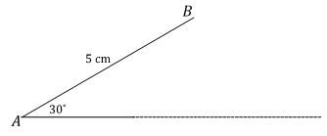

* 1. What is the relationship between the given parts of ?

Two sides and a non-included angle are provided.

* 1. Which parts of the triangle can be drawn without difficulty? What makes this drawing challenging?

The parts that are adjacent, and , are easiest to draw. It is difficult to position .

* 1. A ruler and compass are instrumental in determining where is located.
  + Even though the length of is unknown, extend the ray in anticipation of the intersection with .
  + Draw segment with length cm away from the drawing of the triangle.

MP.5

* + Adjust your compass to the length of .
  + Draw a circle with center and a radius equal to , or cm.

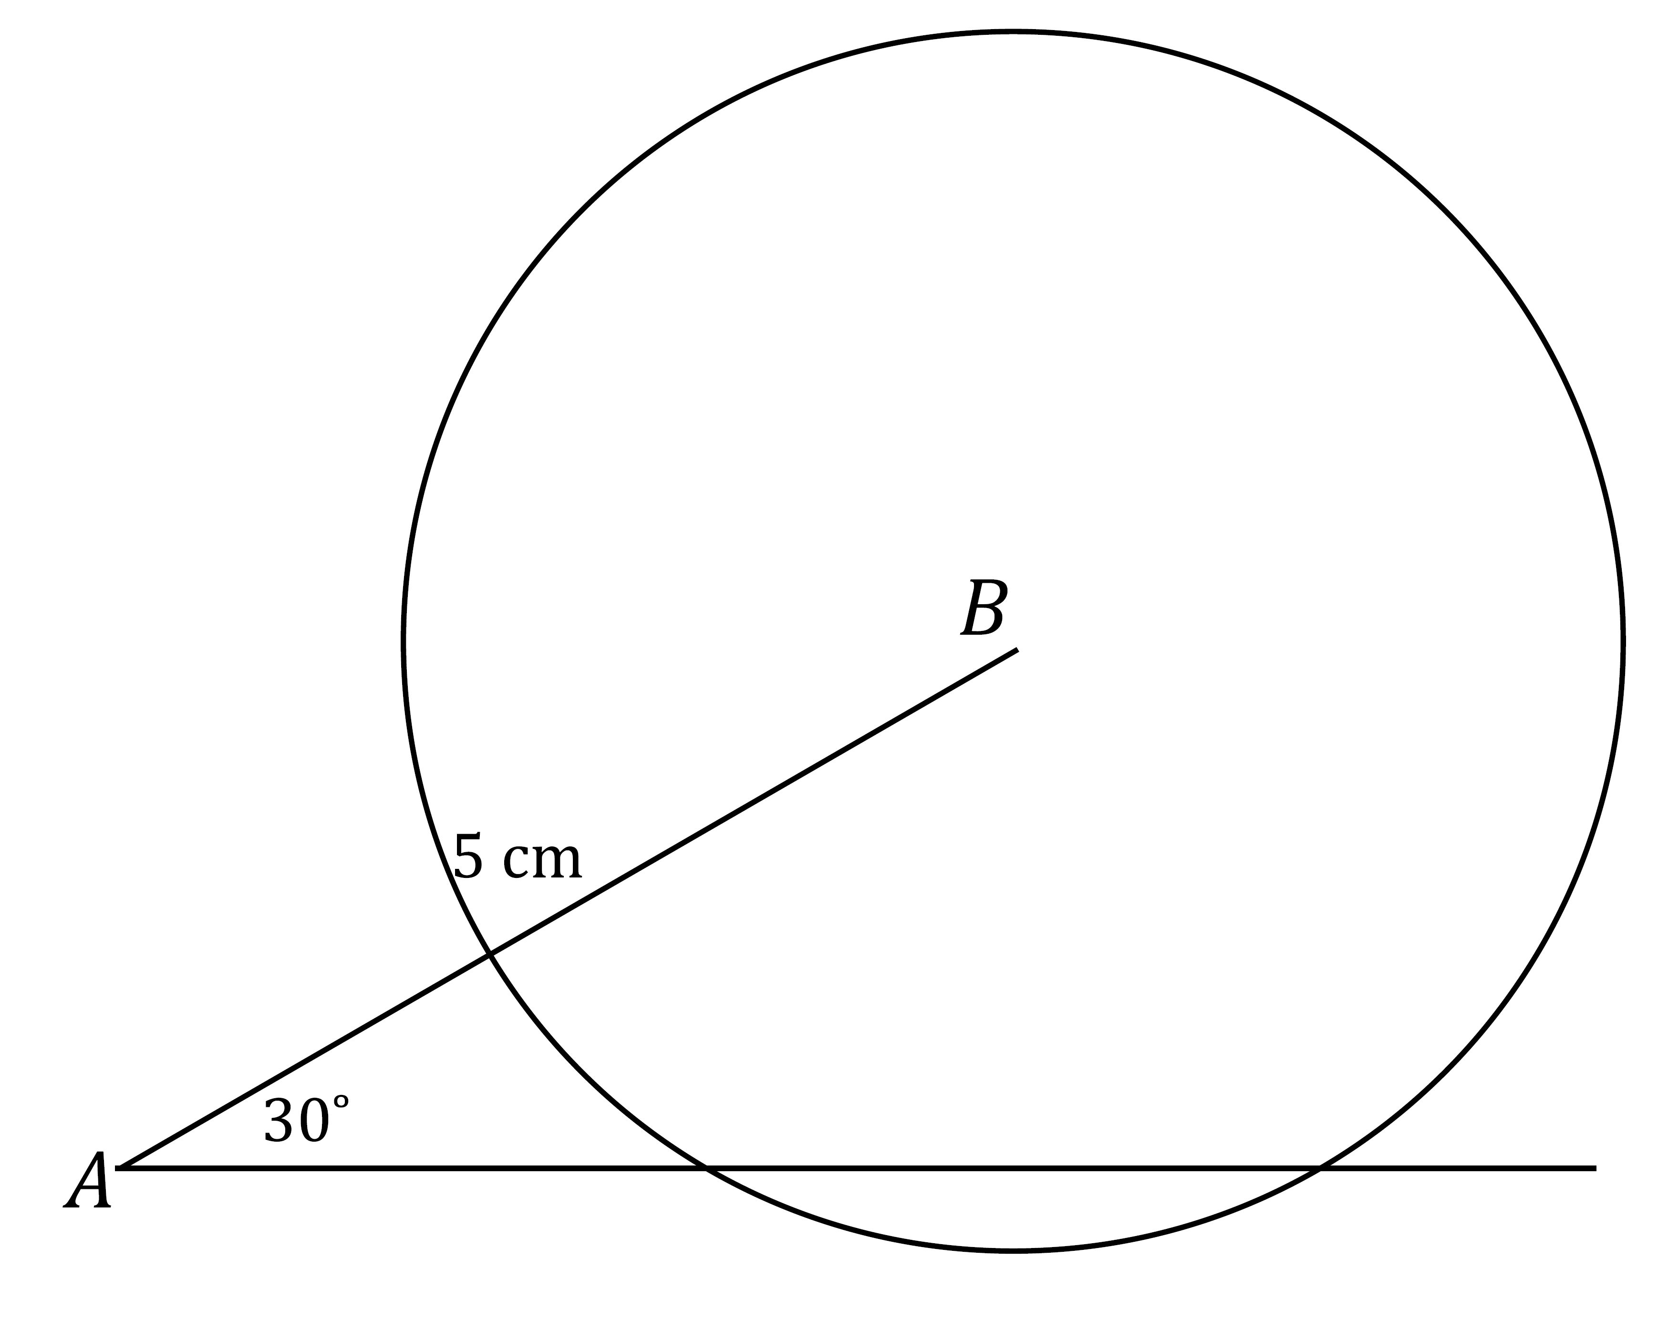

* 1. How many intersections does the circle make with ? What does each intersection signify?

Two intersections; each intersection represents a possible location for vertex .

* As students arrive at part (e), recommend that they label the two points of intersection as and .

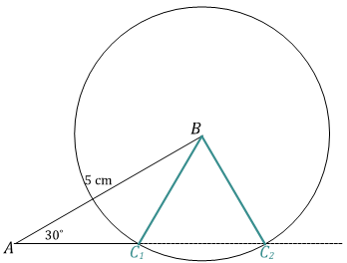

* 1. Complete the drawing of .
  2. Did the results of your drawing differ from your prediction?

**Answers will vary.**

1. Now attempt to draw this triangle: draw , provided cm, cm, and .
   1. How are these conditions different from those in Exercise 1, and do you think the criteria will determine a unique triangle?

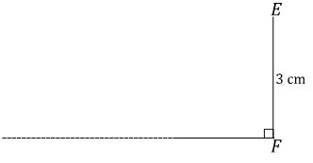The provided angle was an acute angle in Exercise 1; now the provided angle is a right angle. Possible prediction: since the same general criteria (two sides and a non-included angle) determined more than one triangle in Exercise 1, the same can happen in this situation.

*Scaffolding:*

For Exercise 2, part (a), remind students to draw the adjacent parts first (i.e., and .

* 1. What is the relationship between the given parts of ?

Two sides and a non-included angle are provided.

* 1. Describe how you will determine the position of

I will draw a segment equal in length to , or cm, and adjust my compass to this length. Then, I will draw a circle with center and radius equal to . This circle should intersect with the ray .

* 1. How many intersections does the circle make with ?

Just one intersection.

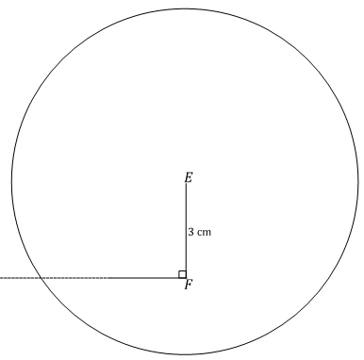

* 1. Complete the drawing of . How is the outcome of different from that of ?

In drawing , there are two possible locations for vertex , but in drawing , there is only one location for vertex .

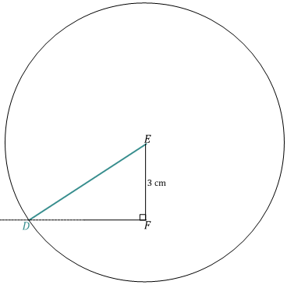

* 1. Did your results differ from your prediction?

Answers will vary.

1. Now attempt to draw this triangle: draw , provided cm, cm, and . Use what you drew in Exercises 1 and 2 to complete the full drawing.

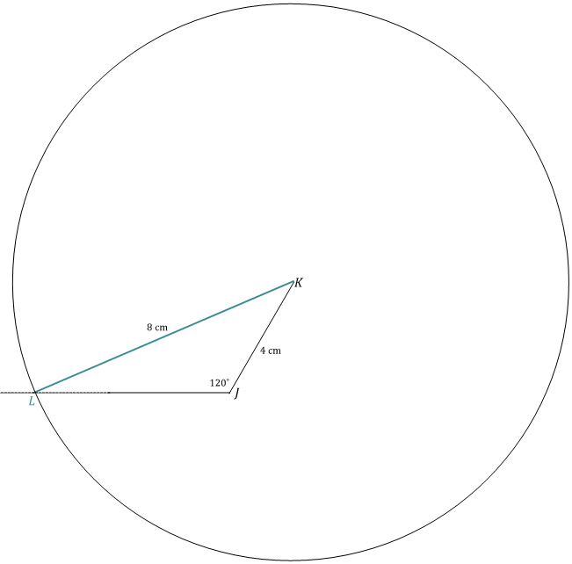

1. **Review the conditions provided for each of the three triangles in the Exploratory Challenge, and discuss the uniqueness of the resulting drawing in each case.**

All three triangles are under the condition of two sides and a non-included angle. The non-included angle in is an acute angle, while the non-included angle in is , and the non-included angle in is obtuse. The triangles drawn in the latter two cases are unique because there is only one possible triangle that could be drawn for each. However, the triangle drawn in the first case is not unique because there are two possible triangles that could be drawn.

**Discussion (8 minutes)**

Review the results from each case of the two sides and non-included angle condition.

* Which of the three cases, or sub-conditions of two sides and a non-included angle, determines a unique triangle?
  + *Unique triangles are determined when the non-included angle in this condition is or greater.*
* How should we describe the case of two sides and a non-included angle that does not determine a unique triangle?
  + *The only case of the two sides and a non-included angle condition that does not determine a unique triangle is when the non-included angle is an acute angle.*
* Highlight how the radius in the figure in Exercise 1, part (e) can be pictured to be “swinging” between and . Remind students that the location of is initially unknown and that ray is extended to emphasize this.

Closing (2 minutes)

* A triangle drawn under the condition of two sides and a non-included angle, where the angle is acute, does not determine a unique triangle. This condition determines two non-identical triangles.
* Consider a triangle correspondence that corresponds to two pairs of equal sides and one pair of equal, non-included angles. If the triangles are not identical, then can be made to be identical to by swinging the appropriate side along the path of a circle with a radius length of that side.
* A triangle drawn under the condition of two sides and a non-included angle, where the angle is or greater, does determine a unique triangle.

Exit Ticket (5 minutes)

Name Date

Lesson 12: Unique Triangles—Two Sides and a Non-Included Angle

Exit Ticket

So far, we have learned about four conditions that determine unique triangles: three sides, two sides and an included angle, two angles and an included side, and two angles and the side opposite a given angle.

* 1. In this lesson, we studied the criterion two sides and a non-included angle. Which case of this criterion determines a unique triangle?
  2. Provided has length cm, has length cm, and the measurement of is , draw , and describe why these conditions do not determine a unique triangle.

Exit Ticket Sample Solutions

So far, we have learned about four conditions that determine unique triangles: three sides, two sides and an included angle, two angles and an included side, and two angles and the side opposite a given angle.

* 1. In this lesson, we studied the criterion two sides and a non-included angle. Which case of this criterion determines a unique triangle?

***For the criterion two sides and a non-included angle, the case where the non-included angle is or greater determines a unique triangle.***

* 1. Provided has length cm, has length cm,and the measurement of is , draw , and describe why these conditions do not determine a unique triangle.

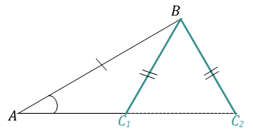

***The non-included angle is an acute angle, and two different triangles can be determined in this case since can be in two different positions, forming a triangle with two different lengths of .***

Problem Set Sample Solutions

1. In each of the triangles below, two sides and a non-included acute angle are marked. Use a compass to draw a non-identical triangle that has the same measurements as the marked angle and marked sides (look at Exercise 1, part (e) of the Exploratory Challenge as a reference). Draw the new triangle on top of the old triangle. What is true about the marked angles in each triangle that results in two non-identical triangles under this condition?
   1. 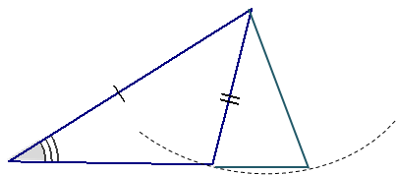

The non-included angle is acute.

* 1. 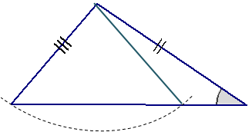

The non-included angle is acute.

* 1. 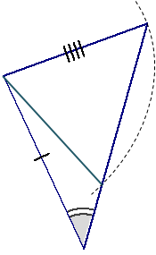

The non-included angle is acute.

1. Sometimes two sides and a non-included angle of a triangle determine a unique triangle, even if the angle is acute. In the following two triangles, copy the marked information (i.e., two sides and a non-included acute angle), and discover which determines a unique triangle. Measure and label the marked parts.

In each triangle, how does the length of the marked side adjacent to the marked angle compare with the length of the side opposite the marked angle? Based on your drawings, specifically state when the two sides and acute non-included angle condition determines a unique triangle.

While redrawing , students will see that a unique triangle is not determined, but in redrawing , a unique triangle is determined. In , the length of the side opposite the angle is shorter than the side adjacent to the angle. However, in , the side opposite the angle is longer than the side adjacent to the angle.

The two sides and acute non-included angle condition determines a unique triangle if the side opposite the angle is longer than the side adjacent to the angle.

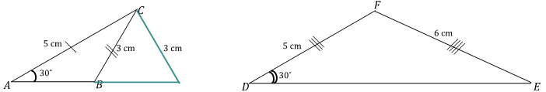

1. A sub-condition of the two sides and non-included angle is provided in each row of the following table. Decide whether the information determines a unique triangle. Answer with a “yes,” “no,” or “maybe” (for a case that may or may not determine a unique triangle).

|  |  |  |
| --- | --- | --- |
|  | Condition | Determines a Unique Triangle? |
| 1 | Two sides and a non-included angle. | yes |
| 2 | Two sides and an acute, non-included angle. | maybe |
| 3 | Two sides and a non-included angle. | yes |
| 4 | Two sides and a non-included angle, where the side adjacent to the angle is shorter than the side opposite the angle. | yes |
| 5 | Two sides and a non-included angle. | maybe |
| 6 | Two sides and a non-included angle, where the side adjacent to the angle is longer than the side opposite the angle. | no |

1. Choose one condition from the chart in Problem 3 that does not determine a unique triangle, and explain why.

Possible response: Condition 6 does not determine a unique triangle because the condition of two sides and an acute non-included angle determines two possible triangles.

1. Choose one condition from the chart in Problem 3 that does determine a unique triangle, and explain why.

Possible response: Condition 1 determines a unique triangle because the condition of two sides and a non-included angle with a measurement of or more determines a unique triangle.