|  |
| --- |
|  |

Lesson 11: Conditions on Measurements that Determine a Triangle

Student Outcomes

* Students understand that three given lengths determine a triangle, provided the largest length is less than the sum of the other two lengths; otherwise, no triangle can be formed.
* Students understand that if two side lengths of a triangle are given, then the third side length must be between the difference and the sum of the first two side lengths.
* Students understand that two angle measurements determine many triangles, provided the angle sum is less than ; otherwise, no triangle can be formed.

Materials

Patty paper or parchment paper (in case dimensions of patty paper are too small)

Lesson Notes

In Lesson 11, students explore side length requirements and angle requirements that determine a triangle. Students reason through three cases in the exploration regarding side length requirements and conclude that any two side lengths must sum to be greater than the third side length. In the exploration regarding angle requirements, students observe the resulting figures in three cases and conclude that the angle sum of two angles in a triangle must be less than . Additionally, they observe that three angle measurements do not determine a unique triangle and that it is possible to draw scale drawings of a triangle with given angle measurements. Students are able to articulate the result of each case in the explorations.

*Scaffolding:*

An alternate activity that may increase accessibility is to provide students with pieces of dry pasta (or other manipulatives) and rulers, and then give the task: “Build as many triangles as you can. Record the lengths of the three sides.” Once students have constructed many triangles, ask, “What do you notice about the lengths of the sides?” Allow written and spoken responses. If necessary, ask students to construct triangles with particular dimensions (such as cm, cm, cm; cm, cm, cm; cm, cm, cm) to further illustrate the concept.

Classwork

Exploratory Challenge 1 (8 minutes)

Students explore the length requirements to form a triangle in pairs.

Exploratory Challenge 1

* 1. Can any three side lengths form a triangle? Why or why not?

Possible response: Yes, because a triangle is made up of three side lengths; therefore, any three sides can be put together to form a triangle

* 1. Draw a triangle according to these instructions:

*Scaffolding:*

Allow students who feel comfortable with a compass to use one instead of the patty paper. The compass is adjusted to cm (), and a circle is drawn with a center at ; similar steps are done for side .

* Draw segment of length cm in your notebook.
* Draw segment of length cm on one piece of patty paper.
* Draw segment of length cm on the other piece of patty paper.
* Line up the appropriate endpoint on each piece of patty paper with the matching endpoint on .
* Use your pencil point to hold each patty paper in place, and adjust the paper to form .

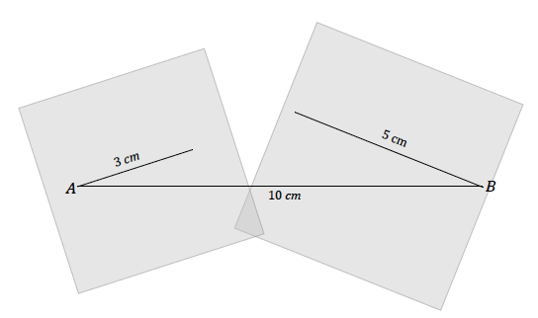

* 1. What do you notice?

cannot be formed because and do not meet.

* 1. What must be true about the sum of the lengths of and if the two segments were to just meet? Use your patty paper to verify your answer.

For and to just meet, the sum of their lengths must be equal to cm.

* 1. Based on your conclusion for part (c), what if cm as you originally had, but cm in length. Could you form ?

can be formed because and can meet at an angle and still be anchored at and .

* 1. What must be true about the sum of the lengths of and if the two segments were to meet and form a triangle?

For and to just meet and form a triangle, the sum of their lengths must be greater than cm.

**Discussion (7 minutes)**

* Were you able to form ? Why not? Did the exercise confirm your prediction?
  + *We could not form because sides and are too short in length to meet.*
* What would the sum of the lengths and have to be to just meet? Describe one possible set of lengths for and . Would these lengths form ? Explain why or why not.

MP.7

* + *The lengths would have to sum to cm to just meet (e.g., cm and* cm). *Because the segments are anchored to either endpoint of , the segments form a straight line or coincide with . Therefore, cannot be formed since , , and are collinear.*
* If a triangle cannot be formed when the two smaller segments are too short to meet or just meet, what must be true about the sum of the lengths of the two smaller segments compared to the longest length? Explain your answer using possible measurements.

MP.7

* + *The sum of the two smaller lengths must be greater than the longest length so that the vertices will not be collinear; if the sum of the two smaller lengths are greater than the longest length while anchored at either endpoint of , the only way they can meet is if , , and are not collinear. One possible set of lengths is cm and* cm.

Help students recognize this fundamental inequality by illustrating it with an image of walking between two points, and .

Observe the two pathways to get from to . Pathway 1 is a straight path from to . Pathway 2 requires you to walk through a point that does not lie on the straight path. Clearly, the total distance when walking through is greater than the distance of walking the straight path. This idea can be visualized from , , or . Hence, the length of any one side of a triangle is always less than the sum of the lengths of the remaining sides.

 

Pathway 2

Pathway 1

* Given two side lengths of a triangle, the third side length must be between the difference of the two sides and the sum of the two sides. For example, if a triangle has two sides with lengths cm and cm, then the third side length must be between the difference () cm and the sum () cm. Explanation: Let be the length of the third side in centimeters. If , then the largest side length is cm, and , or . If , then cm is the longest side length and . So, .

MP.7

Exercise 1 (4 minutes)

* In this exercise, students must consider the length of the last side from two perspectives: one where the last side is not the longest side and one where the last side is the longest side. With these two considerations, the third side is a range of lengths, all of which satisfy the condition that the longest side length is less than the sum of the other two side lengths.

Exercise 1

Two sides of have lengths of cm and cm. What are all the possible whole-number lengths for the remaining side?

The possible whole-number side lengths in cm are ,,, , ,, ,,.

Exploratory Challenge 2 (8 minutes)

Students explore the angle measurement requirements to form a triangle in pairs. Encourage students to document their exploration carefully, even if their results are not what they expected.

Exploratory Challenge 2

* 1. Which of the following conditions determine a triangle? Follow the instructions to try and draw . Segment has been drawn for you as a starting point in each case.
     1. Choose measurements of and for so that the sum of measurements is greater than . Label your diagram.

Your chosen angle measurements:

Were you able to form a triangle? Why or why not?

Selected angle measurements and corresponding diagram indicate one possible response.



We were not able to form a triangle because the non-horizontal ray of and the non-horizontal ray of do not intersect.

* + 1. Choose measurements of and for so that the measurement of is supplementary to the measurement of . Label your diagram.

Your chosen angle measurements:

Were you able to form a triangle? Why or why not?

Selected angle measurements and corresponding diagram indicate one possible response.



We were not able to form a triangle because the non-horizontal ray of and the non-horizontal ray of do not intersect; the non-horizontal rays look parallel.

* + 1. Choose measurements of and for so that the sum of measurements is less than . Label your diagram.

Your chosen angle measurements:

Were you able to form a triangle? Why or why not?

Angle measurements and corresponding diagram indicate one possible response.



*Scaffolding:*

Teachers may want to demonstrate the informal proof and illustrate that the angle sum of a triangle is . Do this by tearing off the corners of a triangle and forming a straight line by placing the three angles adjacent to each other. Note that this is an extension and is not formally discussed until Grade 8.

We were able to form a triangle because the non-horizontal ray of and the non-horizontal ray of intersect.

* 1. Which condition must be true regarding angle measurements in order to determine a triangle?

The sum of two angle measurements of a triangle must be less than .

* 1. Measure and label the formed triangle in part (b) with all three side lengths and the angle measurement for . Now, use a protractor, ruler, and compass to draw with the same angle measurements, but side lengths that are half as long.



Students should begin by drawing any one side length at a length half as much as the corresponding side in , and then drawing angles at each end of this line segment. Students should recognize that is a scale drawing of . Ask students to mark all length measurements as a means of verifying that they are indeed half as long as the corresponding sides of the original triangle.

* 1. Do the three angle measurements of a triangle determine a unique triangle? Why or why not?

Three angles do not determine a unique triangle. For a given triangle with three provided angle measurements, another triangle can be drawn with the same angle measurements but with side lengths proportional to those side lengths of the original triangle.

**Discussion (7 minutes)**

* Why couldn’t be formed in case (i), when the sum of the measurements of and were greater than ?
  + *The non-horizontal rays will not intersect due to the angle they form with .*
* Why couldn’t be formed in case (ii), when the sum of the measurements of and were supplementary?
  + *The non-horizontal rays will not intersect. The lines look parallel; if they are extended, they seem to be the same distance apart from each other at any given point.*
* Confirm that the two non-horizontal rays in this case are, in fact, parallel and two supplementary angle measurements in position to be two angles of a triangle will always yield parallel lines.
* What conclusion can we draw about any two angle measurements of a triangle, with respect to determining a triangle?
  + *The sum of any two angles of a triangle must be less than in order to form the triangle.*
* Do the three angle measurements of a triangle guarantee a unique triangle?
  + *No, we drew a triangle that had the same angle measurements as our triangle in case (iii) but with side lengths that were twice the length of the original triangle*.
* Remind students of their work with scale drawings. Triangles that are enlargements or reductions of an original triangle all have equal corresponding angle measurements but have side lengths that are proportional.

Exercise 2 (4 minutes)

Describe how the questions will be administered. Either list exercises separately with the number in the header or use the header “Exercises” with numbered list following.

Exercise 2

Which of the following sets of angle measurements determines a triangle?

* + - * 1. , **Determines a triangle**
        2. , **Does not determine a triangle**
        3. , **Does not determine a triangle**
        4. , **Determines a triangle**
        5. , **Does not determine a triangle**

Choose one example from above that does determine a triangle and one that does not. For each, explain why it does or does not determine a triangle using words and a diagram.

Possible response:

|  |  |  |
| --- | --- | --- |
| The angle measurements in part (a) determine a triangle because the non-horizontal rays of the angle and the angle will intersect to form a triangle. |  | The angle measurements in part (c) do not determine a triangle because the non-horizontal rays of the angle and the angle will not intersect to form a triangle. |
|  |  |  |

Closing (2 minutes)

* Three given lengths determine a triangle, provided the largest length is less than the sum of the other two lengths; otherwise, no triangle can be formed.
* Two angle measurements determine a triangle, provided the sum of the two angle measurements is less than ; otherwise, no triangle can be formed.
* Three given angle measurements do not determine a unique triangle. Scale drawings of a triangle have equal corresponding angle measurements, but corresponding side lengths that are proportional.

Exit Ticket (5 minutes)

Name Date

Lesson 11: Conditions on Measurements that Determine a Triangle

Exit Ticket

1. What is the maximum and minimum whole-number side length for with given side lengths of cm and cm? Please explain why.
2. Jill has not yet studied the angle measurement requirements to form a triangle. She begins to draw side of and considers the following angle measurements for and . Describe the drawing that results from each set.



* 1. and
  2. and
  3. and

Exit Ticket Sample Solutions

1. What is the minimum and maximum whole-number side length for with given side lengths of cm and cm? Please explain why.

***Minimum: cm. Maximum: cm. Values above this maximum and below this minimum will not satisfy the condition that*** the longest side length is less than the sum of the other two side lengths.

1. Jill has not yet studied the angle measurement requirements to form a triangle. She begins to draw side as a horizontal segment of and considers the following angle measurements for and . Describe the non-horizontal rays in the drawing that results from each set.



* 1. and

***The non-horizontal rays of and will not intersect to form a triangle; the rays will be parallel to each other.***

* 1. and

***The non-horizontal rays of and will intersect to form a triangle.***

* 1. and

***The non-horizontal rays of and will not intersect to form a triangle.***

Problem Set Sample Solutions

*Scaffolding:*

Lessons 7 and 8 demonstrate how to use a compass for questions such as Problem 1.

1. Decide whether each set of three given lengths determines a triangle. For any set of lengths that does determine a triangle, use a ruler and compass to draw the triangle. Label all side lengths. For sets of lengths that do not determine a triangle, write “Does not determine a triangle,” and justify your response.
   1. cm, cm, cm

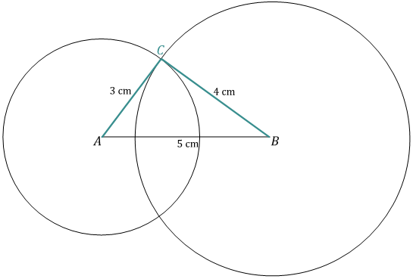

* 1. cm, cm, cm

Does not determine a triangle; the lengths are too short to form a triangle.

* 1. cm, cm, cm

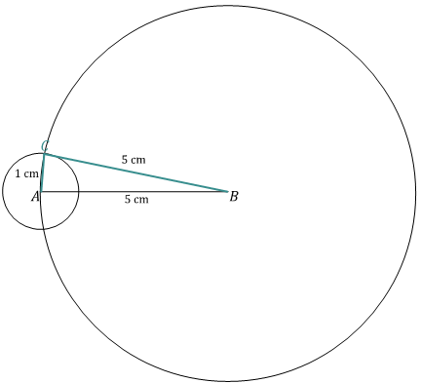

* 1. cm*,* cm, cm

*Does not determine a triangle; the lengths are too short to form a triangle.*

* 1. cm, cm, cm

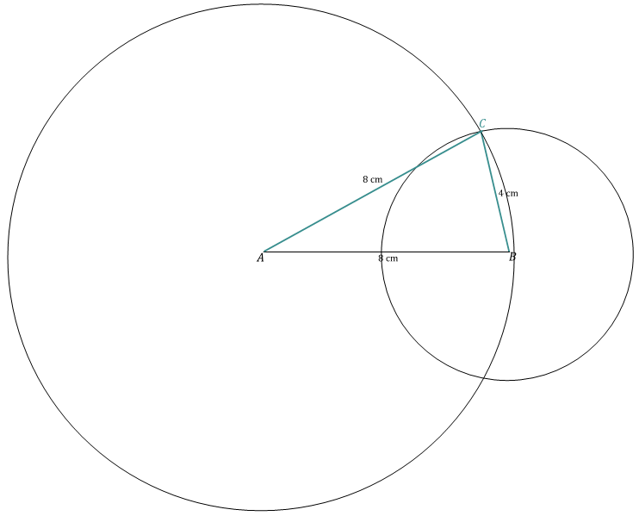

* 1. cm*,* cm, cm

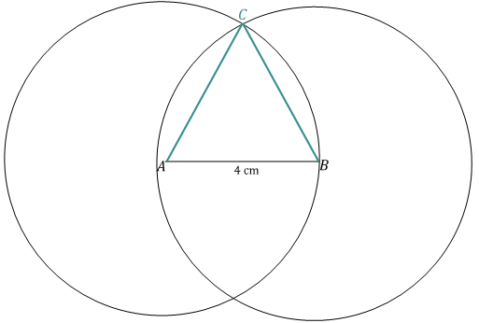

1. For each angle measurement below, provide one angle measurement that will determine a triangle and one that will not determine a triangle. Provide a brief justification for the angle measurements that will not form a triangle. Assume that the angles are being drawn to a horizontal segment ; describe the position of the non-horizontal rays of angles and .

|  |  |  |  |
| --- | --- | --- | --- |
|  | : A Measurement that Determines a Triangle | : A Measurement that *Doesn’t* Determine a Triangle | Justification for No Triangle |
|  | One possible answer: | One possible answer: | The non-horizontal rays do not intersect. |
|  | One possible answer: | One possible answer: | The non-horizontal rays do not intersect. |
|  | One possible answer: | One possible answer: | The non-horizontal rays do not intersect. |
|  | One possible answer: | One possible answer: | The non-horizontal rays do not intersect. |

Note:

* Measurements that determine a triangle should be less than (the measurement of ).
* Measurements that do not determine a triangle should be greater than (the measurement of ).

1. For the given side lengths, provide the minimum and maximum whole-number side lengths that determine a triangle.

|  |  |  |
| --- | --- | --- |
| Given Side Lengths | Minimum Whole Number Third Side Length | Maximum Whole Number Third Side Length |
| cm, cm | cm | cm |
| cm, cm | cm | cm |
| cm, cm | cm | cm |
| cm, cm | cm | cm |