Lesson 10: Conditions for a Unique Triangle―Two Angles and a Given Side

Student Outcomes
- Students understand that two triangles are identical if two pairs of corresponding angles and one pair of corresponding sides are equal under some correspondence; two angle measurements and a given side length of a triangle determine a unique triangle.
- Students understand that the two angles and any side condition can be separated into two conditions: (1) the two angles and included side condition and (2) the two angles and the side opposite a given angle condition.

Lesson Notes
In Lesson 9, students learned two conditions that determine unique triangles: the three sides condition and the two sides and included angle condition. Drawing several examples of triangles under these conditions demonstrated that there was only one possible configuration of a triangle to be drawn. In Lesson 10, students add the two angles and one given side condition to the list of conditions that determine a unique triangle. Since this condition exists in two possible arrangements, the two angles and included side condition and the two angles and the side opposite a given angle condition, it is considered to be two conditions. Drawing a triangle under the two angles and the side opposite a given angle condition requires a step beyond other drawings because the angle opposite the given side needs to be moved around to correctly establish its location. This is done by drawing the angle opposite the given side on a piece of patty paper, parchment paper, or regular paper. By the close of the lesson, students have a total of four conditions that determine a unique triangle.

Materials
Patty paper or parchment paper

Classwork
Opening (5 minutes)
- In Lesson 6, we explored drawing triangles under the condition that two angles and a side length were provided.
- The arrangement of these parts was not specified, and a total of three non-identical triangles were drawn.
- In this lesson, we explore what happens when this condition is modified to take arrangement into consideration.
- Instead of drawing triangles given two angle measurements and a side length, we will draw triangles under the condition that two angles and the included side is provided and under the condition that two angles and the side opposite a given angle is provided.
Exploratory Challenge (25 minutes)
Exploratory Challenge
- A triangle $△XYZ$ has angles $∠X=30°$ and $∠Y=50°$ and included side $XY=6$cm. Draw triangle $△X'Y'Z'$ under the same condition as $△XYZ$. Leave all construction marks as evidence of your work, and label all side and angle measurements.
Under what condition is $△X'Y'Z'$ drawn? Compare the triangle you drew to two of your peers’ triangles. Are the triangles identical? Did the condition determine a unique triangle? Use your construction to explain why.

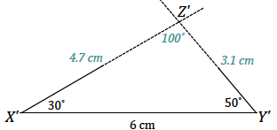
The condition on $△X'Y'Z'$ is the two angles and included side condition. All of the triangles are identical; the condition determined a unique triangle. After drawing the included side length, I used the protractor to draw the provided angle measurements at either endpoint of the included side $X'Y'$. Since these two angle measurements are fixed, the two remaining side lengths will intersect in one location, which is the third vertex of the triangle, $Z'$. There is no other way to draw this triangle; therefore, the condition determines a unique triangle.

- A triangle $△RST$ has angles $∠S=90°$ and $∠T=45°$ and included side $ST=7$cm. Draw triangle $△R'S'T'$ under the same condition. Leave all construction marks as evidence of your work, and label all side and angle measurements.
MP.5
Under what condition is $△R'S'T'$ drawn? Compare the triangle you drew to two of your peers’ triangles. Are the triangles identical? Did the condition determine a unique triangle? Use your construction to explain why.

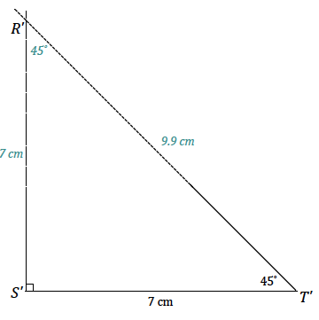
The condition on $△R^{'}S^{'}T^{'}$ is the two angles and included side condition. All of the triangles are identical; the condition determined a unique triangle. After drawing the included side length, I used the protractor to draw the provided angle measurements at either endpoint of the included side $S'T'$. The intersection of the sides of the angle is the third vertex of the triangle, $R'$. There is no other way to draw this triangle; therefore, the condition determines a unique triangle.

- A triangle $△JKL$ has angles $∠J=60°$ and $∠L=25°$ and side $KL=5$ cm. Draw triangle $△J'K'L'$ under the same condition. Leave all construction marks as evidence of your work, and label all side and angle measurements.
MP.5
Under what condition is $△J'K'L'$ drawn? Compare the triangle you drew to two of your peers’ triangles. Are the triangles identical? Did the condition determine a unique triangle? Use your construction to explain why.

Students will quickly realize that this drawing has an element different from other drawings they have done.
- Do you notice anything about this drawing that is different from other drawings you have done?
  - This drawing has parts that are not adjacent to each other, so it is harder to tell how to put the triangle together.
- What parts of the triangle are provided, and what are their relationships?
  - There is a side and one angle adjacent to the side, and there is one angle opposite the side.
- Which part of this drawing can be drawn without much difficulty?
  - The side and the angle adjacent to the side.
- How can the angle opposite the side be correctly positioned?
  - Responses will vary. Elicit the idea of a “floating” angle, or an angle drawn on a separate piece of paper that can be moved around.
Provide students with patty paper, parchment paper, or even small slips of regular paper, and ask them to continue attempting the drawing by putting the angle opposite the side on this slip of paper.
Students will have to line up one ray of the angle on patty paper (the angle opposite the given side) with one ray of the angle adjacent to the given side. They will move the angle around until the free ray of the angle on patty paper meets the endpoint of the given segment.

- Draw the parts that are adjacent. | 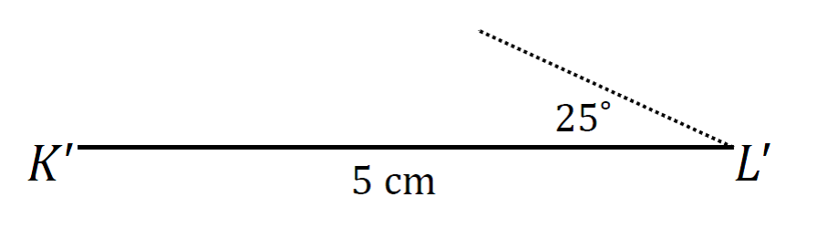
- Draw the $60°$ angle on a piece of patty paper, and then try to align the rays of the angle so that they coincide with point $K'$ and the non-horizontal side of $∠L$. | 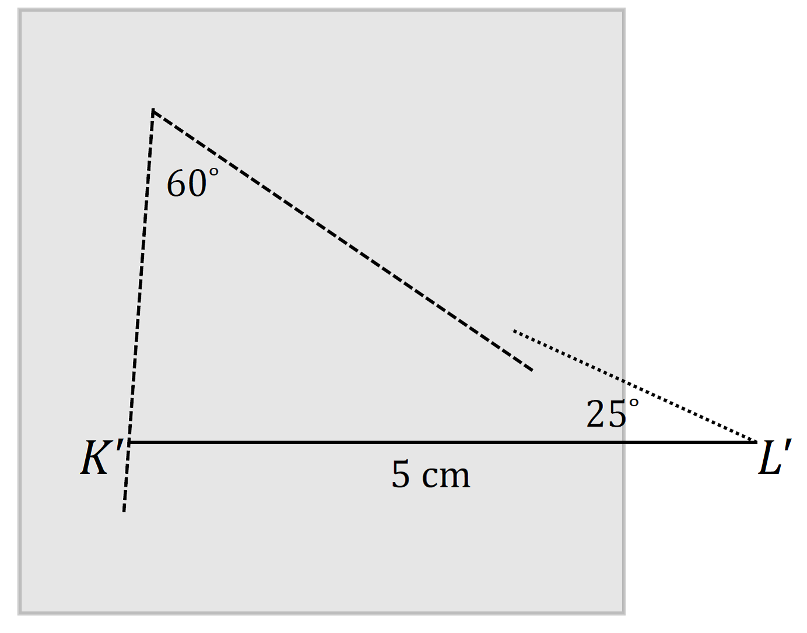
- Move the $60°$ angle (the patty paper) around until it is in place. | 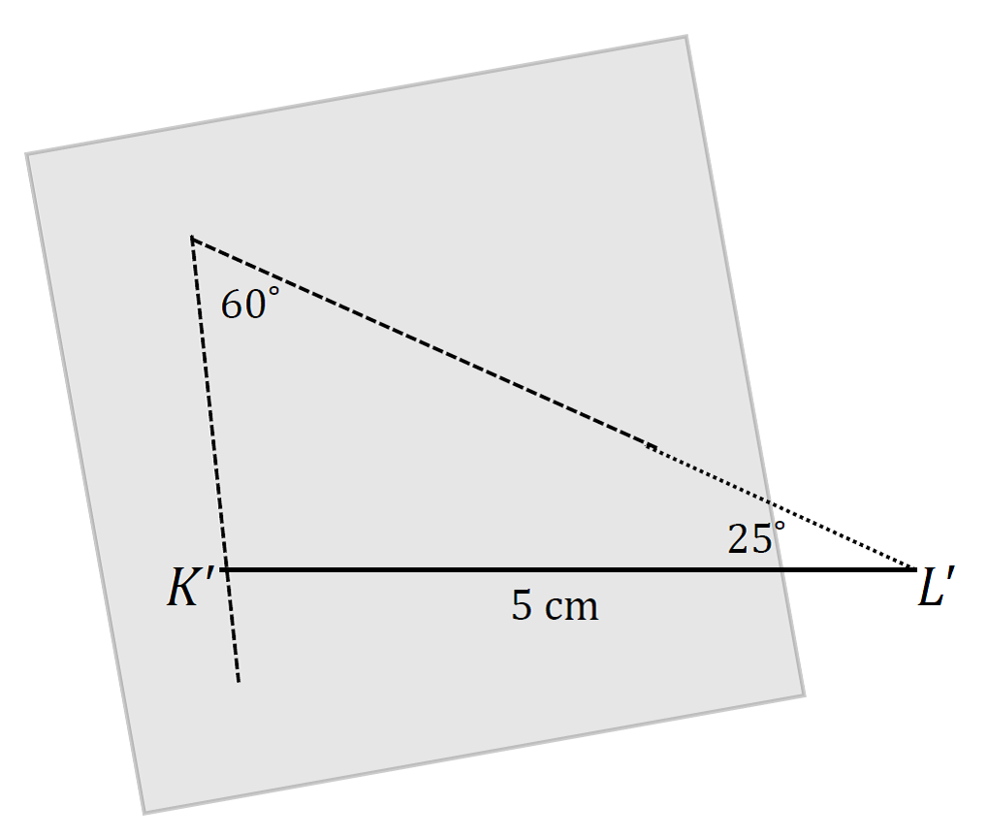
- Once the angle is in place, the rest of the measurements can be determined. | 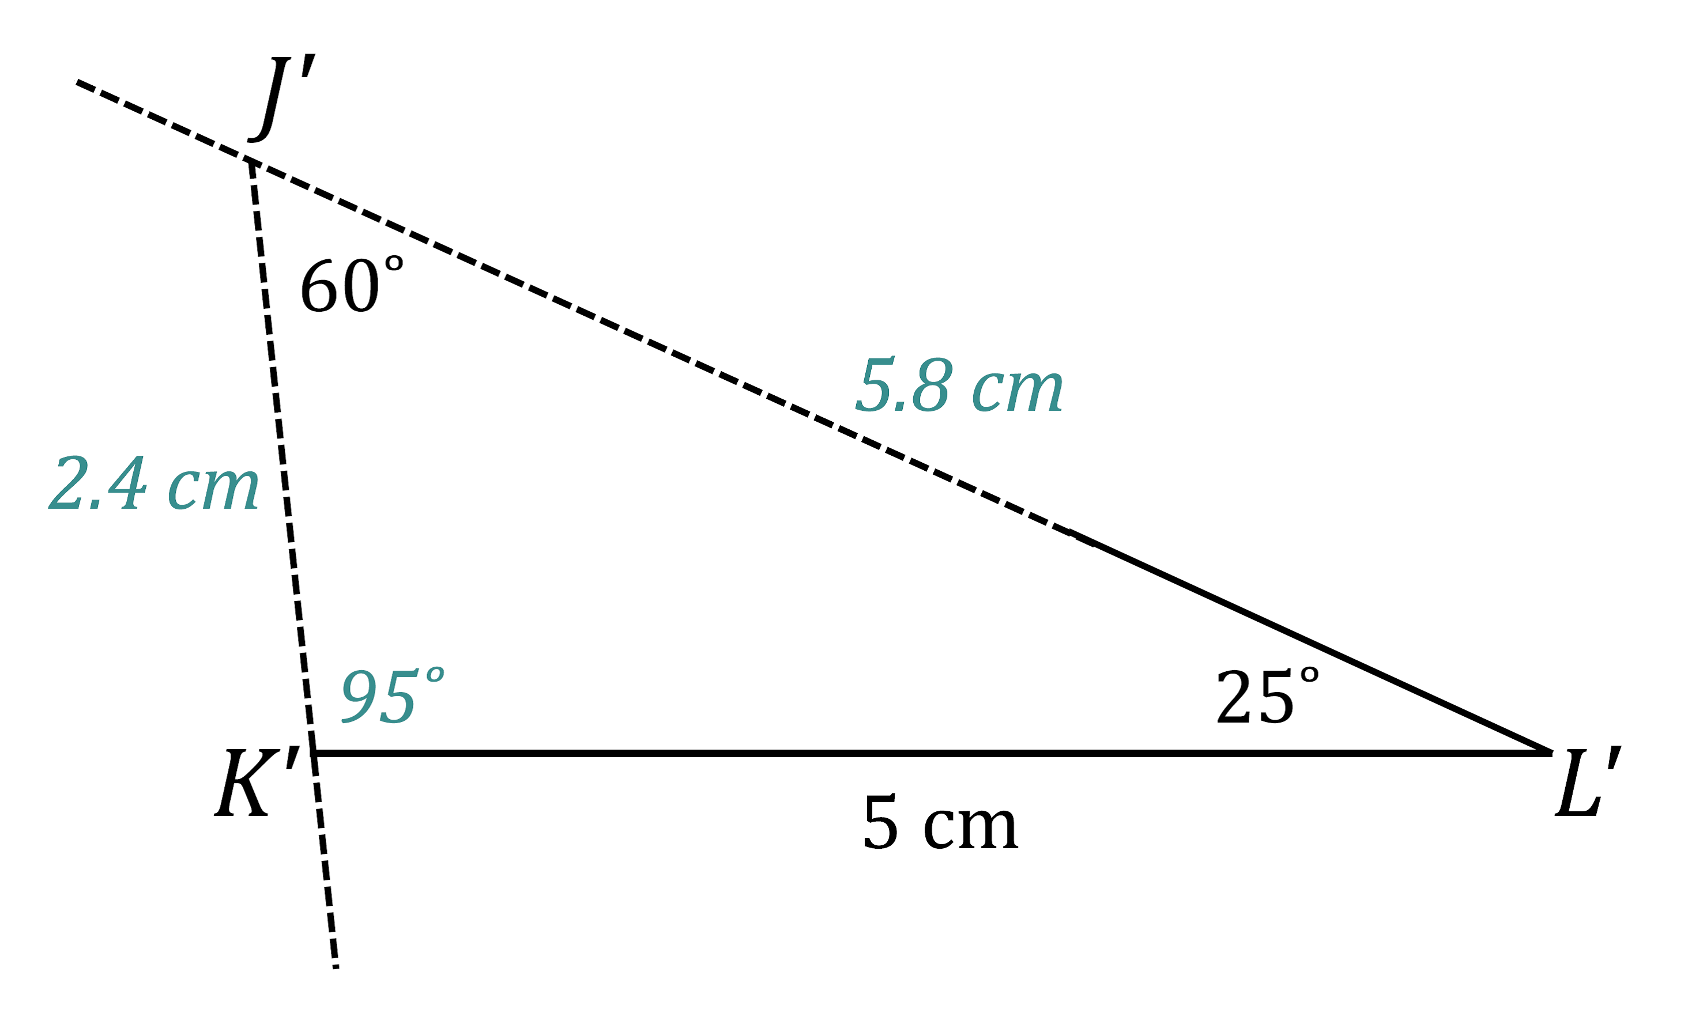

The condition on $△J'K'L'$ is the two angles and the side opposite a given angle condition. All of the triangles are identical; the condition determined a unique triangle. After drawing the given side length, I used the protractor to draw the angle $∠L'$ adjacent to$K'L'$. I drew the angle opposite the given side, $∠J'$, on a slip of paper and lined up one ray of the angle on patty paper with one ray of the angle adjacent to the given side. I moved the angle on patty paper along the coinciding rays until the free ray just met the endpoint of $K'L'$. There is no other way to draw this triangle; therefore, the condition determines a unique triangle.

- A triangle $△ABC$ has angles $∠C=35°$ and $∠B=105°$ and side $AC=7$ cm. Draw triangle $△A'B'C'$ under the same condition. Leave all construction marks as evidence of your work, and label all side and angle measurements.
Under what condition is $△A'B'C'$ drawn? Compare the triangle you drew to two of your peers’ triangles. Are the triangles identical? Did the condition determine a unique triangle? Use your construction to explain why.
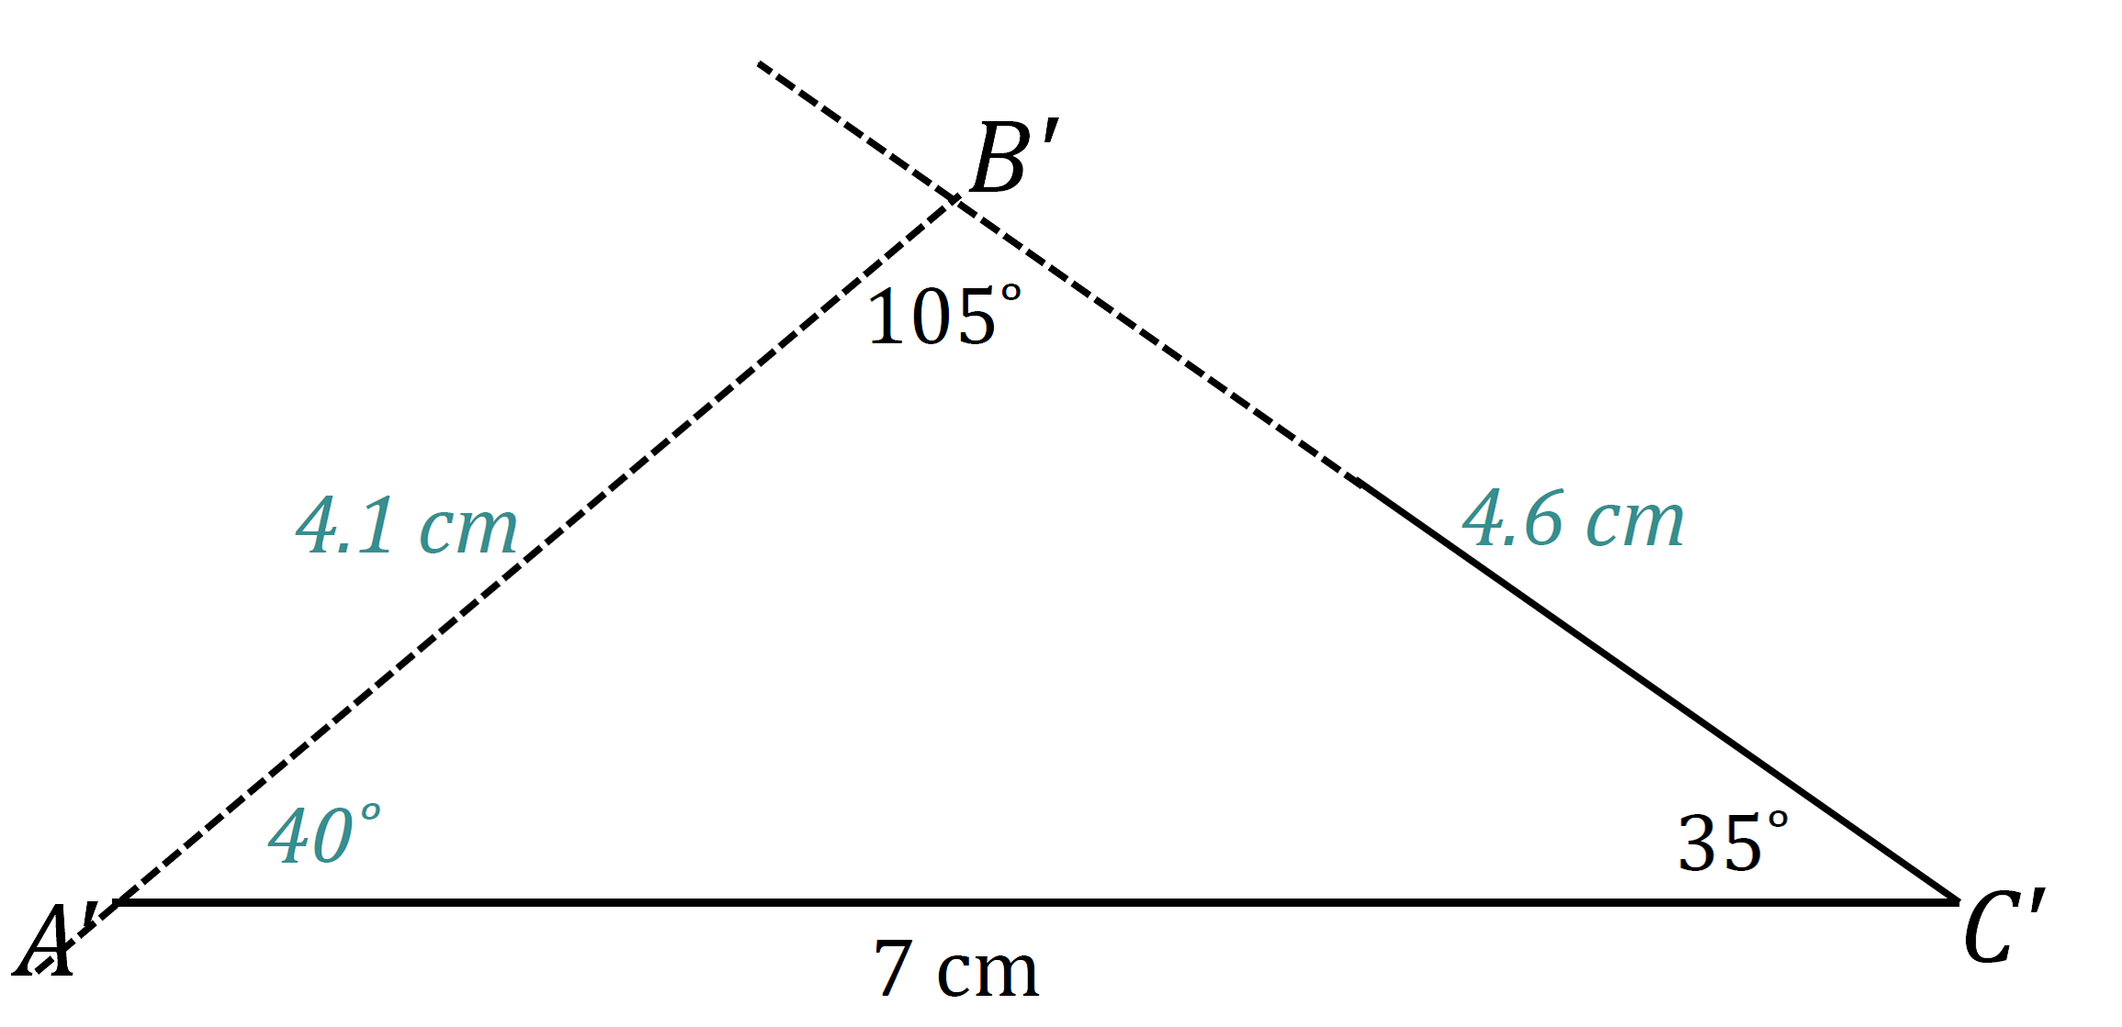
MP.5
The condition on $△A'B'C'$ is the two angles and the side opposite a given angle condition. All of the triangles are identical; the condition determined a unique triangle. After drawing the given side length, I used the protractor to draw the angle $∠C'$ adjacent to $A'C'$. I drew the angle opposite the given side, $∠B'$, on a slip of paper and lined up one ray of the angle on patty paper with one ray of the angle adjacent to the given side. I moved the angle on patty paper along the coinciding rays until the free ray just met the endpoint of $A'C'$. There is no other way to draw this triangle; therefore, the condition determines a unique triangle.

Discussion (8 minutes)
Review responses to the Exploratory Challenge as a whole group, either by sharing out responses from each group or by doing a gallery walk. Consider asking students to write a reflection about what they learned from the Exploratory Challenge.
- Today we saw two conditions that determine unique triangles. What is the complete list of conditions that determine unique triangles?
  - Three sides condition
  - Two sides and included angle condition
  - Two angles and included side condition
  - Two angles and the side opposite a given angle condition

Closing (2 minutes)
- The two angles and any side condition determines a unique triangle.
- Since the condition has two different arrangements, we separate it into two conditions: the two angles and included side condition and two angles and the side opposite a given angle condition.
- When drawing a triangle under the two angles and the side opposite a given angle condition, the angle opposite the given segment must be drawn on separate paper in order to locate the position of the third vertex.

Exit Ticket (5 minutes)
Name Date
Lesson 10: Conditions for a Unique Triangle―Two Angles and a Given Side

Exit Ticket

- $△ABC$ has angles $∠A=50°$ and $∠C=90°$ and side $AB=5.5$cm. Draw triangle $△A'B'C'$ under the same condition. Under what condition is $△A'B'C'$ drawn? Use your construction to explain why $△A'B'C'$ is or is not identical to $△ABC$.

- $△PQR$ has angles $∠Q=25°$ and $∠R=40°$ and side $QR=6.5$cm. Draw triangle $△P'Q'R'$ under the same condition. Under what condition is $△P'Q'R'$ drawn? Use your construction to explain why $△P'Q'R'$ is or is not identical to $△PQR$.
Exit Ticket Sample Solutions

- $△ABC$ has angles $∠A=50°$ and $∠C=90°$ and side $AB=5.5$cm. Draw triangle $△A'B'C'$ under the same condition. Under what condition is $△A'B'C'$ drawn. Use your construction to explain why $△A'B'C'$ is or is not identical to $△ABC$.
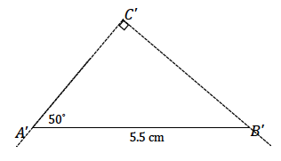
The condition on $△A'B'C'$ is the two angles and the side opposite a given angle condition. Triangle $△A'B'C'$ is identical to $△ABC$ . After drawing the given side length, I used the protractor to draw the angle $∠A'$ adjacent to $A'B'$. I drew the angle opposite the given side, $∠B'$, on a slip of paper and lined up one ray of the angle on patty paper with one ray of the angle adjacent to the given side. I moved the angle on patty paper along the coinciding rays until the free ray just met the endpoint of $A'B'$. There is no other way to draw this triangle; therefore, $△A'B'C'$ must be identical to $△ABC$.

- $△PQR$ has angles $∠Q=25°$ and $∠R=40°$ and side $QR=6.5$ cm. Draw triangle $△P'Q'R'$ under the same condition. Under what condition is $△P'Q'R'$ drawn? Use your construction to explain why $△P'Q'R'$ is or is not identical to $△PQR$.
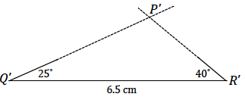
The condition on $△P'Q'R'$ is the two angles and included side condition. Triangle $△P'Q'R'$ is identical to $△PQR$ . After drawing the given side length, I used the protractor to draw the angle $∠Q'$ adjacent to $Q'R'$. After drawing the included side length, I used the protractor to draw the provided angle measurements at either endpoint of the included side $P'Q'$. Since these two angle measurements are fixed, the two remaining side lengths will intersect in one location, which is the third vertex of the triangle, $P'$. There is no other way to draw this triangle; therefore, $△P'Q'R'$ must be identical to $△PQR$.

Problem Set Sample Solutions

- In triangle $△FGH$, $∠F=42°$ and $∠H=70°$. Side $FH=6$ cm. Draw triangle $△F'G'H'$ under the same condition as $△FGH$. Leave all construction marks as evidence of your work, and label all side and angle measurements.
What can be concluded about $△FGH$ and $△F'G'H'$? Justify your response.
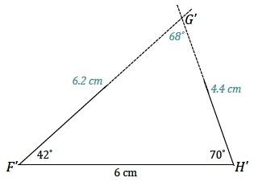
$△FGH$ and $△F'G'H'$ are identical triangles by the two angles and included side condition. Since both triangles are drawn under the same condition, and the two angles and included side condition determines a unique triangle, both triangles determine the same unique triangle. Therefore, they are identical.

- In triangle $△WXY$, $∠Y=57°$ and $∠W=103°$. Side $YX=6.5$ cm. Draw triangle $△W'X'Y'$ under the same condition as $△WXY$. Leave all construction marks as evidence of your work, and label all side and angle measurements.
What can be concluded about $△WXY$ and $△W'X'Y'$? Justify your response.
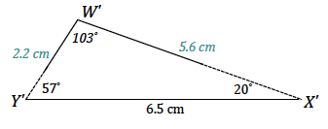
$△WXY$ and $△W'X'Y'$ are identical triangles by the two angles and the side opposite a given angle condition. Since both triangles are drawn under the same condition, and the two angles and the side opposite a given angle condition determines a unique triangle, both triangles determine the same unique triangle. Therefore, they are identical.

- $A$, $Z$, and $E$ are collinear, and $∠B=∠D$. What can be concluded about $△ABZ$ and $△EDZ$? Justify your answer.
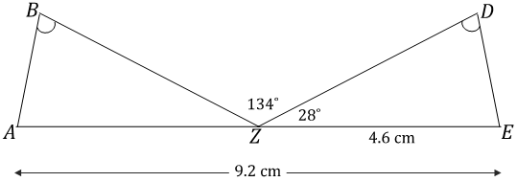
$$124°$$

$△ABZ$ and $△EDZ$ are identical by the two angles and the side opposite a given angle condition. Since segments add, and $AZ$ is $9.2$cm and $ZE$ is $4.6$ cm, $AZ$ must be $4.6$ cm. Since angles on a line sum to $180°$, $∠BZD=124°$, and $∠DZE=28°$, then $∠AZE=28°$. From the diagram, we can see that $∠B=∠D$. The same measurements in both triangles satisfy the two angles and the side opposite a given angle condition, which means they both determine the same unique triangle; thus, they are identical.

- Draw $△ABC$so that $∠A$ has a measurement of $60°$, $∠B$ has a measurement of $60°$, and $AB$ has a length of $8$ cm. What are the lengths of the other sides?
Both of the other side lengths are $8$ cm.
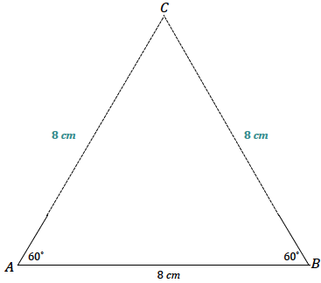
- Draw $△ABC$so that $∠A$ has a measurement of $30°$, $∠B$ has a measurement of $60°$, and $BC$ has a length of $5$ cm. What is the length of the longest side?
The longest side has a length of $10$cm.

