Lesson 9: Conditions for a Unique Triangle―Three Sides and Two Sides and the Included Angle

Classwork
Exploratory Challenge
- A triangle $△XYZ$ exists with side lengths of the segments below. Draw a triangle $△X'Y'Z'$ with the same side lengths as $△XYZ$. Use your compass to determine the sides of $△X'Y'Z'$. Use your ruler to measure side lengths. Leave all construction marks as evidence of your work, and label all side and angle measurements.

Under what condition is $△X'Y'Z'$ drawn? Compare the triangle you drew to two of your peers’ triangles. Are the triangles identical? Did the condition determine a unique triangle? Use your construction to explain why. Do the results differ from your predictions?

- $△ABC$ is located below. Copy the sides of the triangle to create $△A'B'C'$. Use your compass to determine the sides of $△A'B'C'$. Use your ruler to measure side lengths. Leave all construction marks as evidence of your work, and label all side and angle measurements.

Under what condition is $△A'B'C'$ drawn? Compare the triangle you drew to two of your peers’ triangles. Are the triangles identical? Did the condition determine a unique triangle? Use your construction to explain why.

- A triangle $△DEF$ has an angle of $40°$ adjacent to side lengths of $4$ cm and $7$cm. Construct $△D'E'F'$ with side lengths $D^{'}E'=4$cm, $D'F'=7$cm, and included angle $∠D=40°$. Use your compass to draw the sides of $△D'E'F'$. Use your ruler to measure side lengths. Leave all construction marks as evidence of your work, and label all side and angle measurements.

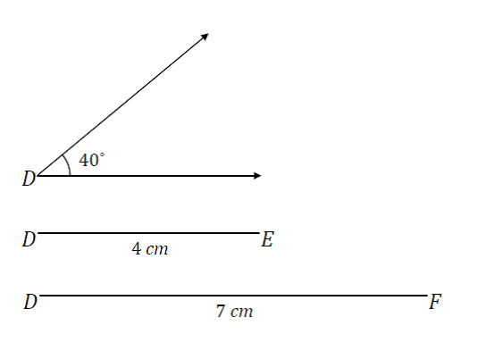
Under what condition is $△D'E'F'$ drawn? Compare the triangle you drew to two of your peers’ triangles. Did the condition determine a unique triangle? Use your construction to explain why.

- $△XYZ$ has side lengths $XY=2.5$cm, $XZ=4$cm, and $∠X=120°$. Draw $△X'Y'Z'$ under the same conditions. Use your compass and protractor to draw the sides of $△X'Y'Z'$. Use your ruler to measure side lengths. Leave all construction marks as evidence of your work, and label all side and angle measurements.

Under what condition is $△X'Y'C'$ drawn? Compare the triangle you drew to two of your peers’ triangles. Are the triangles identical? Did the condition determine a unique triangle? Use your construction to explain why.

Problem Set

- A triangle with side lengths $3$cm, $4$cm, and $5$cm exists. Use your compass and ruler to draw a triangle with the same side lengths. Leave all construction marks as evidence of your work, and label all side and angle measurements.
Under what condition is the triangle drawn? Compare the triangle you drew to two of your peers’ triangles. Are the triangles identical? Did the condition determine a unique triangle? Use your construction to explain why.

- Draw triangles under the conditions described below.
  - A triangle has side lengths $5$cm and $6$cm. Draw two non-identical triangles that satisfy these conditions. Explain why your triangles are not identical.
  - A triangle has a side length of $7$cm opposite a $45°$ angle. Draw two non-identical triangles that satisfy these conditions. Explain why your triangles are not identical.

- Diagonal $BD$ is drawn in square $ABCD$. Describe what condition(s) can be used to justify that $△ABD$ is identical to $△CBD.$ What can you say about the measures of $∠ABD$ and $∠CBD$? Support your answers with a diagram and explanation of the correspondence(s) that exists.

- Diagonals $BD$ and $AC$ are drawn in square $ABCD$. Show that $△ABC$ is identical to $△BAD$, and then use this information to show that the diagonals are equal in length.

- Diagonal $QS$ is drawn in rhombus $PQRS$. Describe the condition(s) that can be used to justify that $△PQS$ is identical to $△RQS.$ Can you conclude that the measures of $∠PQS$ and $∠RQS$ are the same? Support your answer with a diagram and explanation of the correspondence(s) that exists.

- Diagonals $QS$ and $PR$ are drawn in rhombus $PQRS$ and meet at point $T$. Describe the condition(s) that can be used to justify that $△PQT$ is identical to $△RQT.$ Can you conclude that the line segments $PR$ and $QS$ are perpendicular to each other? Support your answers with a diagram and explanation of the correspondence(s) that exists.

