|  |
| --- |
|  |

Lesson 9: Conditions for a Unique Triangle―Three Sides and Two Sides and the Included Angle

Student Outcomes

* Students understand that two triangles are identical if all corresponding sides are equal under some correspondence; three side lengths of a triangle determine a unique triangle.
* Students understand that two triangles are identical if two corresponding sides and the included angle are equal under some correspondence; two sides and an included angle of a triangle determine a unique triangle.

Lesson Notes

Students finished Lesson 8 with the driving question: what conditions produce identical triangles? More specifically, given a few measurements of the sides and angles of a known triangle, but not necessarily given the relationship of those sides and angles, is it possible to produce a triangle identical to the original triangle? This question can be rephrased as: which conditions yield a unique triangle? If several attempts were made to draw triangles under the provided conditions, would it be possible to draw several non-identical triangles? In Lesson 9, students will draw all variations of a triangle with all three side lengths provided. They will also draw all variations of a triangle with two side lengths and the included angle provided. They will conclude that drawing a triangle under either of these conditions always yields a unique triangle.

Classwork

Opening (5 minutes)

Students have learned that triangles are identical if there is a correspondence between the triangles that matches equal sides to angles of equal measurement. What conditions on a triangle always produce identical triangles? In other words, what conditions on a triangle determine a unique triangle?

* Given a triangle, we consider conditions on the triangle such as the measurements of angles, the measurements of sides, and the relationship between those angles and sides.
* If we measure all of the angles and sides and give all the relationships between angles and sides, then any other triangle satisfying the same conditions will be identical to our given triangle.
* If we give too *few* conditions on a triangle, such as the length of one side and the measurement of one angle, then there will be many non-identical triangles that satisfy the conditions.
* Sometimes just a few specific conditions on a triangle make it so that every triangle satisfying those conditions is identical to the given triangle.  In this case, we say the conditions on a triangle determine a *unique triangle*; that is, all triangles created using those conditions will be identical.

Exploratory Challenge (25 minutes)

*Scaffolding:*

Refer students to Lesson 8, Opening Exercise 2, for additional support. Additionally, it may be helpful to provide students with manipulatives (e.g., straws) that model three lengths with which to build the triangle.

Students draw triangles under two different conditions. Questions 1 and 2 are examples designed to illustrate the three sides condition; questions 3 and 4 are examples designed to illustrate the two sides and included angle condition. In all four cases (under two kinds of conditions), students will see that the conditions always yield a unique triangle. Once students have read the instructions, ask them to record their predictions about how many different triangles can be generated under each set of conditions.

**Exploratory Challenge**

1. **A triangle exists with side lengths of the segments below. Draw a triangle with the same side lengths as . Use your compass to determine the sides of . Use your ruler to measure side lengths. Leave all construction marks as evidence of your work, and label all side and angle measurements.**

MP.5

**Under what condition is drawn? Compare the triangle you drew to two of your peers’ triangles. Are the triangles identical? Did the condition determine a unique triangle? Use your construction to explain why. Do the results differ from your predictions?**

**The condition on is the three side lengths. All of the triangles are identical; the condition determined a unique triangle. After drawing the longest side length, I used the compass to locate the third vertex of the triangle by drawing two circles, one with a radius of the smallest side length and the other with a radius of the medium side length. Each circle was centered at one end of the longest side length. Two possible locations were determined by the intersections of the circles, but both determined the same triangle. One is just a flipped version of the other. The three sides condition determined a unique triangle.**

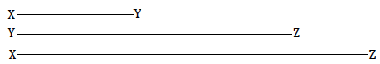



1. **is located below. Copy the sides of the triangle to create . Use your compass to determine the sides of . Use your ruler to measure side lengths. Leave all construction marks as evidence of your work, and label all side and angle measurements.**

MP.5

**Under what condition is drawn? Compare the triangle you drew to two of your peers’ triangles. Are the triangles identical? Did the condition determine a unique triangle? Use your construction to explain why.**

**The condition on is the three side lengths. All of the triangles are identical; the condition determined a unique triangle. After drawing the longest side length, I used the compass to locate the third vertex of the triangle by drawing two circles, one with a radius of the smallest side length and the other with a radius of the medium side length. Each circle was centered at one end of the longest side length. Two possible locations were determined by the intersections of the circles, but both determined the same triangle. One is just a flipped version of the other. The three sides condition determined a unique triangle.**

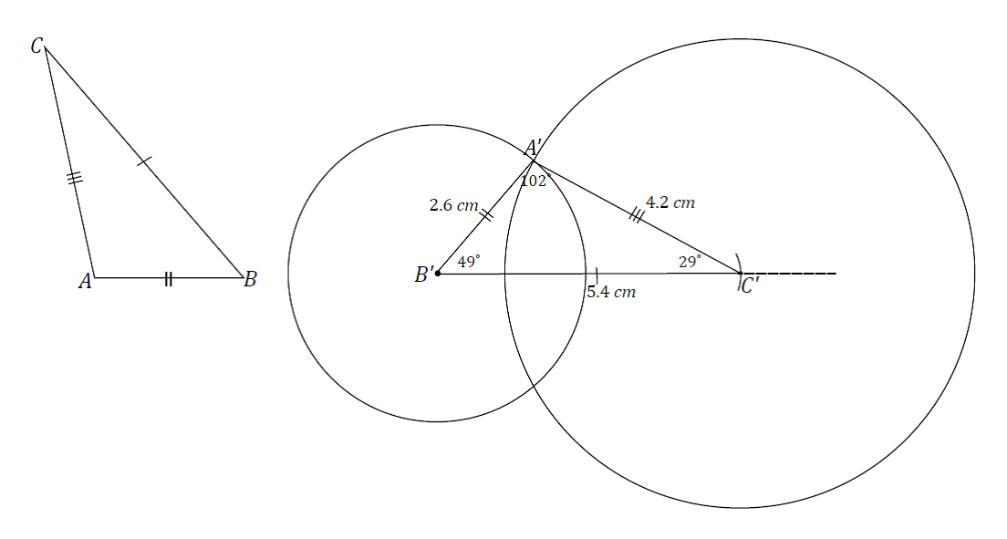

1. **A triangle has an angle of adjacent to side lengths of cm and cm. Construct with side lengths cm, cm, and included angle . Use your compass to draw the sides of . Use your ruler to measure side lengths. Leave all construction marks as evidence of your work, and label all side and angle measurements.**

**Under what condition is drawn? Compare the triangle you drew to two of your peers’ triangles. Did the condition determine a unique triangle? Use your construction to explain why.**

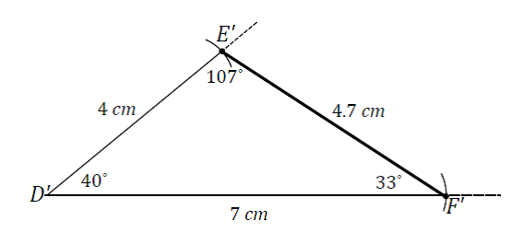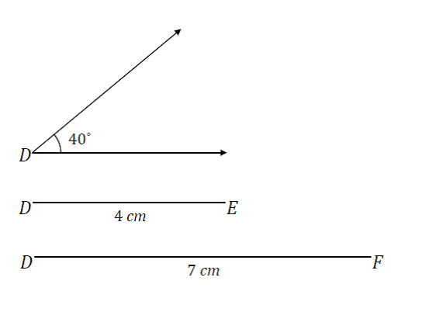**The condition on is two side lengths and the included angle measurement. All of the triangles are identical; the condition determined a unique triangle. Once the angle is drawn and the cm and cm side lengths are marked off on the rays of the angle, there is only one place the third side of the triangle can be. Therefore, all triangles drawn under this condition will be identical. Switching the cm and cm sides also gives a triangle satisfying the conditions, but it is just a flipped version of the other.**

*Scaffolding:*

Consider providing students with manipulatives (e.g., paperclips for angles) with which to build the triangle.

1. **has side lengths cm, cm, and . Draw under the same conditions. Use your compass and protractor to draw the sides of . Use your ruler to measure side lengths. Leave all construction marks as evidence of your work, and label all side and angle measurements.**

MP.5

**Under what condition is drawn? Compare the triangle you drew to two of your peers’ triangles. Are the triangles identical? Did the condition determine a unique triangle? Use your construction to explain why.**

**The condition on is two side lengths and the included angle measurement. The triangle is identical to other triangles drawn under this condition; the conditions produced a unique triangle. Once the angle is drawn and the cm and cm side lengths are marked off on the rays of the angle, there is only one place the third side of the triangle can be. Therefore, all triangles drawn under these conditions will be identical. Switching the cm and   
 cm sides also gives a triangle satisfying the conditions, but it is just a flipped version of the other.**

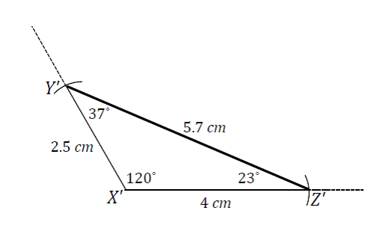

**Discussion (10 minutes)**

Review responses as a whole group, either by sharing out responses from each group or by doing a gallery walk. Consider asking students to write a reflection on the conclusions they reached, either before or after the discussion.

In Lesson 8, students discovered that depending on the condition provided, it is possible to produce many non-identical triangles, a few non-identical triangles, and sometimes identical triangles. The question posed at the close of the lesson asked what kinds of conditions produce identical triangles; in other words, determine a unique triangle. The examples in the Exploratory Challenge demonstrate how the three sides condition and the two sides and included angle condition always determine a unique triangle.

* One of the conditions we saw in Lesson 8 provided two angles and a side, by which a maximum of three non-identical triangles could be drawn. Today, we saw that two sides and an included angle determine a single, unique triangle. What differences exist between these two sets of conditions?
  + *The condition from Lesson 8, two angles and a side, involves different parts of a triangle from the condition in Lesson 9, two sides and an angle. Furthermore, the conditions in Lesson 8 also have a specific arrangement. The angle is specified to be between the sides, while there was no specification for the arrangement of the parts in the condition from Lesson 9.*
* Does the arrangement of the parts play a role in determining whether provided conditions determine a unique triangle?
  + *It seems like it might, but we will have to test out other pieces and other arrangements to be sure.*

Closing (1 minute)

* By drawing triangles under the three sides condition and the two sides and an included angle condition, we saw that there is only one way to draw triangles under each of the conditions, which determines a unique triangle.
* The term *diagonal* is used for several Problem Set questions. Alert students to expect this and review the definition:

In a quadrilateral , the segments and are called the diagonals of the quadrilateral.

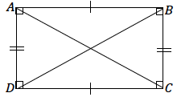

Exit Ticket (4 minutes)

Name Date

Lesson 9: Conditions for a Unique Triangle—Three Sides and Two Sides and the Included Angle

Exit Ticket

Choose either the three sides condition or the two sides and included angle condition, and explain why the condition determines a unique triangle.

Exit Ticket Sample Solutions

Choose either the three sides condition or the two sides and included angle condition, and explain why the condition determines a unique triangle.

In drawing a triangle with three provided side lengths, there is only one way to draw the triangle. Once one length is drawn, the other two lengths are used to draw circles with the lengths as the respective radii of each circle, centered at either end of the segment drawn first. Regardless of which order of segments is used, there is only one unique triangle that can be drawn.

In drawing a triangle with two side lengths and included angle provided, there is only one way to draw the triangle. Once the angle is drawn and the two side lengths are marked off on the rays of the angle, there is only one possible place to position the third side of the triangle, which also determines the two remaining angle measures of the triangle. Therefore, the two sides and included angle condition determines a unique triangle.

Problem Set Sample Solutions

1. **A triangle with side lengths cm, cm, and cm exists. Use your compass and ruler to draw a triangle with the same side lengths. Leave all construction marks as evidence of your work, and label all side and angle measurements.**

**Under what condition is the triangle drawn? Compare the triangle you drew to two of your peers’ triangles. Are the triangles identical? Did the condition determine a unique triangle? Use your construction to explain why.**

**The triangles are identical; the condition determined a unique triangle. After drawing the longest side length, I used the compass to locate the third vertex of the triangle by drawing two circles, one with a radius of the smallest side length and the other with a radius of the medium side length. Each circle was centered at one end of the longest side length. Two possible locations were determined by the intersections of the circles, but both determined the same triangle; one is just a flipped version of the other. The three sides condition determined a unique triangle.**

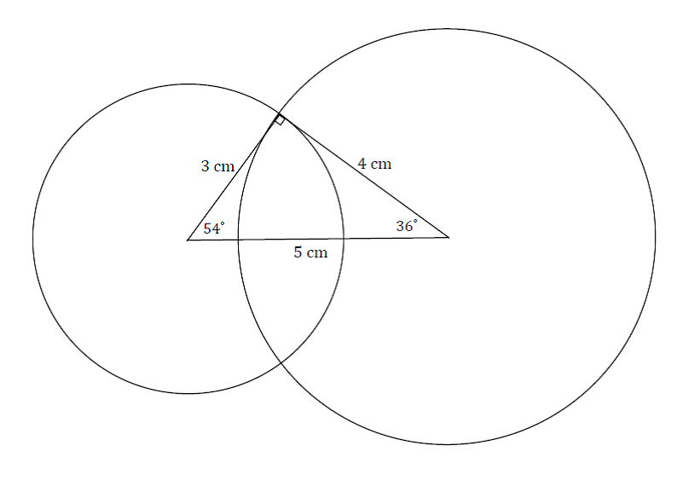

1. Draw triangles under the conditions described below.
   1. A triangle has side lengths cm and cm. Draw two non-identical triangles that satisfy these conditions. Explain why your triangles are not identical.

Solutions will vary; check to see that the conditions are satisfied in each triangle. The triangles cannot be identical because there is no correspondence that will match equal corresponding sides and equal angles between the triangles.

* 1. A triangle has a side length of cm opposite a angle. Draw two non-identical triangles that satisfy these conditions. Explain why your triangles are not identical.

Solutions will vary; check to see that the conditions are satisfied in each triangle. The triangles cannot be identical because there is no correspondence that will match equal corresponding sides and equal angles between the triangles.

1. Diagonal is drawn in square . Describe what condition(s) can be used to justify that  **is identical to What can you say about the measures of and ? Support your answers with a diagram and explanation of the correspondence(s) that exists.**

Two possible conditions can be used to justify that  **is identical to** :

* **is identical to by the two sides and included angle condition. Since all four sides of a square are equal in length, and . All four angles in a square are right angles; therefore, they are equal in measurement: . The two sides and included angle condition is satisfied by the same measurements in both triangles. Since the two sides and included angle condition determines a unique triangle, must be identical to . The correspondence matches corresponding equal sides and corresponding angles. It matches with , so the two angles have equal measure and angle sum of ; therefore, each angle measures .**
* **is identical to by the three sides condition. Again, all four sides of the square are equal in length; therefore, , and . is a side to both and , and . The three sides condition is satisfied by the same measurements in both triangles. Since the three sides condition determines a unique triangle, must be identical to . The correspondence matches equal corresponding sides and equal corresponding angles. It matches with , so the two angles have equal measure and angle sum of ; therefore, each angle measures .**

1. Diagonals and are drawn in square . Show that  **is identical to , and** then use this information to show that the diagonals are equal in length.

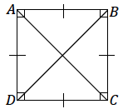Use the two sides and included angle condition to show **is identical to** ; then, use the **correspondence to conclude .**

**is identical to by the two sides and included angle condition. Since and determine the same line segment, . Since all four sides of a square are equal in length, then. All four angles in a square are right angles and are equal in measurement; therefore, . The two sides and included angle condition is satisfied by the same measurements in both triangles. Since the two sides and included angle condition determines a unique triangle, must be identical to . The correspondence matches corresponding equal sides and corresponding angles. It matches the diagonals and . Therefore, .**

1. Diagonal is drawn in rhombus . Describe the condition(s) that can be used to justify that  **is identical to . Can you conclude that the measures of and are the same? Support your answer with a diagram and explanation of the correspondence(s) that exists.**

 **is identical to by the three sides condition. All four sides of a rhombus are equal in length; therefore, and . is a side to both and , and . The three sides condition is satisfied by the same measurements in both triangles. Since the three sides condition determines a unique triangle, must be identical to . The correspondence matches equal corresponding sides and equal corresponding angles. The correspondence matches and ; therefore, they must have the same measure.**

1. Diagonals and are drawn in rhombus and meet at point . Describe the condition(s) that can be used to justify that  **is identical to . Can you conclude that the line segments**  and are perpendicular to each other?  **Support your answers with a diagram and explanation of the correspondence(s) that exists.**

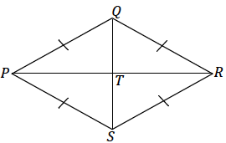 **is identical to by the two sides and included angle condition. All four sides of a rhombus are equal in length; therefore, . is a side to both and , and . Since**  lies on segment , then and . By Problem 5, , and the two sides and included angle condition is **satisfied by the same measurements in both triangles. Since the two sides and included angle condition determines a unique triangle, then must be identical to . The correspondence matches equal corresponding sides and equal corresponding angles. The correspondence matches and ; therefore, they must have the same measure. The angle sum of and is ; therefore, each angle is , and the diagonals are perpendicular to each other.**