|  |
| --- |
|  |

Lesson 7: Drawing Parallelograms

Student Outcomes

* Students use a protractor, ruler, and setsquare to draw parallelograms based on given conditions.

Lesson Notes

In Lesson 6, students drew a series of figures (e.g., complementary angles, vertical angles, circles of different radii, and isosceles triangles). In Lesson 7, students become familiar with a geometry tool known as the setsquare and use it to draw parallelograms under a variety of conditions.

Similar to the previous lesson, students should have experience using tools and experience making comparisons between drawings done with tools and drawings done freehand. Work in this lesson embodies Mathematical Practice 5.

Classwork

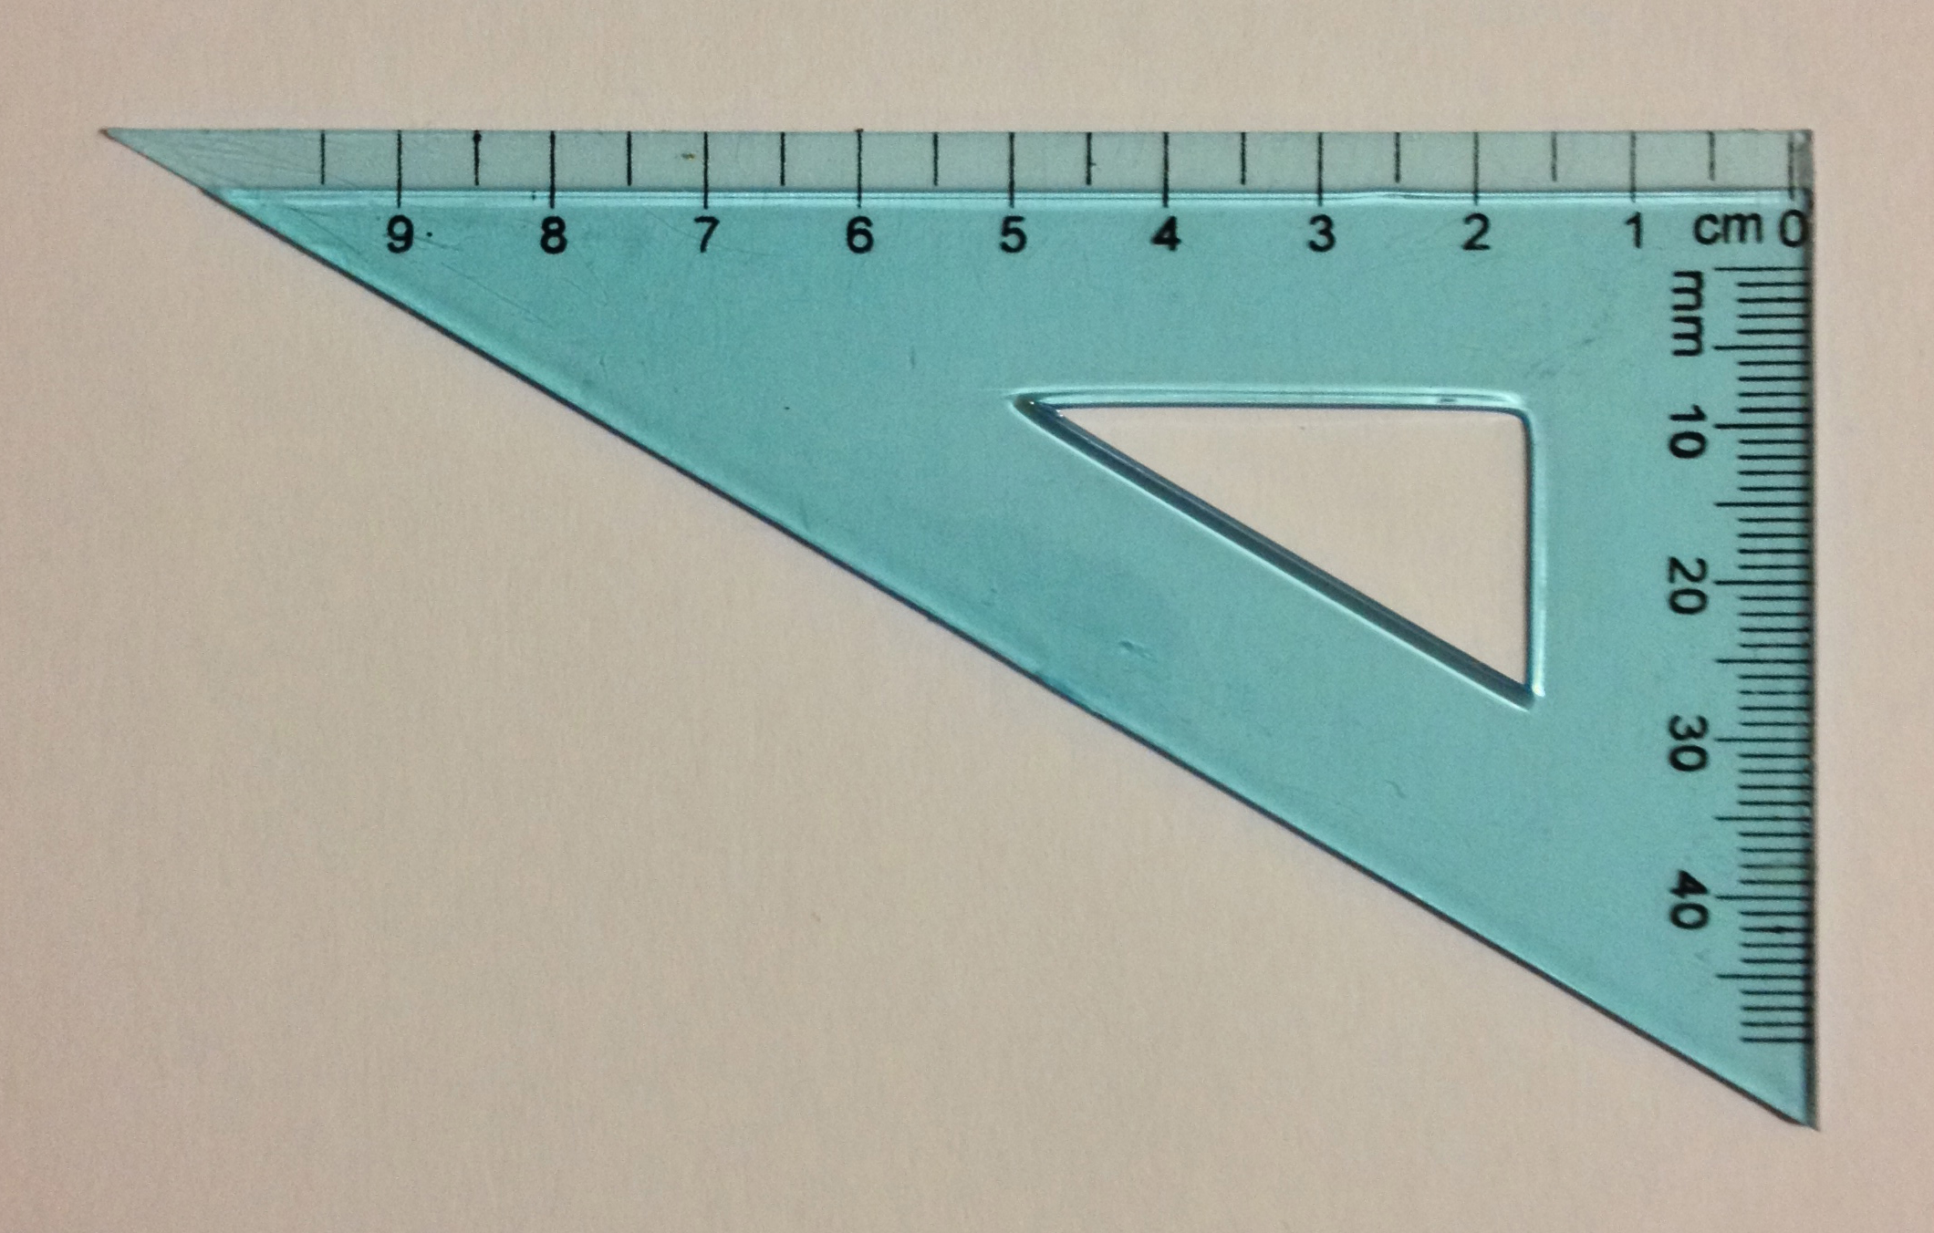Opening (5 minutes)

A setsquare is a triangle with a right angle. It can be made out of plastic or out of paper. Have students create their own setsquares out of paper or cardstock.

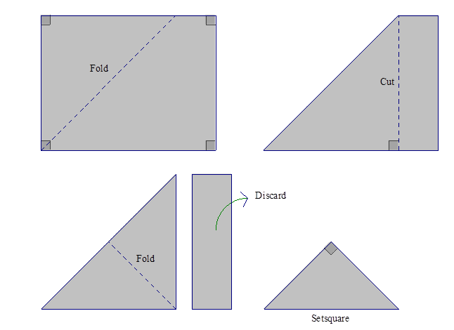

Place tape on the edges of your setsquare.

Have students use a setsquare and a ruler to check if lines are parallel.

We want to determine whether these lines are parallel.

Identify the two sides of the setsquare that meet at the right angle as shown, and . Place the ruler against and align with one of the two lines. Notice that the ruler must be perpendicular to line.

Slide the setsquare along the ruler. Try to line up with the other line. If the edge of the setsquare aligns with the line, the two lines are parallel. If the edge of the setsquare does not align with the line, then the two lines are not parallel.

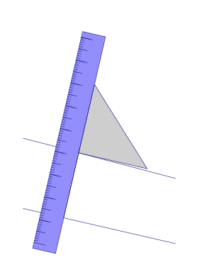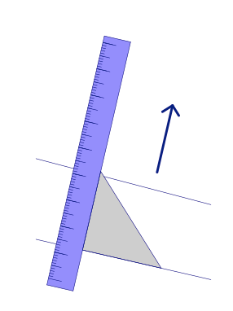

Have students use a setsquare and ruler to draw a line parallel to through the point .

We want to draw a line through parallel to . Align with .

Slide the setsquare along the ruler until it is possible to draw a segment through along .

Use your ruler to extend the segment through . The two lines are parallel.

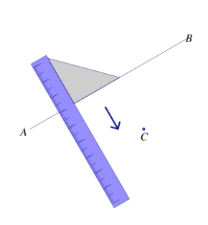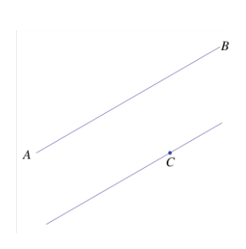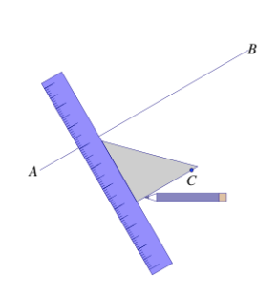

Example 1 (5 minutes)

*Scaffolding:*

Consider providing a visual reminder (e.g., a chart handout or poster) naming the quadrilaterals and their key properties.

Example 1

Use what you know about drawing parallel lines with a setsquare to draw rectangle with dimensions of your choice. State the steps you used to draw your rectangle, and compare those steps to those of a partner’s.

**Possible steps: Draw first. Align the setsquare so that one leg aligns with and place the ruler against the other leg of the setsquare; mark a point , cm away from . Draw a line parallel to through . Realign the setsquare with and situate the ruler so that it passes through and draw with a length of cm. is now drawn perpendicular to . Mark the intersection of the line through and the parallel line to as . Repeat the steps to determine.**

Example 2 (7 minutes)

Example 2

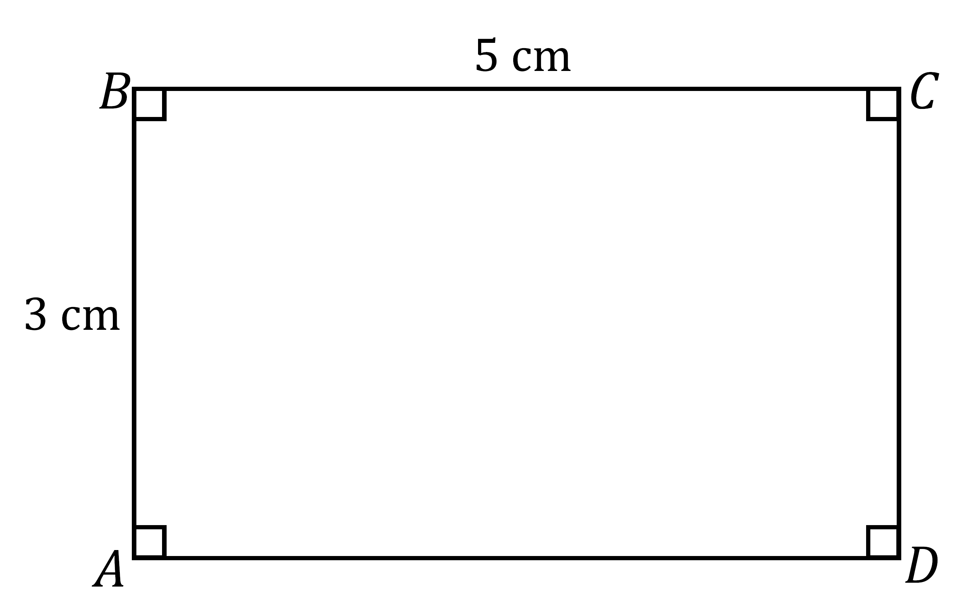Use what you know about drawing parallel lines with a setsquare to draw rectangle with cm and cm. Write a plan for the steps you will take to draw .

**Draw first. Align the setsquare so that one leg aligns with and place the ruler against the other leg of the setsquare; mark a point , cm away from . Draw a line parallel to through . To create the right angle at , align the setsquare so that the leg of the setsquare aligns with and situate the ruler so that the outer edge of the ruler passes through and draw a line through . Mark the intersection of the line through and the parallel line to as . Repeat the steps to determine.**

Make sure that students label all vertices, right angles and measurements. This example also provides an opportunity to review the definition of diagonal:

* In a quadrilateral , the segments and would be called the diagonals of the quadrilateral.

With respect to the solution, students will not respond (and are not expected to respond) with the level of detail found in the solution. The goal is to get them thinking about how they will use their newly acquired skills to draw a rectangle with the setsquare. Share the solution so they have exposure to the precision needed for clear instructions. Eventually, in Grade 10, students will write instructions so precise that a person who doesn’t know what a rectangle is would still be able to draw one by using the instructions.

Example 3 (7 minutes)

Example 3

Use a setsquare, ruler and protractor to draw parallelogram so that the measurement of , cm, the measurement of , and the altitude to is cm.

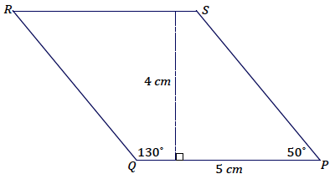**Steps to draw the figure: Draw first. Align the setsquare and ruler so one leg of the setsquare aligns with and mark a point , cm from . Slide the setsquare along the ruler so that one side of the setsquare passes through and draw a line through ; this line is parallel to . Using as one ray of** , draw so that the measurement of and that the ray intersects with the line parallel to (the intersection is ). Draw so that the measurement of ; the ray should be drawn to intersect with the line parallel to (the intersection is ).

Exercise 1 (6 minutes)

Exercise 1

Use a setsquare, ruler, and protractor to draw parallelogram so that the measurement of , cm, the measurement of , and the altitude to is cm.

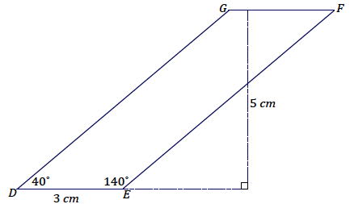**Steps to draw the figure: Draw first. Align the setsquare and ruler so one leg of the setsquare aligns with and mark a point , cm from . Slide the setsquare along the ruler so that one side of the setsquare passes through and draw a line through ; this line is parallel to . Using as one ray of** , draw so that the measurement of and that the ray intersects with the line parallel to (the intersection is ). Draw so that the measurement of ; the ray should be drawn to intersect with the line parallel to (the intersection is ).

Example 4 (7 minutes)

Example 4

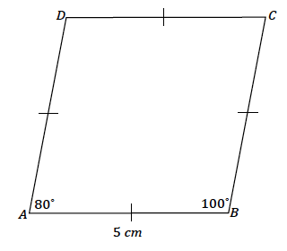Use a setsquare, ruler and protractor to draw rhombus so that the measurement of , the measurement of , and each side of the rhombus measures cm.

**Steps to draw the figure: Draw first. Using as one ray of** , draw so that the measurement of . The other ray, or the to-be side of the rhombus, , should be cm in length; label the endpoint of the segment as . Align the setsquare and ruler so one leg of the setsquare aligns with and the edge of the ruler passes through . Slide the setsquare along the ruler so that the edge of the setsquare passes through and draw a line along the edge of the setsquare. This line is parallel to . Now align the setsquare and ruler so one leg of the setsquare aligns with and the edge of the ruler passes through . Slide the setsquare along the ruler so that the edge of the setsquare passes through and draw a line along the edge of the setsquare. This line is parallel to . Along this line, measure a segment cm with as one endpoint, and label the other endpoint . Join to .

Closing (1 minute)

* Why are setsquares useful in drawing parallelograms?
* *They give us a means to draw parallel lines for the sides of parallelograms.*

Exit Ticket (6 minutes)

Name Date

Lesson 7: Drawing Parallelograms

Exit Ticket

Use what you know about drawing parallel lines with a setsquare to draw square with cm. Explain how you created your drawing.

Exit Ticket Sample Solutions

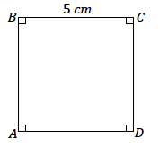Use what you know about drawing parallel lines with a setsquare to draw square with cm. Explain how you created your drawing.

**Draw (any side will do here) first. Align the setsquare and ruler so that one leg of the setsquare aligns with ; mark a point , cm away from . Draw a line parallel to through . To create the right angle at , align the setsquare so that the leg of the setsquare aligns with and situate the ruler so that the outer edge of the ruler passes through and draw a line through . Mark the intersection of the line through and the parallel line to as ; join and . Repeat the steps to determine and join and .**

Problem Set Sample Solutions

1. Draw rectangle with cm and cm.

**Steps to draw the figure: Draw first. Align the setsquare so that one leg aligns with and place the ruler against the other leg of the setsquare; mark a point, , cm away from . Draw a line parallel to through . To create the right angle at , align the setsquare so that its leg aligns with and situate the ruler so that the outer edge of the ruler passes through and draw a line through . Mark the intersection of the line through and the parallel line to as . Repeat the steps to determine.**

1. Use a setsquare, ruler and protractor to draw parallelogram so that the measurement of , cm, , and the altitude to is cm

**Steps to draw the figure: Draw first. Align the setsquare and ruler so one leg of the setsquare aligns with and mark a point, , cm from . Slide the setsquare along the ruler so that one side of the setsquare passes through and draw a line through ; this line is parallel to . Using as one ray of** , draw so that the measurement of and that the ray intersects with the line parallel to (the intersection is ). Draw so that the measurement of ; the ray should be drawn to intersect with the line parallel to (the intersection is ).

1. Use a setsquare, ruler and protractor to draw rhombus so that the measurement of , and each side of the rhombus measures cm.

**Steps to draw the figure: Draw first. Using as one ray of** , draw so that the measurement of . The other ray, or to-be side of the rhombus, , should be cm in length; label the endpoint of the segment as . Align the setsquare and ruler so one leg of the setsquare aligns with and the edge of the ruler passes through . Slide the setsquare along the ruler so that the edge of the setsquare passes through and draw a line along the edge of the setsquare. This line is parallel to . Now align the setsquare and ruler so one leg of the setsquare aligns with and the edge of the ruler passes through . Slide the setsquare along the ruler so that the edge of the setsquare passes through and draw a line along the edge of the setsquare. This line is parallel to . Along this line, measure a segment cm with as one endpoint, and label the other endpoint . Join to .

The following table contains partial information for a parallelogram . Using no tools, make a sketch of the parallelogram. Then use a ruler, protractor, and setsquare to draw an accurate picture.



|  |  |  |  |  |  |
| --- | --- | --- | --- | --- | --- |
|  |  |  | Altitude to |  | Altitude to |
|  |  | **cm** | cm | **cm** | cm |
|  |  | **cm** | cm | **cm** | cm |
|  |  | **cm** | **cm** | cm | cm |

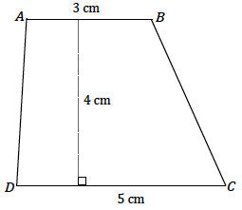

1. Use what you know about drawing parallel lines with a setsquare to draw trapezoid with parallel sides and . The length of is cm and the length of cm; the height between the parallel sides is cm. Write a plan for the steps you will take to draw .

**Draw (or ) first. Align the setsquare and ruler so that one leg of the setsquare aligns with ; mark a point , cm away from . Draw a line parallel to through . Once a line parallel to has been drawn through , measure a portion of the line to be** cm and label either endpoint **as and . Join to and to .**

1. Draw rectangle with cm and cm using appropriate tools.

**Draw first. Align the setsquare so that one leg aligns with and place the ruler against the other leg of the setsquare; mark a point, , cm away from . Draw a line parallel to through . To create the right angle at , align the setsquare so that its leg aligns with and situate the ruler so that its outer edge passes through , and then draw a line through . Mark the intersection of the line through and the parallel line to as . Repeat the steps to determine.**

1. Challenge: Determine the area of the largest rectangle that will fit inside an equilateral triangle with side length cm

Students will quickly discover that rectangles of different dimensions can be drawn; finding the ‘largest’ rectangle may take multiple efforts. The maximum possible area is cm2.

Supplement

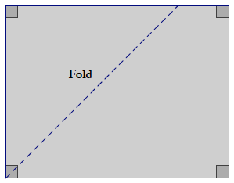

fold