Lesson 5: Identical Triangles

Classwork

Opening

When studying triangles, it is essential to be able to communicate about the parts of a triangle without any confusion. The following terms are used to identify particular angles or sides:

* between
* adjacent to
* opposite to
* the included [side/angle]

Opening Exercises 1–7

Use the figure △ABC to fill in the following blanks.

1. ∠A is ___________________ sides and .
2. ∠B is ___________________ to side and to side .
3. Side is ___________________ to .
4. Side ______ is the included side of and .
5. ______ is opposite to Side .
6. Side is between angles ______ and ______.
7. What is the included angle of and ?

Now that we know what to call the parts within a triangle, we consider how to discuss two triangles. We need to compare the parts of the triangles in a way that is easy to understand. To establish some alignment between the triangles, the vertices of the two triangles are paired up. This is called a correspondence. Specifically, a correspondence between two triangles is a pairing of each vertex of one triangle with one (and only one) vertex of the other triangle. A correspondence provides a systematic way to compare parts of two triangles.



**Figure 1**

In Figure 1, we can choose to assign a correspondence so that matches to , matches to , and matches to . We notate this correspondence with double-arrows: , , and . This is just one of six possible correspondences between the two triangles. Four of the six correspondences are listed below; find the remaining two correspondences.

|  |  |  |
| --- | --- | --- |
|  |  |  |
|  |  |  |

A simpler way to indicate the triangle correspondences is to let the order of the vertices define the correspondence; i.e., the first corresponds to the first, the second to the second, and the third to the third. The correspondences above can be written in this manner. Write the remaining two correspondences in this way.

|  |  |  |
| --- | --- | --- |
|  |  |  |
|  |  |  |

With a correspondence in place, comparisons can be made about corresponding sides and corresponding angles. The following are corresponding vertices, angles, and sides for the triangle correspondence . Complete the missing correspondences:

|  |  |  |  |
| --- | --- | --- | --- |
| Vertices: |  |  |  |
| Angles: |  |  |  |
| Sides: |  |  |  |

**Example 1**

|  |  |
| --- | --- |
| Triangle Correspondence |  |
| Correspondence of Vertices |  |
| Correspondence of Angles |  |
| Correspondence of Sides |  |

Examine Figure 2. By simply looking, it is impossible to tell the two triangles apart unless they are labeled. They look exactly the same (just as identical twins look the same). One triangle could be picked up and placed on top of the other.



Figure 2

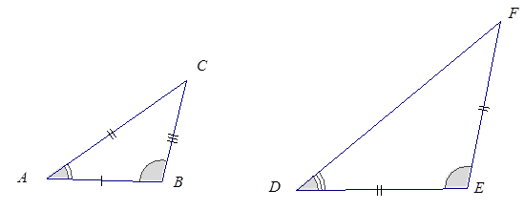Two triangles are identical if there is a triangle correspondence so that corresponding sides and angles of each triangle is equal in measurement. In Figure 2, there is a correspondence that will match up equal sides and equal angles, ; we can conclude that is identical to . This is not to say that we cannot find a correspondence in Figure 2 so that unequal sides and unequal angles are matched up, but there certainly is one correspondence that will match up angles with equal measurements and sides of equal lengths, making the triangles identical.

In discussing identical triangles, it is useful to have a way to indicate those sides and angles that are equal. We mark sides with tick marks and angles with arcs if we want to draw attention to them. If two angles or two sides have the same number of marks, it means they are equal.

In this figure, , and .

**Example 2**

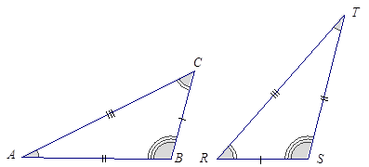Two identical triangles are shown below. Give a triangle correspondence that matches equal sides and equal angles.

Exercise 8

Sketch two triangles that have a correspondence. Describe the correspondence in symbols or words. Have a partner check your work.

Problem Set

Given the following triangle correspondences, use double arrows to show the correspondence between vertices, angles, and sides.

|  |  |
| --- | --- |
| Triangle Correspondence |  |
| Correspondence of Vertices |  |
| Correspondence of Angles |  |
| Correspondence of Sides |  |

|  |  |
| --- | --- |
| Triangle Correspondence |  |
| Correspondence of Vertices |  |
| Correspondence of Angles |  |
| Correspondence of Sides |  |

|  |  |
| --- | --- |
| Triangle Correspondence |  |
| Correspondence of Vertices |  |
| Correspondence of Angles |  |
| Correspondence of Sides |  |

Name the angle pairs and side pairs to find a triangle correspondence that matches sides of equal length and angles of equal angles measurements.

1. 
2. 



1. Consider the following points in the coordinate plane.
   1. How many different (non-identical) triangles can be drawn using any three of these six points as vertices?
   2. How can we be sure that there are no more possible triangles?
2. Quadrilateral is identical with Quadrilateral with a correspondence , , and .
   1. In the figure below, label points , , , and on the second quadrilateral.

*A*



* 1. Set up a correspondence between the side lengths of the two quadrilaterals that matches sides of equal length.
  2. Set up a correspondence between the angles of the two quadrilaterals that matches angles of equal measure.