|  |
| --- |
|  |

Lesson 5: Identical Triangles

Student Outcomes

* Students use a triangle correspondence to recognize when two triangles match identically.
* Students use notation to denote a triangle correspondence and use the triangle correspondence to talk about corresponding angles and sides.
* Students are able to label equal angles and sides of triangles with multiple arcs or tic marks.

Lesson Notes

This lesson provides a basis for identifying two triangles as *identical*. To clearly define triangles as identical, students must understand what a triangle correspondence is and be able to manipulate the relevant notation and terminology. Once this is addressed, students have the means, specifically the language, to discuss what makes a triangle unique in Lesson 7 and forward. Exercise 5 in the Problem Set is designed as an exploratory challenge; it is not expected that students develop an exact answer at this level.

Classwork

Opening (2 minutes)

Opening

When studying triangles, it is essential to be able to communicate about the parts of a triangle without any confusion. The following terms are used to identify particular angles or sides:

* between
* adjacent to
* opposite to
* the included [side/angle]

Opening Exercises 1–7 (15 minutes)

**Opening Exercises 1–7**

**Use the figure to fill in the following blanks.**

1. **is __ *between* ____ sides and .**
2. **is ___ *adjacent* _____ to side and to side .**

MP.6

1. **Side is ___ *opposite* _____ to .**
2. **Side __ __ is the included side of and .**
3. **is opposite to Side .**

MP.6

1. **Side is between angles and .**
2. **What is the included angle of and ? .**

**Now that we know what to call the parts within a triangle, we consider how to discuss two triangles. We need to compare the parts of the triangles in a way that is easy to understand. To establish some alignment between the triangles, the vertices of the two triangles are paired up. This is called a correspondence. Specifically, a correspondence between two triangles is a pairing of each vertex of one triangle with one (and only one) vertex of the other triangle. A correspondence provides a systematic way to compare parts of two triangles.**



**Figure 1**

**In Figure 1, we can choose to assign a correspondence so that matches to , matches to , and matches to . We notate this correspondence with double-arrows: , , and . This is just one of six possible correspondences between the two triangles. Four of the six correspondences are listed below; find the remaining two correspondences.**

|  |  |  |
| --- | --- | --- |
|  |  |  |
|  |  |  |

**A simpler way to indicate the triangle correspondences is to let the order of the vertices define the correspondence; i.e., the first corresponds to the first, the second to the second, and the third to the third. The correspondences above can be written in this manner. Write the remaining two correspondences in this way.**

|  |  |  |
| --- | --- | --- |
|  |  |  |
|  |  |  |

Students have already been exposed to a correspondence without knowing the formal use of the word.  The correspondence between numerical coordinates and geometric points allows methods from algebra to be applied to geometry.  The correspondence between a figure in a scale drawing and the corresponding figure in a scale drawing allows students to compute actual lengths and areas from the scale drawing. In Grade 8, students will learn that figures are congruent when there is a transformation that makes a correspondence between the two figures.  The idea of a correspondence lays the foundation for the understanding of functions that will be discussed in Grade 9.

**Discussion (5 minutes)**

Review the remaining two correspondences that students filled out in both tables.

* Why do we bother setting up a correspondence?
  + *A correspondence provides a systematic way to compare parts of two triangles. Without a correspondence, it would be difficult to discuss the parts of a triangle because we would have no way of referring to particular sides, angles, or vertices.*
* Assume the correspondence. What can be concluded about the vertices?
  + *Vertex corresponds to , corresponds to , and corresponds to .*
* How is it possible for any two triangles to have a total of six correspondences?
  + *The first vertex can be matched with any of three vertices. Then, the second vertex can be matched with any of the remaining two vertices.*

**With a correspondence in place, comparisons can be made about corresponding sides and corresponding angles. The following are corresponding vertices, angles, and sides for the triangle correspondence . Complete the missing correspondences:**

|  |  |  |  |
| --- | --- | --- | --- |
| **Vertices:** |  |  |  |
| **Angles:** |  |  |  |
| **Sides:** |  |  |  |

Example 1 (5 minutes)

Example 1

Given the following triangle correspondences, use double arrows to show the correspondence between vertices, angles, and sides.

|  |  |
| --- | --- |
| Triangle Correspondence |  |
| Correspondence of Vertices |  |
| Correspondence of Angles |  |
| Correspondence of Sides |  |

**Examine Figure 2. By simply looking, it is impossible to tell the two triangles apart unless they are labeled. They look exactly the same (just as identical twins look the same). One triangle could be picked up and placed on top of the other.**



Figure 2

**Two triangles are identical if there is a triangle correspondence so that corresponding sides and angles of each triangle is equal in measurement. In Figure 2, there is a correspondence that will match up equal sides and equal angles, ; we can conclude that is identical to . This is not to say that we cannot find a correspondence in Figure 2 so that unequal sides and unequal angles are matched up, but there certainly is one correspondence that will match up angles with equal measurements and sides of equal lengths, making the triangles identical.**

**Discussion (5 minutes)**

In Figure 2, is identical to .

* Which side is equal in measurement to ? Justify your response.
  + *because it is known that the triangle correspondence matches equal sides and equal angles.*
* Which angle is equal in measurement to ? Justify your response.
  + *because it is known that the triangle correspondence matches equal sides and equal angles.*

In discussing identical triangles, it is useful to have a way to indicate those sides and angles that are equal. We mark sides with tick marks and angles with arcs if we want to draw attention to them. If two angles or two sides have the same number of marks, it means they are equal.

In this figure, , and **.**

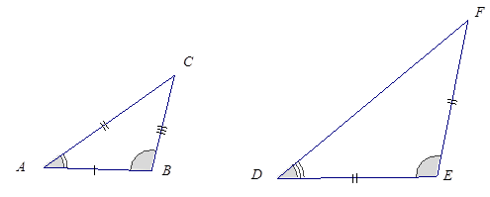

Example 2 (3 minutes)

*Scaffolding:*

Triangle cardstock cut-outs may facilitate the process of determining a correspondence. Find this image in the supplement to Lesson 5 in a size large enough to cut out.

Example 2

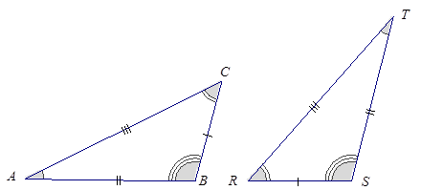Two identical triangles are shown below. Give a triangle correspondence that matches equal sides and equal angles.

Exercise 8 (3 minutes)

Exercise 8

1. Sketch two triangles that have a correspondence. Describe the correspondence in symbols or words. Have a partner check your work.

Answers will vary. Encourage students to check for correct use of notation and correctly made correspondences.

Vocabulary

**Correspondence:** A *correspondence* between two triangles is a pairing of each vertex of one triangle with one (and only one) vertex of the other triangle.

If , Y, and is a correspondence between two triangles (written ), then matches , side matches side , and so on.

Closing (2 minutes)

* Two triangles and their respective parts can be compared once a correspondence has been assigned to the two triangles. Once a correspondence is selected, corresponding sides and corresponding angles can also be determined.
* Corresponding vertices are notated by double arrows; triangle correspondences can also be notated with double arrows.
* Triangles are identical if there is a correspondence so that corresponding sides and angles are equal.
* An equal number of tick marks on two different sides indicates the sides are equal in measurement. An equal number of arcs on two different angles indicates the angles are equal in measurement.

Exit Ticket (5 minutes)

Name Date

Lesson 5: Identical Triangles

Exit Ticket

1. The following triangles are identical and have the correspondence . Find the measurements for each of the following sides and angles.

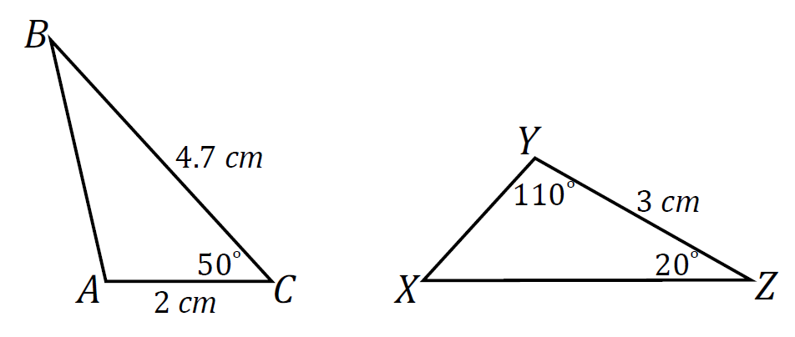

________

________

________

________

________

________

1. Explain why correspondences are useful.

Exit Ticket Sample Solutions

1. The following triangles are identical and have the correspondence . Find the measurements for each of the following sides and angles.

* cm*

*cm*

*cm*

1. Explain why correspondences are useful.

*A correspondence allows a systematic way to compare parts of two triangles. We can make statements about similarities or differences between two triangles using a correspondence, whereas without one we would not have a reference system to make such comparisons.*

Problem Set Sample Solutions

Given the following triangle correspondences, use double arrows to show the correspondence between vertices, angles, and sides.

|  |  |
| --- | --- |
| Triangle Correspondence |  |
| Correspondence of Vertices |  |
| Correspondence of Angles |  |
| Correspondence of Sides |  |

|  |  |
| --- | --- |
| Triangle Correspondence |  |
| Correspondence of Vertices |  |
| Correspondence of Angles |  |
| Correspondence of Sides |  |

|  |  |
| --- | --- |
| Triangle Correspondence |  |
| Correspondence of Vertices |  |
| Correspondence of Angles |  |
| Correspondence of Sides |  |

Name the angle pairs and side pairs to find a triangle correspondence that matches sides of equal length and angles of equal angles measurements.

|  |  |  |
| --- | --- | --- |
|  |  |  |
|  |  |  |
|  | | |



|  |  |  |
| --- | --- | --- |
|  |  |  |
|  |  |  |
|  | | |



1. 

|  |  |  |
| --- | --- | --- |
|  |  |  |
|  |  |  |
|  | | |

1. Consider the following points in the coordinate plane.
   1. How many different (non-identical) triangles can be drawn using any three of these six points as vertices?

There are a total of triangles, but only different triangles. Each triangle is identical with one of these four:

   

* 1. How can we be sure that there are no more possible triangles?

Any other triangle will have a correspondence so that equal sides and angles of equal measurement can be lined up (i.e., one can be laid over another and the two triangles will match).

1. Quadrilateral is identical with Quadrilateral with a correspondence ,, , and .

*A*



* 1. In the figure below, label points , , , and on the second quadrilateral.
  2. Set up a correspondence between the side lengths of the two quadrilaterals that matches sides of equal length.

, , , and

* 1. Set up a correspondence between the angles of the two quadrilaterals that matches angles of equal measure.

, , , and

Example 2 Scaffolding Supplement

