Topic E
Two- and Three-Digit Measurement Subtraction Using the Standard Algorithm
3.NBT.2, 3.NBT.1, 3.MD.1, 3.MD.2
Focus Standard: | 3.NBT.2 | Fluently add and subtract within 1000 using strategies and algorithms based on place value, properties of operations, and/or the relationship between addition and subtraction.
Instructional Days: | 4
Coherence -Links from: | G2–M2 | Addition and Subtraction with Length Units
 | G2–M5 | Addition and Subtraction Within 1000 with Word Problems to 100
-Links to: | G4–M1 | Place Value, Rounding, and Algorithms for Addition and Subtraction
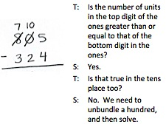
Students work with the standard algorithm for subtraction in Topic E. As in Topic D, they use two- and three-digit metric measurements and intervals of minutes within 1 hour to subtract. The sequence of complexity that builds from Lessons 18–20 mirrors the progression used for teaching addition. In Lesson 18, students begin by decomposing once to subtract, modeling their work on the place value chart. They use three-digit minuends that may contain zeros in the tens or ones place. Students move away from the magnifying glass method used in Grade 2 (see Grade 2, Module 4) but continue to prepare numbers for subtraction by decomposing all necessary digits before performing the operation. By the end of the lesson, they are less reliant on the model of the place value chart and practice using the algorithm with greater confidence.

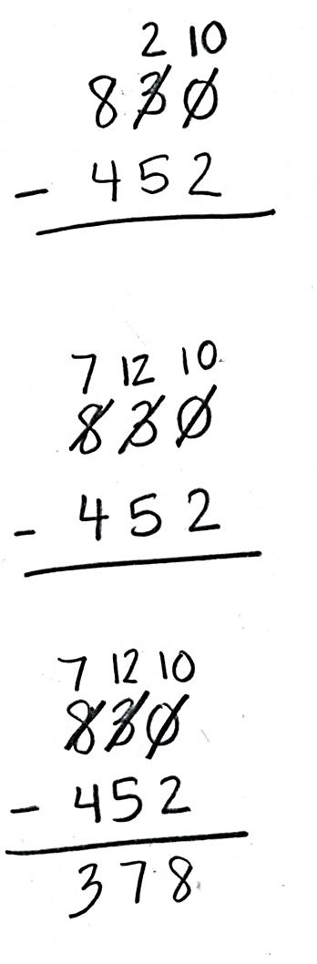
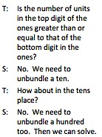
Lesson 19 adds the complexity of decomposing twice to subtract. Minuends may include numbers that contain zeros in the tens and ones places. Lesson 20 consolidates the learning from the two prior lessons by engaging students in problem solving with measurements using the subtraction algorithm. As in Lesson 17, the students draw to model problems, round to estimate differences, and use the algorithm to subtract precisely. They compare estimates with solutions and assess the reasonableness of their answers.
Lesson 21 synthesizes the skills learned in the second half of the module. Students round to estimate the sums and differences of measurements in word problem contexts. They draw to model problems and apply the algorithms to solve each case introduced in Topics D and E precisely. As in previous lessons, students use their estimates to reason about their solutions.
A Teaching Sequence Towards Mastery of Two- and Three-Digit Measurement Subtraction Using the Standard Algorithm
Objective 1: Decompose once to subtract measurements including three-digit minuends with zeros in the tens or ones place.
(Lesson 18)
Objective 2: Decompose twice to subtract measurements including three-digit minuends with zeros in the tens and ones places.
(Lesson 19)
Objective 3: Estimate differences by rounding and apply to solve measurement word problems.
(Lesson 20)
Objective 4: Estimate sums and differences of measurements by rounding, and then solve mixed word problems.
(Lesson 21)

