Topic A
Time Measurement and Problem Solving
3.NBT.2, 3.MD.1
Focus Standard: | 3.NBT.2 | Fluently add and subtract within 1000 using strategies and algorithms based on place value, properties of operations, and/or the relationship between addition and subtraction.
 | 3.MD.1 | Tell and write time to the nearest minute and measure time intervals in minutes. Solve word problems involving addition and subtraction of time intervals in minutes, e.g., by representing the problem on a number line diagram.
Instructional Days: | 5
Coherence -Links from: | G2–M2 | Addition and Subtraction of Length Units
-Links to: | G4–M2 | Unit Conversions and Problem Solving with Metric Measurement
Lesson 1 is an exploration in which students use stopwatches to measure time as a physical quantity. They might, for example, time how long it takes to write the fact 7 × 8 = 56 forty times or measure how long it takes to write numbers from 0 to 100. Students time their own segments as they run a relay, exploring the continuity of time by contextualizing their small segment within the number of minutes it takes the whole team to run.
Lesson 2 builds students’ understanding of time as a continuous unit of measurement. This lesson draws upon the Grade 2 skill of telling time to the nearest 5 minutes (2.MD.7) and the multiplication learned in Module 1 as students relate skip-counting by fives and telling time to the number line. They learn to draw the model, labeling hours as endpoints and multiples of 5 (shown below). Through this work, students recognize the analog clock as a portion of the number line shaped into a circle, and, from this point on, use the number line as a tool for modeling and solving problems.
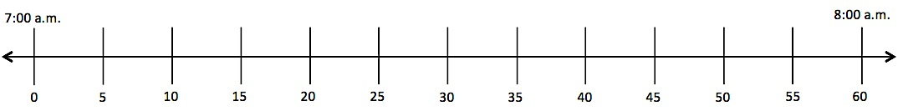

Lesson 3 increases students’ level of precision as they read and write time to the nearest minute. Students draw number line models that represent the minutes between multiples of 5 (number line model shown below). They quickly learn to apply the strategy of counting by fives and some ones to read time to the nearest minute on the clock. In preparation for Lessons 4 and 5, students add minutes by counting on the number line and clock. For example, they might use the count by fives and some ones strategy to locate 17 minutes and then keep counting to find 4 minutes more.
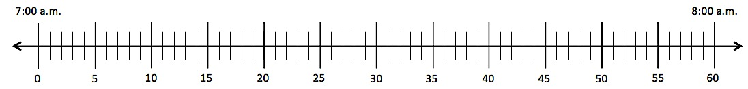

In Lesson 4, students begin measuring time intervals in minutes within 1 hour to solve word problems. They reinforce their understanding of time as a continuous unit of measurement by counting forward and backward using the number line and the clock. They might solve, for example, a problem such as, “Beth leaves her house at 8:05 a.m. and arrives at school at 8:27 a.m. How many minutes does Beth spend traveling to school?”
Lesson 5 carries problem solving with time a step further. Students measure minute intervals and then add and subtract the intervals to solve problems. Students might solve problems such as, “I practiced the piano for 25 minutes and the clarinet for 30 minutes. How long did I spend practicing my instruments?” Calculations with time in this lesson—and throughout Grade 3—never cross over an hour or involve students converting between hours and minutes.
A Teaching Sequence Towards Mastery of Time Measurement and Problem Solving
Objective 1: Explore time as a continuous measurement using a stopwatch.
(Lesson 1)
Objective 2: Relate skip-counting by fives on the clock and telling time to a continuous measurement model, the number line.
(Lesson 2)
Objective 3: Count by fives and ones on the number line as a strategy to tell time to the nearest minute on the clock.
(Lesson 3)
Objective 4: Solve word problems involving time intervals within 1 hour by counting backward and forward using the number line and clock.
(Lesson 4)
Objective 5: Solve word problems involving time intervals within 1 hour by adding and subtracting on the number line.
(Lesson 5)

