Lesson 14
Objective: Model numbers with more than 9 ones or 9 tens; write in expanded, unit, standard, and word forms.

Suggested Lesson Structure
 Fluency Practice (10 minutes)
 Application Problem (12 minutes)
 Concept Development (28 minutes)
 Student Debrief (10 minutes)
Total Time (60 minutes)
Fluency Practice (10 minutes)
- Sprint: Review of Subtraction in the Teens 2.OA.2 (8 minutes)
- Happy Counting Up and Down by Ones Crossing 100 2.NBT.2 (2 minutes)
Sprint: Review of Subtraction in the Teens (8 minutes)
Materials (S) Review of Subtraction in the Teens Sprint
Happy Counting Up and Down by Ones Crossing 100 (2 minutes)
T: Let’s play Happy Counting!
T: Watch my fingers to know whether to count up or down. A closed hand means stop. (Show signals as you explain.)
T: We’ll count by ones, starting at 76. Ready? (Rhythmically point up until a change is desired.
Show a closed hand then point down. Continue, mixing it up.)
S: 76, 77, 78, 79, 80, 81 (stop). 80, 79, 78 (stop). 79, 80, 81, 82, 83, 84, 85, 86, 87, 88, 89, 90, 91, 92 (stop). 91, 90, 89, 88, 87 (stop). 88, 89, 90, 91, 92, 93, 94, 95 (stop). 94, 93 (stop). 94, 95, 96, 97, 98, 99, 100, 101, 102, 103 (stop). 102, 101, 100, 99, 98 (stop). 99, 100, 101, 102, 103, 104, 105, 106.
Application Problem (12 minutes)
A second grade class has 23 students. What is the total number of fingers of all the students?
T: Read this problem with me.

NOTES ON
MULTIPLE MEANS
OF ACTION AND EXPRESSION:
Adjust the number or the task to challenge students working above grade level. Below are two suggestions for extending the problem:
- A second-grade class has 23 students. What is the total number of fingers of the students? What is the total number of toes? How many fingers and toes are there altogether?
- A second-grade class has 23 students. What is the total number of fingers of the students? How many more students need to join the class so that there are 300 student fingers in all?

T: I’m very curious to see what you’ll draw to solve this! Talk with your partner to share ideas, and then I’ll give you two minutes to draw and label your picture.
T: (Allow several minutes.) Who would like to share their thinking?
S: I drew 23 circles to be the 23 students. Then, I put the number 10 in each to be the 10 fingers for everybody. Then, I skip-counted by tens and got to 230. I drew 23 ten-disks because each student has 10 fingers. Then, I circled 1 group of 10 circles and wrote 100 because 10 tens equals 100. Then, I circled another group of 10 circles. That made 200. And, there were 3 tens left, which is 30. So, the answer is 230.
T: 230 what?
S: 230 fingers!
T: Why is it easier to draw 23 ten-disks than, say, 23 sets of hands?
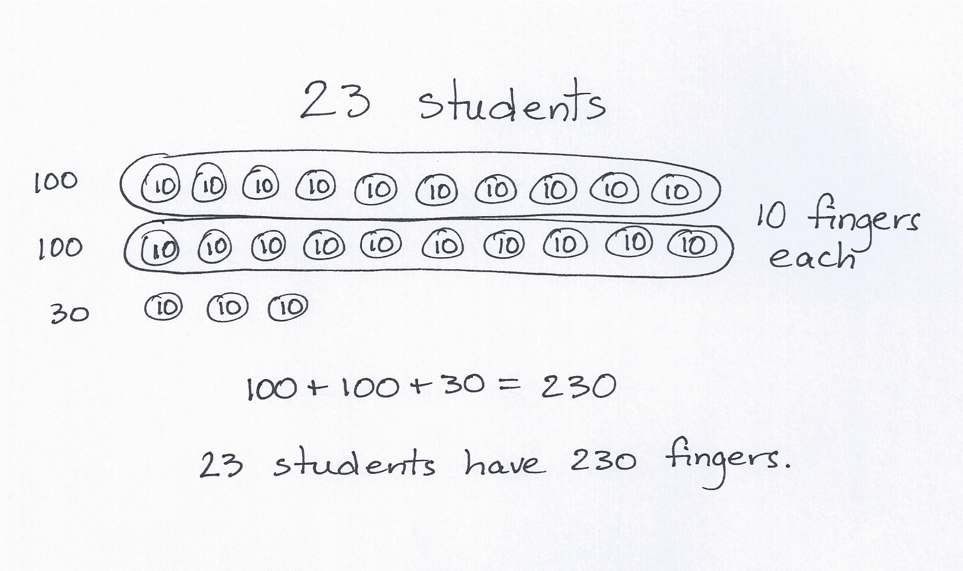
S: It’s faster! It takes longer to draw two hands for every student instead of just 1 circle for each student.
T: Good reasoning! It’s good to be fast if you can be accurate, but it’s also important to use a strategy that makes sense to you.
T: So, how many fingers do 23 students have?
S: 23 students have 230 fingers!
T: Please add that statement to your paper.

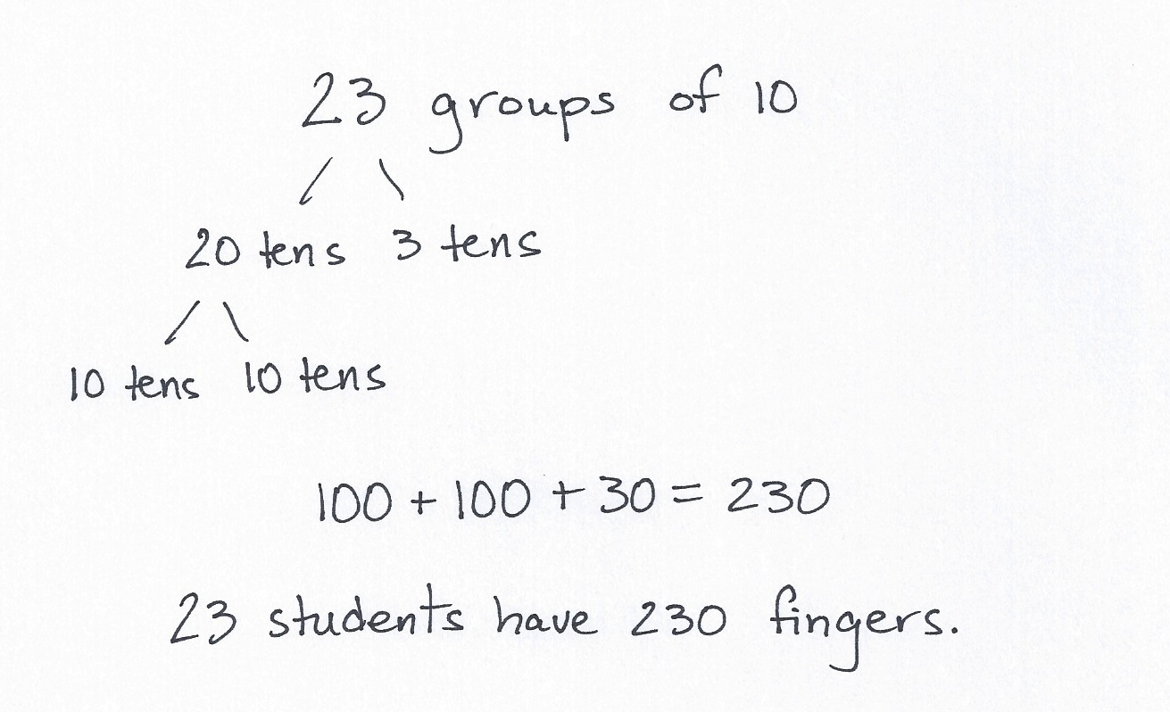
Concept Development (28 minutes)
Materials: (S) Place value disks (9 hundreds, 15 tens, 15 ones), unlabeled hundreds place value chart (Lesson 8 Template)
T: Slide the place value chart inside your personal white boards.
T: On your place value chart, show me the number 14.
S: (Show.)
T: What disks did you use from greatest to smallest?
S: 1 ten and 4 ones.
T: Change 1 ten for 10 ones. (Pause as students work.) What disks did you use this time?
S: 14 ones.
T: Discuss with your partner why this statement is true. (Silently write 1 ten 2 ones = 12 ones.)
S: Yes, it is true. It’s true because 1 ten is 10 ones and 10 + 2 is 12 ones. Yes, but my teacher said you can’t have more than 9 ones. It’s okay to use more. It’s just faster to use a ten.
T: Show me the number 140 with your disks.
S: (Show.)
T: What place value disks did you use from greatest to smallest?
S: 1 hundred 4 tens.
T: Change 1 hundred for 10 tens. (Pause as students work.) What disks did you use this time?
S: 14 tens.
T: Touch and count by tens to find the total value of your tens.
S: 10, 20, 30, 40, 50, 60, 70, 80, 90, 100, 110, 120, 130, 140.
T: What is the value of 14 tens? Answer in a full sentence, “The value of 14 tens is….”
S: The value of 14 tens is 140.
T: Discuss why this statement is true with your partner. (Silently write: 1 hundred 4 tens = 14 tens.)
T: Now, discuss with your partner why this is true. (Silently write: 14 tens = 140 ones.)
T: Show me the number 512.
T: What disks did you use?
S: 5 hundreds 1 ten 2 ones.
T: Change 1 ten for 10 ones. (Pause as students work.) What disks did you use?
S: 5 hundreds 12 ones.
T: Discuss why the statement is true. (Write 5 hundreds 1 ten 2 ones = 5 hundreds 12 ones.
Continue with more guided examples if necessary with a small group.)
T: Let’s try some more. First model A and then B. Tell the total value of each number you model.

A B
1 hundred 5 tens 2 ones 15 tens 2 ones
11 tens 1 hundred 1 ten
1 ten 3 ones 13 ones
12 tens 9 ones 1 hundred 2 tens 9 ones

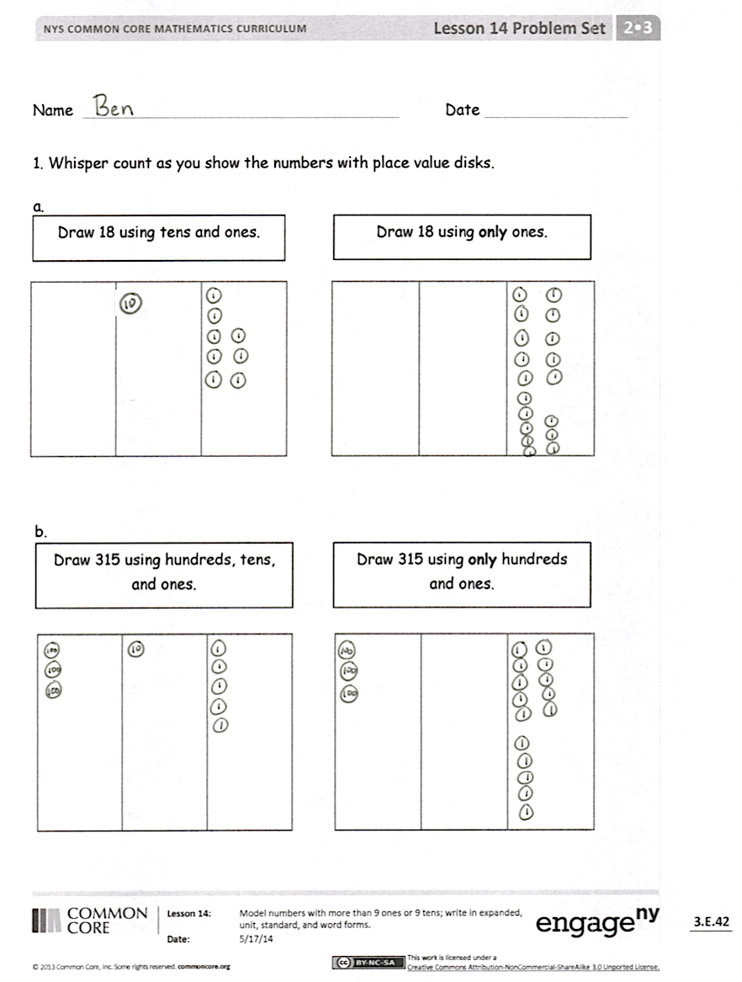
Problem Set (12 minutes)
Materials: (S) Problem Set
Students should do their personal best to complete the Problem Set within the allotted 10 minutes. For some classes, it may be appropriate to modify the assignment by specifying which problems they work on first. Some problems do not specify a method for solving. Students should solve these problems using the RDW approach used for Application Problems.
Directions: Represent each number two ways on the place value charts. The instructions will tell you what units to use.
Student Debrief (10 minutes)
Lesson Objective: Model numbers with more than 9 ones or 9 tens; write in expanded, unit, standard, and word forms.
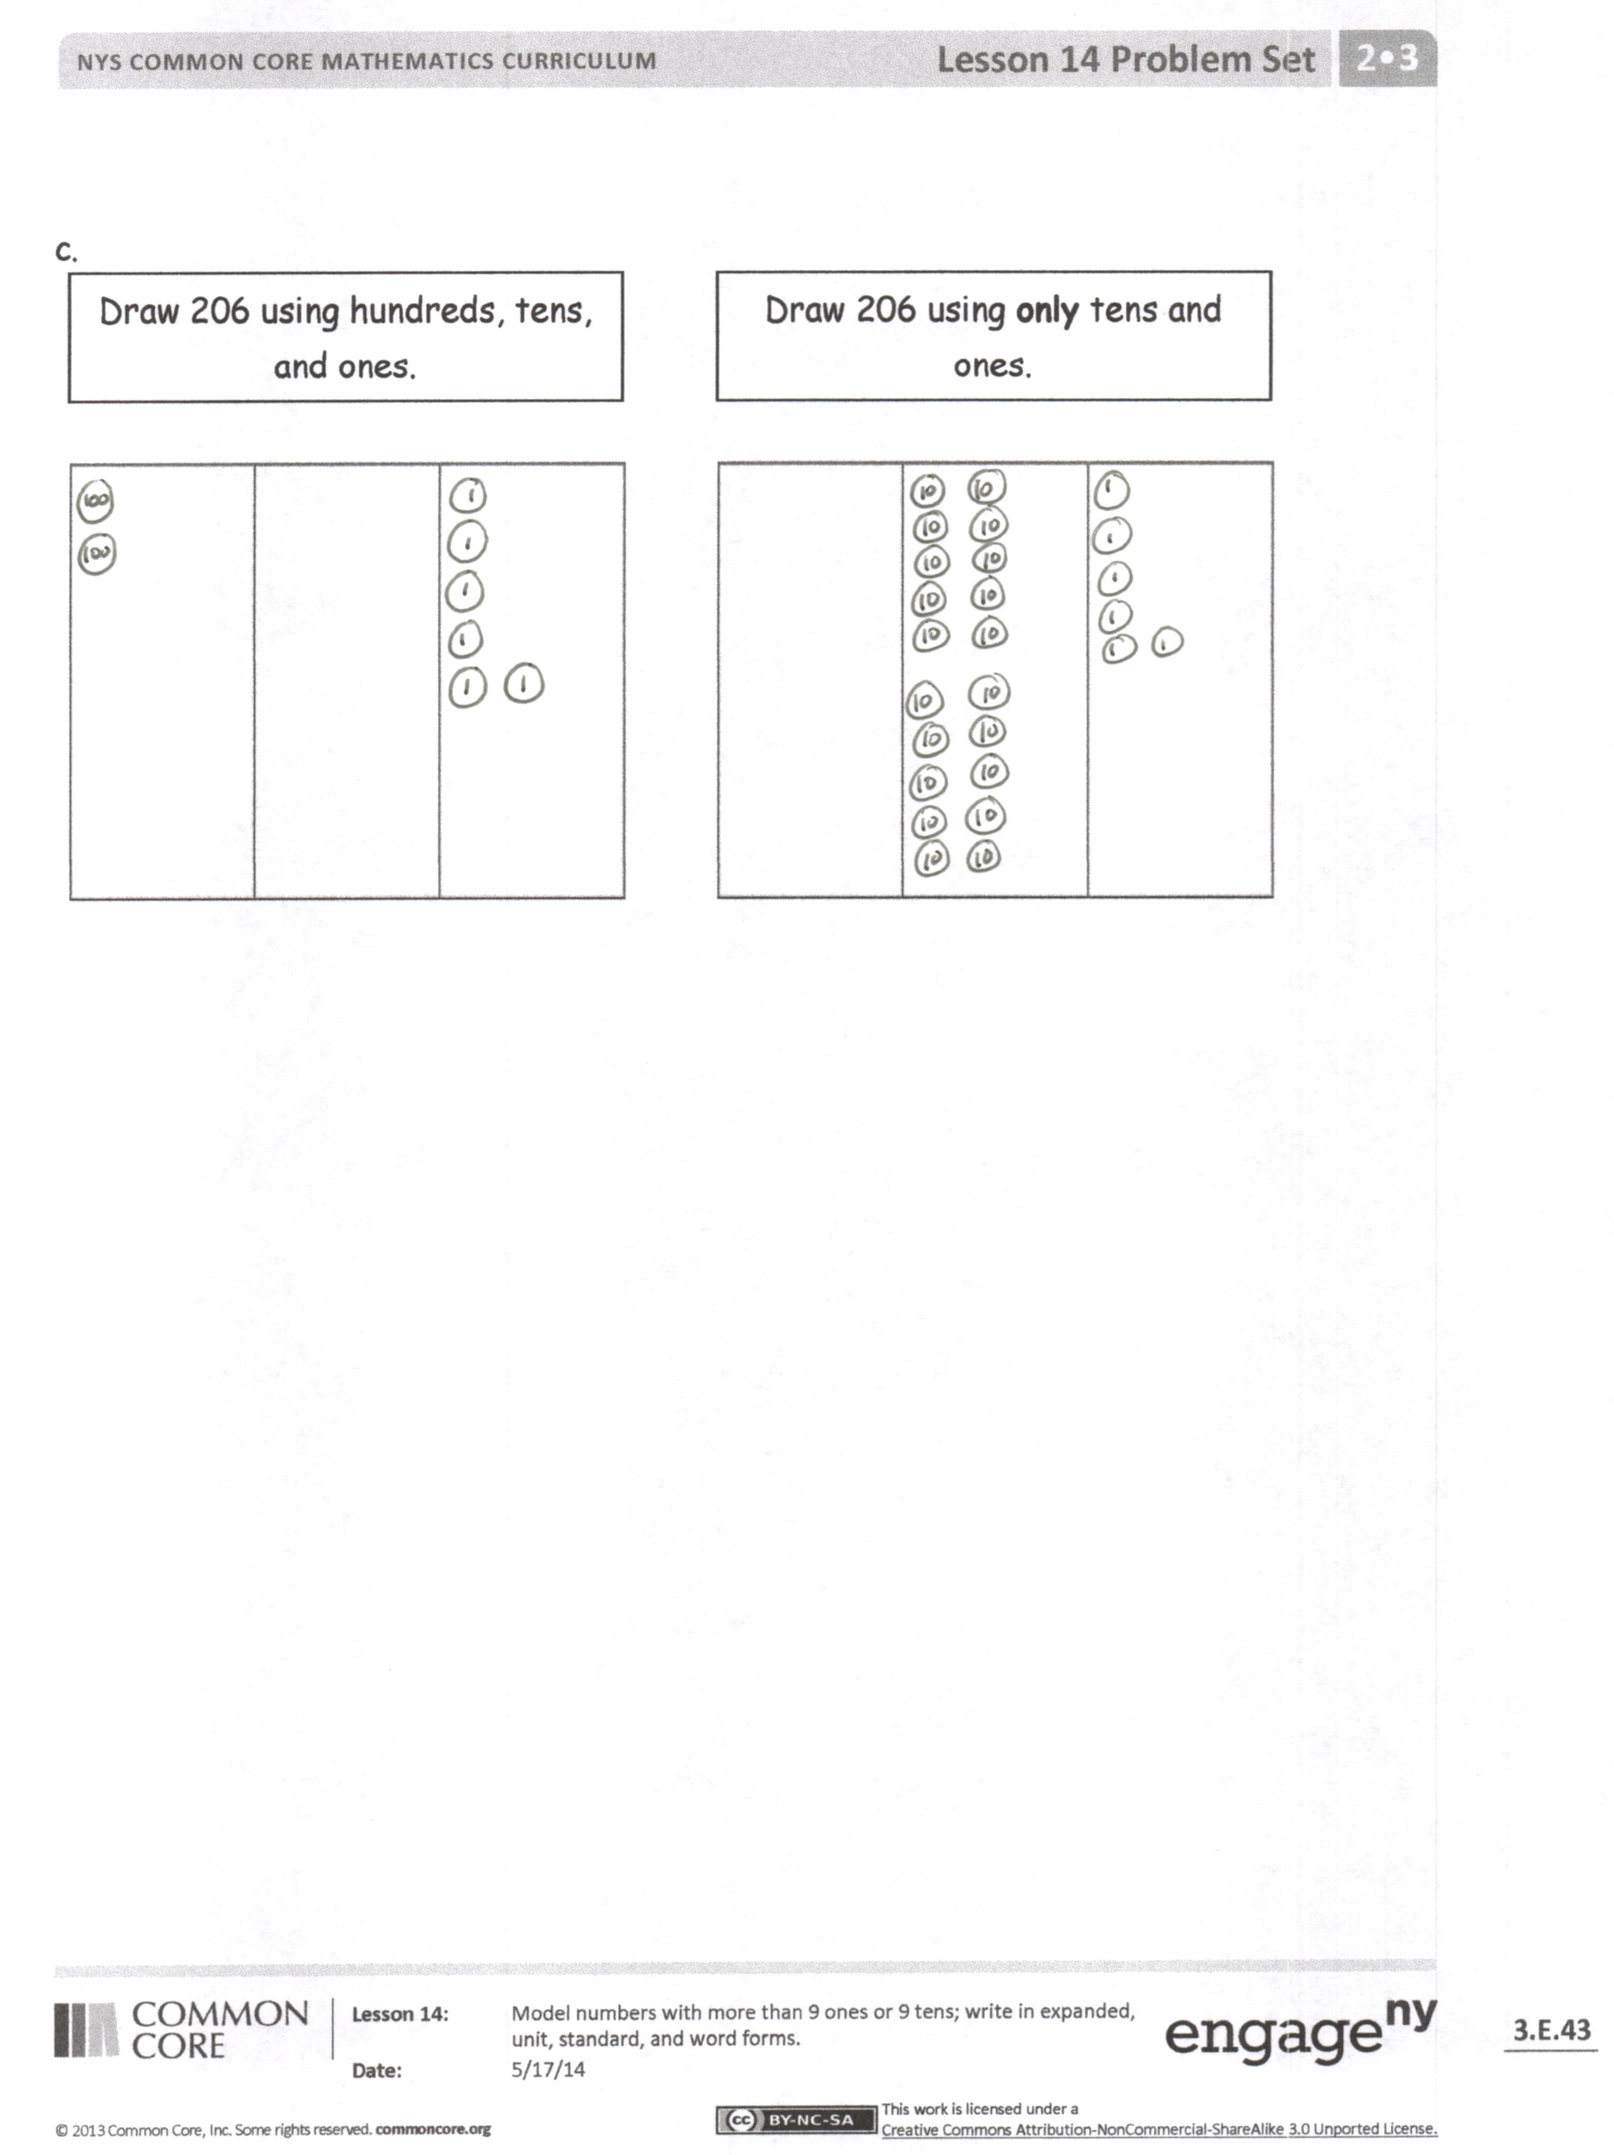
The Student Debrief is intended to invite reflection and active processing of the total lesson experience.
Invite students to review their solutions for the Problem Set. They should check work by comparing answers with a partner before going over answers as a class. Look for misconceptions or misunderstandings that can be addressed in the Debrief. Guide students in a conversation to debrief the Problem Set and process the lesson.
T: Bring your Problem Set to our Debrief.
T: Check your work carefully with a partner. How did you show each number? I will circulate and look at your drawings, too.
T: (Allow two minutes.) Which ones were hard for you?
T: (Ask questions, especially with the third page. If no one is forthcoming, choose one you saw many struggled with as you circulated.)
T: Let’s look at Question 1(c). What number is written?
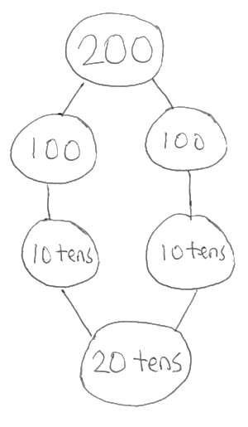
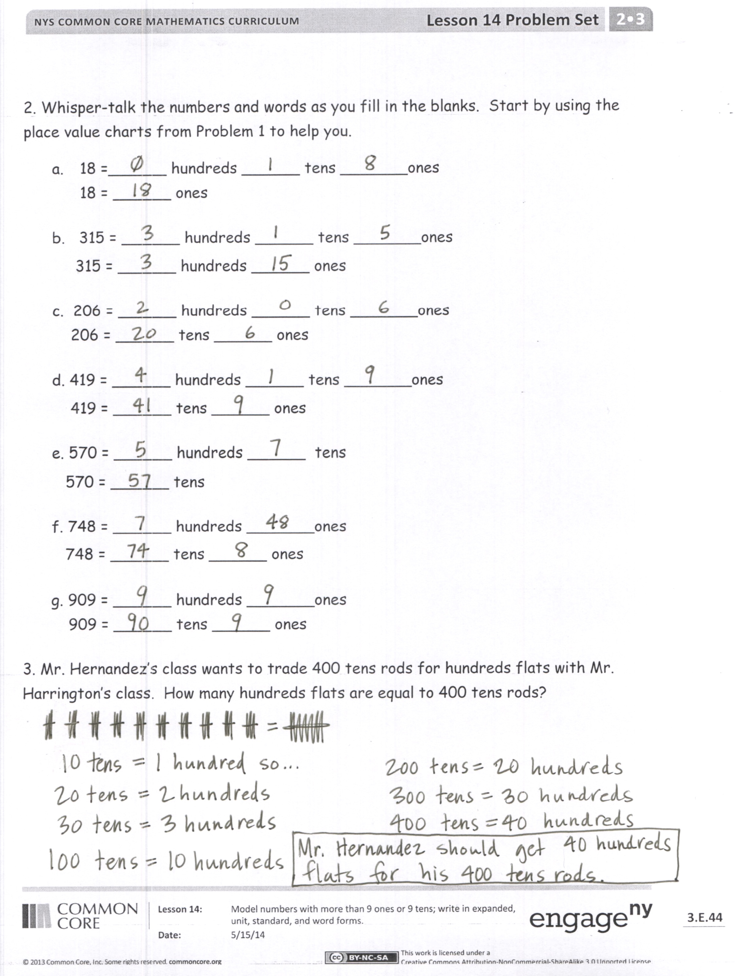
S: 206.
T: Say 206 in expanded form.
S: 200 + 6.
T: 100 + 100 is…?
S: 200.
T: 100 is how many tens?
S: 10 tens.
T: 10 tens + 10 tens is…?
S: 20 tens.
T: 20 tens is…?
S: 200.
T: 206 = 2 hundreds 6 ones = 20 tens 6 ones. Talk to your partner about why this is true.
T: We can have more than 9 units. Let’s try some.
T: The value of 30 tens is…?
S: 300.
T: 18 tens?
S: 180.
T: Excellent.

NOTES ON
MULTIPLE MEANS
OF ENGAGEMENT:
The Debrief relies heavily on oral language and automaticity with that language. If your students need support, it may be appropriate to have them answer some questions on their personal white boards. Alternatively, ask students to chorally respond at a signal so that you can build wait time in between responses.
Exit Ticket (3 minutes)
After the Student Debrief, instruct students to complete the Exit Ticket. A review of their work will help you assess the students’ understanding of the concepts that were presented in the lesson today and plan more effectively for future lessons. You may read the questions aloud to the students.

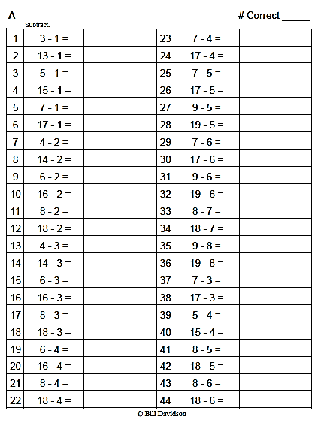
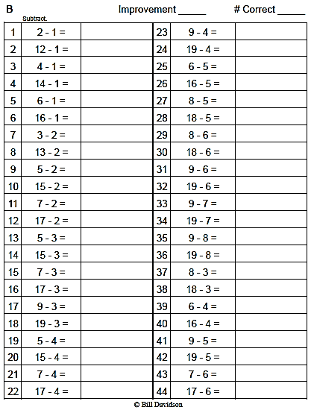
Name Date
- Whisper count as you show the numbers with place value disks.

a.
Draw 18 using tens and ones.

Draw 18 using only ones.

b.
Draw 315 using only hundreds and ones.

Draw 315 using hundreds, tens, and ones.

c.
Draw 206 using only tens and ones.

Draw 206 using hundreds, tens, and ones.

- Whisper-talk the numbers and words as you fill in the blanks. Start by using the place value charts from Problem 1 to help you.
- 18 = ______ hundreds ______ tens _______ones
18 = ______ ones
- 315 = ______ hundreds ______ tens _______ones
315 = ______ hundreds ______ ones
c. 206 = ______ hundreds ______ tens _______ones
206 = ______ tens ______ ones
d. 419 = ______ hundreds ______ tens _______ones
419 = ______ tens ______ ones
e. 570 = ______ hundreds ______ tens
570 = ______ tens
f. 748 = ______ hundreds _______ ones
748 = ______ tens ______ ones
g. 909 = ______ hundreds _______ ones
909 = ______ tens ______ ones
- Mr. Hernandez’s class wants to trade 400 tens rods for hundreds flats with Mr. Harrington’s class. How many hundreds flats are equal to 400 tens rods?

Name Date
- Whisper count as you show the numbers with place value disks.

- Draw 241 using hundreds, tens, and ones.

- Draw 241 using only tens and ones.

- Fill in the blanks.
- 45 = ______ hundreds ______ tens _______ ones
45 = ______ ones
- 682 = ______ hundreds ______ tens _______ ones
682 = ______ hundreds ______ ones

Name Date
            - Whisper-talk the numbers and words as you fill in the blanks.
- 16 = ______ tens _______ ones
16 = ______ ones

- 217 = ______ hundreds ______ tens _______ ones
217 = ______ hundreds ______ ones

- 320 = ______ hundreds ______ tens _______ ones
320 = ______ tens ______ ones

- 139 = ______ hundreds ______ tens _______ ones
139 = ______ tens ______ ones
- 473 = ______ hundreds ______ tens _______ ones
473 = ______ tens ______ ones
- 680 = ______ hundreds ______ tens
680 = ______ tens
- 817 = ______ hundreds _______ ones
817 = ______ tens ______ ones
- 921 = ______ hundreds _______ ones
921 = ______ tens ______ ones

- Write down how you can skip-count by ten from 350 to 240. You might use place value disks, number lines, bundles, or numbers.

