Lesson 13

Objective: Read and write numbers within 1,000 after modeling with place value disks.

Suggested Lesson Structure

 Fluency Practice (10 minutes)

 Application Problem (10 minutes)

 Concept Development (30 minutes)

 Student Debrief (10 minutes)

**Total Time (60 minutes)**

Fluency Practice (10 minutes)

* Sprint: Place Value Counting to 100 **2.NBT.3** (8 minutes)
* 100 More/100 Less **2.NBT.2** (1 minute)
* How Many Tens/How Many Hundreds **2.NBT.1** (1 minute)

Sprint: Place Value Counting to 100 (8 minutes)

Materials: (S) Place Value Counting to 100 Sprint

100 More/100 Less (1 minute)

T: I’ll say a number. You say the number that is 100 more. Wait for my signal. Ready?

T: 70.

S: 170!

T: 200.

S: 300!

T: 480.

S: 580!

T: 900.

S: 1,000!

Continue with 100 more, then switch to 100 less.

How Many Tens/How Many Hundreds (1 minute)

T: I’ll say a number. You say how many tens are in that number. For example, I say, “14 ones.” You say, “1 ten.” Wait for my signal. Ready?

T: 20 ones.

S: 2 tens!

T: 28 ones.

S: 2 tens!

T: 64 ones.

S: 6 tens!

T: 99 ones.

S: 9 tens!

Continue in this manner, and then switch to asking how many hundreds.

T: 15 tens.

S: 1 hundred!

T: 29 tens.

S: 2 hundreds!

T: 78 tens.

S: 7 hundreds!

Application Problem (10 minutes)

Sarah’s mom bought 4 boxes of crackers. Each box had 3 smaller packs of 10 inside. How many crackers were in the 4 boxes?

|  |  |
| --- | --- |
|  | NOTES ON  MULTIPLE MEANS  OF REPRESENTATION: |
| The difference between the words *packs* and *boxes* could be difficult for English language learners to understand. Before you begin, it may be helpful to define these words with a simple labeled sketch that students can refer to as they read the problem. | |
|  | |
|  | |
|  | |

T: Read this problem with me.

T: We always have to pay special attention to the information given.

T: How many boxes are there?

S: 4.

T: What is inside each box?

S: 3 packs of 10 crackers.

T: What unit are we solving for, boxes or crackers? Reread the question and then tell your partner.

S: Crackers.

T: Correct. Now, discuss with your partner what you could draw that would help you answer the question.

pack

box

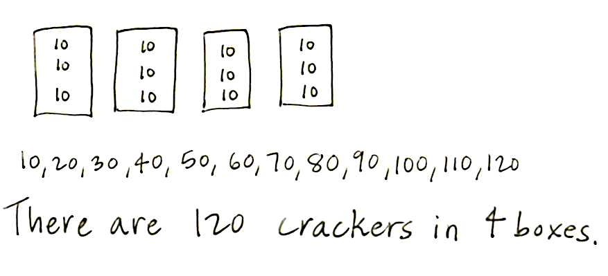S: I drew 4 boxes and wrote 10, 10, 10 in each one. Then, I skip-counted by tens and got 120. 🡪 I drew 4 big circles and put 3 ten-disks inside each. Then, I used doubles, 3 tens + 3 tens is   
6 tens, and 6 tens + 6 tens is 12 tens or 120. 🡪 I drew the same picture as Yesenia, but I skip-counted 3, 6, 9, 12. And, since they’re tens,   
I said 30, 60, 90, 120.

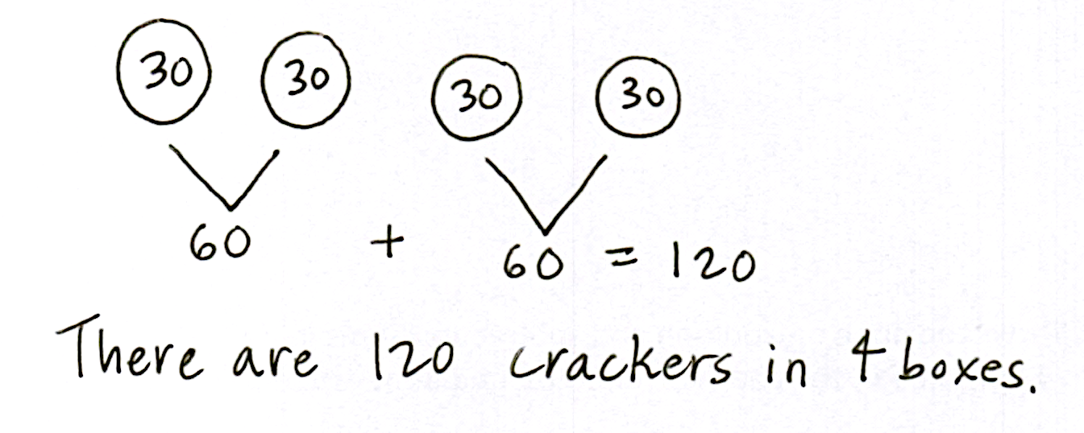T: Great strategies for solving! So, what is the   
answer to the question?

S: There are 120 crackers in the 4 boxes.

Concept Development (30 minutes)

Drawing Place Value Disks to Represent Numbers (10 minutes)

Materials: (T) Plenty of white board space, empty number line (Template) (S) Personal white board, empty number line (Template)

T: I’m going to draw some pictures of numbers. As I draw, count out loud for me.

T: (Draw an unlabeled place value chart on the board and draw pictures of the disks to represent 322.)

S: 100, 200, 300, 310, 320, 321, 322.

T: What is the value of the number on my place value chart? Write the value on your personal white board. Show the value to me at the signal.

S: (Show 322.)

T: Excellent. Try another. (Silently draw disks to represent 103 as students count the value.)

S: 100, 101, 102, 103.

T: What’s the total value of this new number? Write it on your personal board. Show the value to me at the signal.

S: (Show 103.)

T: Now, we’ll try a new process. I’m thinking of a number. Don’t count while I draw. Wait until I have finished drawing before you whisper its value to your partner.

T: (Silently and quickly draw 281 on the place value chart. Be sure to draw the ten-frame way as modeled in the Problem Set below.)

T: Write this new number on your personal board.

T: Here is another one. (A possible sequence would be 129, 710, 807, 564.)

T: What is it about the way I am drawing that is making it easy for you to tell the value of my number so quickly? Talk to your partner.

S: The labels are easy to read. 🡪 She draws the place value disks like a ten-frame. 🡪 The place value chart makes the units easy to see.

|  |  |
| --- | --- |
|  | NOTES ON  MULTIPLE MEANS  OF ACTION AND EXPRESSION: |
| Some students may need to use place value disks to model numbers before drawing them. Allow students to use the disks for the first problem, but wean them off as quickly as possible. For each digit, prompt students to visualize the disks that they will draw, say the number, then make the drawing before going on to the next digit. This helps build confidence by creating manageable steps. | |
|  | |
|  | |
|  | |

T: I hear a lot of interesting ideas. We have some great tools here. What tools are we using?

S: A place value chart. 🡪 Place value disks. 🡪 The  
ten-frame.

T: Now, it is your turn to represent some numbers by drawing place value disks.

**Problem Set (10 minutes)**

Students should do their personal best to complete the Problem Set within the allotted 10 minutes. For some classes, it may be appropriate to modify the assignment by specifying which problems they work on first. Some problems do not specify a method for solving. Students should solve these problems using the RDW approach used for Application Problems.

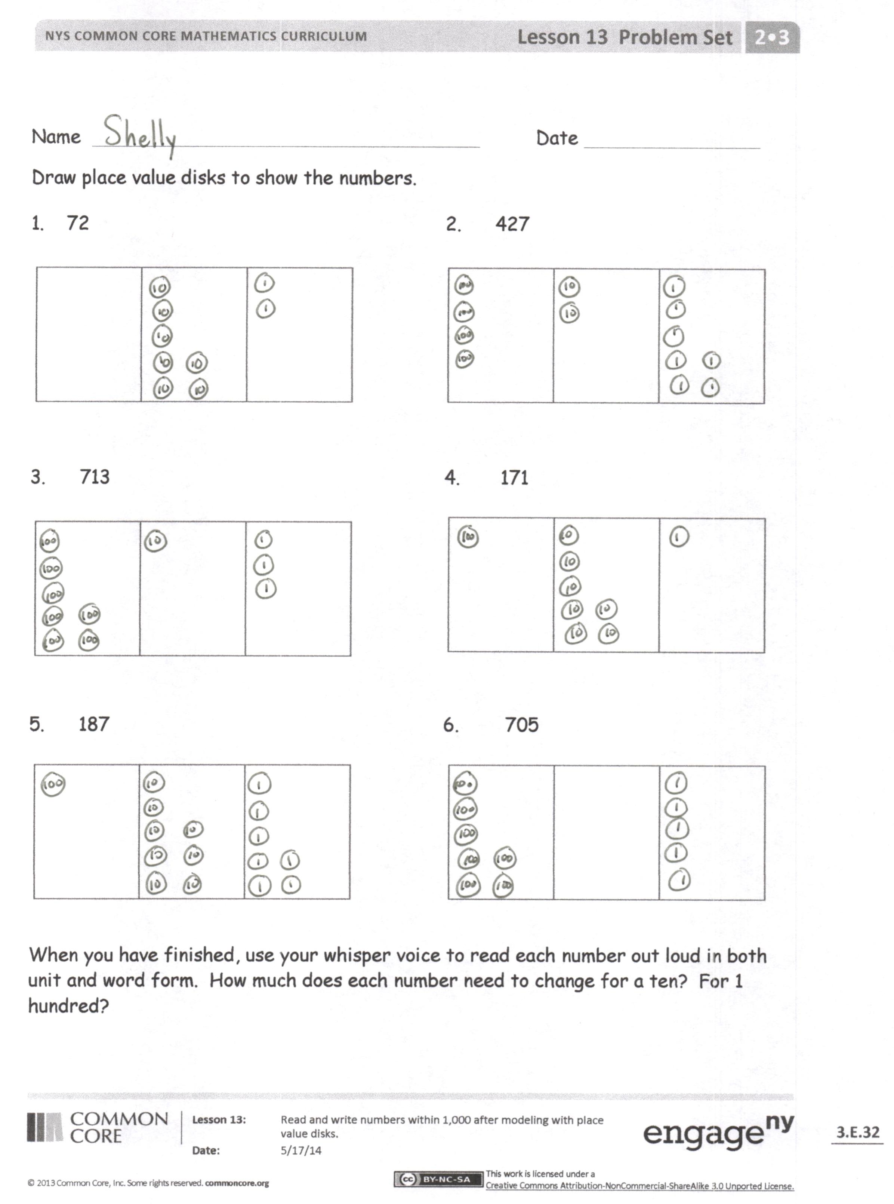Directions: Draw the numbers indicated using place value disks drawn the ten-frame way.

Notes on drawing place value disks:

* Have the students draw the value of the unit first, and then circle it. (Otherwise, students might draw the circle first and then cram the unit’s value inside.)
* Have the students start drawing from the top down in each place of the place value chart, filling their column of 5 (if your number is 5 or greater).
* Start from the bottom up to build towards the other five for 6, 7, 8, and 9.

**Estimating Numbers on the Empty Number Line (10 minutes)**

T: Let’s represent the same numbers from our Problem Set on empty number lines. Imagine we are traveling from 0 to 72.

T: (Point to the beginning and end of the first number line.) Here is 0’s address for now.   
And here is 72’s address at the other end of the number line.

T: How many tens am I going to travel?

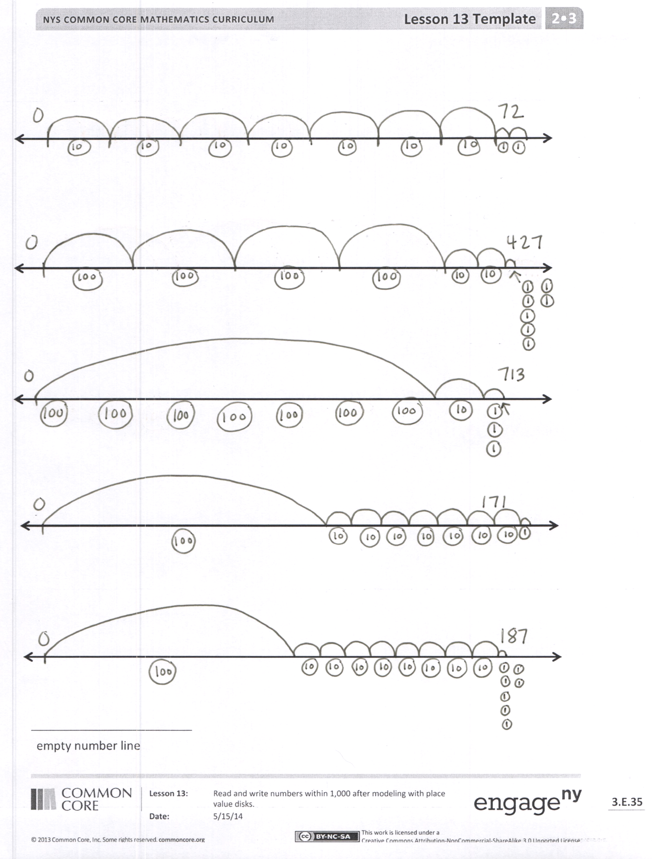S: 7 tens.

T: I would like the 7 jumps to be as equal as I can make them. I like drawing little arrows to show the jumps I make. Count for me. (Draw 7 large jumps and 2 small jumps.)

S: 1 ten, 2 tens, 3 tens, 4 tens, 5 tens, 6 tens, 7 tens, 1 one, 2 ones.

T: Below, I’m going to draw my disks (as pictured).

T: Now, you try. Here is an empty number line template. Use a pencil because you might erase a few times. Make your address for 0 and 72, and then get to 72 the best you can with 7 tens and   
2 ones.

T: (Circulate and support. Move them on to 427. “What units do you have in that number?” “Which is the largest?” “Draw the disks below to show the units within each hop.” Continue with the following possible sequence: 713, 171, 187.)

Encourage students to have fun and think about the best way to show each number on the empty number line. Accept all reasonable work. Do not be overly prescriptive. Watch for students who make different units the same size.   
“Yes, the disks are the same size but will the hops be the same size on the number line?” This is an estimation exercise and a chance to consider the size of a unit while working with the disks.

**Student Debrief (10 minutes)**

**Lesson Objective:** Read and write numbers within 1,000 after modeling with place value disks.

Materials: (T) Base ten bundles of straws on the carpet, Problem Sets

The Student Debrief is intended to invite reflection and active processing of the total lesson experience.

Invite students to review their solutions for the Problem Set. They should check work by comparing answers with a partner before going over answers as a class. Look for misconceptions or misunderstandings that can be addressed in the Debrief. Guide students in a conversation to debrief the Problem Set and process the lesson.

T: Bring your work to the carpet. Check your partner’s place value charts. Make sure the correct number of units is drawn for each one and that they are easy to read. Make sure they are in the correct place, too.

**MP.6**

S: (Share.)

T: Let’s start by analyzing our place value charts. In each number there is a 7. With your partner, review the values of the sevens. (Allow time for partners to review.)

T: Read the numbers in order from Problems 1 through 6 when I give the signal.

S: (Read.)

T: Discuss with your partner the bundles that would match each of your six numbers. I have the bundles on the carpet here for you to refer to.

T: Now, share your number lines with your partner. Explain your thinking about the size of your hops.

S: I knew I had to get in 7 hops by the end of the line, so I made them smaller here than in this one. 🡪 It’s interesting because this line was 427 and this line was 72. 🡪 So, on this one, I made 4 really big hops and 2 small ones and then 7 minis. 🡪 Then, 700. I decided to just make one big hop for all the hundreds.

T: Let’s read through the numbers we showed both on the place value chart and on the empty number line.

**MP.6**

S: 72, 427, 713, 171, 187.

T: As we already saw, each of our numbers has a 7 in it. Show your partner how you represented the 7 in each number on your number line. Why are they different?

S: This was 7 hundreds and this was 7 ones so these were little and these were big. 🡪 Both of these numbers had 7 in the tens place, but 72 is smaller than 171 so the hops were bigger when I was only going to 72. 🡪 705 and 713 both have 7 hundreds. On this number line, I hopped 7 times but on this number line I made one big jump for all seven. I guess that it’s just about the same though.

T: So, I’m hearing you say that the biggest difference was in the way the 7 tens in 171 and 72 looked, the unit in the middle.

T: It’s so interesting because a number could be counting something really small like 70 grains of rice or something really big like 70 planets! We read and write numbers and they describe things. Turn and talk to your partner. What could our number 427 be describing?

S: 427 apples. 🡪 427 students. 🡪 427 ants. 🡪 427 stars.

Exit Ticket (3 minutes)

After the Student Debrief, instruct students to complete the Exit Ticket. A review of their work will help you assess the students’ understanding of the concepts that were presented in the lesson today and plan more effectively for future lessons. You may read the questions aloud to the students.

Write the number.

# Correct _____

Write the number. Improvement _____ # Correct _____

Name Date

Draw place value disks to show the numbers.

1. 72 2. 427

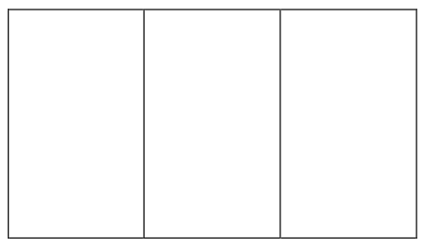

3. 713 4. 171



5. 187 6. 705



When you have finished, use your whisper voice to read each number out loud in both unit and word form. How much does each number need to change for a ten? For 1 hundred?

Name Date

1. Draw place value disks to show the numbers.

a. 560 b. 506



1. Draw and label the jumps on the number line to move from 0 to 141.

Name Date

Draw place value disks to show the numbers.

1. 43 2. 430



3. 270 4. 720



5. 702 6. 936



When you have finished, use your whisper voice to read each number out loud in both unit and word form. How much does each number need to change for a ten? For 1 hundred?

[1]

1. empty number line