Lesson 12

Objective: Change 10 ones for 1 ten, 10 tens for 1 hundred, and 10 hundreds for 1 thousand.

Suggested Lesson Structure

 Fluency Practice (10 minutes)

 Application Problem (10 minutes)

 Concept Development (30 minutes)

 Student Debrief (10 minutes)

**Total Time (60 minutes)**

Fluency Practice (10 minutes)

* 10 More/10 Less **2.NBT.2** (2 minutes)
* Sprint: Sums to 10 with Ten Numbers **2.OA.2** (8 minutes)

10 More/10 Less (2 minutes)

T: I’ll say a number. You say the number that is 10 more. Wait for my signal. Ready?

T: 50.

S: 60!

T: 90.

S: 100!

T: 130.

S: 140!

Continue with 10 more, then switch to 10 less.

Sprint: Sums to 10 with Ten Numbers (8 minutes)

Materials: (S) Sums to 10 with Ten Numbers Sprint

Application Problem (10 minutes)

How many packages of 10 cookies can Collette make using 124 cookies? How many cookies does she need to complete another package of 10?

T: Let’s read this problem together.

|  |  |
| --- | --- |
|  | NOTES ON  MULTIPLE MEANS  OF ACTION AND EXPRESSION: |
| Some children will quickly see that there are 12 tens and 4 ones in the number 124. In this instance, adjust the number or the task to create a challenge for students working above grade level. Below are suggestions for extending the problem:   * How many packages of 10 cookies can Collette make using 124 cookies? How many cookies does she need to complete 3 more packages of 10? How many cookies will she have then? * How many packages of 10 cookies can Collette make using 124 cookies? How many more cookies does she need to make 20 packages? | |

T: Visualize. Close your eyes and see the number 124 in the different ways we’ve learned to represent numbers.

T: Discuss how you could solve this problem with your partner. Then draw a model and solve.

T: (Allow two or three minutes.) Who would like to share their thinking?

S: I drew place value disks to show 124. Then, I changed the 100 disk for 10 tens and I saw that 10 tens and   
2 tens make 12 tens. Then, I drew 6 more ones disks to make another package of 10. 🡪 I knew that 100 is   
10 tens and 20 is 2 tens so I drew 12 tens. And, she needs 6 more cookies to make another ten. 🡪 I remember that 120 is 12 tens, so that’s the answer. And, 6 ones plus 4 ones equals another ten.

T: Excellent reasoning! So, how many packages of   
10 cookies can Collette make?

S: She can make 12 packages of 10 cookies. (Write the statement on the board.)

T: As I walked around I noticed that most of you drew place value disks. Is it easier to draw place value disks than bundles?

S: Yes.

T: Why?

S: It’s faster!

T: Yes. We want to be efficient.

T: Please add the statement to your paper if you haven’t already.

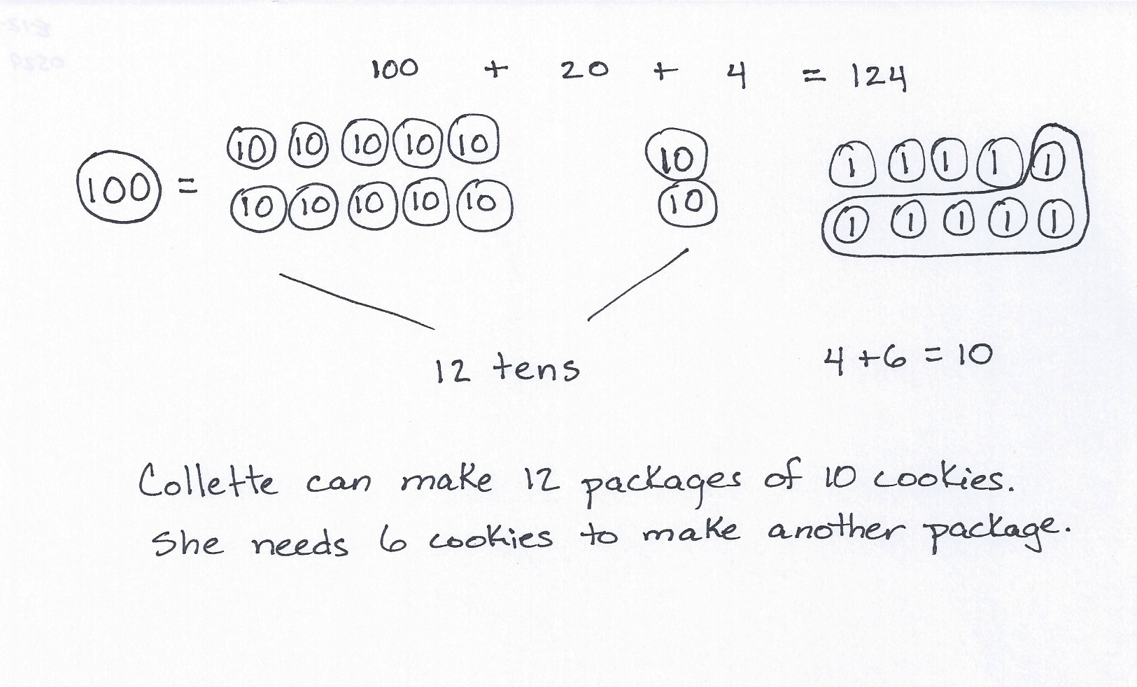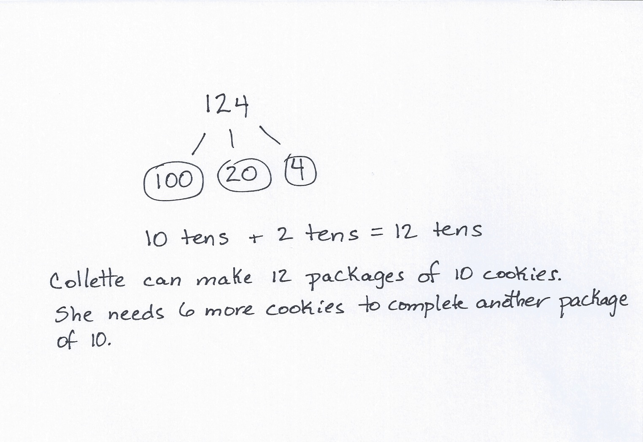

Concept Development (30 minutes)

Materials: (S) Place value disks (10 ones, 10 tens, 10 hundreds), unlabeled hundreds place value chart (Lesson 8 Template) per pair

Part A: Show the Equivalence of 10 Ones and 1 Ten, 10 Tens and 1 Hundred, 10 Hundreds and 1 Thousand

Students work in pairs.

T: Slide the place value chart inside your personal white boards.

T: Show me 10 ones in two vertical columns of 5, the ten-frame way, on your place value chart.

S: (Work.)

T: What is the value of your 10 ones?

S: 10!

T: 10 potatoes?

S: 10 ones.

T: Can you change 10 ones to make a larger unit?

S: Yes.

T: What unit can you make?

S: A ten.

T: Change 10 ones for 1 ten. Did you put your 1 ten to the left or to the right?

S: To the left!

T: Yes, on the place value chart our numbers get bigger to the left!

T: Skip-count by tens on your place value chart until you have placed 10 tens.

T: Can you change to make a larger unit? (Repeat the cycle with 10 tens and 10 hundreds.)

T: Just like with our bundles, bills, and blocks, disks allow us to see how numbers work.

Part B: Count by Ones from 186 to 300 Using Place Value Disks

T: Show (silently write 186 on the board) with your place value disks. Make sure you show your units the ten-frame way.

S: (Show.)

T: Let’s count up to 300 by ones. How many more ones do I need to make ten?

S: 4 ones.

T: It is easy to see because of the ten-frame format in which you have laid out your disks. Use that structure as you count to 300 please.

T: Let me hear you whisper count as you count by ones.

S: (Whisper.) 187, 188, 189, 190.

T: Pause. Can you change for a larger unit?

S: Yes. We can change 10 ones for 1 ten.

T: Do that and then keep counting with your partner up to 300. If you finish before your classmates, count down from 300 to 275.

While students are counting, circulate and say, “Pause a moment. What number are you on? Did you just make a unit? How many more do you need to count to make the next larger unit?”

T: (Continue once most students have finished.) What were some numbers where you had to change 10 smaller units for 1 of the next unit to the left?

S: 190, 200, 250, 300, etc.

T: Use your words to tell your partner what happened when you got to both 200 and 300.

S: We made 1 ten. 🡪 We made 1 hundred. 🡪 We changed to make a ten from the ten ones. Then, that ten meant we could change 10 tens for 1 hundred.

T: Mark is expressing the change from 299 to 300 very well. Mark, will you share?

S: We changed to make a ten from the ten ones. Then, that ten meant we could change 10 tens for   
1 hundred.

T: Restate Mark’s explanation to your partner. You certainly may use your own words to express the same idea. (Pause while students talk.)

T: Think about the number 257. Do you remember what it looks like with your disks?

S: Yes!

T: How many more ones did 257 need to make a ten?

S: 3 ones.

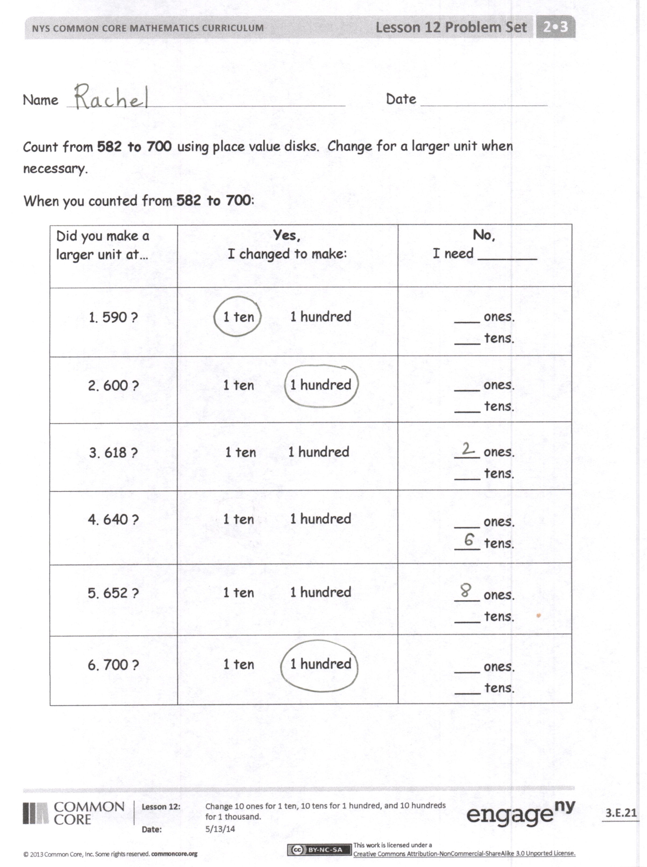T: The place value disks help us to visualize that because we put them in rows. We can easily see that missing 3 ones.

T: Next, you are going to count from 582 to 700 and as you go, think about how many more you need to make the next unit.

Problem Set (10 minutes)

Materials: (S) Problem Set, place value disks, unlabeled hundreds place value chart (Lesson 8 Template)

Students should do their personal best to complete the Problem Set within the allotted 10 minutes. For some classes, it may be appropriate to modify the assignment by specifying which problems they work on first. Students should solve these problems using the RDW approach used for Application Problems.

Directions: Count by ones from 582 to 700 using your place value disks.

* 1. Model 582 with your place value disks. Count up by ones to 700.
  2. Pause at each number listed on your Problem Set. At that number, did you make a larger unit?
  3. If the answer is yes, tell what unit or units you made.
  4. If the answer is no, tell how much more you need to make the next largest unit.
  5. If you finish before time is up, model counting down to each number on the Problem Set beginning with 700.

Student Debrief (10 minutes)

**Lesson Objective:** Change 10 ones for 1 ten, 10 tens for 1 hundred, and 10 hundreds for 1 thousand.

The Student Debrief is intended to invite reflection and active processing of the total lesson experience.

Invite students to review their solutions for the Problem Set. They should check work by comparing answers with a partner before going over answers as a class. Look for misconceptions or misunderstandings that can be addressed in the Debrief. Guide students in a conversation to debrief the Problem Set and process the lesson.

T: Think about the number 582. Do you remember what it looks like with your disks?

**MP.7**

S: Yes!

T: How many more ones did 582 need to make a ten?

S: 8 ones.

|  |  |
| --- | --- |
|  | NOTES ON  MULTIPLE MEANS  OF ENGAGEMENT: |
| It may be challenging for some English language learners to say the names of larger numbers. Invite students to use their personal white boards to write each number as they count. Writing and seeing the number supports oral language development. | |

T: The place value disks help us to visualize. We can easily see the 8 missing ones. Go over the answers on your Problem Set with a partner.

S: (Share answers.)

T: At which numbers did you not make a change?

S: 618 and 652.

T: And at which numbers did you make a change?

S: 590, 600, 640 and 700.

T: How many tens does 590 need to change 10 tens for 1 hundred?

**MP.3**

S: 1 ten.

T: How many hundreds does 600 need to change 10 hundreds for 1 thousand?

S: 4 hundreds.

T: How many tens does 640 need to change 10 tens for 1 hundred?

T: 6 tens.

T: How many hundreds does 700 need to change 10 hundreds for 1 thousand?

S: 3 hundreds.

T: With your partner, count without disks from each of the numbers on the Problem Set to 900 using ones, tens, and hundreds. Remember how we used to count bundles by counting ones to complete a ten, then counting tens to complete a hundred, then counting up by hundreds? Visualize the disks to help you.

S: (590, 600, 700, 800, 900, etc.)

**MP.7**

T: Today, we focused on changing 10 ones for 1 ten, 10 tens for 1 hundred, and 10 hundreds for   
1 thousand.

Exit Ticket (3 minutes)

After the Student Debrief, instruct students to complete the Exit Ticket. A review of their work will help you assess the students’ understanding of the concepts that were presented in the lesson today and plan more effectively for future lessons. You may read the questions aloud to the students.



# Correct ___

Add.



Improvement _____ # Correct ___

Add.

Name Date

Count from **582 to 700** using place value disks. Change for a larger unit when necessary.

|  |  |  |
| --- | --- | --- |
| Did you make a larger unit at… | **Yes,**  I changed to make: | **No,**  I need _______ |
| 1. 590? | 1 ten 1 hundred | ___ ones.  ___ tens. |
| 2. 600? | 1 ten 1 hundred | ___ ones.  ___ tens. |
| 3. 618? | 1 ten 1 hundred | ___ ones.  ___ tens. |
| 4. 640? | 1 ten 1 hundred | ___ ones.  ___ tens. |
| 5. 652? | 1 ten 1 hundred | ___ ones.  ___ tens. |
| 6. 700? | 1 ten 1 hundred | ___ ones.  ___ tens. |

When you counted from **582 to 700**:

Name Date

* + 1. Match to show the equivalent value.
  1. 10 ones 1 hundred
  2. 10 tens 1 thousand
  3. 10 hundreds 1 ten
     1. Draw disks on the place value chart to show 348.

|  |  |  |
| --- | --- | --- |
|  |  |  |

* 1. How many more ones to make a ten? _____ ones
  2. How many more tens to make a hundred? _____ tens
  3. How many more hundreds to make a thousand? _____ hundreds

Name Date

Count by ones from **368 to 500**. Change for a larger unit when necessary.

When you counted from **368 to 500:**

|  |  |  |
| --- | --- | --- |
| Did you make a larger unit at… | **Yes,**  I changed to make: | **No,**  I need _______ |
| 1. 377? | 1 ten 1 hundred | ___ ones.  ___ tens. |
| 2. 392? | 1 ten 1 hundred | ___ ones.  ___ tens. |
| 3. 400? | 1 ten 1 hundred | ___ ones.  ___ tens. |
| 4. 418? | 1 ten 1 hundred | ___ ones.  ___ tens. |
| 5. 463? | 1 ten 1 hundred | ___ ones.  ___ tens. |
| 6. 470? | 1 ten 1 hundred | ___ ones.  ___ tens. |