Lesson 11
Objective: Count the total value of ones, tens, and hundreds with place value disks.

Suggested Lesson Structure
 Fluency Practice (12 minutes)
 Application Problem (9 minutes)
 Concept Development (25 minutes)
 Student Debrief (14 minutes)
Total Time (60 minutes)
Fluency Practice (12 minutes)
- Rekenrek Counting: Numbers in Unit Form Between 11 and 100 2.NBT.1 (4 minutes)
- Sprint: Addition and Subtraction to 10 2.OA.2 (8 minutes)
Rekenrek Counting: Numbers in Unit Form Between 11 and 100 (4 minutes)
Materials: (T) Rekenrek
T: (Show 11.) What number is showing?
S: 11!
T: The unit form way?
S: 1 ten 1 one.
T: Good. Keep counting the unit form way. (Move beads to count by ones to 15.)
S: 1 ten 2 ones, 1 ten 3 ones, 1 ten 4 ones, 1 ten 5 ones.
T: This time say each number two ways. First, the unit form way, then just as ones. Let’s do one together so you know what I mean. (Switch to counting by tens and show 25.)
T: Me first. 2 tens 5 ones is 25 ones. Your turn.
S: 2 tens 5 ones is 25 ones.
T: Good. Say the numbers that I show both ways. (Continue to count by tens to 55.)
S: 3 tens 5 ones is 35 ones, 4 tens 5 ones is 45 ones, 5 tens 5 ones is 55 ones.
T: This time say the ones first, then the unit form. (Switch to counting by ones to 61.)
S: 56 ones is 5 tens 6 ones, 57 ones is 5 tens 7 ones, 58 ones is 5 tens 8 ones, 59 ones is 5 tens 9 ones, 60 ones is 6 tens, 61 ones is 6 tens, 1 one.
Continue with the following possible sequence: Count down by tens from 97 to 37 and count down by ones from 37 to 25.
Sprint: Addition and Subtraction to 10 (8 minutes)
Materials: (S) Addition and Subtraction to 10 Sprint
Application Problem (9 minutes)
Samantha is helping the teacher organize the pencils in her classroom. She finds 41 yellow pencils and 29 blue pencils. She throws away 12 that are too short. How many pencils are left in all?
T: When you read this story, what do you see?
S: Pencils. Yellow and blue pencils. 12 pencils that are too short.
T: Can you draw something to represent the pencils?
S: We can draw the pencils. We can draw bundles. We can draw boxes of 10 pencils.
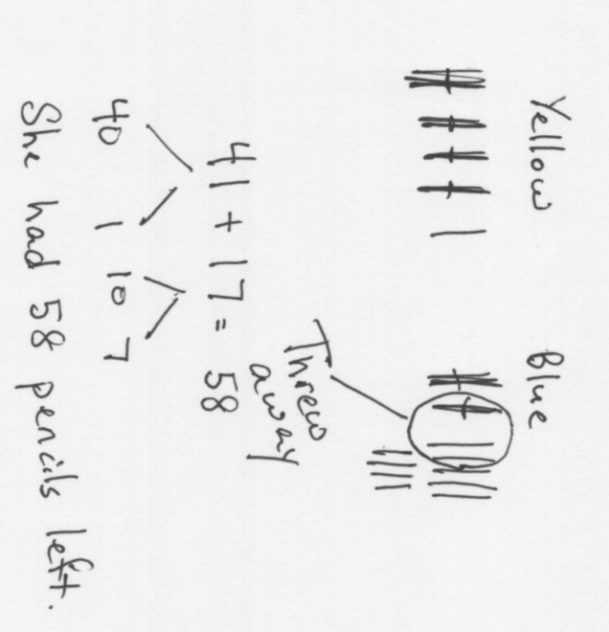
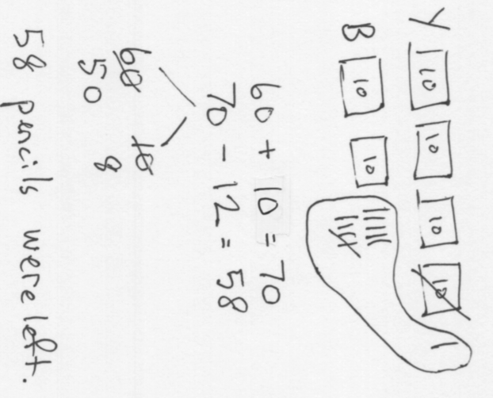
T: I’m only giving you two minutes to draw, so would it be wiser to draw bundles, boxes, or all of the pencils?
S: Bundles or boxes.
T: Go ahead and do that.
S: (Draw.)
T: Go ahead and solve the problem.
S: (Solve and write their statements.)
T: The answer is?
S: 58 pencils are left.
T: Thank you for answering in a complete statement.
T: What does your drawing show you? Talk with your partner.
S: We have two parts, the yellow and the blue pencils, and one part, the ones that are too short, are being thrown away. I could take the 12 away from the blue pencils. I could add the yellow and blue pencils and take away the short ones from the total. I could take the short ones away from the yellow pencils and then add the blue. Yeah, that’s true because even though it was maybe a mix of blue and yellow ones that were too short, it still will tell the right total in the end.
T: Let’s look at two different work samples that solved the problem in different ways.
Concept Development (25 minutes)
Materials: (T) Dienes blocks (9 hundreds, 9 tens, 9 ones), unlabeled hundreds place value chart (Lesson 8 Template), place value disks (9 hundreds, 9 tens, 9 ones) (S) Dienes blocks (2 hundreds, 9 tens, 9 ones) unlabeled hundreds place value chart (Lesson 8 Template), place value disks (6 hundreds, 9 tens, 9 ones) place value disks (Template)
T: Slide the place value chart inside your personal white boards.
T: With your blocks, show me this number. (Silently write 13 on the board.)
S: (Show.)
T: Whisper the number first in unit form, then in standard form.
S: 1 ten 3 ones, thirteen.
T: (Point to place value disks) Show me the same number with your place value disks and whisper the unit form and standard form as you work.
S: (Show and whisper.)
T: With your blocks, show the number to me. (Silently write 103 on the board.)
S: (Show.)
T: Whisper the number first in unit form, then in standard form.
S: 1 hundred 3 ones, one hundred three.

NOTES ON
MULTIPLE MEANS
OF ACTION AND EXPRESSION:
In order to promote deeper discussion, vary the grouping in the classroom, such that students who speak the same native languages are grouped together. This works particularly well when the discussion is open-ended and invites students to reflect on their own learning through the context of a hypothetical situation. Importantly, it does not require translation. Key vocabulary is familiar and supported with visuals, and it is secondary in purpose to the thinking that students are asked to produce.
T: Show me the same number with your place value disks, and whisper as you work.
S: (Show.)
Continue alternating between blocks and disks possibly with the following sequence: 129, 130, 230, 203, 199, 200. (For now, please resist using the words more or less.)
T: Talk with your partner about the difference between modeling your numbers with blocks and modeling your numbers with place value disks.
S: The blocks were yellow and the place value disks were different colors. The blocks were bigger and smaller and the place value disks were all the same size. The place value disks have the name on them. The blocks don’t. You just count.
T: Up to this point, we have been using bundles (hold up 1 hundred) and bills (hold up 1 hundred dollar bill). Talk to your partner and compare the blocks and place value disks to the bundles and bills. How are they the same? How are they different?
S: The bills have the name on them like the place value disks. With the bundles you can count the number of straws like the blocks. The bundles and blocks both are bigger when you have a bigger number. The bills and place value disks stay the same size. They all represent hundreds, tens and ones. The bills and the straws we see at home, but these blocks and place value disks are just in math class. I’ve never seen them anywhere else.
T: Okay, as I am circulating and listening, I hear some very thoughtful insights.
T: Here is a question to discuss with your partner. Imagine you are a teacher. How would you use these tools to teach different things to your class? (Write or post each word with a small pictorial for each to support language use.)
- Bundles

NOTES ON
MULTIPLE MEANS
OF ENGAGEMENT:
This Problem Set lends itself well to pairing up accelerated and struggling students. Encourage students with varying skill levels and/or levels of English language competence to teach and assist one another when building the models. This cultivates a classroom community that thrives on mutual support and cooperation. As students work together to solve problems, monitor their progress to ensure that everyone is engaged and participating.
- Blocks
- Bills
- Place value disks
Problem Set (10 minutes)
Students should do their personal best to complete the Problem Set within the allotted 10 minutes. For some classes, it may be appropriate to modify the assignment by specifying which problems they work on first. Some problems do not specify a method for solving. Students should solve these problems using the RDW approach used for Application Problems.
Problem 1(a–e): Model the numbers on your place value chart using the fewest number of blocks or disks possible.
- Partner A use base ten blocks.
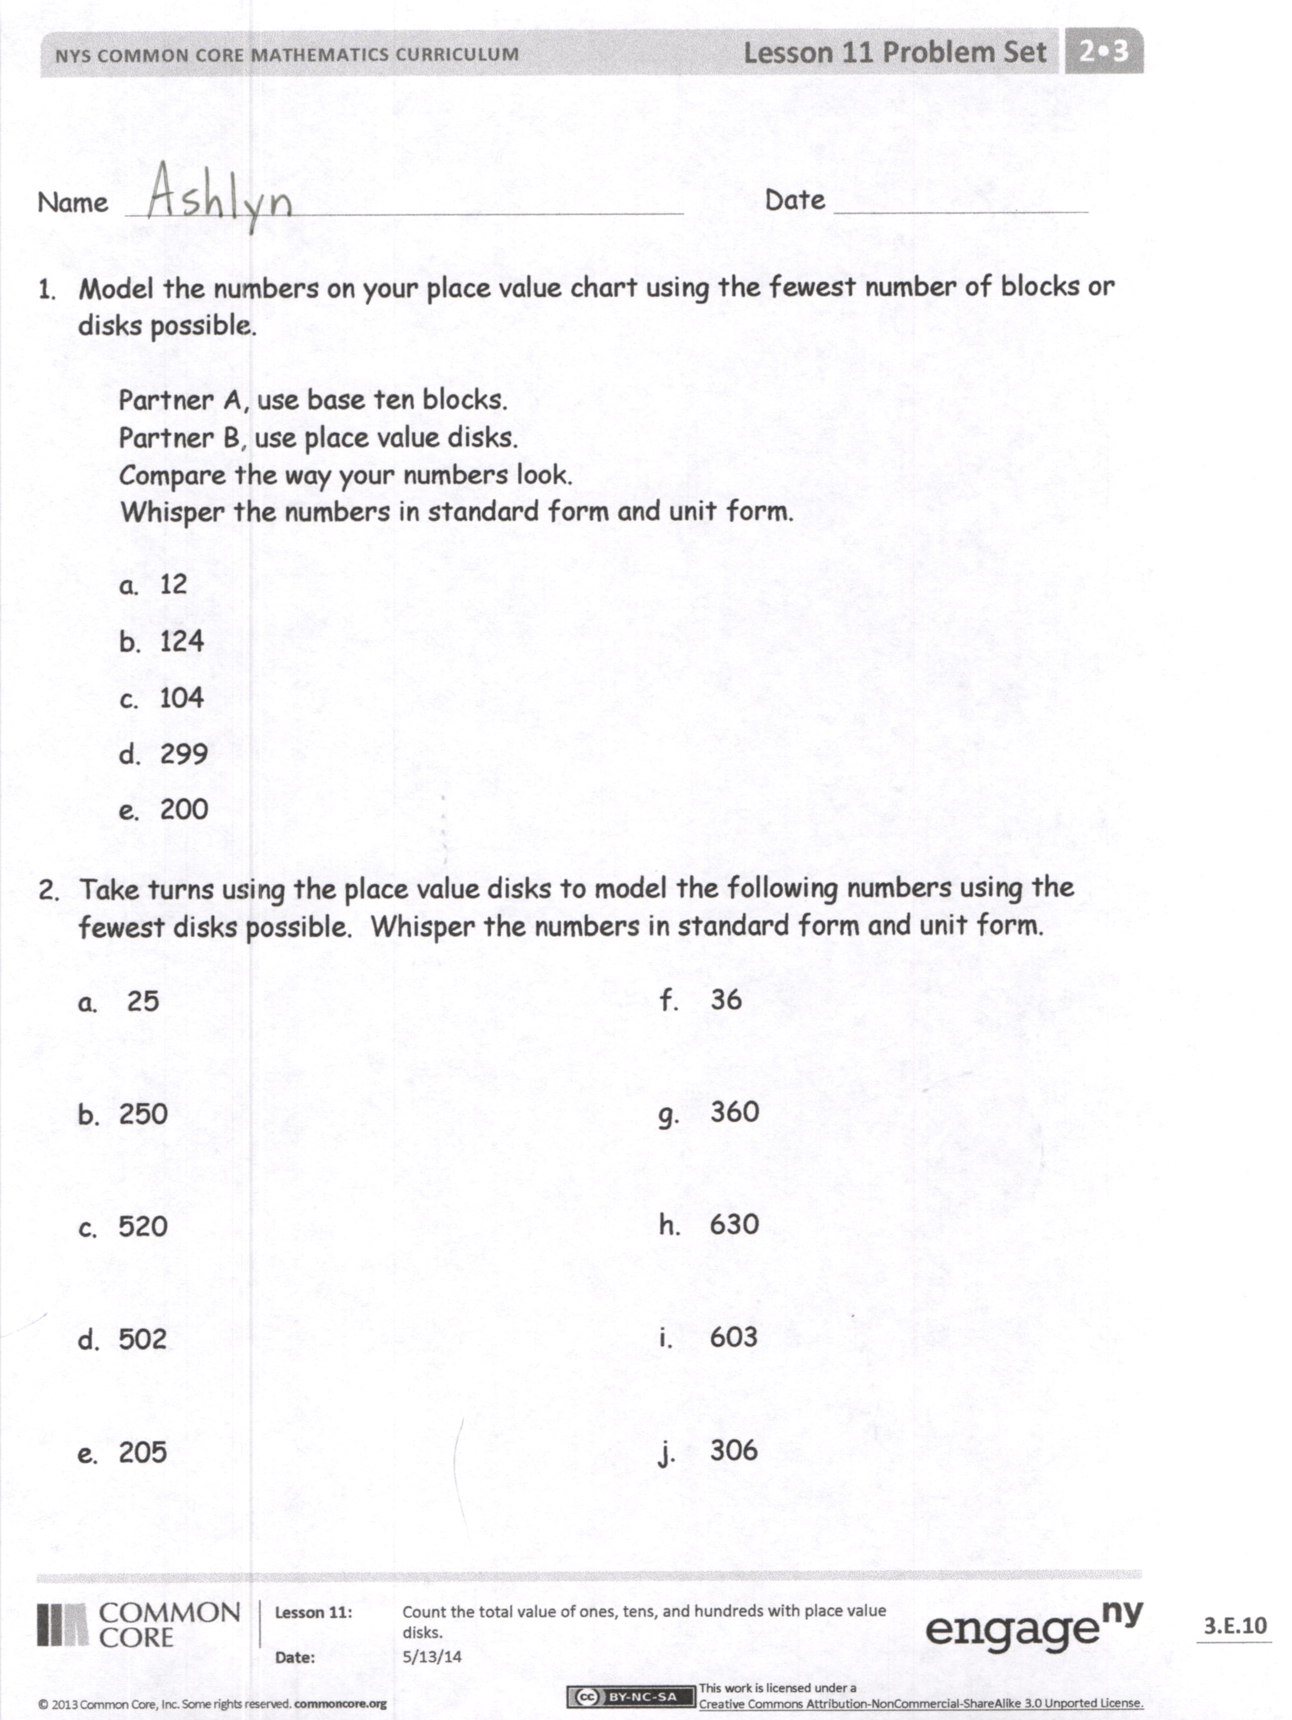
- Partner B use place value disks.
- Whisper each number in unit and standard form.
Problem 2(a–j): Model the numbers on your place value chart using the fewest number of place value disks possible.
- Partners A and B alternate using place value disks.
- Whisper each number in unit and standard form.
Student Debrief (14 minutes)
Lesson Objective: Count the total value of ones, tens, and hundreds with place value disks.
The Student Debrief is intended to invite reflection and active processing of the total lesson experience.
Invite students to review their solutions for the Problem Set. They should check work by comparing answers with a partner before going over answers as a class. Look for misconceptions or misunderstandings that can be addressed in the Debrief. Guide students in a conversation to debrief the Problem Set and process the lesson.
T: Come to the carpet with your partner and your Problem Set. Whisper skip-count down by tens from 300 as you transition to the carpet.

T: Let’s begin with Problem 2(a) and (b). Discuss with your partner how the numbers changed using this sentence frame (posted or written).
I changed ________ to ________.
I changed ________ to ________.
The value of my number changed from ________ to ________.
S: (Might catch on quickly.) I changed 2 tens to 2 hundreds. I changed 5 ones to
5 tens. The value of my number changed from 25 to 250.
T: (If not, ask a student to model.) Let’s have Alejandro use his words for us.
S: I changed 2 tens to 2 hundreds. I changed 5 ones to 5 tens. That changed the value of my number from 25 to 250.
T: Just as Alejandro demonstrated, tell your partner how the numbers changed from Problem 2(b) to 2(c).
S: I changed 2 hundreds to 5 hundreds. I changed 5 tens to 2 tens. The value of my number changed from 250 to 520.
T: You improved! Keep going through the Problem Set’s numbers using words to tell about the changes. (Continue for about four minutes as you circulate and support.)
T: Today we used a new tool, place value disks. Did you enjoy using them?
S: Yes!
T: We will keep our bundles of straws and our base ten blocks here in the math materials center. They will always help us remember the value of our units. I will hold up a unit, you show me the correct place value disk.
T: (Silently hold up a flat. Students hold up a hundred-disk. Hold up a bundle of 10 straws. Students hold up a ten-disk. Hold up a one dollar bill, etc.)
T: Quietly go back to your seats to complete your Exit Ticket.
Exit Ticket (3 minutes)
After the Student Debrief, instruct students to complete the Exit Ticket. A review of their work will help you assess the students’ understanding of the concepts that were presented in the lesson today and plan more effectively for future lessons. You may read the questions aloud to the students.

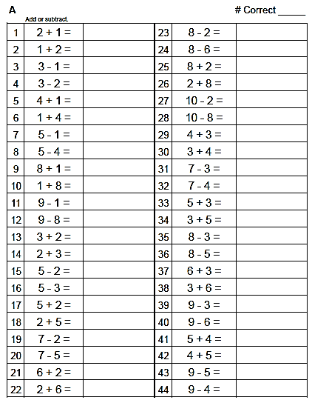

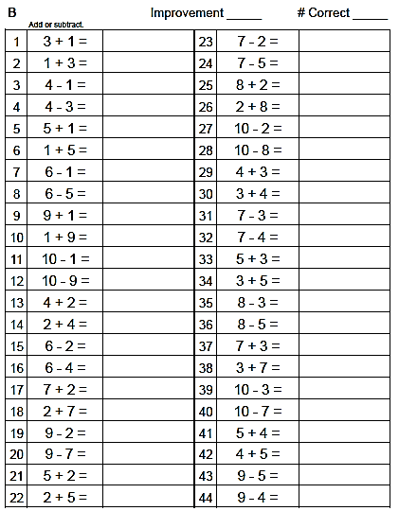

Name Date
- Model the numbers on your place value chart using the fewest number of blocks or disks possible.

Partner A, use base ten blocks.
Partner B, use place value disks.
Compare the way your numbers look.
Whisper the numbers in standard form and unit form.

- 12
- 124
- 104
- 299
- 200
- Take turns using the place value disks to model the following numbers using the fewest place value disks possible. Whisper the numbers in standard form and unit form.

- 25
- 250
- 520
- 502
- 205
- 36
g. 360
h. 630
i. 603
j. 306
Name Date
1. Tell the value of the following numbers.
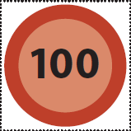 | 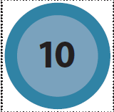
a. b.
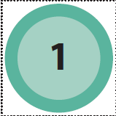

a. __________________ b. __________________

2. Fill in the sentences below to tell about the change from 36 to 360.

  - I changed ______________________ to ______________________.
  - I changed ______________________ to ______________________.

Name Date
Note: Distribute the place value disk template. Students may cut it apart and store the place value disks in a baggie for use at home.
- Model the following numbers for your parent using the fewest disks possible. Whisper the numbers in standard form and unit form (1 hundred 3 tens 4 ones).

  - 15
  - 152
  - 102
  - 290
  - 300

- Model the following numbers using the fewest place value disks possible. Whisper the numbers in standard form and unit form.

- 42 f. 53
- 420 g. 530
- 320 h. 520
- 402 i. 503
- 442 j. 55

100
100
100
100
100
100
100
100
100
100
10
10
10
10
10
10
10
10
10
10
1
1
1
1
1
1
1
1
1
1

place value disks

