Lesson 9
Objective: Count from $10 to $1,000 on the place value chart and the empty number line.

Suggested Lesson Structure
 Fluency Practice (15 minutes)
 Application Problem (8 minutes)
 Concept Development (30 minutes)
 Student Debrief (7 minutes)
Total Time (60 minutes)
Fluency Practice (15 minutes)
- Count and Change Coins to 30 Cents 2.MD.8 (3 minutes)
- Mixed Counting with Ones, Tens, and Hundreds from 1,000 to 0 2.NBT.2 (5 minutes)
- Skip-Count by Twos Beginning at 394 2.NBT.3 (7 minutes)
Count and Change Coins to 30 Cents (3 minutes)
Materials: (T) 11 pennies, 3 dimes

NOTES ON
Multiple Means
of Representation:
This simple activity is students’ first formal experience using coins. For this reason, it’s quite guided. In the next lesson students play again, counting higher and beginning and ending with numbers other than multiples of 10.
The key is to promote gradual independence in working with coins: "I do, we do, you do."

T: (Display and label a penny and a dime.) A penny has a value of 1 cent, or 1 one. A dime has a value of 10 cents, or 1 ten.
T: Let’s count pennies. We’ll count them by ones because they have a value of 1 cent. (Lay out 1 penny at a time as students count to 10.)
S: 1, 2, 3, 4, 5, 6, 7, 8, 9, 10.
T: A dime has the same value as 1 ten. At the signal, say how many pennies are in a dime.
S: 10 pennies are in 1 dime.
T: We’ve counted 10 pennies; let’s change them for 1 dime.
T: Let’s keep going, counting on from 10. (Point to the dime, then lay out pennies as students count to 20.)
S: 10, 11, 12, 13, 14, 15, 16, 17, 18, 19, 20.
T: What is the value of our coins?
S: 20 cents!
T: We’ve completed another ten (point to the pennies). What step can we take to reduce the number of coins, but keep the value of our 20 cents the same? Turn and whisper to your partner.
S: We can change our 10 pennies for another dime.
T: (Change the 10 pennies for another dime.) Thumbs up if this was your idea.
S: (Give thumbs up.)
T: Let’s keep counting. Remember to count the dimes by tens and the pennies by ones.
Continue until students have reached 30 cents and changed 10 pennies for 1 dime a third time.
Mixed Counting with Ones, Tens, and Hundreds from 1,000 to 0 (5 minutes)
Materials: (T) Bundle of one hundred, one ten, and a single stick from Lesson 1
Vary numbers in this second round. You may also choose to isolate a sequence that your students find particularly challenging, and provide them with a minute of partner practice to count up and down the sequence as fast as possible.
Skip-Count by Twos Beginning at 394 (7 minutes)
Materials: (S) Blank piece of paper
Using a blank piece of paper and a pencil, students count by twos beginning at 394. They write numbers, counting as fast and as high as they can for one minute. "Skip-count by" follows the same energizing routine for administration as Sprints. Refer to the Directions for Administration of Sprints, which are in the Module 1 Overview.
Like Sprints, after animated correction, an extra minute for independent practice, sharing with a partner, and a brief kinesthetic exercise, students repeat the counting task. The vast majority of students immediately see improvement on the second effort. Celebrate improvement in the same way you do with a Sprint.
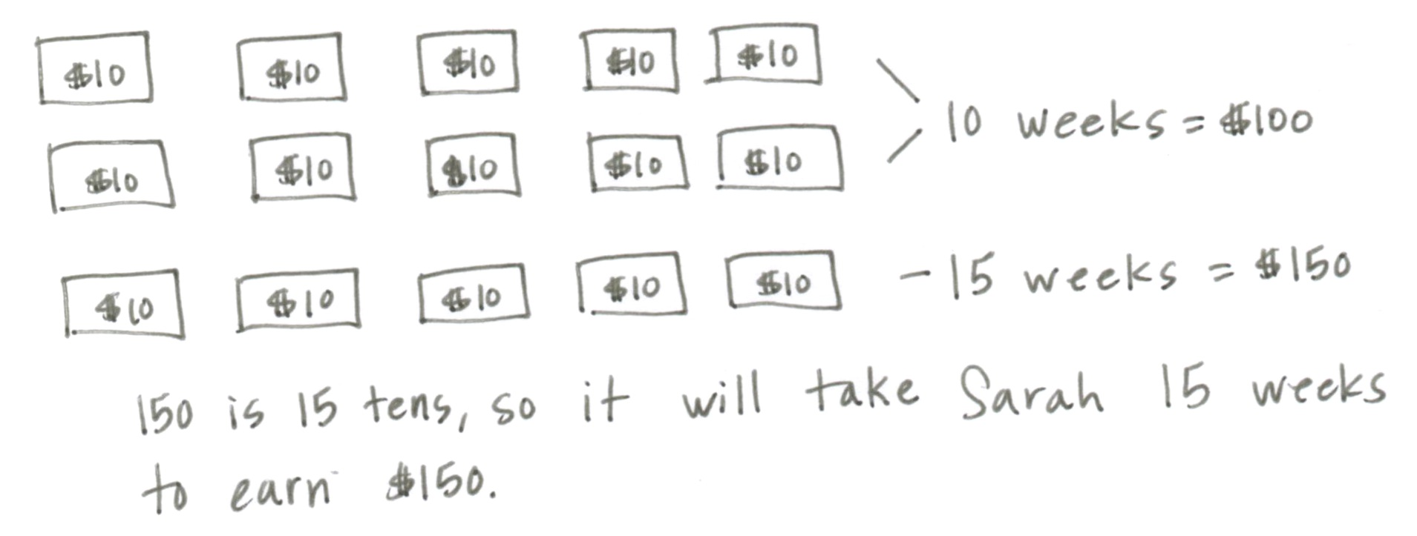
Application Problem (8 minutes)
Sarah earns $10 each week for weeding the garden. If she saves all of the money, how many weeks will it take her to save up $150?
T: Read the problem with me.
T: Work with your partner to come up with 2 different strategies to solve this problem. (Circulate and listen.)
S: I drew circles to be the tens and skip-counted up to 150. Then I counted and it was 15 circles. I wrote 150 equals 1 hundred 5 tens. I know 1 hundred is the same as 10 tens, plus 5 tens. That’s 15 tens. I just know 15 tens is the same as 150 so she needs 15 weeks. I wrote 150 = 100 + 50. I know 100 equals 10 tens and 50 equals 5 tens so the answer is 10 + 5, 15.
T: I like the way you’re using unit form and expanded form to solve. Now that you’ve heard other strategies, talk with your partner about the one you like best and why.
T: (Allow a few minutes.) How many weeks will it take Sarah to save up $150? Give me a complete sentence.
S: It will take Sarah 15 weeks to save $150.
T: Please write that statement on your paper.
Concept Development (30 minutes)
Counting from $776 to $900 (15 minutes)
Materials: (S) Personal white board, unlabeled hundreds place value chart (Lesson 8 Template), 10 one dollar bills, 10 ten dollar bills, 10 hundred dollar bills, baggie per pair
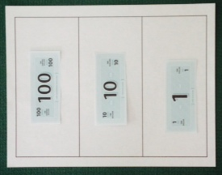
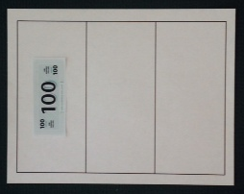
Part A: Counting by One Dollar Bills from $776 to $900 (8 minutes)
Directions:
- Slide the place value chart inside your personal white boards.
- Model $776 on your place value chart.
- Model and whisper count up to $900 by ones.
- Change 10 one dollar bills for 1 ten dollar bill and 10 ten dollar bills for 1 hundred dollar bill as you are able.
- Each time you change 10 bills for 1 bill, let your partner handle the money.
- If you finish before 5 minutes are up, continue counting to 1,000.

T: (Allow students time to work.) You have counted using ones. Partners, talk to your neighboring pair. When you were counting your money, when did you change 10 bills for 1 bill? Give at least two examples.
T: (Wait for pairs to share.) What unit were you just counting by?
S: Ones.

Part B: Counting by One Dollar, Ten Dollar, and Hundred Dollar Bills from $776 to $900 (7 minutes)

NOTES ON
Multiple Means
of Engagement:
Push comprehension to higher levels by inviting students to analyze alternate strategies for efficiency and ease of use. These are often sweet conversations to have with students as they line up, for example. "Which did you feel was the best way to count from 776 to 900 today?"
Some examples of ways to count from $776 to $900 using three units:

- 776 777, 778, 779, 780, 790, 800, 900

- 776 876, 886, 896, 897, 898, 899, 900

- 776 876, 877, 878, 879, 880, 890, 900

T: Show $776 again. This time, count up to $900 on your place value chart with one, ten, and hundred dollar bills. Work with your partner to use all three units of money. If you finish early, count back down to $776.
MP.2
S: (Work for two to three minutes.)
T: How did you count from 776 to 900? (Leave off the dollar signs and record their responses as numerals, as modeled to the right, as they explain to the class.)
S: Count by ones to 780. Skip-count by tens to 800. Count one hundred to get to 900. (See ways to count to the right.)
T: All (or both if you generate two ways) of these counts use three units, ones, tens, and hundreds in different ways.
T: Turn and talk to your partner. What are the friendly numbers in count A?
MP.3
S: 780 and 800.
T: What did we count by first?
S: Ones.
T: How many ones?
S: 4 ones (Count them if necessary).
T: (Draw an empty number line across the board below the counts.) We started at 776 (write) and we counted up 4 ones. What number did our 4 ones get us to?
MP.3
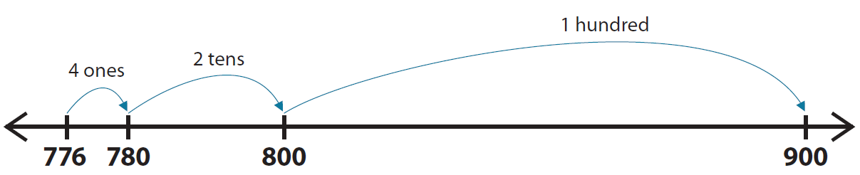
S: 780.
T: (Write 4 ones and 780 on the number line as pictured.) Next what did we count by?
S: Tens.
T: How many tens did we skip-count?
S: 2 tens.
T: What number did 2 tens get us to?
S: 800.
T: (Write 2 tens and 800 as pictured.) Next, what did we count by?
S: Hundreds.
T: How many hundreds did we count?
S: 1 hundred.
T: What number did 1 hundred get us to?
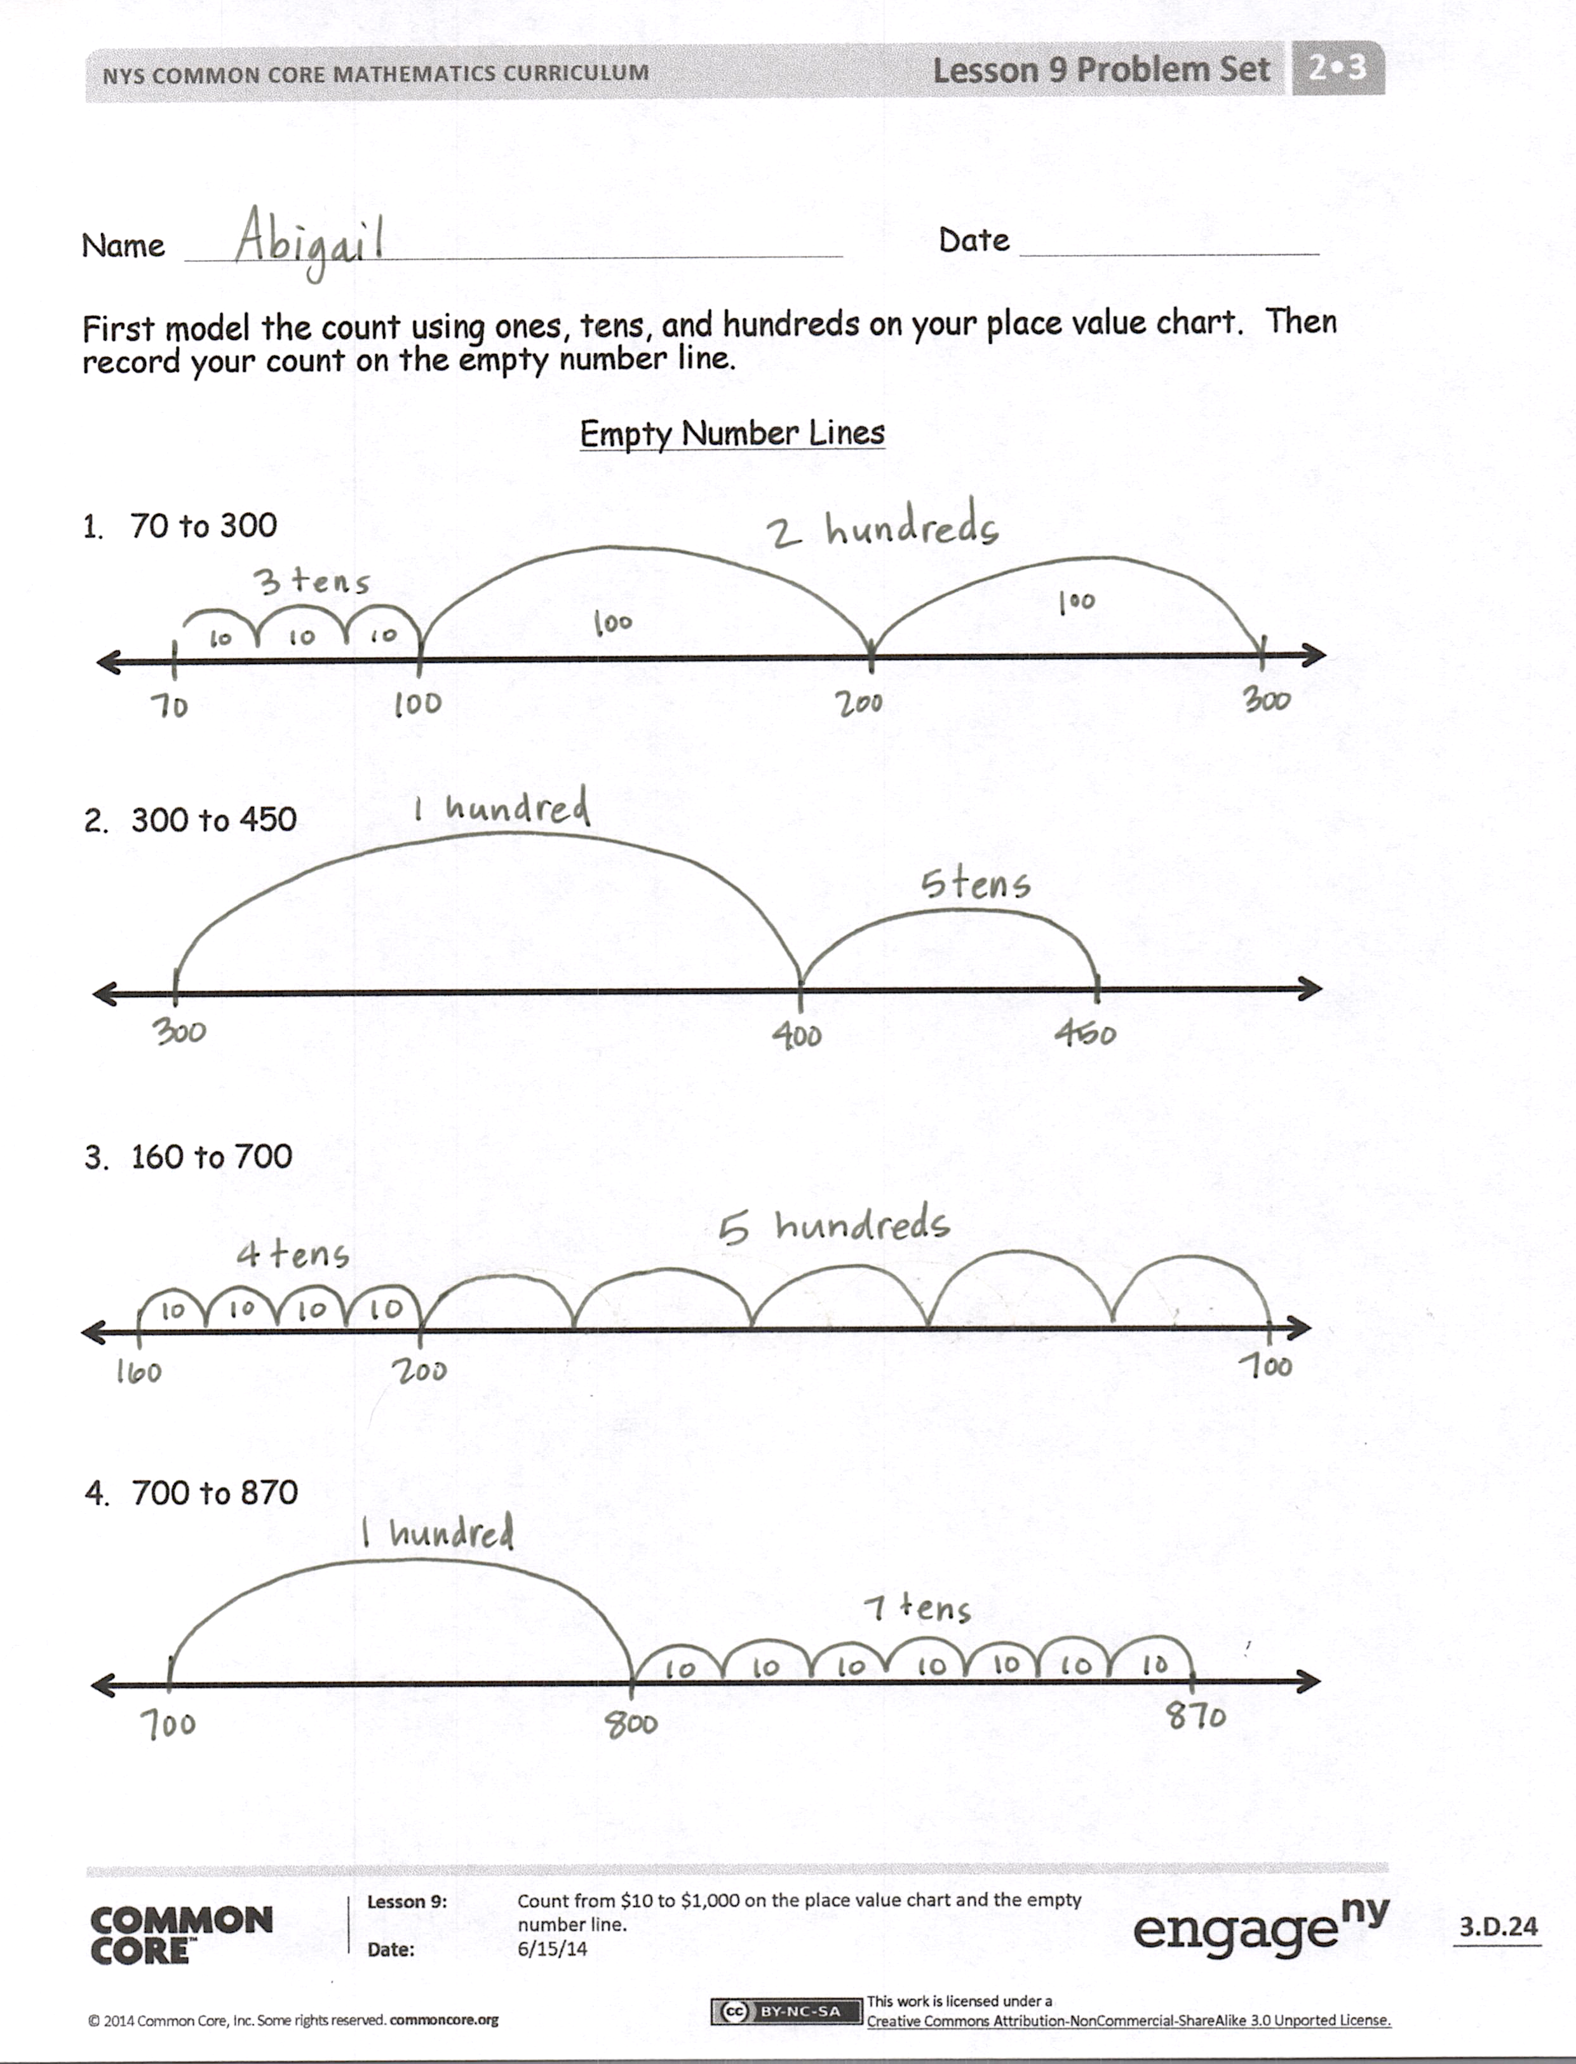
S: 900.
MP.2
T: (Write 1 hundred and 900 as pictured.) Turn and talk to your partner. Explain how the number line shows how we counted from 776 to 900. (Allow time for students to share.)
T: Can we use this same way to count when counting bundled straws, numbers, or money?
S: Yes!
T: A bank teller or store cashier will usually give you your change using a count like the one that we showed on our number line. A lot of times they count silently until they get to a friendly number. Try it.
S: (As teacher lays out bills, silently count 777, 778, 779, speak 780, silently count 790, speak 800, 900 dollars.
T: Let’s try it one more time.
S: (Repeat the count.)
T: Yes. You are hired!! Bank tellers and cashiers use friendly numbers because the count is easier for the customer to follow.
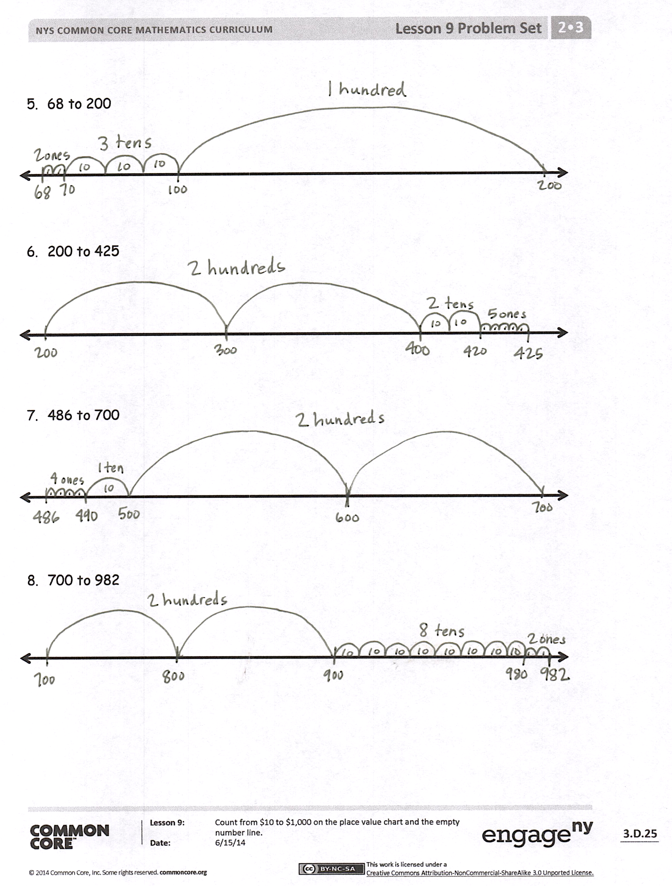
Problem Set (15 minutes)
Students should do their personal best to complete the Problem Set within the allotted 15 minutes. For some classes, it may be appropriate to modify the assignment by specifying which problems they work on first. Some problems do not specify a method for solving. Students should solve these problems using the RDW approach used for Application Problems.
Directions:
- Model the count using your money on the place value chart. Use tens and hundreds for 1–4.
- Record your count on the empty number line Problem Set. Use our example to help you.
- 70 to 300.
- 300 to 450.
- 160 to 700.
- 700 to 870.
- Use ones, tens, and hundreds for 5–8.
- 68 to 200.
- 200 to 425.
- 486 to 700.
- 700 to 982.
Student Debrief (7 minutes)
Lesson Objective: Count from $10 to $1,000 on the place value chart and the empty number line.
The Student Debrief is intended to invite reflection and active processing of the total lesson experience.
Invite students to review their solutions for the Problem Set. They should check work by comparing answers with a partner before going over answers as a class. Look for misconceptions or misunderstandings that can be addressed in the Debrief. Guide students in a conversation to debrief the Problem Set and process the lesson.
T: Bring your Problem Sets with you. Go over the skip-counting you recorded on your number line. Show your partner your work and see if you counted the same way.
T: (Circulate, watch, and listen. Resume talking after students have had time to compare and share, about one minute.)
T: Were your number lines exactly the same?
S: No!
T: There is more than one way to count, just as we saw in our lesson today. However, the number of tens and hundreds should be the same. Let’s go over that.
T: Problem 1, how many hundreds did you count?
S: 2 hundreds.
T: How many tens did you count?
S: 3 tens.
T: What is the value of 2 hundreds 3 tens?
S: 230.
T: Talk to your partner. What does that 230 represent? (Circulate, watch, and listen.)
S: (After about one minute, call on students to share their thinking.) It means that we counted 2 hundred dollar bills and 3 ten dollar bills when we were skip-counting from 70 to 300. It means that on our number line first I went 3 tens and then 2 hundreds. It means that from 70 to 300 is 230. Yeah, it means that 300 is 230 more than 70. It means that 70 and 230 makes 300. Hey, it’s like addition.
T: Excellent. When we put these two parts together, 70 and 230 (point to the number line and then hold up the bills) we get $300.
T: Let’s look at the next one. Did you skip-count by tens or hundreds first?
S: I counted by 1 hundred first because it’s super easy to add 1 hundred to 3 hundred.
S: I skip-counted by tens first just to be different, to see what would happen.
T: How many hundreds did you count?
S: 1 hundred.
T: How many tens did you count?
S: 5 tens.
T: What is the value of 1 hundred 5 tens?
S: 150.
T: Talk to your partner about what that 150 represents.
S: (Talk for about a minute. The students have picked up some ideas now from the first example and will be chattier now. Have them briefly share out ideas.)
T: Let’s quickly go through the answers to the next two.
Repeat the process for Problems 3 and 4. Accept all number lines that make sense. It’s okay if students break 5 hundreds into 5 hops on the number line. Go quickly through some answers so that the pace does not slow.
T: Today we used a tool we are very familiar with, a number line. What number lines have we used before?
S: The meter strip. The clock. Our number line on the classroom wall. Our rulers are kind of like one, too.
T: How was the number line we used today different from all those other number lines? Talk to your partner.
S: It didn’t have marks. It was empty. It didn’t tell us what to count by. We counted in different units, ones, tens, and hundreds. It made me think because I had to guess where a jump of ten was or a hundred. Yes, it was like you just made a good guess where to draw.
T: (Listen and circulate.) I’m hearing you say that this empty number line helps you think about numbers and which jumps on the number line are bigger and which are smaller. Did it help you to model first with your money and then do it?
S: Yes!
T: Excellent. Two different ways to count! We used the number line and the place value chart. When we counted and skip-counted on the number line, as the numbers got bigger we moved from left to right (point and demonstrate silently).
T: However, when we counted on the place value chart, as the numbers got bigger we moved from right to left (demonstrate by bundling silently).
T: Turn and tell your partner how counting on the place value chart is different than on the number line.
Exit Ticket (3 minutes)
After the Student Debrief, instruct students to complete the Exit Ticket. A review of their work will help you assess the students’ understanding of the concepts that were presented in the lesson today and plan more effectively for future lessons. You may read the questions aloud to the students.

Name Date
First, model the count using ones, tens, and hundreds on your place value chart. Then, record your count on the empty number line.

Empty Number Lines

- 70 to 300

- 300 to 450

- 160 to 700

- 700 to 870

- 68 to 200

- 200 to 425

- 486 to 700

- 700 to 982

Name Date
- Jeremy counted from $280 to $435. Use the number line to show a way that Jeremy could have used ones, tens, and hundreds to count.

- Use the number line to show another way that Jeremy could have counted from $280 to $435.

- Use the number line to show how many hundreds, tens, and ones you use when you count from $776 to $900.

To count from $776 to $900, I used ____ hundreds ____tens ____ones.

Name Date
- Write the total amount of money shown in each group.

 | $100 |  | $100 |  | $10 |  | $10 |  | $1 |  | $1 |  | $10 |  | $100
 | $100 |  | $100 |  | $10 |  | $10 |  | $1 |  | $1 |  | $10 |  | $100
 | $100 |  | $100 |  | $10 |  | $10 |  | $1 |  | $1 |  | $10 |  | $100
 | $100 |  | $100 |  | $10 |  | $10 |  | $1 |  | $1 |  | $100 |  | $1
 | $100 |  | $100 |  | $10 |  | $10 |  | $1 |  | $1 |  | $100 |  | $1

_________ _________ _________ ________

- Show one way to count from $82 to $512.

- Use each number line to show a different way to count from $580 to $994.

- Draw and solve.
Julia wants a bike that costs $75. She needs to save $25 more to have enough money to buy it. How much money does Julia already have?
Julia already has $___________.

