Lesson 8
Objective: Count the total value of $1, $10, and $100 bills up to $1,000.

Suggested Lesson Structure
 Fluency Practice (8 minutes)
 Application Problem (8 minutes)
 Concept Development (34 minutes)
 Student Debrief (10 minutes)
Total Time (60 minutes)
Fluency Practice (8 minutes)
- Mixed Counting with Ones, Tens, and Hundreds from 1,000 to 0 2.NBT.2 (5 minutes)
- Doubles 2.OA.2 (1 minute)
- Related Facts Within 20 2.OA.2 (2 minutes)
Mixed Counting with Ones, Tens, and Hundreds from 1,000 to 0 (5 minutes)
Materials: (T) Bundle of one hundred, one ten, and a single stick from Lesson 1
T: Let’s play Mixed Counting using what we know about counting by ones, tens, and hundreds. I’ll hold bundles to show you what to count by. A bundle of 100 means count by hundreds, a bundle of 10 means count by tens, and a single stick means count by ones.
T: Let’s start at 1,000 and count down. Ready? (Hold up a bundle of 10 until students count to 940. If necessary, create visual support with the difficult language of these numbers by writing them on the board as students count.)
S: 990, 980, 970, 960, 950, 940.
T: (Hold up a bundle of 100 until students count to 540.)
S: 840, 740, 640, 540.
T: (Hold up a bundle of 10 until students count to 500.)
S: 530, 520, 510, 500.
T: (Hold up a single one until students count to 495.)
S: 499, 498, 497, 496, 495.
T: (Hold up a ten until students count to 465.)
S: 485, 475, 465.
Continue, varying practice counting with ones, tens, and hundreds.
Doubles (1 minute)
T: I’ll say a doubles fact. You tell me the answer. Wait for my signal. Ready?
T: 5 + 5.
S: 10.
T: 3 + 3.
S: 6.
T: 6 + 6.
S: 12.
T: 1 + 1.
S: 2.
T: 4 + 4.
S: 8.
T: 9 + 9.
S: 18.
T: 2 + 2.
S: 4.
T: 10 + 10.
S: 20.
T: 8 + 8.
S: 16.
T: 7 + 7.
S: 14.
Related Facts Within 20 (2 minutes)
T: I say, “10 – 6.” You say, “6 + 4 = 10.” Wait for my signal. Ready?
T: 8 – 3.
S: 3 + 5 = 8.
T: 13 – 7.
S: 7 + 6 = 13.
T: 11 – 8.
S: 8 + 3 = 11.
T: 15 – 9.
S: 9 + 6 = 15.
Continue in this manner for two minutes.

Application Problem (8 minutes)

NOTES ON
Multiple Means
of Action and Expression:
“Pretend Partner A is the parent and Partner B is the child. Partner B, explain to your parent in your own words what Valeria just shared with the class.”
This type of exchange gives students the opportunity to process key information. The language and thinking of the child who makes the original statement provides support for others. The process of reformulating the idea helps solidify understanding, and verbalizing it helps students clarify and internalize it.

Stacey has $154. She has 14 one dollar bills. The rest is in ten dollar bills. How many ten dollar bills does she have?
T: Let’s read this problem together.
T: Think for a moment then discuss with your partner: How does this problem relate to what we’ve been studying over the past several lessons? What similarities do you notice?
MP.2
S: Money comes in tens and ones, too. We’ve been learning about hundreds, tens, and ones, and money is just like that. A ten dollar bill is like a bundle of ten. It’s units of a hundred, ten, and one just like with the straws. It’s like the place value chart but with money instead of numbers.
T: How can making this connection help you solve the problem? Talk it over with your partner and use what you’ve learned to solve. (Circulate and listen for discussions that rely on unit form, expanded form, and exchanging units to solve.)
S: I know 154 is 1 hundred 5 tens 4 ones. Stacey has 14 ones, and that’s the same as 1 ten 4 ones. So she needs 10 tens to make the hundred and 4 more tens to make 5 tens. She already has 4 ones. 10 tens plus 4 tens is 14 tens.
T: Outstanding reasoning, Valeria!
T: Pretend Partner A is the parent and Partner B is the child. Partner B, explain to your parent in your own words what Valeria just shared with the class. Use words, numbers, and pictures to help your parent understand. Then, switch roles. (Allow students a few minutes.)
T: How many ten dollar bills does Stacey have?
S: 140. 14 ten dollar bills.
T: I like the way many of you said the unit as part of your answer. It helps us be clear about whether we’re answering the question correctly.
T: Reread the question.
S: How many ten dollar bills does she have?
T: Does Stacey have 140 ten dollar bills?
S: No.
T: Always check to be sure your answer makes sense. That’s why it’s important to answer the question with a statement. The question is not how much money does she have. It’s how many ten dollar bills does she have.
T: So, how many ten dollar bills does Stacey have? Give me a complete sentence.
S: Stacey has 14 ten dollar bills.
T: Good! Please add that statement to your paper.
Concept Development (34 minutes)
Materials: (S) Personal white board, unlabeled hundreds place value chart (Template), 10 one dollar bills, 10 ten dollar bills and 10 hundred dollar bills (put money in a plastic baggie “wallet” with the ones should be in the front, tens in the middle, and hundreds in the back)
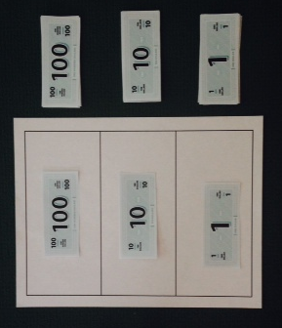
Part A: Counting by 1 Dollar up to $124 (6 minutes)
Note: Have students slide the place value chart template inside their personal white boards. Guide them to place 10 bills of each denomination above each column (pictured). Explain that the place value chart is unlabeled because the value is shown on each bill. Students will encounter this again when they work with place value disks in Topic E.
Directions:
- Count up to $124 by one dollar bills on your place value chart.
- When you get 10 one dollar bills, change them for 1 ten dollar bill.
- When you have 10 ten dollar bills, change them for 1 hundred dollar bill.
- Whisper count the value of your money as you go.
- Each time you make a change, let the other partner handle the money.
T: How is counting up to $124 with money bills different from counting up to 124 with bundles?
S: With straws, we could just get a rubber band. With straws we bundled but with money we changed 10 ones for 1 ten. Yeah, we got a different bill from our wallet. The 10 ten dollar bills got changed for 1 hundred dollar bill. It was a trade, 10 things for 1 thing. The hundred dollar bill has a greater value but it doesn’t show.
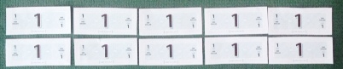
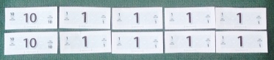
Part B: Manipulating the Value of 10 Bills (6 minutes)
T: Partner A, put 5 one dollar bills in a row horizontally across your desk.
T: Partner B, express the value of the money using this sentence frame. “The value of _ dollar bills is .”
S: The value of 5 one dollar bills is $5.
T: Partner B, put another row of 5 one dollar bills directly below the first row.
T: Partner A, express the new value of the money.
S: The value of 10 one dollar bills is $10.
T: Partner A, change the 2 one dollar bills on the far left for 2 ten dollar bills.
T: Partner B, express the value of the money.
S: The value of 2 ten dollar bills and 8 one dollar bills is $28.
T: Partner B, write the value of the money in expanded form on your personal white board.
S: (Write $20 + $8 = $28.)
T: Show me.
S: (Show the expanded form.)

NOTES ON
Multiple Means
of Engagement:
Speaking and writing simultaneously is a powerful combination, giving students multi-modal input: oral, auditory, and kinesthetic. Whispering adds mystery and is therefore engaging. Circulate and listen intently to the math content in the students' speech. Encourage partners to listen intently, too.

T: Partner B, change the next 2 one dollar bills on the left for 2 ten dollar bills.
T: Partner A, express the value of the money.
S: The value of 4 ten dollar bills and 6 one dollar bills is $46.
T: Partner A, write the value of the money in expanded form.
S: (Write $40 + $6 = $46.)
T: Show me.
S: (Show the expanded form.)
T: Partner A, change 6 one dollar bills to 6 ten dollar bills.
T: Partner B, express the value of the money.
S: The value of 10 ten dollar bills is $100!
Part C: Hundred, Ten, and One Dollar Bills (11 minutes)
T: Show me $64.
T: Partner A, change the 2 ten dollar bills on the left to 2 one hundred dollar bills.
T: What is the new value?
S: The value of 2 hundred dollar bills, 4 ten dollar bills, and 4 one dollar bills is $244.
T: Write the value of the money in expanded form.
S: (Write $200 + $40 + $4 = $244.)
T: Show me.
S: (Show the expanded form.)
T: Partner B, change 1 ten dollar bill on the left to 1 hundred dollar bill.
T: What is the new value?
S: The value of 3 hundred dollar bills, 3 ten dollar bills, and 4 one dollar bills is $334.
T: Write the value of the money in expanded form.
S: (Write $300 + $30 + $4 = $334.)
T: Show me.
S: (Show the expanded form.)

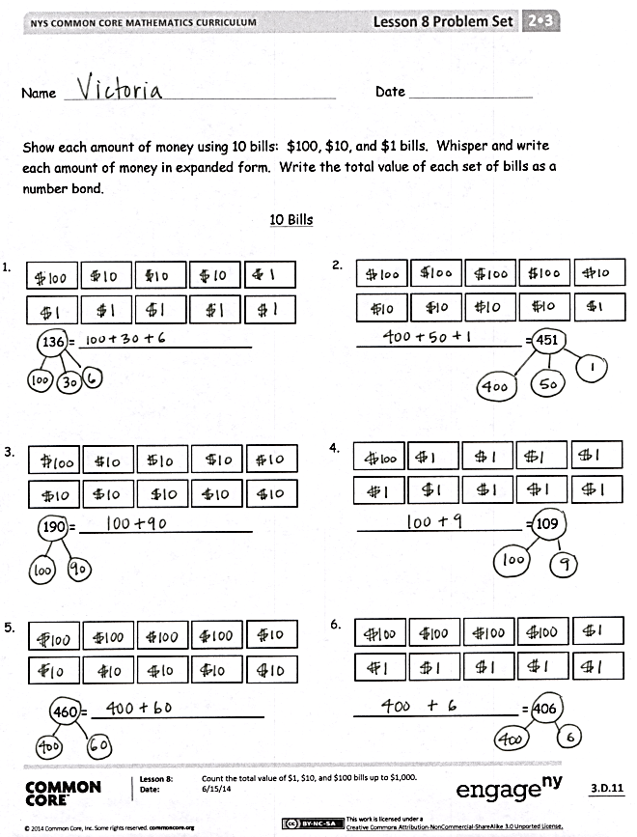
Continue as above using the following sequence:
- From $334, change 3 tens to 3 hundreds. (The new amount is $604.)
- From $604, change 4 ones to 4 tens. (The new amount is $640.)
- From $640, change 2 tens to 2 hundreds. (The new amount is $820.)
- From $820, change 1 ten to 1 one. (The new amount is $811.)
- From $811, change 1 ten to 1 one. (The new amount is $802.)
- From $802, change 2 ones to 2 hundreds. (The new amount is $1,000.)
Problem Set (11 minutes)
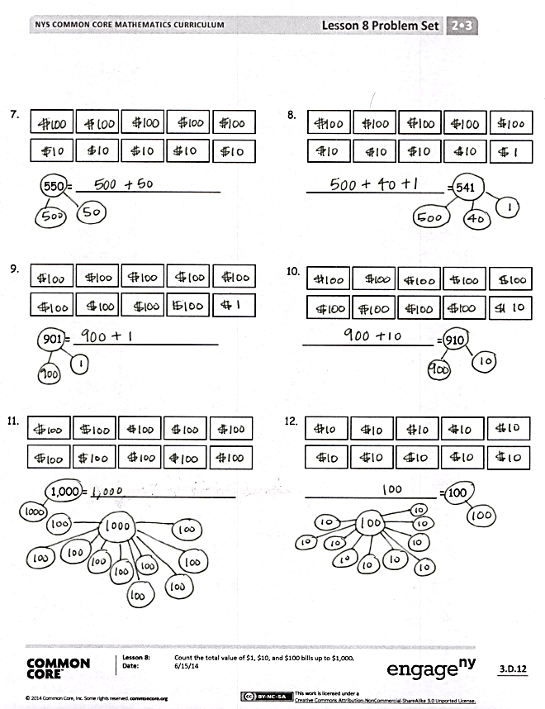
Students should do their personal best to complete the Problem Set within the allotted 11 minutes. For some classes, it may be appropriate to modify the assignment by specifying which problems they work on first. Some problems do not specify a method for solving. Students should solve these problems using the RDW approach used for Application Problems.
Directions:
1. Represent each amount of money using 10 bills.
2. Write and whisper each amount of money in expanded form.
3. Write the total value of each set of bills as a number bond.

Student Debrief (10 minutes)
Lesson Objective: Count the total value of $1, $10, and $100 bills up to $1,000.
Materials: (T) 1 bundle of 100 straws
(S) Completed Problem Set
The Student Debrief is intended to invite reflection and active processing of the total lesson experience.

Invite students to review their solutions for the Problem Set. They should check work by comparing answers with a partner before going over answers as a class. Look for misconceptions or misunderstandings that can be addressed in the Debrief. Guide students in a conversation to debrief the Problem Set and process the lesson.
T: Discuss with your partner: Using any combination of $1, $10, and $100 bills, what is the smallest amount of money you can show with 10 bills, and what is the greatest amount of money you can show with 10 bills?
T: (As students discuss the question, circulate and listen.)
T: I heard many of you saying the smallest amount is…?
S: $10.
T: The largest amount is…?
S: $1,000.
T: So the value of the money changes, but what stays the same?
S: The size of the bills stays the same.
T: How do you know the value of the money?
S: By looking at it. The value of each bill is written on it.
T: If you were blind, could you know its value?
S: No!
T: That’s true here in America, but it’s interesting to note that in other countries bills come in different sizes and even colors!
T: (Hold up a hundred bundle.) What about the value of this bundle? If you were blind would you know? Talk to your partner about that.
S: Yes, because you could feel it was big. Yes, because you could count the sticks. Yes, because you could count the number of tens.
T: (Hold up a hundred dollar bill.) Somebody decided this bill had a value of $100! But this bundle is 100 because it has 100 sticks and we can count them.
T: Share your Problem Set with your partner. Compare answers and drawings for one minute.
T: I will read the answers now. If you got it correct, say yes.
T: (Read the answers as students correct.)
T: Take a moment to analyze and talk about Problems 3 and 4: $190, and $109. What is different about the numbers?
S: $190 has no one dollar bills and 9 ten dollar bills. $109 is less than $190 because it has 9 ones and no tens. Wow. That is a big difference. Hmmm, that’s 10, 20, 30, 40, 50, 60, 70, 80, 90. That’s $81 more!
T: Do the same thing with Problems 2, 5, and 6: $451, $460, and $406. What is different about the numbers?
S: $460 is 9 dollars more than $451. $460 and $406 switched the number of tens and ones. There are 6 ten dollar bills in $460, but only 6 one dollar bills in $406.
T: When you counted to $124, what happened when you had 10 one dollar bills?
S: You could change them for 1 ten dollar bill.
T: What happened when you had 10 ten dollar bills?
S: You could change them for 1 hundred dollar bill.
T: Which has a greater value, 3 hundred dollar bills or 9 ten dollar bills?
S: 3 hundred dollar bills!
T: We counted the total value of many different amounts of money!
Exit Ticket (3 minutes)
After the Student Debrief, instruct students to complete the Exit Ticket. A review of their work will help you assess the students’ understanding of the concepts that were presented in the lesson today and plan more effectively for future lessons. You may read the questions aloud to the students.

Name Date
Show each amount of money using 10 bills: $100, $10, and $1 bills. Whisper and write each amount of money in expanded form. Write the total value of each set of bills as a number bond.
10 Bills

1.

2.

136 = _____________________ ____________________ = 451

3.

4.

190 = _____________________ ____________________ = 109

6.

5.

460 = _____________________ ____________________ = 406

8.

7.

550 = _____________________ ____________________ = 541

10.

9.

901 = _____________________ ___________________ = 910

12.

11.

1,000 = _____________________ ___________________ = 100

Name Date
- Write the total value of the money shown below in standard and expanded form.
$1
$1
$1
$1
$1
$1
$10
$10
$10
$10
$10
$100
$100
$100

Standard form: _____________________
Expanded form: _____________________

- What is the value of 3 ten dollar bills and 9 one dollar bills? ________________

- Draw money to show 2 different ways to make $142, using only $1, $10, and $100 bills.

Name Date
- Write the total value of the money.
$10
$10
$10
$10
$10
$10
$1
$10
$10
$10

________

$100
$100
$10
$1
$1
$1
$1
$1
$1
$1

________

- Fill in the bills with $100, $10, or $1 to show the amount.

$172

$226

- Draw and solve.

Brandon has 7 ten dollar bills and 8 one dollar bills. Joshua has 3 fewer ten dollar bills and 4 fewer one dollar bills than Brandon. What is the value of Joshua’s money?

unlabeled hundreds place value chart

