Lesson 6
Objective: Write base ten numbers in expanded form.

Suggested Lesson Structure
 Fluency Practice (12 minutes)
 Application Problem (8 minutes)
 Concept Development (30 minutes)
 Student Debrief (10 minutes)
Total Time (60 minutes)
Fluency Practice (12 minutes)
- Meter Strip Addition 2.NBT.5 (7 minutes)
- Unit Form Counting from 398 to 405 2.NBT.3 (3 minutes)
- Think 10 to Add 9 2.OA.2 (2 minutes)
Meter Strip Addition: With Two-Digit Numbers and Totals in the Ones that Are Greater
Than 12
(7 minutes)
Materials: (S) Meter strip (Lesson 1 Fluency Template), personal white board
T: (Each student has a meter strip.) We’re going to practice addition using our meter strips.
T: Put your finger on 0. Slide up to 27 centimeters. (Wait) Slide up 35 more centimeters. You might first skip-count by ten three times, then go up 5 ones.
T: How many centimeters did you slide up altogether?
S: 62 centimeters.
T: Tell your partner a number sentence describing sliding from 27 to 62.
S: 27 + 35 = 62.
T: Put your finger on 0 centimeters. Slide up to 38 centimeters. (Wait) Slide up 36 more centimeters.
T: How many centimeters did you slide up altogether?
S: 74 centimeters!
T: At the signal say a number sentence describing sliding from 38 to 74.
S: 38 + 36 = 74.
Continue with the following possible sequence: 37 + 37, 45 + 28, 49 + 26, 68 + 28, and 57 + 29.

T: In each of these problems we had more than 9 ones so we had to make a new ten. I will write an expression. Wait for the signal. Say “make ten” if you have more than 9 ones. Say, “you can’t make ten,” if there are not enough ones.
T: 35 + 22.
S: You can’t make ten.
T: 63 + 16.
S: You can’t make ten.
T: 48 + 29.
S: Make ten.
T: 36 + 54.
S: Make ten.
T: 27 + 16.
S: Make ten.
T: Now, turn to your partner and on your personal white board, write as many addition expressions as you can solve on your meter strip that need to make ten. You have one minute. Take your mark, get set, go!
Unit Form Counting from 398 to 405 (3 minutes)
Materials: (T) Hide Zero cards (Lesson 4 Template 1)
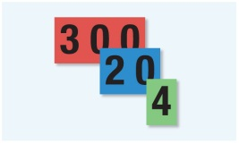
T: Today we’re going to practice unit form counting. This time we’ll include hundreds! The unit form way to say 324 is “3 hundreds 2 tens 4 ones.” (Pull the cards apart to show the 300, 20, and 4.)
MP.6
T: Try this number. (Show 398. Signal.)
S: 3 hundreds 9 tens 8 ones.
T: (Pull cards apart.) That’s right!
T: Let’s count on from 398 the unit form way. (Display 399–405 with Hide Zero cards as students count.)
S: 3 hundreds 9 tens 9 ones, 4 hundreds, 4 hundreds 1 one, 4 hundreds 2 ones, 4 hundreds 3 ones, 4 hundreds 4 ones, 4 hundreds 5 ones.
Think 10 to Add 9 (2 minutes)
T: Listen carefully! If I say, “9 + 5,” you say, “10 + 4.” Wait for my signal. Ready?
T: 9 + 5.
S: 10 + 4.
T: 9 + 3.
S: 10 + 2.
T: 9 + 7.
S: 10 + 6.
T: 9 + 4.
S: 10 + 3.
T: 9 + 2.
S: 10 + 1.
T: 9 + 6.
S: 10 + 5.
T: 9 + 9.
S: 10 + 8.
T: 9 + 8.
S: 10 + 7.
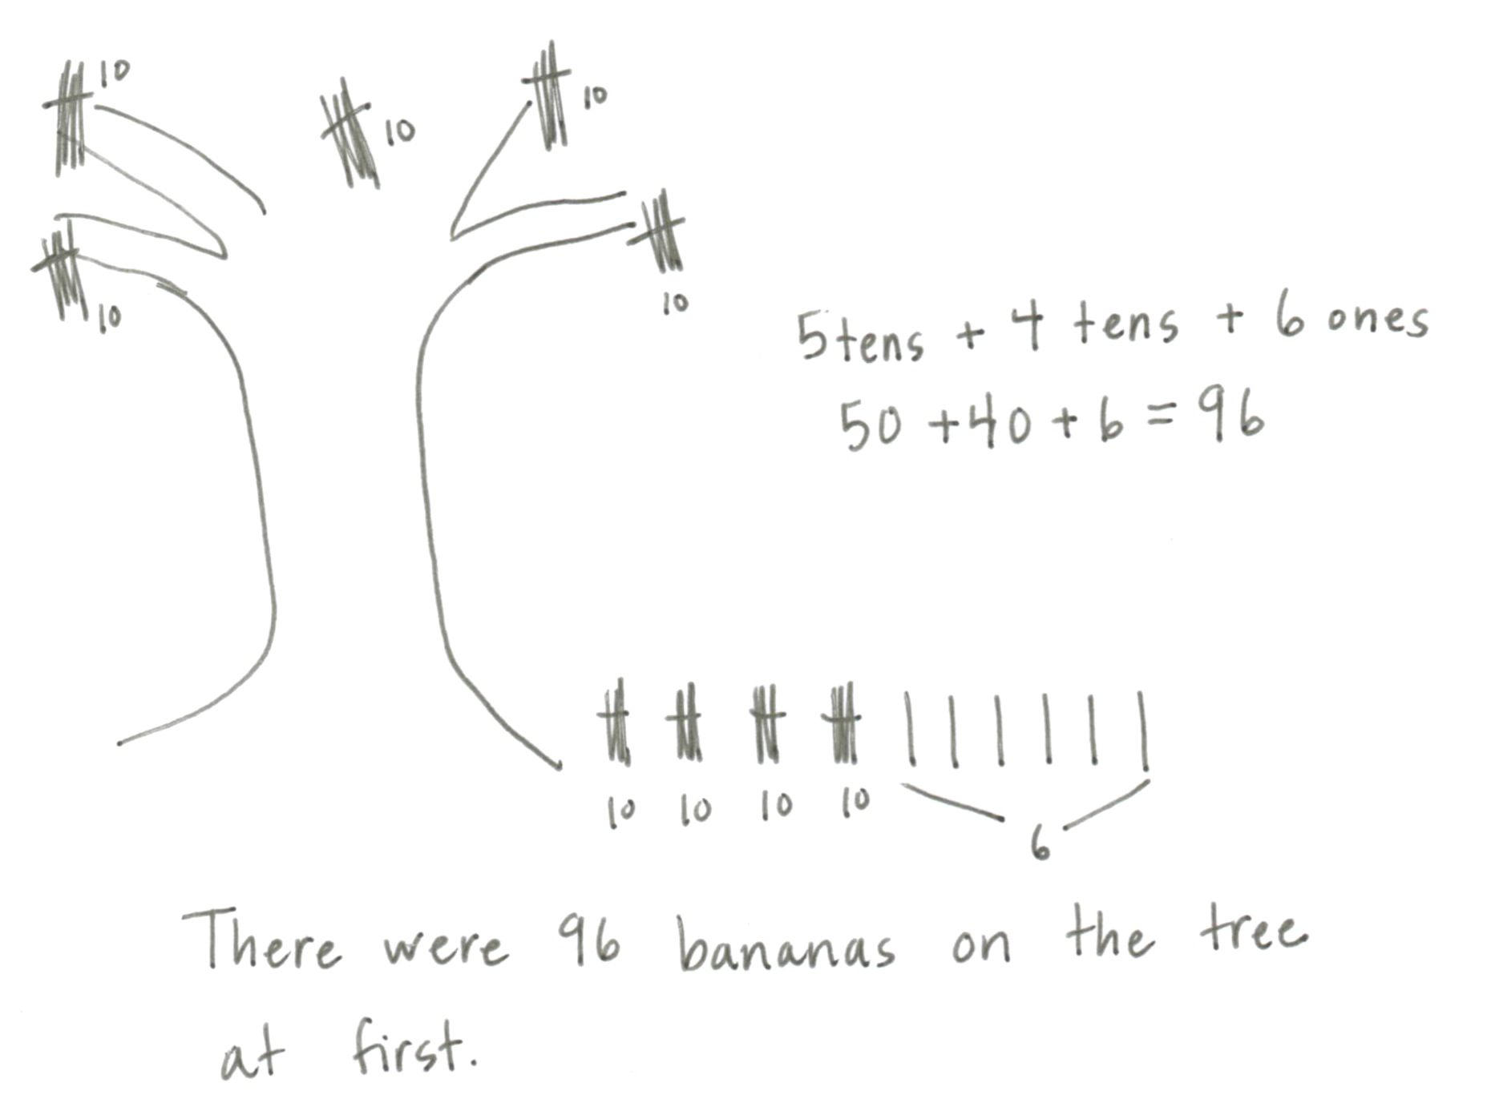
Application Problem (8 minutes)
Timmy the monkey picked 46 bananas from the tree. When he was done, there were 50 bananas left. How many bananas were on the tree at first?
T: Read the problem with me.
T: Close your eyes and visualize Timmy the monkey and all those bananas.
T: Talk with your partner: What can you draw to show what you see?
S: I can draw the 46 bananas Timmy picked, and I can draw 50 bananas that are still on the tree.
T: What is the question asking? Read it again.
S: How many bananas were on the tree at first?
T: At first means at the very beginning of the story, before Timmy picked any bananas.
T: Work with your partner. How many different ways can you find the answer? (Circulate and listen for different strategies.)
T: Who would like to share their thinking?
S: At the beginning all the bananas were on the tree, so I drew 4 tens 6 ones and 5 tens and then I added and got 9 tens 6 ones, 96. I know 50 is 5 tens so I counted on 5 tens from 46: 56, 66, 76, 86, 96. I made a number bond of 46 as 40 and 6, and then I wrote 50, and 40 plus 50 is 90, plus 6 more is 96.
T: Such creative problem solving! And did we all get the same answer?
S: Yes!
T: So how many bananas were on the tree at first? Give me a complete sentence.
S: 96 bananas were on the tree at first!
T: Yes! Please add that statement to your paper.

Concept Development (30 minutes)
Materials: (T) Place value “box,” bundles of straws for modeling (S) Hide Zero cards (Lesson 4 Template 1), math journal or paper
Expanded Form in Unit Order (8 minutes)
T: (Have the number 243 both written and modeled in the place value boxes.) Read this number to me in unit form. (Point.)
S: 2 hundreds 4 tens 3 ones.
T: Count for me up to 243 using the bundles in my place value box. (Record their count numerically by unit on the board in a single line horizontally as pictured to the right.)
100 100 10 10 10 10 1 1 1

S: 1 hundred, 2 hundred, 2 hundred ten, 2 hundred twenty….
T: Each time we count a new unit, we are adding it to what we had before. Let’s reread this putting in addition symbols.
T: (Write in the symbols as students read.)
S: 100 + 100 + 10 + 10 + 10 + 10 + 1 + 1 + 1 = 243.
100 + 100 + 10 + 10 + 10 + 10 + 1 + 1 + 1 = 243
200 + 40 + 3 = 243

T: Explain to your partner why this is the same as 243.
T: (Point to 100 + 100.) The answer is?
S: 200.
T: (Write it below, then point to 10 + 10 + 10 + 10.) The answer is?
S: 40.
T: (Write it below, then point to 1 + 1 + 1.) The answer is?
S: 3.
T: (Write it below.) 100 + 100 + 10 + 10 + 10 + 10 + 1 + 1 + 1 = ?
T: Say the number in unit form.
S: 2 hundreds 4 tens 3 ones.
T: (Point to the number sentence.) Are there 2 hundreds? 4 tens? 3 ones?
S: Yes!
T: 200 + 40 + 3 is?
S: 243.
T: Show 243 with your Hide Zero cards.
T: 240 + 3 is?
S: 243.
T: 200 + 43 is?
S: 243.
T: There are different ways we can write our number. Now, let’s add the total value of each unit.
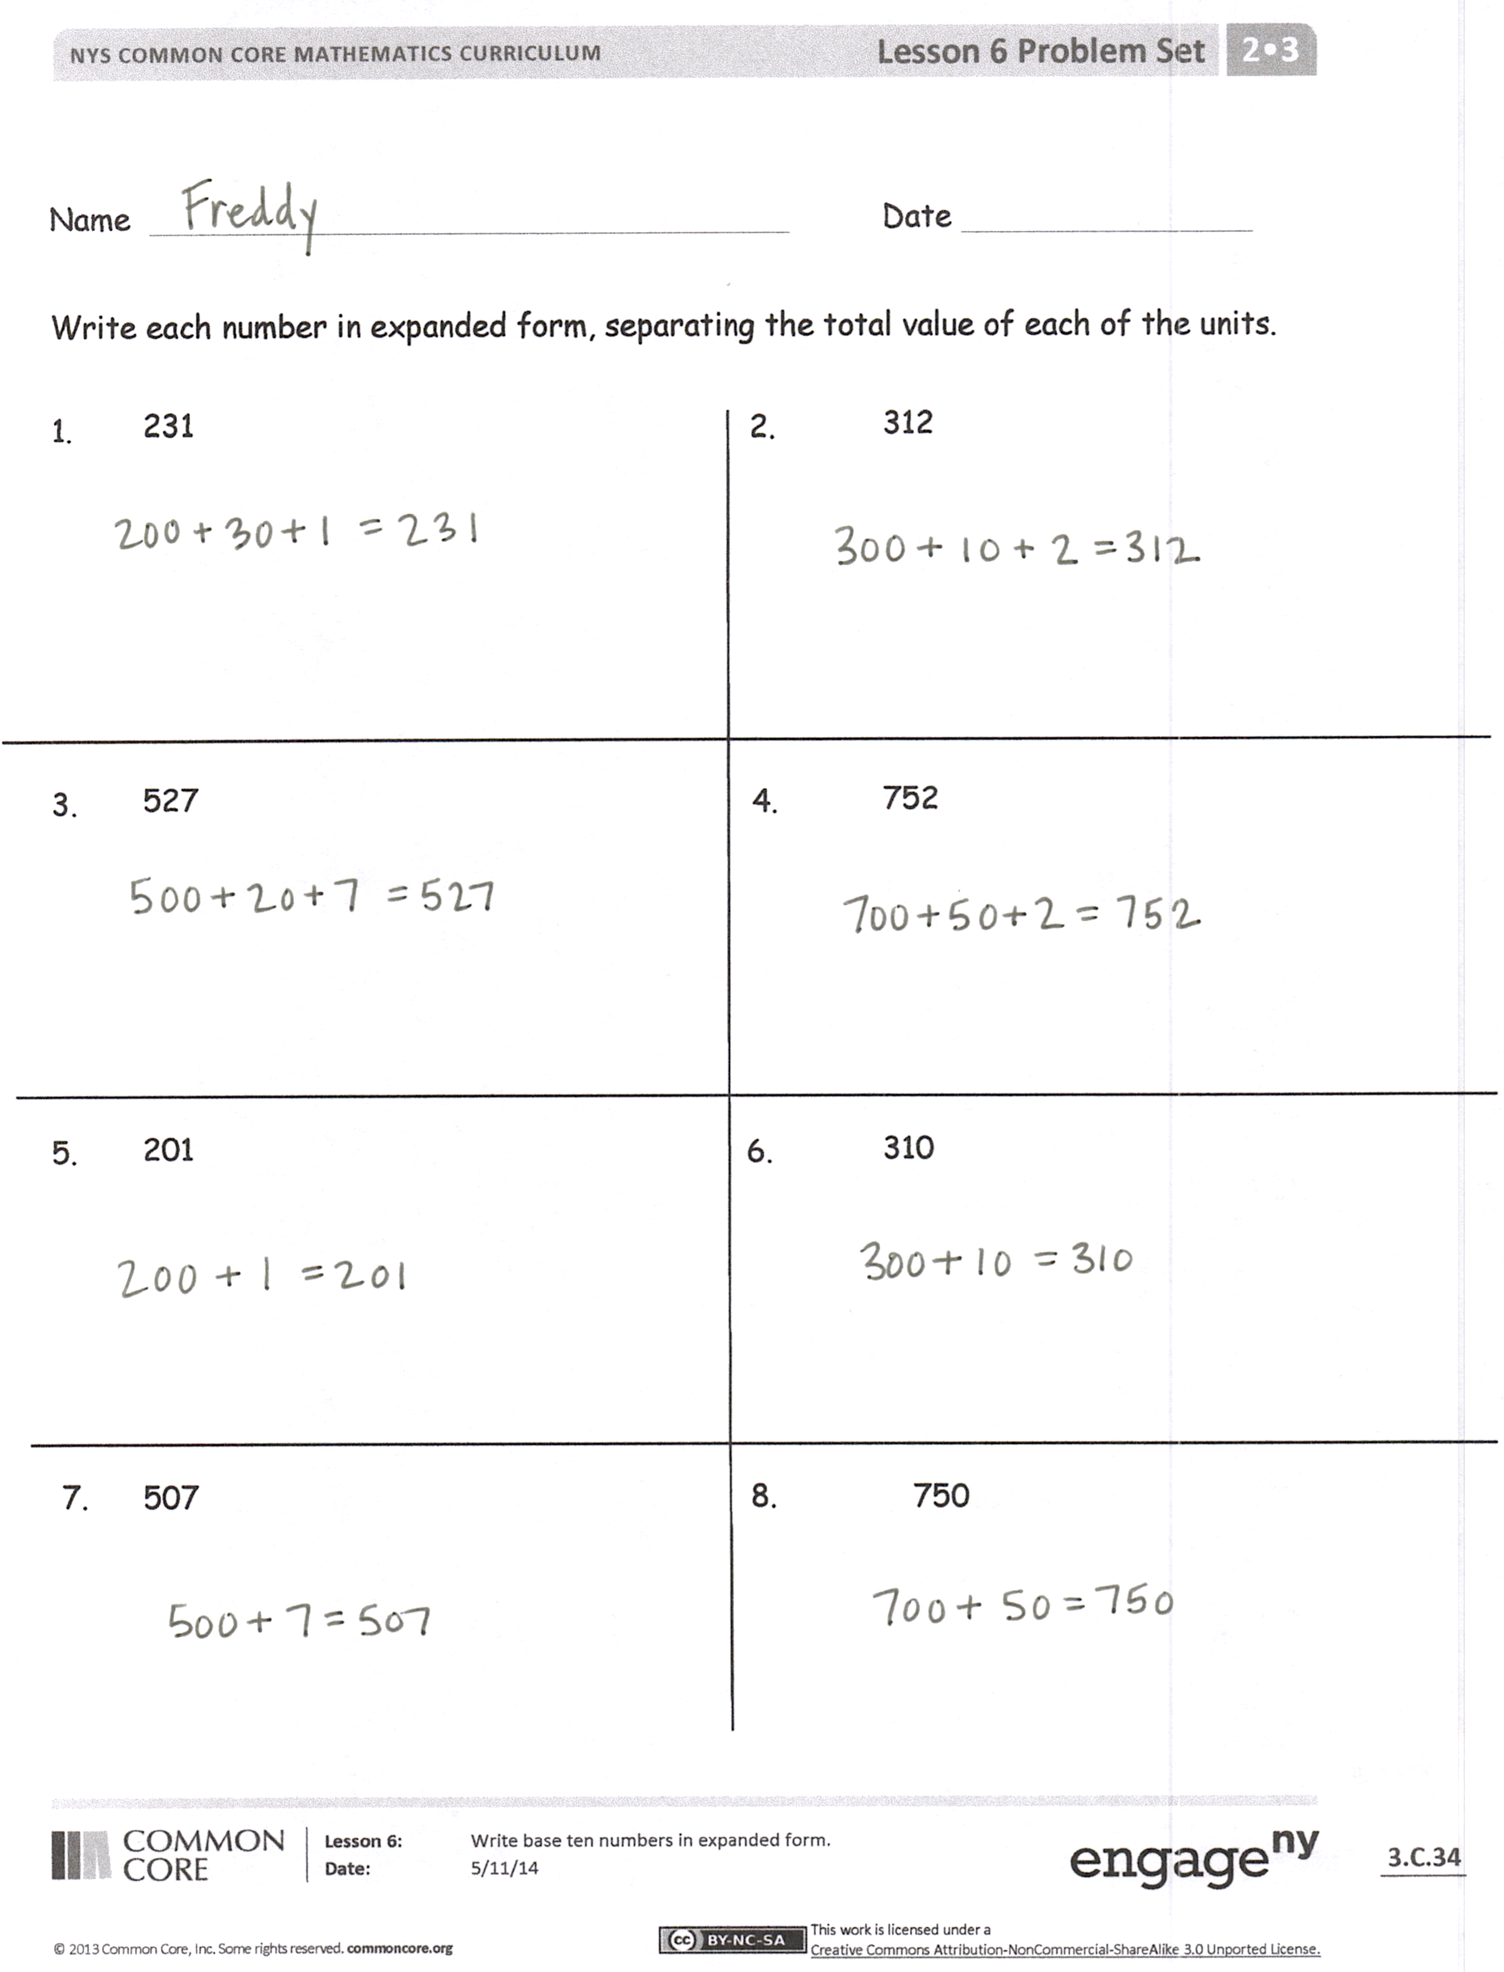
T: What is the total value of the hundreds in 243?
S: 200.
T: (Continue with the tens and ones.)
T: Now again, give me an addition sentence that adds up the total value of each of the units.
S: 200 + 40 + 3 = 243.
Problem Set Side 1 (7 minutes)
Students should do their personal best to complete the Problem Set within the allotted 7 minutes. For some classes, it may be appropriate to modify the assignment by specifying which problems they work on first. Some problems do not specify a method for solving. Students should solve these problems using the RDW approach used for Application Problems.
T: Excellent. Now you’ll practice that so you get really good at it. On your Problem Set, write each number as an addition sentence separating the total value of each of the units. Let’s do the first one together. (Guided practice.)
T: You have five minutes to do your personal best.
Guided Practice: Expanded Form out of Unit Order (10 minutes)
T: Let’s move the units around. (Pick up the 2 bundles of hundreds and move them to the end.)
T: (Write) 10 + 10 + 10 + 10 + 1 + 1 + 1 + 100 + 100 = ?

NOTES ON
Multiple Means
of Representation:
When completing the Problem Set, let struggling students use the base ten materials, either the Dienes blocks or the straw bundles. The concrete representation often helps trigger the language and improves their confidence. Transition them to the abstract number and its word form by hiding the materials rather than taking them away entirely.

T: Explain to your partner why this is the same as 243.
T: (Point to the number sentence.) Are there 2 hundreds?
4 tens? 3 ones?
S: Yes!
T: 40 + 3 + 200 is?
S: 243.

10 + 10 + 10 + 10 + 1 + 1 + 1 + 100 + 100 = 243

40 + 3 + 200 = 243

T: Can someone explain what they understand about the order of the units and the total value? Talk about it with your partner first. (After a few moments.)

S: I notice that 3 and 40 and 200 is the same as 200 and 3 and 40. They’re both 243. We can write the units in any order but the total stays the same. It doesn’t matter which unit we say first. It all adds up to the same amount.
T: Yes! It’s important to be on the lookout for patterns and structures you can use to make sense out of math!
T: You’ve discovered there are different ways we can write our units but the order does not affect the totals.
T: What is 2 + 4 + 3?
S: 9.
T: What is 3 + 4 + 2?
S: 9.
T: Explain to your partner why these totals are equal.
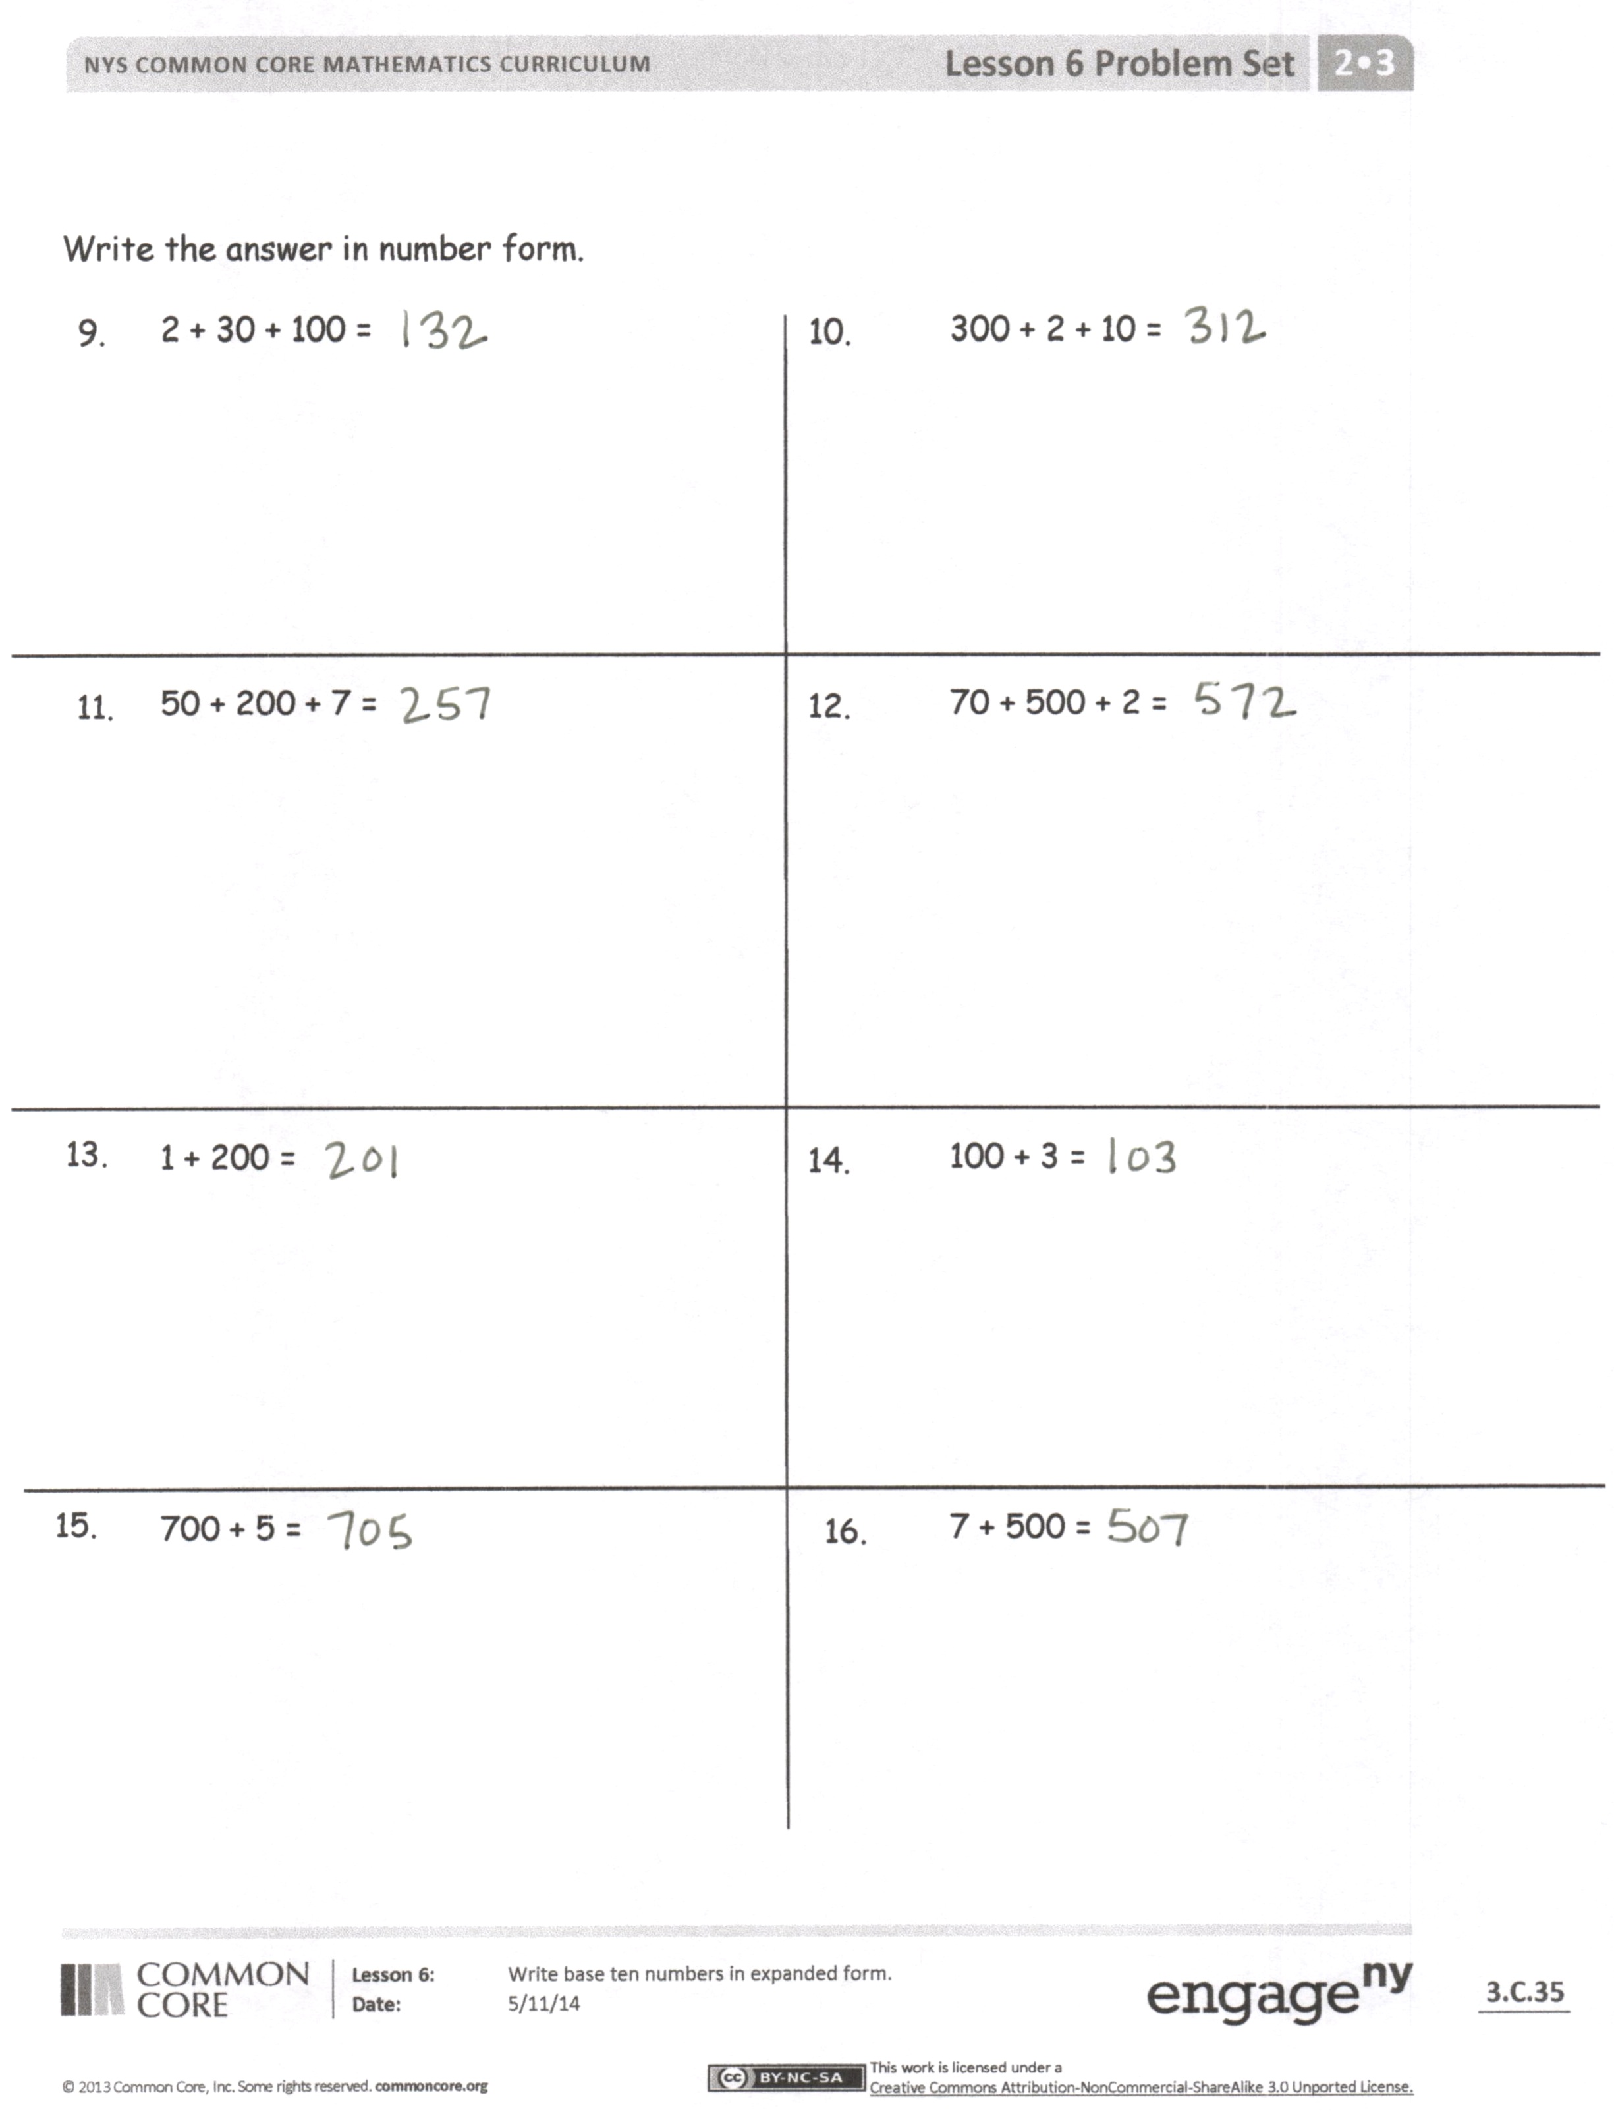
S: 6 + 3 is 9 and 7 + 2 is 9, too. When you add it doesn’t matter if the parts are switched around. You can make both problems 5 + 4 just by adding 2 and 3 first. You can make both sides equal to 7 + 2 just by adding the 4 and 3 first.
T: Is the same true if our numbers are larger?
2 + 4 + 3 = 3 + 4 + 2
9 = 9

200 + 40 + 3 = 40 + 3 + 200
243 = 243
S: Yes!
Problem Set Side 2 (5 minutes)
T: Excellent. Let’s practice that so you get really good at it. I have written some addition problems that tell the total value of each unit. Please write the total value in numerals. Be careful because they are not in order from the largest to the smallest unit!
Student Debrief (10 minutes)
Lesson Objective: Write base ten numbers in expanded form.
The Student Debrief is intended to invite reflection and active processing of the total lesson experience.
Invite students to review their solutions for the Problem Set. They should check work by comparing answers with a partner before going over answers as a class. Look for misconceptions or misunderstandings that can be addressed in the Debrief. Guide students in a conversation to debrief the Problem Set and process the lesson.
T: Bring your Problem Set to our lesson Debrief. Check your answers for two minutes in groups of three.
S: (Check answers.)
T: Now, I’m going to read the answers. If you got it correct, whisper yes.
T: Number 1, 200 + 30 + 1 = 231.
S: Yes! (Continue through both sides of the Problem Set at a lively pace.)
T: Work out any mistakes you made for one minute. Ask your group for help if you need it.
S: (Work together.)
T: I have written up pairs of problems that I want you to compare. How are they the same? How are they different?
1 and 2
3 and 4
1 and 5
2 and 6
3 and 7
4 and 8
9 and 10
11 and 12
1 and 9
2 and 10
7 and 16
Look for other connections, too.

NOTES ON
Multiple Means
of Action and Expression:
Not all students will finish copying the rows in the given time frame. Early finishers can generate their own examples of expanded form and trade papers with a partner to check their work.

T: When we write our numbers as addition sentences with parts representing the total value of each unit, it is called expanded form. It helps us to see the value of each place.
T: Let’s write an example in our math journal. You have two minutes to do your personal best. Write Expanded Form and then write the following examples to help you. Start by copying the entire first row.
T: (Write Expanded Form on the board for students to copy.)
Examples:
200 + 40 + 9 = 249 9 + 40 + 200 = 249
900 + 10 + 3 = 913 913 = 3 + 900 + 10
400 + 3 = 403 3 + 400 = 403
200 + 50 = 250 250 = 200 + 50
Exit Ticket (3 minutes)
After the Student Debrief, instruct students to complete the Exit Ticket. A review of their work will help you assess the students’ understanding of the concepts that were presented in the lesson today and plan more effectively for future lessons. You may read the questions aloud to the students.

Name Date
Write each number in expanded form, separating the total value of each of the units.
- 231 | - 312
- 527 | - 752
- 201 | - 310
- 507 | - 750
Write the answer in number form.
- 2 + 30 + 100 = | - 300 + 2 + 10 =
- 50 + 200 + 7 = | - 70 + 500 + 2 =
- 1 + 200 = | - 100 + 3 =
- 700 + 5 = | - 7 + 500 =

Name Date

Write in number form.
- 10 + 10 + 1 + 1 + 100 + 100 + 100 = ________
- 400 + 70 + 6 = ___________
- __________ = 9 + 700 + 10
- __________ = 200 + 50
- 2 + 600 = ___________
- 300 + 32 = ___________
Write in expanded form.
- 974 = ____________________
- 435 = ____________________
- 35 = _____________________
- 310 = ____________________
- 703 = ____________________

Name Date
  - Match the numerals with the number names.
- 14

- 913

- 470

- 916

- 519

- 815

- 213

- 40

- 230

- 960

- 417

- 850

- 590
    - Two hundred thirty
    - Forty
    - Nine hundred sixty
    - Four hundred seventy
    - Eight hundred fifty
    - Five hundred nineteen
    - Four hundred seventeen
    - Fourteen
    - Nine hundred thirteen
    - Eight hundred fifteen
    - Five hundred ninety
    - Two hundred thirteen
    - Nine hundred sixteen

  - Write the answer in number form.
- 1 + 1 + 1 + 1 + 10 + 10 + 10 + 10 + 100 + 100 = __________
- 300 + 90 + 9 = ___________
- ___________ = 5 + 100 + 20
- ___________ = 600 + 50
- 3 + 400 = ___________
- 900 + 76 = ___________

  - Write each number in expanded form.
  - 533 = _____________________
  - 355 = _____________________
  - 67 = ______________________
  - 460 = _____________________
  - 801 = _____________________

