Lesson 5

Objective: Write base ten three-digit numbers in unit form; show the value of each digit.

Suggested Lesson Structure

 Fluency Practice (12 minutes)

 Application Problem (10 minutes)

 Concept Development (28 minutes)

 Student Debrief (10 minutes)

**Total Time (60 minutes)**

Fluency Practice (12 minutes)

* Exchange to Get to 100 **2.NBT.1a** (5 minutes)
* Meter Strip Addition **2.NBT.5** (7 minutes)

Exchange to Get to 100 (5 minutes)

Materials: (S) Dienes blocks: 12 ones, 10 tens, and 1 hundred per student; 1 die per pair

To keep student engagement high, you might modify the game for the class or for individuals. These are some adjustment suggestions:

* Two pairs at a table can “race” against each other rather than compete individually. This provides support and may reduce anxiety for students below grade level or students with disabilities.
* Students below grade level or those with disabilities may benefit from writing the new total after each turn.
* Switch the game to become Exchange to Get to 0. Students start at 100 and subtract the number of ones rolled on the die, exchanging tens rods for ones cubes.

Meter Strip Addition: Using Two-Digit Numbers with Totals in the Ones Place that Are Less Than or Equal to 12 (7 minutes)

Materials: (S) Meter strip (Lesson 1 Fluency Template)

T: (Each student has a meter strip.) We’re going to practice addition using our meter strips.

T: Put your finger on 0. Slide up to 20. (Wait.) Slide up 9 more.

T: How many centimeters did you slide up altogether?

S: 29 centimeters.

T: Tell your partner a number sentence describing sliding from 20 to 29.

S: 20 + 9 = 29.

T: Put your finger on 0. Slide up to 34. (Wait.) Slide up 25 more.

T: How many centimeters did you slide up altogether?

S: 59 centimeters!

T: Whisper a number sentence describing sliding from 34 to 59.

S: 34 + 25 = 59

Continue with the following possible sequence: 46 + 32, 65 + 35, 57 + 23, 45 + 36, and 38 + 24.

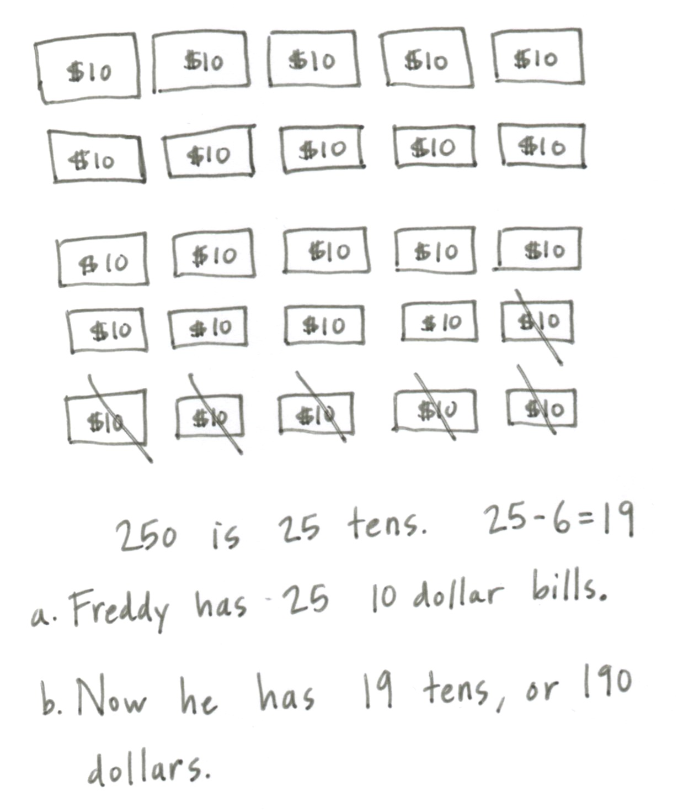Application Problem (10 minutes)

Freddy has $250 in ten dollar bills.

a. How many ten dollar bills does Freddy have?

b. He gave 6 ten dollar bills to his brother. How many ten dollar bills does he have left?

T: Let’s read this problem together.

T: Talk with your partner about how you can draw the information given in the problem.

T: (Circulate. Listen for clear, concise explanations, as well as creative approaches to solving.)

S: I drew tens and skip-counted by 10 all the way up to 250. 🡪 I counted by tens up to $250 and kept track with a tally. 🡪 I skip-counted by tens to 100. That was 10 tens so then I just added 10 tens and then 5 tens. 🡪 I know 10 tens are in 100, so I drew 2 bundles of 100 and wrote 10 under each one. And I know 50 is 5 tens. So I counted 10, 20, 25 tens.

|  |  |
| --- | --- |
|  | NOTES ON  Multiple Means  of Engagement: |
| Invite students to analyze different solution strategies. If you have the technical capability, project carefully selected student work two at a time. This is an argument for having word problems on half sheets of paper to facilitate comparison. Assign students the same problem for homework. This gives them the chance to try one of the new strategies.  Use the names of students in your class and culturally relevant situations within story problems to engage students. For example, Freddy is a student in this class. | |

T: How many ten dollar bills does Freddy have?

S: Freddy has 25 ten dollar bills.

T: Please add that statement to your paper.

T: Now talk with your partner about Part B of this problem. Can you use your drawing to help you solve? (After a minute.)

S: I crossed off 6 tens and counted how many were left.

T: Raise your hand if you did the same thing? Who solved it another way?

S: I counted on from 6 tens.

T: I hear very good thinking! So tell me, how many ten dollar bills does Freddy have left?

S: Freddy has 19 ten dollar bills!

T: Add that statement to your paper.

Concept Development (28 minutes)

Materials: (T) Bundles of straws from Lesson 1, place value “box,” Hide Zero cards (Lesson 4 Template 1) (S) Hide Zero cards 1–5, 10–50, and 100–500 (Lesson 4 Template 1) cut apart (as pictured) and in a baggie

T: (Have 4 ones, 3 tens, and 2 hundreds already in the place value boxes.) Count for me.

S: 1 one, 2 ones, 3 ones, 4 ones. 1 ten, 2 tens, 3 tens.   
1 hundred, 2 hundreds.

T: Can I make larger units?

S: No!

T: In order from greatest to smallest, how many of each unit are there?

S: 2 hundreds, 3 tens, 4 ones.

T: What number does that represent?

S: 234.

T: What if we have 3 tens, 4 ones, and 2 hundreds. What number does that represent?

S: 234!

|  |  |
| --- | --- |
|  | NOTES ON  Multiple Means  of Action and Expression: |
| Remember, not all students will complete the same amount of work. Provide extra examples for early finishers such as adding to the number of ones, tens, and hundreds in the place value boxes. Provide more examples at a simpler level for students who need additional practice before moving on to numbers with zeros, such as those in the Problem Set below. | |

T: (Show 234 with Hide Zero cards. Pull the cards apart to show the value of each digit separately. Push them back together to unify the values as one number.) Open your bag. Build the number 234 with your Hide Zero cards.

S: (Find the cards in their bags and build the number.)

T: Which of your cards shows this number of straws? (Hold up 2 hundreds.) This number of straws? (Hold up 4 ones.) Which has greater value, 2 hundreds or 4 ones?

S: 2 hundreds.

T: (Write on the board hundreds tens ones.) Tell me the number of each unit. (Point to the number modeled in the place value box.)

S: 2 hundreds 3 tens 4 ones.

T: That is called **unit form**.

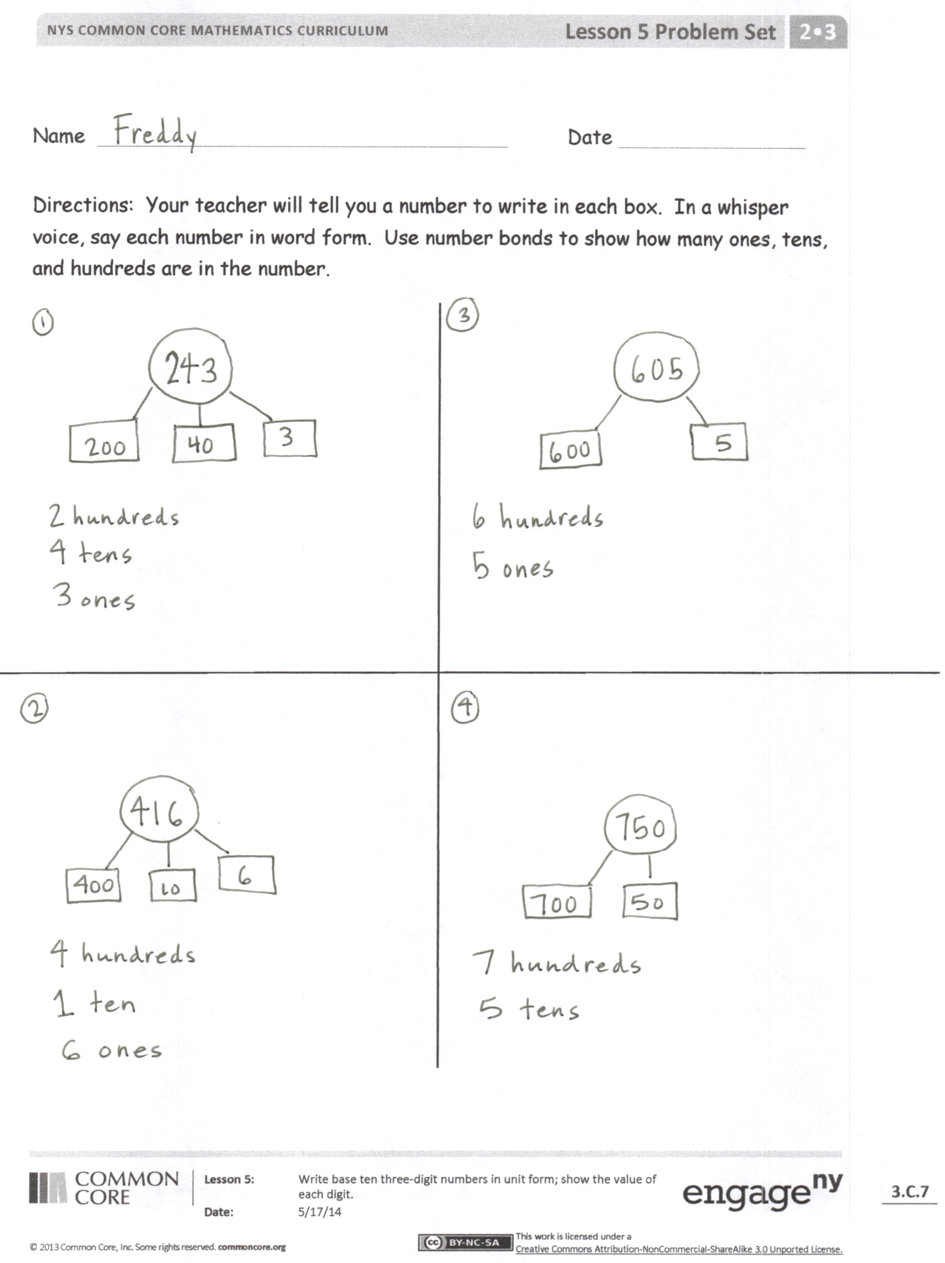T: We can also write this number as (write on board) two hundred thirty-four. This is the **word form**.

T: Work with your partner with your Hide Zero cards showing 234. Pull the cards apart and push them together. Read the number in unit form and in word form.

Guide students through the following sequence of activities.

* Model numbers in the place value boxes.
* Students represent them with their Hide Zero cards.
* Students say the number in word form and unit form.

A suggested sequence might be: 351, 252, 114, 144, 444, 250, and 405. These examples include numbers that repeat a digit and those with zeros. Also, in most of the examples the numbers have digits that are smaller in the hundreds place than in the tens or ones. This is so that as you circulate, you can ask questions such as, “Which has more value, this 4 or this 4?” “What is the meaning of the zero?”

Problem Set (10 minutes)

Students should do their personal best to complete the Problem Set within the allotted 10 minutes. For some classes, it may be appropriate to modify the assignment by specifying which problems they work on first. Some problems do not specify a method for solving. Students should solve these problems using the RDW approach used for Application Problems.

T: (Tell students the following numbers to model on the Problem Set: 243, 416, 605, and 750.)

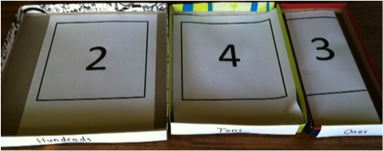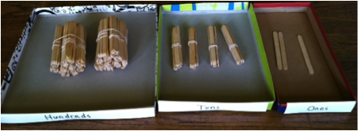

Note: The Problem Set advances to numbers not within the students’ set of Hide Zero cards. Have the students represent each number with number bonds where each part is shaped like a Hide Zero card. As needed, you can represent the numbers in the place value boxes. Hold all students accountable for saying each number in a whisper voice.

Student Debrief (10 minutes)

**Lesson Objective:** Write base ten three-digit numbers in unit form; show the value of each digit.

Materials: (T) Blank paper to write numerals (as pictured), place value “box,” bundles of straws for modeling   
(S) Individual place value charts (Template), personal white board

The Student Debrief is intended to invite reflection and active processing of the total lesson experience.

T: Bring your Problem Set to our Debrief. (Post, draw, or project a place value chart.)

T: Whisper this number to me. (Point to 243 on the Problem Set.)

S: 243.

T: (Model it with bundles in the place value box.) How many hundreds?

**MP.6**

S: 2 hundreds.

T: (Replace the 2 hundreds with the digit 2.)

T: How many tens?

S: 4 tens.

T: (Replace the 4 tens with the digit 4.)

T: How many ones?

S: 3 ones.

T: (Replace the 3 ones with the digit 3.)

T: We now have represented 243 on the place value chart as a number. It is up to you to know the units represented and to remember that 2 hundreds has a different value than 2 ones.

T: (Write 416 and display in the place value box. Point to the number on the place value chart.) Say the value in **unit form**.

S: 4 hundreds 1 ten 6 ones.

T: (Point to the number 416.) Say the number in **word form**.

S: Four hundred sixteen.

T: (Write 605 and display in the place value box. Point to the number on the place value chart.) Say the value in unit form.

S: 6 hundreds 0 tens 5 ones.

T: (Point to the number 605.) Say the number in word form.

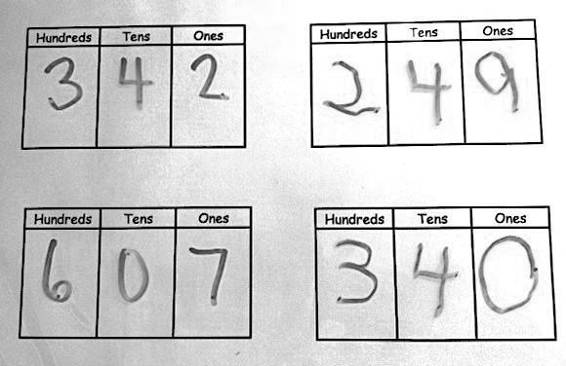S: Six hundred five.

T: (Finish with 750.)

Students slide the individual place value charts template into their personal white boards. An example of a filled in template is pictured.

T: Turn to your partner. Partner A, write a number in your place value chart. Partner B says the number in unit form and then word form. Then, switch roles.

Circulate and listen for one minute. Take notes as necessary. Students should speak with confidence. Note those that still have insecurity even if their answers are correct. This is evidence that they simply need more practice.

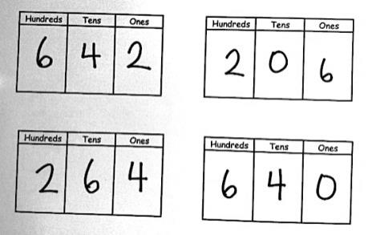T: (Display a set of four numbers as pictured.) What is the value of this 6? Answer in a complete sentence using the sentence frame: “The value is ___.”

S: The value is 6 hundreds.

T: What is the value of this 6?

S: The value is 6 tens.

T: You knew the different values because you saw where I pointed. The place told you the value.

T: Tell your partner how you knew the value of each 6.

S: Because one was here and one was in the middle. 🡪 Because that is where we had bundles of tens and hundreds. 🡪 Because it says hundreds and tens there above. 🡪 Because this 6 was in the hundreds place and this 6 was in the tens place.

T: What is the first number on our chart?

S: 642.

T: Look, 264 has 2, 4, and 6 but in different places! The place tells us the value.

T: We call this a place value chart because each place (point to each place) has a value. We use 0–9 but their place tells us the unit represented.

T: Take turns telling your partner each of these numbers in unit form and in word form. If you finish early, write an interesting number for your partner to analyze. (Allow a few minutes.)

T: Let’s close our lesson by having you explain to your partner what a place value chart is. Use the words *value, unit,* and *place.*

Exit Ticket (3 minutes)

After the Student Debrief, instruct students to complete the Exit Ticket. A review of their work will help you assess the students’ understanding of the concepts that were presented in the lesson today and plan more effectively for future lessons. You may read the questions aloud to the students.

Name Date

Your teacher will tell you a number to write in each box. In a whisper voice, say each number in word form. Use number bonds to show how many ones, tens, and hundreds are in the number.

Name Date

1. Look at the Hide Zero cards. What is the value of the 6?

|  |  |  |
| --- | --- | --- |
| 5 | 6 | 9 |

1. 6 b. 600 c. 60
2. What is another way to write 5 ones 3 tens 2 hundreds?

a. 325 b. 523 c. 253 d. 235

1. What is another way to write 6 tens 1 hundred 8 ones?

a. 618 b. 168 c. 861 d. 681

1. Write 905 in unit form.

Name Date

7

6

4

1. What is the value of the 7 in ? ________________________

2. Make number bonds to show the hundreds, tens, and ones in each number. Then, write the number in unit form.

*Example:*

200

60

3

263

2 hundreds 6 tens 3 ones

1. 333
2. 330
3. 303
4. Draw a line to match unit form with number form.
5. 1 hundred 1 one = 11
6. 1 ten 1 one = 710
7. 7 tens 1 one = 110
8. 7 hundreds 1 one = 701
9. 1 hundred 1 ten = 101
10. 7 hundreds 1 ten = 71

[1]

ones

hundreds

tens

ones

hundreds

tens

ones

hundreds

tens

ones

hundreds

tens

1. individual place value charts