Lesson 1
Objective: Bundle and count ones, tens, and hundreds to 1,000.

Suggested Lesson Structure
 Fluency Practice (20 minutes)
 Concept Development (35 minutes)
 Student Debrief (5 minutes)
Total Time (60 minutes)
Fluency Practice (20 minutes )

- Meter Strip Subtraction: Taking Multiples of 10 from Numbers Within 10 to 100 2.NBT.5 (5 minutes)
- Skip-Count Up and Down by Fives on the Clock 2.NBT.2 (11 minutes)
- Happy Counting: Up and Down by Ones from 95 to 121 2.NBT (2 minutes)
- Skip-Count by Tens: Up and Down Crossing 100 2.NBT.2 (2 minutes)
Meter Strip Subtraction: Taking Multiples of 10 from Numbers Within 10 to 100 (5 minutes)

NOTES ON
MULTIPLE MEANS
OF ACTION AND EXPRESSION:
The pace in meter strip subtraction may be too rapid for some groups of students. If necessary, adjust it by providing more practice with multiples of 10 before moving on to other numbers.
Students start with their fingers at 0 and slide to the whole amount each time. This step maintains their knowledge of the distance between 0 and a given measurement. It provides visual and kinesthetic reinforcement of number sequence and relationships between numbers on the number line for students who may need it.

Materials: (S) Meter strip (Fluency Template)
T: Put your finger on 0 to start. I’ll say the whole measurement. Slide up to that number. Then take away 10 centimeters and tell me how many centimeters your finger is from 0.
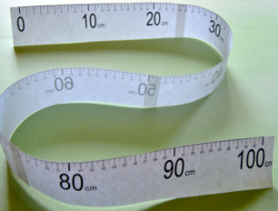
T: Let’s try one. Fingers at 0 centimeters! (Pause.) 50 centimeters.
S: (Slide their fingers to 50.)
T: Remember to take 10. (Pause.) How far is your finger from 0?
S: 40!
T: 40 what?
S: 40 centimeters!
T: Slide your finger back to 0. (Pause.) 85 centimeters.
T: (Pause.) How far is your finger from 0?
S: 75 centimeters!
T: Good. Slide back to 0. (Pause.) 49 centimeters.
Continue with examples as necessary.
T: Nice work. This time I’ll say the whole measurement, and you take 20 centimeters. Ready?
T: Slide back to 0. (Pause.) 65 centimeters.
S: 45 centimeters!
Continue with the following possible sequence: Slide from 0 to 32, then take 20; to 36, then take 30; to 78, then take 50; to 93, then take 40; to 67, then take 60, etc.

Skip-Count Up and Down by Fives on the Clock (11 minutes)

NOTES ON
MULTIPLE MEANS
OF REPRESENTATION:
Students have just finished working with meter strips, which are concrete number lines. In this activity they move to working with an abstract number line: the clock. A clock is a circular number line. Visually demonstrate this for students by making the clock from a 24 inch ribbon marked off every 2 inches, similar to the one pictured with this activity.
You may want to measure the intervals in advance, making the marks very lightly so that they are hard for others to see. Then, begin the activity by making the marks dark enough for all to see as students count along by ones to notice that there are 12 marks.

Materials: (T) A “clock” made from a 24-inch ribbon marked off at every 2 inches

T: (Display the ribbon as a horizontal number line – example pictured above.) Count by fives as I touch each mark on the ribbon.
S: (Starting with 0, count by fives to 60.)
T: (Make the ribbon into a circle resembling a clock.) Now I’ve shaped my ribbon to look like a…
S: Circle! Clock!
T: Let’s call it a clock. Again, count by fives as I touch each mark on the clock.
S: (Starting with 0, skip-count by fives to 60.)
T: This time, the direction my finger moves on the clock will show you whether to count up or down. (As you explain, demonstrate sliding your finger forward and backward around the clock.)
T: As I slide to the marks, you count them by fives.

NOTES ON
MULTIPLE MEANS
OF REPRESENTATION:
Partner Talk
Partner talk provides an opportunity for English language learners to rehearse language in a smaller, safer setting. It also provides an opportunity to pair children who can support one another with a shared first language. Balance pairings so that students feel supported, but also benefit from the peer modeling and individualized practice with English provided by structured partner talk.
Partner talk serves struggling and advanced students by allowing them to work at their own levels. It’s wise to consider students’ strengths as you assign who will talk first. It can work well for Partner A to model strong language when partnered with English language learners or less verbally advanced students.
Questioning
If students have difficulty growing ideas or sustaining conversation, you might ask an advancing question: "Yes, you can count on both of them. What do you measure with each?"
This scaffold is especially relevant for students who have difficulty staying focused and students below grade level. It also provides scaffolding for English language learners who, in order to respond, may rely on the vocabulary you use in the question you ask.

Starting at 12, slide forward to 4 as students count on. On a clock, 12 represents both 0 and 60. We are not stating 0 so that students count on effectively.
S: 5, 10, 15, 20.
T: How many minutes is that?
S: 20 minutes!
T: (Starting from 4 slide your finger forward to 9. Do not restate 20. Count on.)
S: 25, 30, 35, 40, 45.
T: How many minutes is that?
S: 45 minutes!
T: (Keep your finger at 9.) What if I slide back one mark, then how many minutes?
S: 40 minutes!
T: Good. What if I slide forward one mark, then how many minutes?
S: 45 minutes!
T: Nice job. Let’s count back from 50. (Start from 50 and slide back 5 times.)
S: 45, 40, 35, 30, 25.
T: How many minutes now?
S: 25 minutes!
Continue. Notice which switches or numbers your students find most difficult and use their cues to guide the practice you provide.
T: Let’s pause for a couple of minutes to think about the tools we’ve used so far today.
T: With your partner, compare the meter strip to the clock. How are they the same? How are they different?
For about one or two minutes, circulate and listen for responses. Use questioning strategies to support student communication and the level of their insights.
MP.3
S: They’re both curly. Remember our paper meter strips were curly, too? They can both be a straight line. The clock has 12 marks and the other one has a lot more. You can count with both of them. The clock goes to 60 and the meter strip goes to 100. On one you skip-count by fives and on the other you can skip-count by twos or tens. All the marks on the clock are the same space apart, and the marks on the meter strip are the same space apart. You can use them both to measure. One measures time and one measures length.
T: I hear some of you saying that we use both tools to measure. It’s true that clocks and meter strips both measure.

NOTES ON
MULTIPLE MEANS
OF ENGAGEMENT:
"It’s true that we use both tools to measure. It’s true that clocks and meter strips both measure lengths."
This is an example of telling rather than eliciting, a unifying way to follow partner sharing. The telling makes a certain fact common knowledge from which new ideas grow. It’s okay to tell rather than elicit. Strategically telling is a facilitation technique that keeps the conversation moving. Use it to correct misconceptions and set students up to go deeper along a line of reasoning.

T: What makes them useful for measuring? Talk with your partner for 30 seconds.
S: They both have marks that are the same space apart. The numbers go from smallest to biggest. They’re both like rulers, but they have different units. Clocks measure time. We can’t see that! It’s like they both keep track of our counts. And they both give us a place to count.
MP.3
T: I used a ribbon to make our clock. What would happen if I moved it back into a horizontal line so that it looked more like a meter strip? Partner A, could I still use it to measure the length of time? Tell Partner B why or why not.
S: I think so. You’re not changing the numbers on it. You can still count how many minutes. When you’ve counted the whole thing you know an hour went by.

NOTES ON
MULTIPLE MEANS
OF REPRESENTATION:
Move the ribbon back into a horizontal line and present it to students near the meter strip for a visual comparison.
Providing a visual representation allows English language learners to access the content while learning important vocabulary. In this case, a visual comparison also helps clarify the topic of discussion. Maximize the benefits of visual comparison by placing the ribbon alongside the meter strip before Partner A shares with Partner B.

T: (Move the ribbon back into a horizontal line and present it to students near the meter strip for a visual comparison.) Partner B, tell Partner A why you agree or disagree.
S: I disagree. There are no little hands to tell you where to count, to tell you how many minutes have gone by.
T: Keep thinking and talking about these two measurement tools. Ask your parents what they think!

Happy Counting: Up and Down by Ones from 95 to 121 (2 minutes)
T: Let’s count by ones, starting at 95. Ready? (Rhythmically points up until a change is desired. Show a closed hand then point down. Continue, mixing it up.)
S: 95, 96, 97, 98, 99, 100, 101, 102 (stop) 101, 100 (stop) 101, 102, 103, 104, 105, 106, 107, 108, 109, 110, 111, 112 (stop) 111, 110, 109 (stop) 110, 111, 112, 113, 114, 115, 116, 117 (stop) 116, 115, 114 (stop).

Skip-Count by Tens: Up and Down Crossing 100
(2 minutes)

NOTES ON
MULTIPLE MEANS
OF ENGAGEMENT:
As often as possible, create opportunities for every student to respond every time. The vignettes throughout the entire module facilitate this by continuously demonstrating varied response patterns and materials including choral response, partner talk, personal white boards, and individual tools like meter strips. Response patterns built on 100% student participation have powerful effects on student engagement and lesson pacing.
Choral response allows English language learners to listen to correct pronunciation and language structure while practicing with the support of peer voices. Choral response that incorporates chanting, like the counting activities presented to the left, allows struggling students and those with auditory processing difficulty to be supported by the group as they pick up on language and patterns.
Wait time is an important component of choral response. It provides children with an opportunity to independently process the question and formulate an answer before speaking. This is a useful scaffold for English language learners and struggling students. Wait time is built into many vignettes where the dialogue says "pause" or when the teacher asks students to wait for a signal to respond.

T: Let’s skip-count by tens starting at 60!
T: Ready? (Rhythmically points up until a change is desired. Show a closed hand then point down. Continue, mixing it up.)
S: 60, 70, 80, 90, 100, 110, 120, 130, 140 (stop) 130, 120, 110, 100, 90 (stop) 100, 110, 120, 130, 140, 150, 160, 170, 180, 190, 200, 210, 220 (stop) 210, 200, 190, 180 (stop).

Concept Development (35 minutes)
Materials: (T) Box of 1,000 straws or sticks
Students are seated in a U shape or circle on the carpet. Quite dramatically empty the contents of the box onto the carpet.
T: Let’s count these straws! About how many do you think there might be? Discuss your ideas with your partner.
T: Let’s see how many there really are.
T: How can we count them in a way that is fast and accurate, or efficient, so that we can get to recess on time?
S: We could split them up into piles and share the work. By twos! By fives! By tens. By ones.
T: There are some very clear ideas. Discuss with your partner which method would be the most efficient, counting by ones, twos, fives, or tens.
T: I hear most groups agreeing that counting by tens is the most efficient. Why is it more efficient to count by units of ten than units of two?
S: Because there will be more units of two so it will take longer. The tens are the biggest so there are fewer of them to confuse us when we count.
T: Are you ready to get going? Let’s count 10 straws and then wrap them in a rubber band to make a new unit of ten. I will put a pile of straws and rubber bands in front of each group of 3 students.
S: (Work for about 8 minutes to finish bundling all the straws.)
T: Let’s make even larger units: Hundreds. It takes 10 tens to make a hundred. Count with me.

S. (Place a ten before each count.) 1 ten, 2 tens, 3 tens, 4 tens, 5 tens, 6 tens, 7 tens, 8 tens, 9 tens, 10 tens.
T: What is the value of 10 tens?
S: 1 hundred.
T: How many straws equal 1 ten?
S: 10 straws.
T: Now, let’s count the number of straws in 10 tens or 1 hundred.
S: (Repeat the process.) 10, 20, 30, 40, 50, 60, 70, 80, 90, 100.
T: So, how many straws are in 10 tens?
S: 100 straws.
T: What is another way to say 10 tens?
S: 1 hundred.
T: As a group, bundle 10 tens to make 1 hundred. Put the tens and ones you have left over to one side.
S: (Work.)
T: Tell your neighboring group how many of each unit, ones, tens, and hundreds, you have. The single straws are units of one.
S: We have 1 hundred, 6 tens and 4 ones.
T: Let’s make the single straws into as many tens as we can. How many extra ones does your group have?
S: 3.
T: Students, what do we need to add to 3 ones to make 10 ones? (Pause.)
S: 7 ones.
T: Which group has 7 ones? (Or, can we combine 2 groups’ straws to get 7 ones?) Pass them to Group 1.
Repeat the make ten process with all the extra ones.
T: Now that we have made as many units of ten as possible, let’s make more units of one hundred.
T: Group 2, how many tens do you have that are not bundled as 1 hundred?

NOTES ON
MULTIPLE MEANS
OF ENGAGEMENT:
All through this module, students must pay attention to the units they are counting and use precise language to convey their knowledge. Hold them accountable: 6 tens + 4 tens is 10 tens.

S: 6 tens.
T: Students, at the signal, what do we need to add to 6 tens to make 10 tens?
S: 4 tens.
T: 6 tens plus 4 tens is?
S: 10 tens.
T: What is another way to say 10 tens?
S: 1 hundred.
T: How can you prove that 10 tens is the same as 100?
S: I could unbundle the hundred and count all the tens. I can skip-count by 10 and count how many times it takes to get to 100. When I skip-count on my fingers it takes all 10 to get to 100.
Repeat the make 1 hundred process, bundling all the tens as hundreds.
T: Now that we have made as many hundreds as possible, let’s make units of one thousand.
T: Think about the structure and pattern of numbers as we’ve moved from ones to tens to hundreds. Then talk with your partner: How many hundreds do you think make 1 thousand? Be ready to explain why.
S: When we count, the numbers always go 1, 2, 3, 4, 5, 6, 7, 8, 9, 10 and then we get a new unit. There are 10 hundreds in 1 thousand because we always make one bigger group out of 10 smaller groups.
T: Yes, 10 of a smaller unit make 1 of the next largest unit. I like the way you used what you’ve learned about the structure of numbers to figure out something new.
T: So, how many hundreds are in 1 thousand? Give me a complete sentence.
S: 10 hundreds are in 1 thousand!
T: Group 3, how many hundreds do you have?
S: 2 hundreds.
T: Students, complete the sentence: 2 hundreds plus how many hundreds equals 10 hundreds? (Pause.)
S: 2 hundreds plus 8 hundreds equals 10 hundreds.
T: Hand all your hundreds over! (Bundle them up to make one thousand.)
T: Count the hundreds for me. I’ll listen.
S: 1 hundred, 2 hundreds…. etc.
T: How many hundreds do we have here?
S: 10 hundreds!
T: Another name for 10 hundreds is 1 thousand, a new unit!
T: At the signal, what is the largest unit we worked with today?
S: 1 thousand!
T: The next largest?
S: 1 hundred!
T: The next?
S: 1 ten!
T: The smallest?
S: 1 one!
T: (Give each pair 1 straw and a bundle of 1 ten and 1 hundred.) Show and tell your partner our units in order from smallest to greatest and greatest to smallest.
T: How many different units did we work with today?
S: 4 units!
T: Tell me the unit names from smallest to greatest.
S: Ones, tens, hundreds, and thousands.
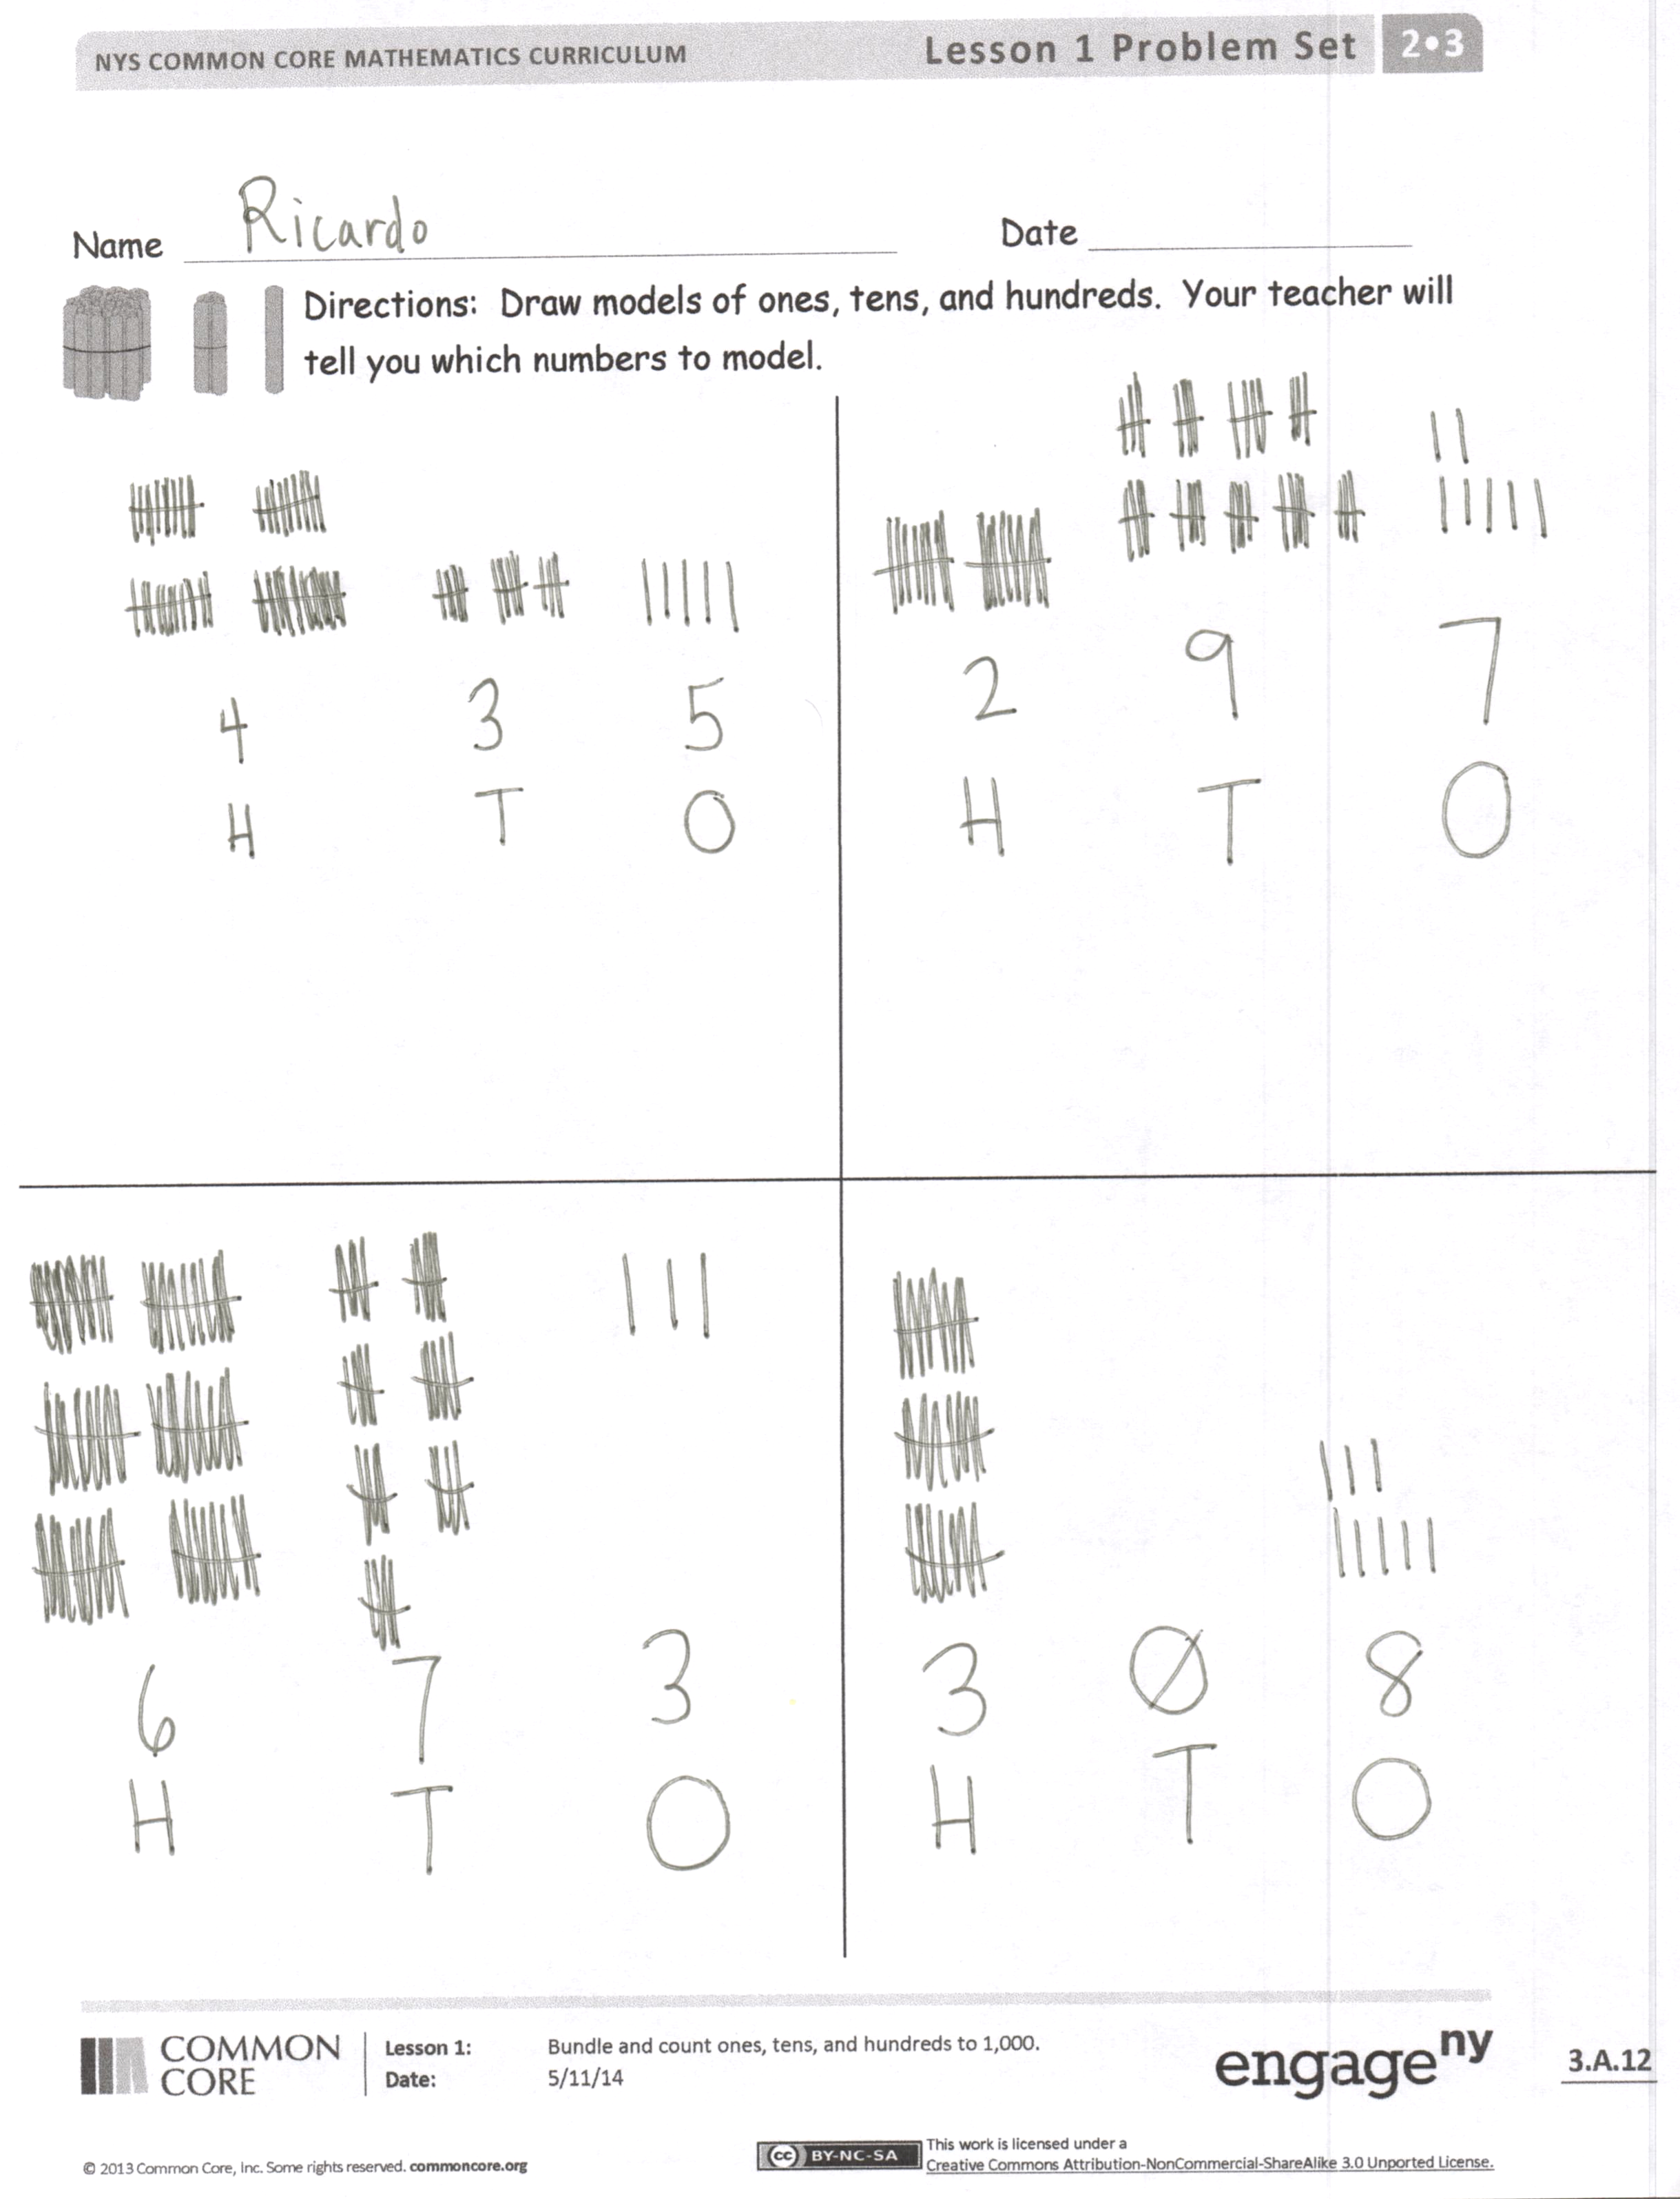
Problem Set (10 minutes)
Students should do their personal best to complete the Problem Set within the allotted 10 minutes. Some problems do not specify a method for solving. This is an intentional reduction of scaffolding that invokes MP.5, Use Appropriate Tools Strategically. Students should solve these problems using the RDW approach used for Application Problems.
For some classes, it may be appropriate to modify the assignment by specifying which problems students should work on first. With this option, let the purposeful sequencing of the Problem Set guide your selections so that problems continue to be scaffolded. Balance word problems with other problem types to ensure a range of practice. Consider assigning incomplete problems for homework or at another time during the day.
T: We used straws to show units of hundreds, tens, and ones. Now, let’s draw models of these units.
T: (Draw a sample of each unit, as shown in the picture.)
T: Draw and label 4 hundreds. Whisper count as you draw.
S: (Whisper count and draw as you model.)
T: Whisper count, draw, and label 3 tens.
S: (Whisper count and draw.)
T: Now, whisper count, draw, and label 5 ones. If you don’t have enough room in the box, use your eraser and try again.
S: (Whisper count and draw.)
T: Tell me the number of each unit in order from largest to smallest.
S: 4 hundreds, 3 tens, 5 ones.
T: The name of that number is?
S: 435!
T: Yes.
T: In the next box down, draw and label 6 hundreds, 7 tens, 3 ones.
S: (Work.)
T: When I say, "Show me your work," hold up your paper so I can see your independent effort.
Repeat the process with the following: 297 and 308.

Student Debrief (5 minutes)
Lesson Objective: Bundle and count ones, tens, and hundreds to 1,000.
The Student Debrief is intended to invite reflection and active processing of the total lesson experience.
Invite students to review their solutions for the Problem Set. They should check work by comparing answers with a partner before going over answers as a class. Look for misconceptions or misunderstandings that can be addressed in the Debrief. Guide students in a conversation to debrief the Problem Set and process the lesson.
T: Bring your Problem Set to the carpet.
T: Let’s read our first number by units.
S: 4 hundreds, 3 tens, 5 ones.
T: How do we say 3 tens 5 ones?
S: Thirty-five.
T: We read this number as four hundred thirty-five. Say it for me.
S: Four hundred thirty-five.
T: How do we say the next number down?
S: Six hundred seventy-three.
T: Excellent. Read the next numbers on your paper to your partner. (Allow time to do so.)
T: To begin our Problem Set, we drew two numbers. 435 is one number. 673 is another number.
T: What are the different units in the number 435, from largest to smallest?
S: Hundreds, tens, ones.
T: So we used three different units to make one number!
T: What is this unit called? (Hold up 1 hundred straws or sticks.)
S: 1 hundred.
T: Discuss with your partner three questions I will write on the board:
1. How many units of 1 are in 1 ten?
2. How many units of 10 are in 1 hundred?
3. How many units of 100 are in 1 thousand?
T: I hear a lot of intelligent answers. Show me what you know by completing your exit ticket. Return to your seat as soon as you have it. If you finish early, count by 10 on the back of your paper as high as you can go!
Exit Ticket (3 minutes)
After the Student Debrief, instruct students to complete the Exit Ticket. A review of their work will help you assess the students’ understanding of the concepts that were presented in the lesson today and plan more effectively for future lessons. You may read the questions aloud to the students.

Name Date
Draw models of ones, tens, and hundreds. Your teacher will tell you which numbers to model.

Name Date
- Draw lines to match and make each statement true.
10 tens = 1 thousand
10 hundreds = 1 ten
10 ones = 1 hundred

- Circle the largest unit. Box the smallest.
4 tens 2 hundreds 9 ones

- Draw models of each and label the following number:
2 tens 7 ones 6 hundreds

Name Date
- 2 ones + ____ ones = 10 2. 6 tens + ____ tens = 1 hundred
2 + ____ = 10 60 + ____ = 100
- Rewrite in order from largest to smallest units.
6 tens Largest _________________________

3 hundreds _________________________

8 ones Smallest _________________________

- Count each group. What is the total number of sticks in each group?

Bundles of 100 Bundles of 10 Ones

_____________ _____________ ______________
What is the total number of sticks? _______
- Draw and solve.
Moses has 100 stickers. Jared has 60 stickers. Jared wants to have the same number of stickers as Moses. How many more stickers does Jared need?

Jared needs _____ more stickers.
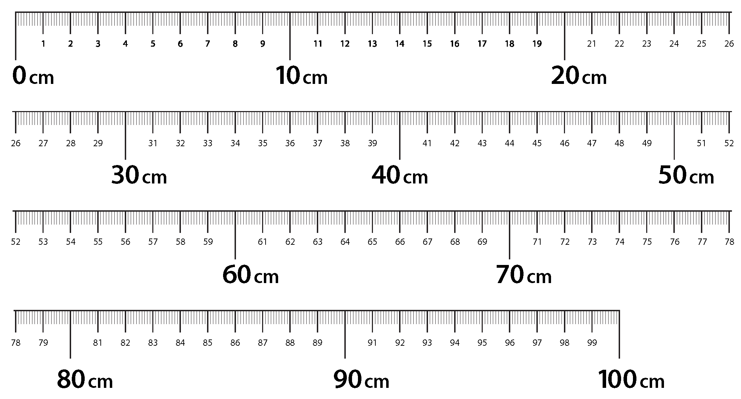

meter strip

