Lesson 7
Objective: Measure and compare lengths using standard metric length units and non-standard length units; relate measurement to unit size.

Suggested Lesson Structure
 Fluency Practice (11 minutes)
 Application Problem (6 minutes)
 Concept Development (33 minutes)
 Student Debrief (10 minutes)
Total Time (60 minutes)
Fluency Practice (11 minutes)
- Which Is Shorter? 2.MD.4 (2 minutes)
- Sprint: Subtraction 2.NBT.5 (9 minutes)
Which Is Shorter? (2 minutes)
Note: Students prepare for comparing lengths by identifying the shorter length and providing the number sentence to find the difference.
T: I am going to say two lengths. Tell me which length is shorter. Ready? 6 centimeters and 10 centimeters.
S: 6 centimeters.
T: Give the number sentence to find how much shorter.
S: 10 cm – 6 cm = 4 cm.
Continue with the following possible sequence: 12 cm and 22 cm, 16 cm and 20 cm, 20 cm and 13 cm, 20 cm and 9 cm, 9 cm and 19 cm, 24 cm and 14 cm, 12 cm and 24 cm, 23 cm and 15 cm, and 18 cm and 29 cm.
Sprint: Subtraction (9 minutes)
Materials: (S) Subtraction Sprint
Note: Students practice their simple subtraction skills in preparation for the lesson content.
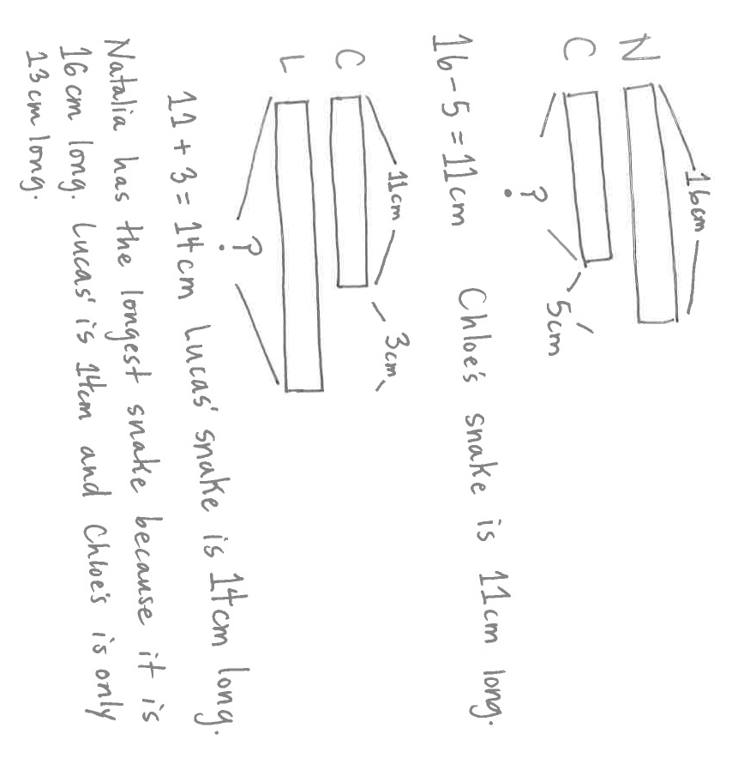
Application Problem (6 minutes)
Natalia, Chloe, and Lucas are making clay snakes. Natalia's snake is 16 centimeters long. Chloe's snake is 5 centimeters shorter than Natalia's. How long is Chloe's snake? Draw a picture and use numbers to explain your thinking.
Lucas's snake is 3 centimeters longer than Chloe's snake. Who has the longest snake: Natalia, Lucas, or Chloe? Add to your picture and use numbers to explain your thinking.
Note: This multiple-step problem presents a challenge for students to extend their understanding of measuring and comparing. Students are asked to connect addition and subtraction concepts to comparison language and to draw a conclusion.
Concept Development (33 minutes)
Materials: (S) Personal white board, 1 30 centimeter ruler (various types, e.g., wood, plastic, tape, etc.), 1 baggie per pair (containing 1 straw, 1 new crayon, 1 wedge eraser, 1 square sticky note, 30 paper clips)

NOTES ON
MULTIPLE MEANS
OF REPRESENTATION:
Extend thinking by connecting to real world experiences. Ask students, “What are some other items you might use to measure your straw?” Students will identify objects that are easy to use as a measure: erasers, fingers, crayons, etc., either by using mark and move forward or by laying multiple copies.

Note: Prepare half of the baggies with small paper clips and half the baggies with large paper clips. Use only one size paper clip per table so partners don’t see that they are different sizes.
T: Measure your straw with your paper clips.
S: (Measure.)
T: How long is the straw?
S: 6 paper clips long. About 5 paper clips long.
T: (Record measurements on the board.)
T: Why do you think the measurements are different? Turn and talk.
MP.3
S: Maybe they didn’t start at the beginning of the straw. They measured wrong.
T: Take out your crayon and measure with your paper clips. Share your measurement with your partner.
Students continue to measure the other items in their baggies. After each item, discuss and record the unit measure (in paper clips) of each item. Notice that measurements are different, but do not explain why.
T: Let’s switch baggies with our neighbors and measure again.
Tables now switch bags and measure all items in the baggie using the other size paper clip. Record measurements on the board. Have students discuss the difference between the measurements made using the large paper clips and those using the small paper clips.
T: Do you know why your measurements were different?
S: We had different size paper clips!
T: Why does the size of my paper clip matter?
S: You can fit more small paper clips than big paper clips along the side of the item.

NOTES ON
MULTIPLE MEANS
OF ENGAGEMENT:
Inverse relationships require thoughtful consideration because they seem to challenge logic and reasoning.
Post sentence frames for English language learners for reference during the Debrief:
“The _________ the unit, the ___________ number of units in a given measurement.”
Invite students to brainstorm real-life examples of inverse relationships. (e.g., The longer you sleep in the morning, the less time you have to get ready for school.)

T: What does that tell you about measurement and unit size?
S: If it’s a small unit size, you get a bigger measurement number.
MP.3
T: Let’s measure again using small and big paper clips mixed together.
S: (Use varying amounts of small and big paper clips to measure their straws.)
T: What were your results? (Record results.)
T: Why are all these measurements different?
S: We all had different sizes. Some people had lots of big paper clips.
T: So, if I wanted to order a table and I told you I want it to be 80 paper clips long, what might happen?
S: They wouldn’t know which one you want. You could get a big table or a tiny table.
T: (Pass out different types of centimeter rulers, e.g., tape measures, wooden rulers, plastic rulers. Have students
re-measure each object in their baggies. Record the measurements on the board in centimeters.)
T: What do you notice about the measurement of the object when you use a centimeter ruler?
S: The measurements for each object are the same even if the ruler looks different.
T: What is the same about all the rulers?
S: They are the same, except one is wood and one is plastic. The rulers all have centimeters. The centimeters are all the same size.
T: Why is it more efficient to measure with a centimeter instead of paper clips?
S: Because everyone knows how big a centimeter is. All centimeters are the same.
Problem Set (10 minutes)
Students should do their personal best to complete the Problem Set within the allotted 10 minutes. For some classes, it may be appropriate to modify the assignment by specifying which problems they work on first. Some problems do not specify a method for solving. Students should solve these problems using the RDW approach used for Application Problems.
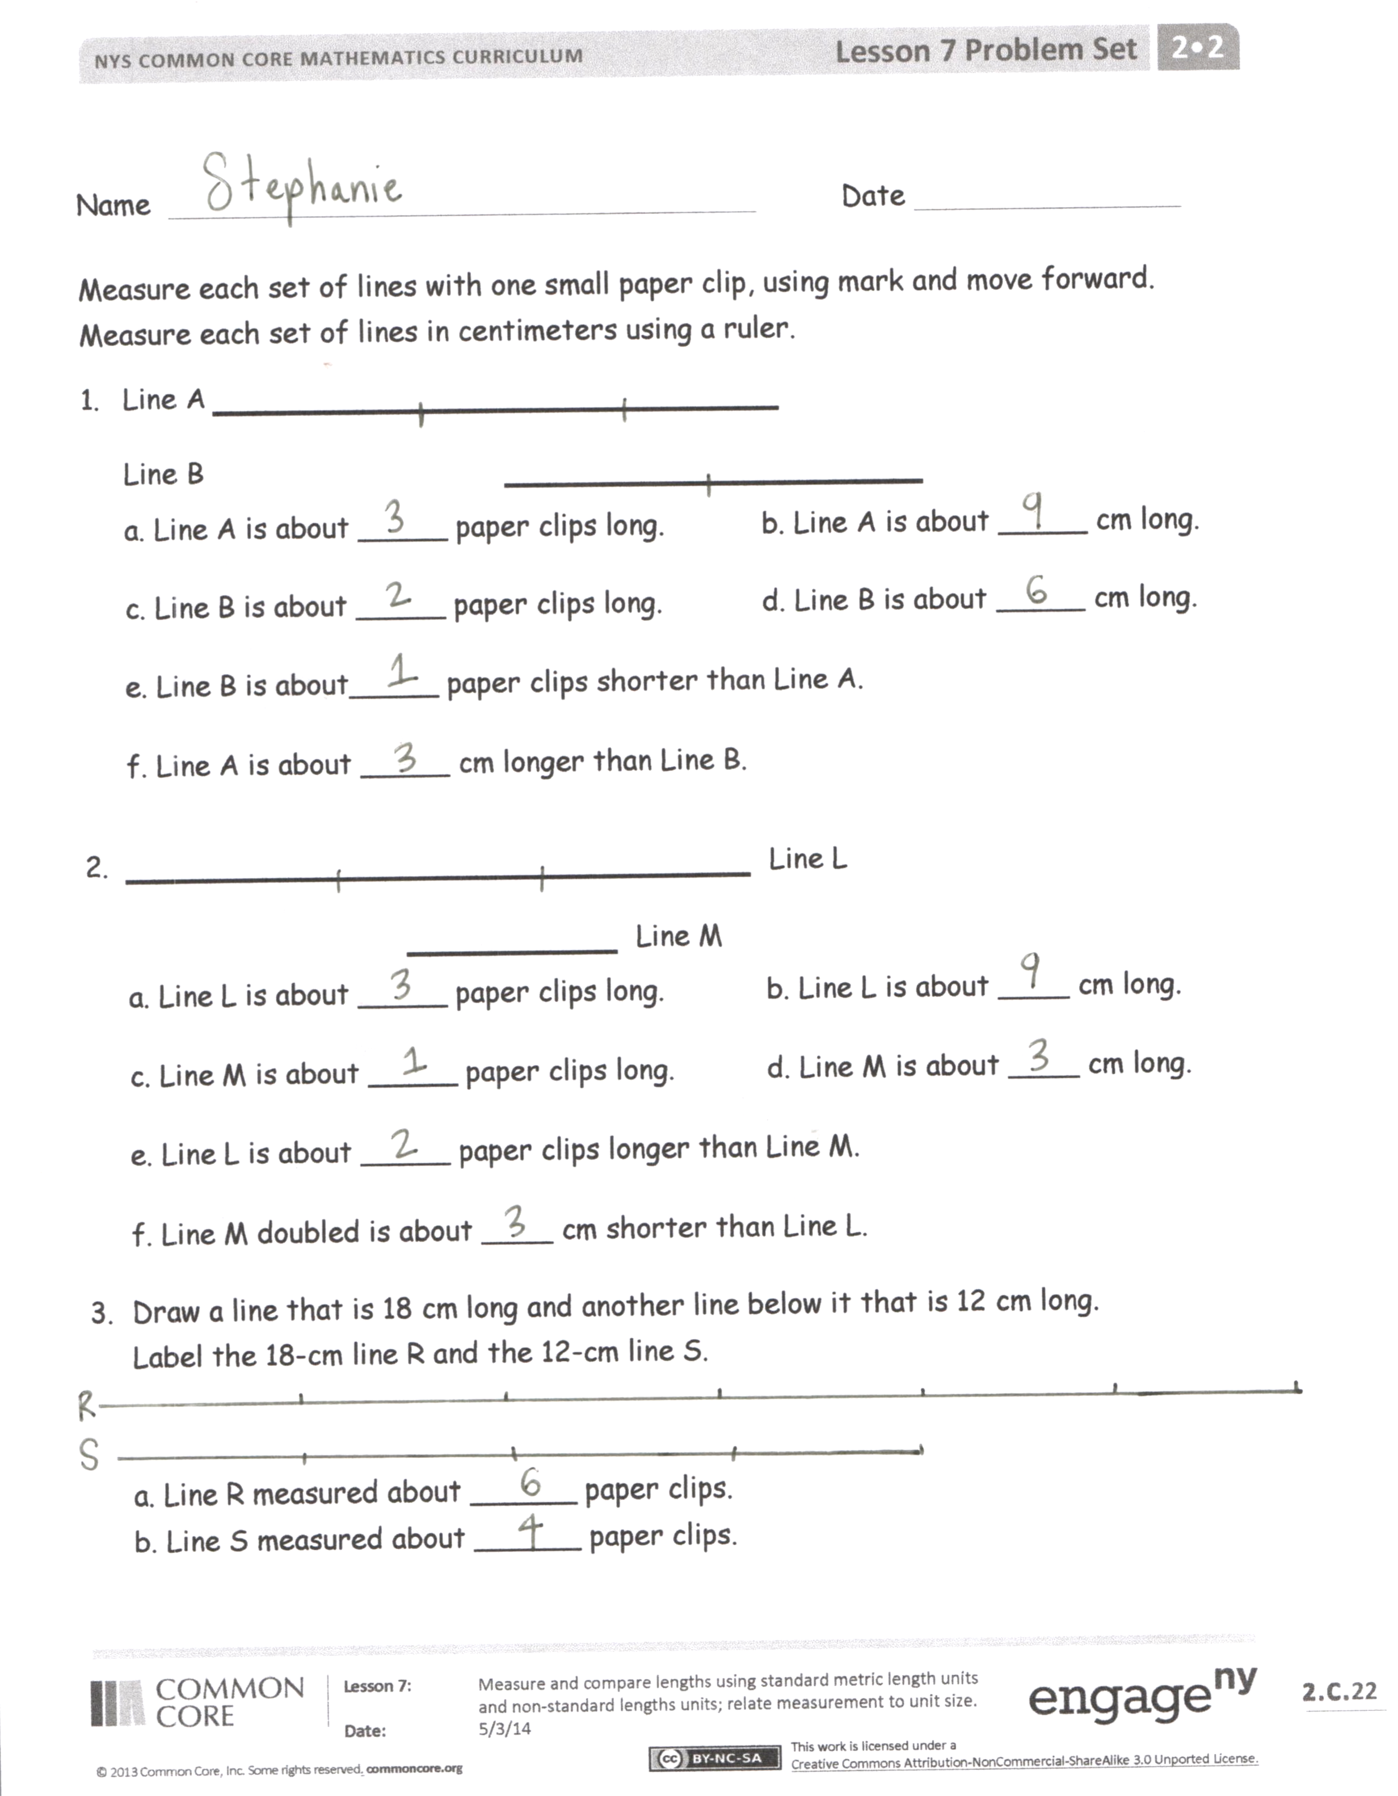
Student Debrief (10 minutes)
Lesson Objective: Measure and compare lengths using standard metric length units and non-standard length units; relate measurement to unit size.
The Student Debrief is intended to invite reflection and active processing of the total lesson experience.
Invite students to review their solutions for the Problem Set. They should check work by comparing answers with a partner before going over answers as a class. Look for misconceptions or misunderstandings that can be addressed in the Debrief. Guide students in a conversation to debrief the Problem Set and process the lesson.
You may choose to use any combination of the questions below to lead the discussion.
- Turn to your partner and compare your answers to Problems 1 and 2. Which math strategies did you use to determine which line was longer or shorter?
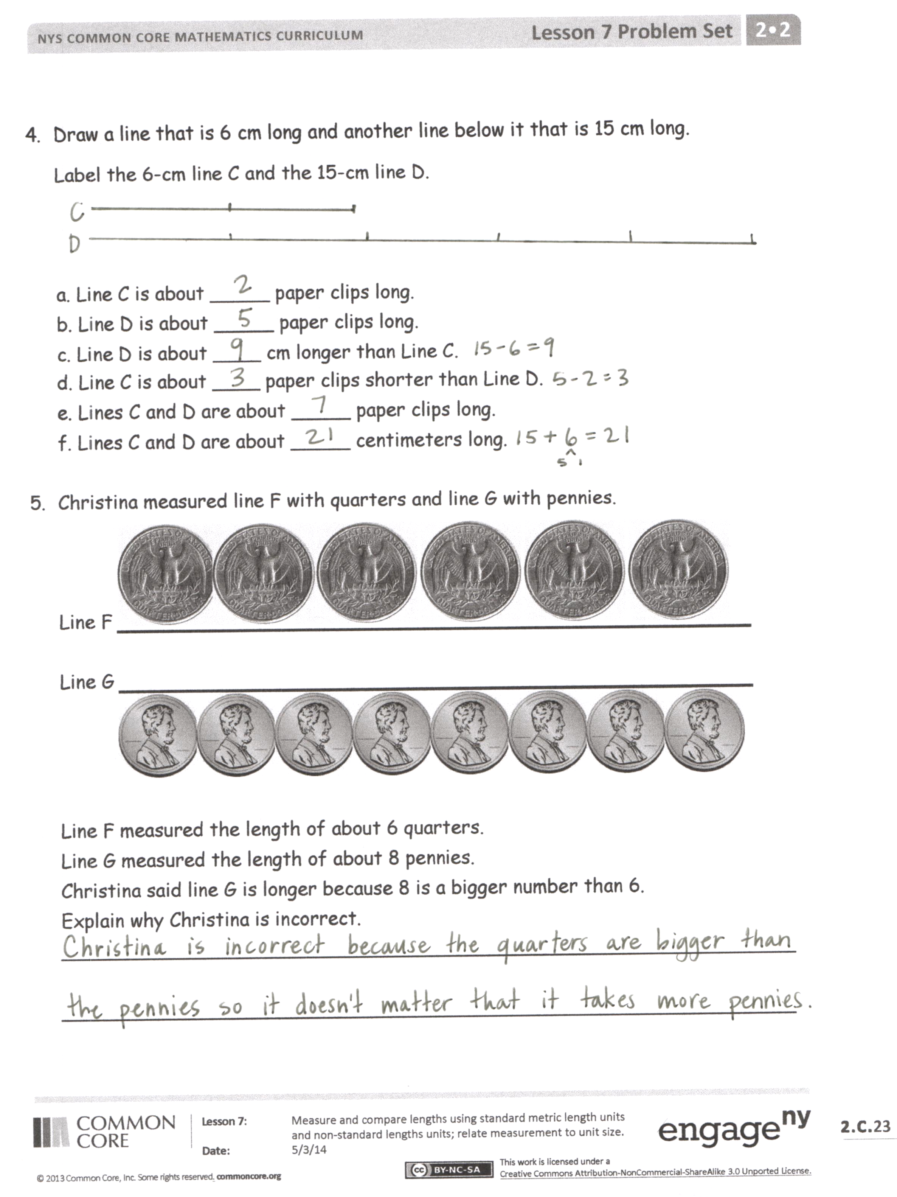
- Look at Problem 5. Turn and talk to your partner about why Christina’s answer is incorrect.
- Do you think that paper clips are a reliable measurement tool? Is a ruler a better measurement tool? Why?
- What did you notice about the relationship between the unit of length (e.g., paper clips, centimeters) and the number of units needed to measure the lines? Use comparative words (bigger, smaller, greater, fewer) in your response.
- Let’s think back to our Application Problem. Would it have been possible to accurately compare the lengths of the clay snakes with a non-standard length unit? What challenges can you predict?
Exit Ticket (3 minutes)
After the Student Debrief, instruct students to complete the Exit Ticket. A review of their work will help you assess the students’ understanding of the concepts that were presented in the lesson today and plan more effectively for future lessons. You may read the questions aloud to the students.
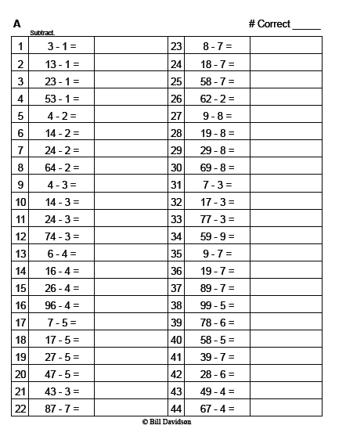

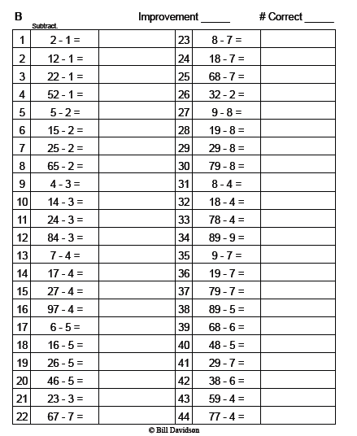

Name Date

Measure each set of lines with one small paper clip, using mark and move forward. Measure each set of lines in centimeters using a ruler.
- Line A ____________________
Line B ______________
a. Line A is about _____ paper clips long. b. Line A is about _____ cm long.
c. Line B is about _____ paper clips long. d. Line B is about _____ cm long.
e. Line B is about _____ paper clips shorter than Line A.
f. Line A is about _____ cm longer than Line B.
- _____________________ Line L
_______ Line M
a. Line L is about _____ paper clips long. b. Line L is about ____ cm long.
c. Line M is about _____ paper clips long. d. Line M is about ____ cm long.
e. Line L is about _____ paper clips longer than Line M.
f. Line M doubled is about ____ cm shorter than Line L.
- Draw a line that is 18 cm long and another line below it that is 12 cm long.
Label the 18 cm line R and the 12 cm line S.

a. Line R measured about ______ paper clips.
b. Line S measured about ______ paper clips.
- Draw a line that is 6 cm long and another line below it that is 15 cm long.
Label the 6 cm line C and the 15 cm line D.

a. Line C is about _____ paper clips long.
b. Line D is about _____ paper clips long.
c. Line D is about ____ cm longer than Line C.
d. Line C is about ____ paper clips shorter than Line D.
e. Lines C and D together are about _____ paper clips long.
f. Lines C and D together are about _____ centimeters long.

- Christina measured Line F with quarters and Line G with pennies.
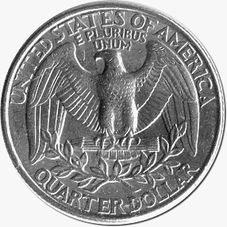

Line F ________________________________

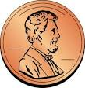
Line G ________________________________

Line F measured the length of about 6 quarters.
Line G measured the length of about 8 pennies.
Christina said Line G is longer because 8 is a bigger number than 6.
Explain why Christina is incorrect.
______________________________________________________________

______________________________________________________________

Name Date

Measure the lines with small paper clips and then with a centimeter ruler. Then, answer the questions below.

Line 1 ___________________________
Line 2 ______________
Line 3 ____________________

a. Line 1 is about _____ paper clips long. b. Line 1 is about _____ cm long.
c. Line 2 is about _____ paper clips long. d. Line 2 is about _____ cm long.
e. Line 3 is about _____ paper clips long. f. Line 3 is about _____ cm long.
Explain why each measurement has more centimeters than paper clips.

_____________________________________________________________

_____________________________________________________________

_____________________________________________________________

Name Date

Use a centimeter ruler and paper clips to measure and compare lengths.
- _____________________ Line Z

a. Line Z is about _____ paper clips long. b. Line Z is about ____ cm long.
c. Line Z doubled would measure about ____ paper clips or about _____ cm long.
- __________________________________ Line A
______________ Line B
a. Line A is about _____ paper clips long. b. Line A is about ____ cm long.
c. Line B is about _____ paper clips long. d. Line B is about ____ cm long.
e. Line A is about _____ paper clips longer than Line B.
f. Line B doubled is about ____ cm shorter than Line A.
- Draw a line that is 9 cm long and another line below it that is 12cm long.

Label the 9 cm line F and the 12 cm line G.
a. Line F is about _____ paper clips long.
b. Line G is about _____ paper clips long.
c. Line G is about ____ cm longer than Line F.
d. Line F is about ____ paper clips shorter than Line G.
e. Lines F and G are about _____ paper clips long.
f. Lines F and G are about _____ centimeters long.
- Line X is 1 meter. Line Y is 89 centimeters.
a. Line X is _______ centimeters.
b. Which line is longer? Line X Line Y c. How much longer? _________cm

- Line P is 2 meters. Line Q is 300 centimeters.
a. Line P is _______ centimeters.
b. Line Q is ________ meters.
c. Which line is longer? Line P Line Q
d. How much longer? _____________________

- Jordan measured the length of a line with large paper clips. His friend measured the length of the same line with small paper clips.
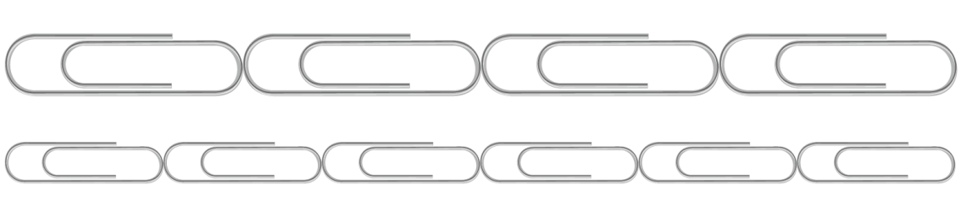
_____________________________

a. About how many paper clips did Jordan use? _______ large paper clips

b. About how many small paper clips did his friend use? _____ small paper clips

c. Why did Jordan’s friend need more paper clips to measure the same line as Jordan?
________________________________________________________

________________________________________________________

