Grade 7: Module 2A: Unit 1: Lesson 7
Analyzing Word Choice: Understanding Working Conditions in the Mills

Long-Term Targets Addressed (Based on NYSP12 ELA CCLS)
I can cite several pieces of text-based evidence to support an analysis of literary text. (RL.7.1)
I can analyze the interaction of literary elements of a story or drama. (RL.7.3)
I can use a variety of strategies to determine the meaning of unknown words or phrases. (L.7.4)
I can analyze figurative language, word relationships, and nuances in word meanings. (L.7.5)
I can effectively engage in discussions with diverse partners about seventh-grade topics, texts, and issues. (SL7.1)
Supporting Learning Targets | Ongoing Assessment
- I can use context clues—both in the sentence and on the page—to determine the meaning of unknown words.  - By engaging in a discussion with my partner, I can analyze one section of Lyddie to deepen my understanding of the plot, characters, and setting.  - I can cite specific textual evidence to explain what working conditions were like in the mills and how they affected Lyddie.  - I can analyze how the author’s word choices create vivid descriptions of Lyddie’s living and working conditions. | - Checking for Understanding entry task  - Chapter 10 of Lyddie Text-Dependent Questions  - Working Conditions anchor chart—student version

Agenda | Teaching Notes
- Opening  - Entry Task: Checking for Understanding  (10 minutes)  - Work Time  - Close Read of Pages 75 and 76 in Lyddie  (25 minutes)  - Adding to Working Conditions Anchor Chart  (8 minutes)  - Closing and Assessment  - Previewing Homework (2 minutes)  - Homework  - Read Chapter 11 of Lyddie and complete Reader’s Notes for Chapter 11. | - Students continue to analyze working conditions in the mill and how they affect Lyddie.  - This lesson adds a focus on word choice and figurative language, as students discuss how author Katherine Paterson’s choice of language helps the readers better understand Lyddie’s working conditions and how they affected her.  - In advance: Prepare sets of Working Conditions note cards (one set per pair). Students will not write on these, so you can prepare one class set and use it with multiple classes.  - Review: Lyddie Reader’s Notes, Chapters 9 and 10; Lyddie, Chapters 9 and 10  - Post: Learning targets.

Lesson Vocabulary | Materials
personification; goods, flaw (65), decipher (66), radical (67), infamous, operatives (69), strenuous (74), laden, bowels (75), inferno, meager (76), commenced (77), ravenous. fatigue (78) | - Checking for Understanding Chapters 9 and 10 entry task (one per student)  - Weaving Room Discussion Appointments handout (from Lesson 3)  - Working Conditions note cards (one set per pair; teacher-created; see Supporting Materials)  - Reading Closely: Guiding Questions handout (from Odell Education; also see stand-alone document on EngageNY.org and odelleducation.com/resources) (one per student)  - Document camera  - Lyddie (book; one per student; focus on pages 75 and 76)  - Chapter 10 of Lyddie Text-Dependent Questions (one per student)  - Chapter 10 of Lyddie Close Reading Guide (for Teacher Reference)  - Working Conditions anchor chart, student version (begun in Lesson 1)  - Working Conditions anchor chart (begun in Lesson 1)  - Lyddie Reader’s Notes, Chapter 11 (one per student)  - Lyddie Reader’s Notes, Chapter 11, Teacher’s Edition (for Teacher Reference)

Opening | Meeting Students’ Needs
A. Entry Task: Checking for Understanding (10 minutes)
- Distribute Checking for Understanding, Chapters 9 and 10 entry task to students. Direct students to complete the entry task individually. As they do so, circulate to check the Reader’s Notes (Chapters 9 and 10) for completion.
- When students are done, call on several to share their answers to the Checking for Understanding entry task. Prompt them: “How did your Reader’s Notes help you answer that question?”
- Post the correct definitions of the words in the Reader’s Dictionary and prompt students to correct their Reader’s Notes as necessary. Ask:
  - “Why did the author use the word ravenous instead of ‘hungry’ and fatigue instead of ‘tiredness’?”
- Listen for students to point out that ravenous and fatigue are stronger words, representing more extreme sensations. Paterson is trying to give her readers a vivid sense of what it might have been like to live during this time.
- Refer students to or distribute the Reading Closely: Guiding Questions handout. Students also used this in Module 1. Direct students’ attention to the section on language and have them “popcorn read” the questions aloud. Tell students that they will be asking these types of questions today as they read a passage from
Lyddie closely.
- Remind students that today they will continue to work on the learning target: “I can cite specific textual evidence to explain what working conditions were like in the mills and how they affected Lyddie.” They will reread part of Chapter 10 and practice analyzing working conditions in preparation for the Mid-Unit 1 Assessment in Lesson 9.

Work Time | Meeting Students’ Needs
A. Close Read of Pages 75 and 76 in Lyddie (25 minutes)  - Focus students on pages 75 and 76 of Lyddie.  - Set a purpose for the reading session today: Students will learn about what working conditions were like in the mill and how that affected Lyddie. Ask the students what is happening at the beginning of Chapter 10. Give them a minute to review their books and ask them to raise their hands when they know. When most of the class has a hand up, ask a student to share out. Listen for: “It is the start of Lyddie’s first full day of work in the weaving room.”  - Begin by asking students to read silently as you read the text aloud. Tell them to pay careful attention the language Paterson uses and how she tries to help the reader imagine what Lyddie’s life was like. As they noticed in the entry task, Paterson will not say: “The work was hard.” Instead, she will use more precise words (such as those discussed in the entry task), and she will layer details together to try to make readers feel like they are there.  - Read the text aloud with expression and drama from the top of page 75 to “She had lost all appetite” at the end of page 76.  - Direct students to use their Weaving Room Discussion Appointment sheet and move to work with their Shuttle partner. Once they are settled, distribute a set of Working Conditions note cards and two copies of Chapter 10 of Lyddie Text-Dependent Questions to each pair.  - Tell students that they will practice analyzing specific quotes from the text to see how Paterson helps readers vividly imagine Lyddie’s life and work. Display Chapter 10 of Lyddie Text-Dependent Questions and use the Chapter 10 of Lyddie Close Reading Guide to guide students through a series of text-dependent questions related to excerpts from pages 75 and 76 of Lyddie.  - After students have worked for 10 minutes, cold call pairs to share their answers about which Working Conditions note card matched with a quote. Consider discussing some of the other questions on the Close Reading Guide to help students analyze word choice. | - Consider working with a small group whose work suggests they may need extra support with this close rereading activity.  - Consider having struggling readers complete fewer questions. This differentiates the task by quantity of questions rather than complexity of text and gives all readers the chance to read complex text closely.

Work Time (continued) | Meeting Students’ Needs
B. Adding to Working Conditions Anchor Chart (8 minutes)
- Direct pairs to get out their Working Conditions anchor chart—student version from Lesson 6. Ask them to use the quotes they analyzed today to add to the chart. This is just what they did in Lesson 6; they are rereading the specific quotes to add both facts about working conditions and questions to research about working conditions today.
- Call on several pairs to share out, celebrating interesting questions and reminding students that they will have the opportunity to explore these questions in Unit 3. As students share, prompt them to explain evidence in the text that supports their ideas. Add their ideas to the Working Conditions anchor chart. Prompt students to revise their own charts as necessary.
- Ask students to turn in their Working Conditions anchor chart—student version and the Chapter 10 of Lyddie Text-Dependent Questions worksheet as they leave. When you review this work, identify students who seem to be struggling to analyze specific quotes to better understand Lyddie’s working conditions. Consider working with these students in a small group during Lesson 8.

Closing and Assessment | Meeting Students’ Needs
A. Previewing Homework (2 minutes)
- Preview the homework for the next few days with students: Chapter 11 is due in Lesson 8, and Chapters 12 and 13 are due in Lesson 9.
- The assessment (in Lesson 9) focuses on Chapters 12 and 13. Students may wish to read all or part of Chapter 12 this evening but should make a plan that ensures that they will have read through Chapter 13 before the assessment in Lesson 9.

Homework | Meeting Students’ Needs
- Read Chapter 11 of Lyddie and complete Reader’s Notes for Chapter 11.

Grade 7: Module 2A: Unit 1: Lesson 7
Supporting Materials

Name:
Date:

Use your Reader’s Notes from Chapters 9 and 10 of Lyddie to answer the questions below.

- Lyddie’s roommates call Diana a radical; Diana says that she is infamous. What do these two words mean, and why do people use them to refer to Diana?

- After her first full day in the factory, Lyddie goes upstairs and Betsy reads out loud to her. The text says: “She fought sleep, ravenous for every word” (78). What does ravenous mean? What does this sentence show about Lyddie’s response to the book?

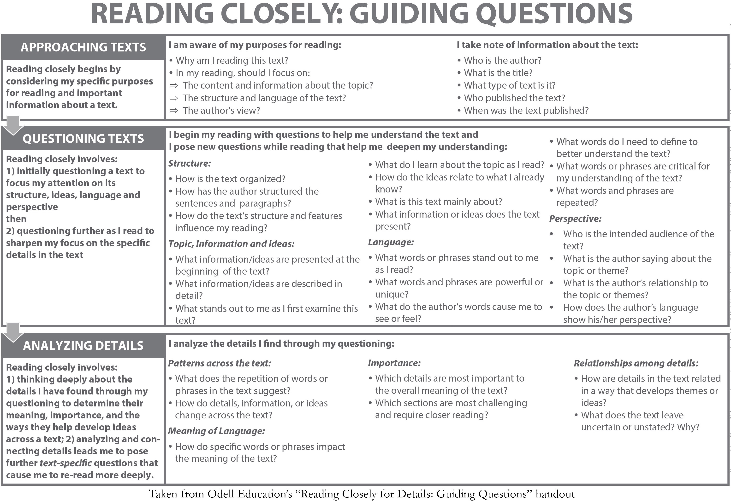

Teacher Directions: copy this page and cut into rows/strips. Each pair of students needs one complete set of the three note cards.

The air in the factory was humid and dusty. | The looms were powerful and could injure workers if they weren’t careful. | Workers lived and ate in crowded, noisy boardinghouses.
The air in the factory was humid and dusty. | The looms were powerful and could injure workers if they weren’t careful. | Workers lived and ate in crowded, noisy boardinghouses.
The air in the factory was humid and dusty. | The looms were powerful and could injure workers if they weren’t careful. | Workers lived and ate in crowded, noisy boardinghouses.
The air in the factory was humid and dusty. | The looms were powerful and could injure workers if they weren’t careful. | Workers lived and ate in crowded, noisy boardinghouses.
The air in the factory was humid and dusty. | The looms were powerful and could injure workers if they weren’t careful. | Workers lived and ate in crowded, noisy boardinghouses.

Name:
Date:

Questions | Answers
- The text says: “Now that she thought of it, she could hardly breathe, the air was so laden with moisture and debris” (75).
- What does laden mean? How do you know?
- What would it feel like to breathe air “laden with moisture and debris”?
- Which Working Conditions note card best explains what this quote helps the reader understand about Lyddie’s life and work?
- The text says: “Even though Diana had stopped the loom, Lyddie stood rubbing the powder into her fingertips, hesitating to plunge her hands into the bowels of the machine” (75).
- What does the phrase bowels of the machine mean?
- Personifying is to give the characteristics of a person or animal to a non-living object. What is Paterson personifying? Why does she do this?
- Which Working Conditions note card best explains what this quote helps the reader understand about Lyddie’s life and work?

Questions | Answers
- “Her quiet meals in the corner of the kitchen with Triphena, even her meager bowls of bark soup with the seldom talkative Charlie, seemed like feasts compared to the huge, rushed, noisy affairs in Mrs. Bedlow’s house” (76).
- What does the word meager mean? How do you know?
- It’s contradictory to suggest a meager meal could be a feast. How could this be true for Lyddie?
- Which Working Conditions note card best explains what this quote helps the reader understand about Lyddie’s life and work?

Questions | Answers
- The text says: “Now that she thought of it, she could hardly breathe, the air was so laden with moisture and debris” (75).  - What does laden mean? How do you know?  - What would it feel like to breathe air “laden with moisture and debris”?  - Which Working Conditions note card best explains what this quote helps the reader understand about Lyddie’s life and work? | - Students should discuss the questions with their seat partners and record their answers on the Chapter 10 of Lyddie Text-Dependent Questions handout.  - Pairs should work through these questions at their own pace. Some pairs may finish all three; others may only finish two.  - As pairs work, circulate to listen in on their conversations and to ask prompting and probing questions.  1. Listen for students to say: “Laden means to be ‘filled with a great quantity.’”  - Working Conditions note card: The air in the factory was humid and dusty.  Prompting and probing questions:  - “What is the difference between laden and full of?”  - “What feeling does the word laden give the sentence? How is it more effective than full of?”

Questions | Answers
- The text says: “Even though Diana had stopped the loom, Lyddie stood rubbing the powder into her fingertips, hesitating to plunge her hands into the bowels of the machine” (75).  - What does the phrase bowels of the machine mean?  - Personifying is to give the characteristics of a person or animal to a non-living object. What is Paterson personifying? Why does she do this?  - Which Working Conditions note card best explains what this quote helps the reader understand about Lyddie’s life and work? | 2. Listen for students to say: “Bowels of the machine means the ‘innards’ of the machine. The author is talking about the physical location where Lyddie’s hands must go, but she is also comparing the loom to a beast. This helps give a sense of Lyddie’s nervousness and her worry that the machines might get the best of her.”  - Working Conditions note card: The looms were powerful and could injure workers if they weren’t careful.  - Prompting and probing questions:  - “Bowels means ‘inner organs,’ like your intestines and stomach. Does a machine have organs? What might be inside it?”  - “Why does Paterson use a word usually used to describe a person or animal to describe a machine?”

Questions | Answers
- “Her quiet meals in the corner of the kitchen with Triphena, even her meager bowls of bark soup with the seldom talkative Charlie, seemed like feasts compared to the huge, rushed, noisy affairs in Mrs. Bedlow’s house” (76).  - What does the word meager mean? How do you know?  - It’s contradictory to suggest a meager meal could be a feast. How could this be true for Lyddie?  - Which Working Conditions note card best explains what this quote helps the reader understand about Lyddie’s life and work? | 3. Listen for students to say: “Meager means ‘deficient, scant, very little.’ A bowl of bark soup does not sound like a lot of food. Feast implies a meal that you relish and enjoy, and Lyddie enjoyed her quiet meals with less food more than the noisy, rushed meals with lots of food.”  - Working Conditions note card: Workers lived and ate in crowded, noisy boardinghouses.  Prompting and probing questions:  (For students who are stuck)  - “Three meals are being compared here. What are they? What does the word affairs mean here?”  - “Which meal has the most food? Which meal does she enjoy the least?”  - “Why does Paterson say “like feasts compared to” and not “better than”? How does that help you better understand Lyddie’s experience?

Chapter | Setting | Characters | Plot | How do setting, character, and/or plot interact?
11 |  |  |  | How is life different for Lyddie in the summer? Why?  What does Lyddie buy? Why?

Reader’s Dictionary, Chapter 11

Word/Phrase | Page | Definition | Word/Phrase | Page | Definition
anticipation | 79 |  | blacklisted | 81
grasp | 79 |  | engage | 81 | hire
honorable discharge | 81 | leaving a place of work with a good record | proficient | 81
Other new words:

Chapter | Setting | Characters | Plot | How do setting, character, and/or plot interact?
11 |  |  |  | How is life different for Lyddie in the summer? Why?  What does Lyddie buy? Why?

Reader’s Dictionary, Chapter 11

Word/Phrase | Page | Definition | Word/Phrase | Page | Definition
anticipation | 79 | expecting something to happen | blacklisted | 81 | being put on a list of people who are disapproved of and therefore should be avoided (or not hired)
grasp | 79 | hold tightly | engage | 81 | hire
honorable discharge | 81 | leaving a place of work with a good record | proficient | 81 | skillful, capable
Other new words:

