Lesson 6

Objective: Measure and compare lengths using centimeters and meters.

Suggested Lesson Structure

 Fluency Practice (11 minutes)

 Application Problem (7 minutes)

 Concept Development (32 minutes)

 Student Debrief (10 minutes)

**Total Time (60 minutes)**

Fluency Practice (11 minutes)

* Happy Counting **2.NBT.2**  (2 minutes)
* Sprint: Find the Longer Length **2.NBT.4** (9 minutes)

Happy Counting (2 minutes)

Materials: (T) 2 meter sticks

Note: Students fluently count by tens crossing the hundred and relate it to metric units.

T: Let’s do some Happy Counting in centimeters. Watch me as I pinch the meter stick where the centimeters are while we count. When I get to 100 centimeters (1 meter), I will call a volunteer to hold another meter stick.

T: Let’s count by tens, starting at 70 centimeters. When we get to 100 centimeters, we say 1 meter, and then we will go back to counting by centimeters. Ready? (Pinch the meter stick to stop on a number, moving pinched fingers up and down to lead students in Happy Counting by tens on the meter stick.)

S: 70 cm, 80 cm, 90 cm, 1 m, 110 cm, 120 cm. (Switch direction.) 110 cm, 1 m, 90 cm, 80 cm. (Switch direction.) 90 cm, 1 m, 110 cm, 120 cm.

T: Now, let’s say it with meters and centimeters. Let’s start at 80 centimeters. Ready?

S: 80 cm, 90 cm, 1 m, 1 m 10 cm, 1 m 20 cm, 1 m 30 cm, 1 m 40 cm. (Switch direction.) 1 m 30 cm, 1 m 20 cm. (Switch direction.) 1 m 30 cm, 1 m 40 cm, 1 m 50 cm, 1 m 60 cm, 1 m 70 cm, 1 m 80 cm, 1 m 90 cm, 2 m.

Sprint: Find the Longer Length (9 minutes)

Materials: (S) Find the Longer Length Sprint

Note: Students prepare for comparing lengths in the lesson by identifying the longer length in a Sprint.

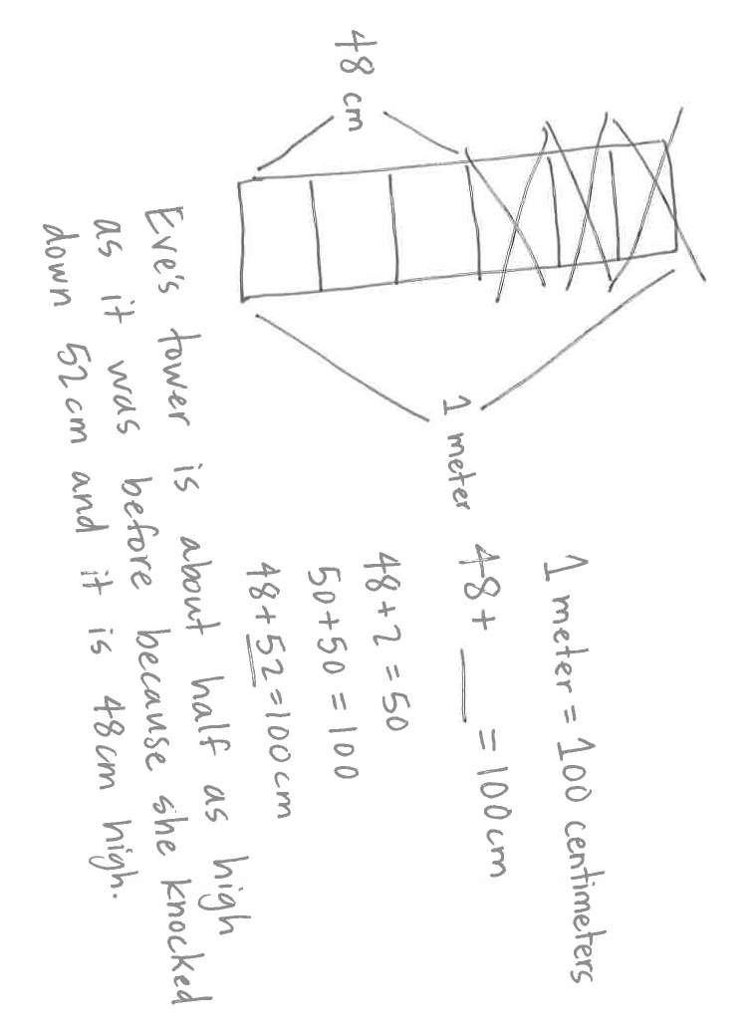Application Problem (7 minutes)

Eve builds a block tower that reaches the height of her bedroom doorknob, which is 1 meter high. Her little sister knocks some blocks down. Eve measures her new tower, and it is 48 centimeters tall. How does Eve’s new tower compare to when it was first built? Draw a picture on your personal board and use numbers or words to explain your thinking.

Note: In Lesson 5, students used mental benchmarks to estimate various lengths. This problem connects the concept of mental benchmarks to the language of comparisons. The question above is open-ended in nature, so student responses may vary from simple comparisons (e.g., it’s smaller now) to exact calculations, or even to the observation that it is now about half the size of the original tower. This problem serves as a bridge to today’s Concept Development, wherein students are asked to measure and compare various lengths to determine which is longer and which is shorter.

|  |  |
| --- | --- |
|  | NOTES ON  MULTIPLE MEANS  OF ACTION AND EXPRESSION: |
| Couple comparative vocabulary with illustrative gestures and questions such as the following:   * Who is taller? Shorter? (Ask with students standing back to back.) * How wide is this shoe? How long? Which shoe is longer? Which shoe is shorter? * Point to visuals while speaking to highlight the corresponding vocabulary. | |

Concept Development (32 minutes)

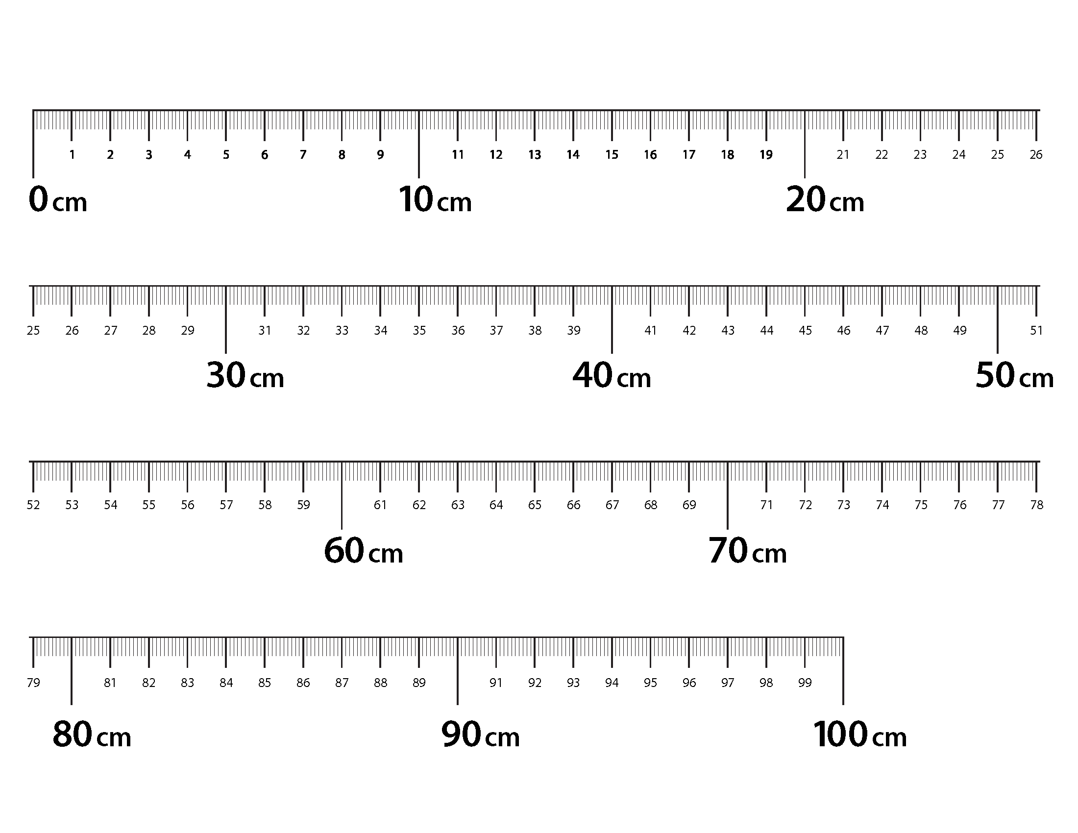Materials: (S) Personal white board, centimeter ruler, meter strip (Template), 2 sheets of paper per pair

Note: Meter strips can be made either in advance of the lesson or by students during the lesson.

T: I want to know: How long is the paper? With your pencil, label this side *A*. (Point to the longer side.)

S: (Write an A along the length of the paper.)

T: Use your **meter** **strip** to measure Side A, then write the measurement.

S: (Measure and record.)

T: Label this side *B.* (Point.)

**MP.2**

S: (Write a B along the width of the paper.)

T: How wide is the paper? Measure Side B and record the measurement.

S: (Measure and record.)

T: Which side is longer, Side A or Side B?

S: Side A.

T: How can I find out how much longer? Figure out a way with your partner.

S: Put two of them next to each other to see. 🡪 You could measure. 🡪 Measure and subtract.

T: Go to your seat with your partner and find out: How much longer is Side A than Side B?

Students go to their seats with two pieces of paper and solve the problem. Allow two–three minutes for students to complete the task. Observe student strategies to choose who will share. Select two or three students who use different approaches to share with the class.

|  |  |
| --- | --- |
|  | NOTES ON  MULTIPLE MEANS  OF ENGAGEMENT: |
| The language of comparison may be particularly challenging for English language learners. Scaffold understanding of Problem 5 in the Problem Set using these techniques:   * Break down the problem into small, workable chunks (e.g., “If Alice’s ribbon is 1 meter long, how many centimeters long is her ribbon?”) * Reframe the comparing sentence (e.g., “How much *more* ribbon does Alice have than Carol?”) * Teach students to ask themselves questions. “What type of problem is this? What do I know? What is unknown?”   These scaffolds also support Problem 6 on the Problem Set. | |

T: Who would like to share the strategy they used?

**MP.2**

S: I lined up the two pieces of paper and measured the one that was sticking out. 🡪 I measured both sides and counted on.

T: What strategy could you use if you only had one piece of paper?

S: Measure and add on! 🡪 Measure and subtract!

T: (Model measuring the difference in length using both strategies.)

Repeat the process above using the meterstrips to measure and compare the lengths of other objects around the room (e.g., desks and classroom board, the width of the door and the height of the door, the length of a bookcase and the height of a bookcase, student desk and teacher desk). Allow students to record their measurements and work on their personal white boards or in their math journals. Then, have students complete the Problem Set.

Problem Set (10 minutes)

Students should do their personal best to complete the Problem Set within the allotted 10 minutes. For some classes, it may be appropriate to modify the assignment by specifying which problems they work on first. Some problems do not specify a method for solving. Students should solve these problems using the RDW approach used for Application Problems.

Student Debrief (10 minutes)

**Lesson Objective**: Measure and compare lengths using centimeters and meters.

The Student Debrief is intended to invite reflection and active processing of the total lesson experience.

Invite students to review their solutions for the Problem Set. They should check work by comparing answers with a partner before going over answers as a class. Look for misconceptions or misunderstandings that can be addressed in the Debrief. Guide students in a conversation to debrief the Problem Set and process the lesson.

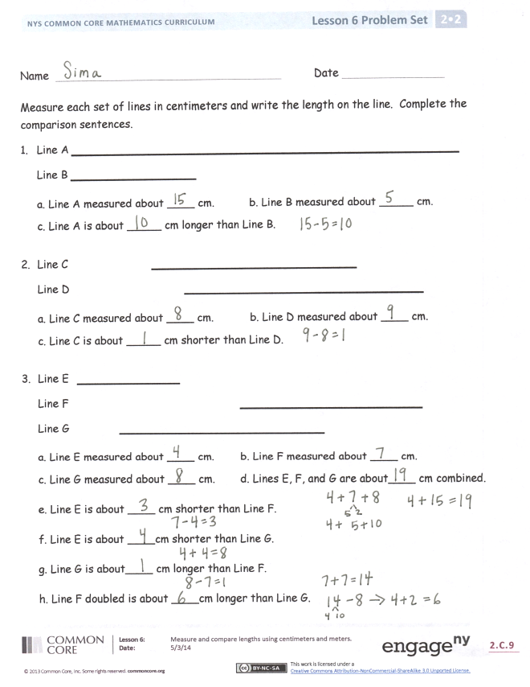You may choose to use any combination of the questions below to lead the discussion.

* For Problems 1–3, discuss with your partner how you determined the difference in length of the lines you measured. What is interesting about Line F in Problem 3?
* How did finding the missing addend in Problem 4 help you to answer Problem 5?
* Explain to your partner how you solved Problem 6 or Problem 7. How did you show your thinking?
* When you were measuring the paper today, how did your strategy change the second time you solved the problem? Which strategy was more efficient and accurate?
* How would you convince me that there is a benefit to measuring with centimeters versus meters? How about a ruler versus a **meter strip**?

Exit Ticket (3 minutes)

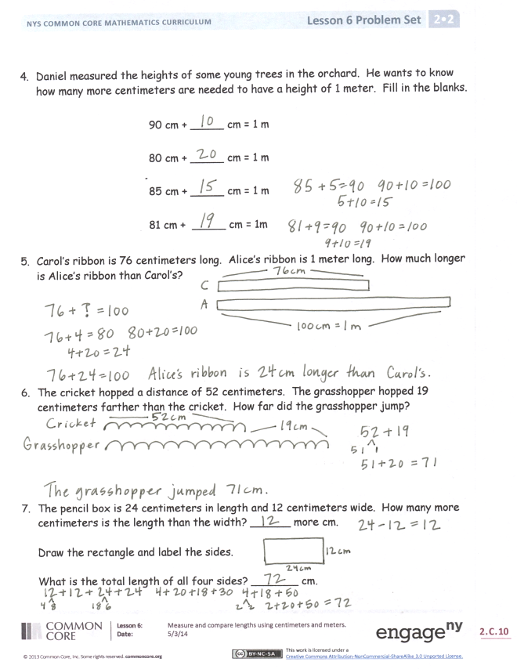After the Student Debrief, instruct students to complete the Exit Ticket. A review of their work will help you assess the students’ understanding of the concepts that were presented in the lesson today and plan more effectively for future lessons. You may read the questions aloud to the students.





Name Date

Measure each set of lines in centimeters, and write the length on the line. Complete the comparison sentences.

1. Line A **__________________________________**

Line B **___________**

a. Line A measured about ____ cm. b. Line B measured about _____ cm.

c. Line A is about _____ cm longer than Line B.

1. Line C **__________________**

Line D **_____________________**

a. Line C measured about ____ cm. b. Line D measured about ____ cm.

c. Line C is about _____ cm shorter than Line D.

1. Line E **_________**

Line F **________________**

Line G **__________________**

a. Line E measured about ____ cm. b. Line F measured about ____ cm.

c. Line G measured about ____ cm. d. Lines E, F, and G are about____ cm combined.

e. Line E is about ____ cm shorter than Line F.

f. Line E is about ____ cm shorter than Line G.

g. Line G is about____ cm longer than Line F.

h. Line F doubled is about ____ cm longer than Line G.

1. Daniel measured the heights of some young trees in the orchard. He wants to know how many more centimeters are needed to have a height of 1 meter. Fill in the blanks.

90 cm + _____ cm = 1 m

80 cm + _____ cm = 1 m

85 cm + _____ cm = 1 m

81 cm + _____ cm = 1m

1. Carol’s ribbon is 76 centimeters long. Alice’s ribbon is 1 meter long. How much longer is Alice’s ribbon than Carol’s?
2. The cricket hopped a distance of 52 centimeters. The grasshopper hopped 19 centimeters farther than the cricket. How far did the grasshopper jump?
3. The pencil box is 24 centimeters in length and 12 centimeters wide. How many more centimeters is the length than the width? ______ more cm

Draw the rectangle and label the sides.

What is the total length of all four sides? _______ cm

Name Date

Measure the length of each line and compare.

Line M **___________________________**

Line N **___________**

Line O **_____________________**

1. Line M is about ____ cm longer than Line O.

2. Line N is about ____ cm shorter than Line M.

3. Line N doubled would be about ____ cm (longer/shorter) than Line M.

Name Date

Measure each set of lines in centimeters, and write the length on the line. Complete the comparison sentences.

1. Line A **________________________________**

Line B **_______________________**

a. Line A is about ____ cm longer than line B.

b. Line A and B are about _____ cm combined.

1. Line X **__________________**

Line Y **____________________**

Line Z **___________**

a. Line X measured about ____ cm.

b. Line Y measured about ____ cm.

c. Line Z measured about ____ cm.

d. Lines X, Y, and Z are about____ cm combined.

e. Line Z is about ____ cm shorter than Line X.

f. Line X is about ____ cm shorter than Line Y.

g. Line Y is about ____ cm longer than Line Z.

h. Line X doubled is about ____ cm longer than line Y.

1. Line J is 60 cm long. Line K is 85 cm long. Line L is 1 m long.

a. Line J is ____ cm shorter than line K.

b. Line L is ____ cm longer than line K.

c. Line J doubled is ____ cm more than line L.

d. Lines J, K, and L combined are ____ cm.

1. Katie measured the seat height of four different chairs in her house. Here are her results:

Loveseat height: 51 cm

Dining room chair height: 55 cm

Highchair height: 97 cm

Counter stool height: 65 cm

* 1. How much shorter is the dining room chair than the counter stool? ____ cm
  2. How much taller is the highchair than the loveseat? ____ cm
  3. What is the difference between the height of tallest chair and the height of the shortest chair? ____ cm
  4. How much taller is a meter stick than the counter stool? ____ cm
  5. How much taller is a meter stick than the loveseat? ____ cm

1. Max ran 15 meters this morning. This afternoon, he ran 48 meters.
   1. How many more meters did he run in the afternoon?
   2. How many meters did Max run in all?
2. The length of the tabletop is 2 meters long. If the tablecloth on the table is 256 centimeters, how much longer is the tablecloth than the tabletop?

[1] 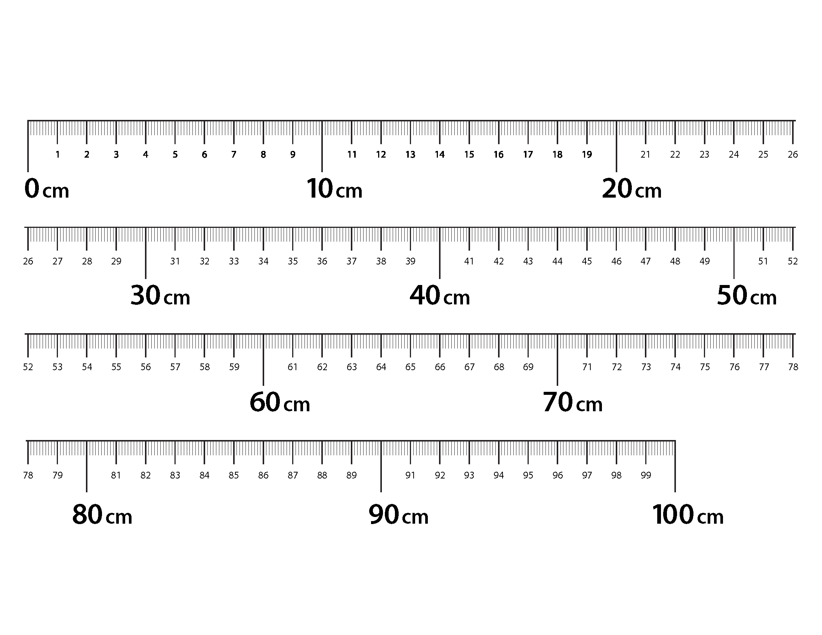

1. meter strip