Lesson 5
Objective: Develop estimation strategies by applying prior knowledge of length and using mental benchmarks.

Suggested Lesson Structure
 Fluency Practice (8 minutes)
 Application Problem (7 minutes)
 Concept Development (35 minutes)
 Student Debrief (10 minutes)
Total Time (60 minutes)
Fluency Practice (8 minutes)
- Break Apart by Tens and Ones 2.NBT.1 (4 minutes)
- Take Out a Part 2.OA.2 (4 minutes)
Break Apart by Tens and Ones (4 minutes)
Note: These fluency activities review place value understanding from Module 1 and help develop skills needed for Module 3.
Materials: (S) Personal white board
T: If I say 64, you write 6 tens 4 ones. If I say 7 tens 2 ones, you write 72.
T: Turn your board over when you’ve written your answer. When I say, “Show me,” hold it up.
T: 5 tens 2 ones. (Pause.) Show me.
S: (Hold up boards showing 52.)
T: 84. (Pause.) Show me.
S: (Show 8 tens 4 ones.)
Continue with the following possible sequence: 7 tens 3 ones, 79, 8 tens 9 ones, 9 tens 9 ones, 10 tens 2 ones, 10 tens 4 ones, 104, 10 tens 8 ones, 11 tens, and 11 tens 5 ones.
T: Partner B, quiz Partner A for one minute.
Take Out a Part (4 minutes)
Note: In this activity, students build fluency with decomposing a whole, which allows them to use the make a ten strategy with larger numbers (e.g., 80 + 50 = 80 + 20 + 30).
T: Let’s take out 2 tens from each number.
T: I say 5 tens. You say, 2 tens + 3 tens = 5 tens.
T: 5 tens.
S: 2 tens + 3 tens = 5 tens.
T: 7 tens.
S: 2 tens + 5 tens = 7 tens.
T: Let’s take out 20 from each number.
T: I say 50. You say, 20 + 30 = 50.
T: 50.
S: 20 + 30 = 50.
T: 70.
S: 20 + 50 = 70.
Continue with the following possible sequence: 83, 52, 97, 100, 105, 110, and 120.
T: Now, let’s take out 40. If I say 60, you say 40 + 20 = 60.
T: 50. Wait for the signal.
S: 40 + 10 = 50.
Continue with the following possible sequence: 70, 75, 81, and 87.
Application Problem (7 minutes)
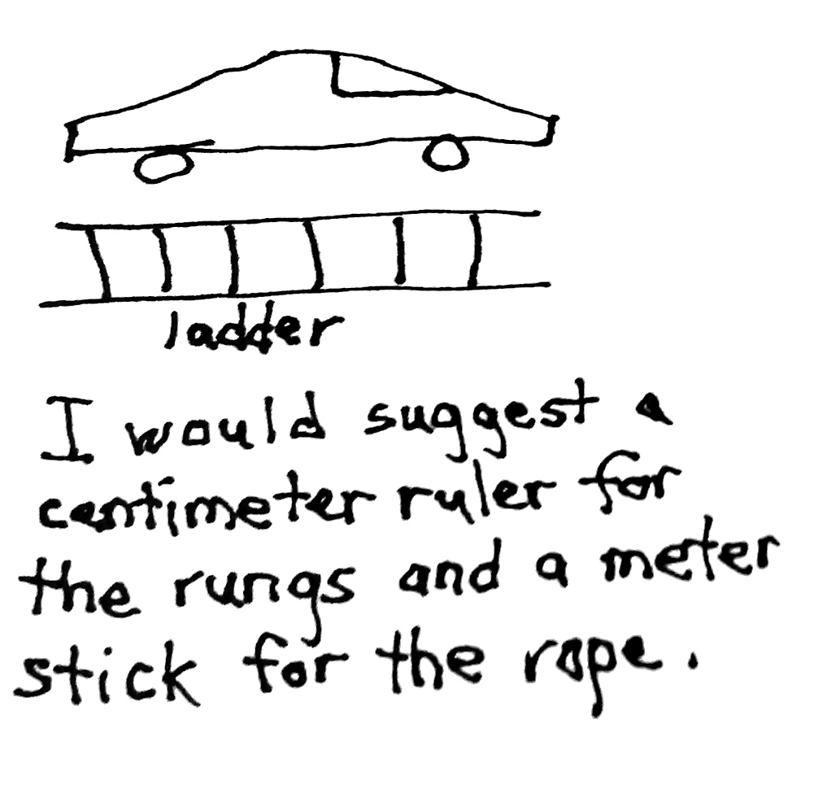
Jenna and Bobby are building a rope ladder for their treehouse. They would like the ladder to be about the length of a sports car. They want to use rope for the sides of the ladder and wood for the steps. Which measurement tools would you suggest that Jenna and Bobby use to measure the length of the rope and the length of the wooden steps for their ladder? Draw a picture and use words to explain your thinking.
Note: This problem asks students to choose the appropriate measurement tool by applying prior knowledge of length and making comparisons. Students work independently using personal white boards, and then compare their responses with a partner. The teacher listens in on conversations and invites a few students to share their responses with the whole class. The teacher may wish to return to this problem during the Debrief to estimate the amount of rope needed to build the ladder.
Concept Development (35 minutes)
Materials: (T) Meter stick (displayed horizontally for student reference), three-ring binder (S) 1 unused unsharpened pencil, 1 centimeter cube, centimeter ruler from Lesson 3, meter tape, 1 wedge eraser
T: Put your pinky on your centimeter cube. Would you say it’s about the same width as the centimeter cube?

NOTES ON
MULTIPLE MEANS
OF REPRESENTATION:
In this lesson, students will be learning multiple benchmark measurements. To help all students remember the benchmarks, these techniques may prove useful:
- Partner language with visuals by posting pictures of the benchmarks.
- Instruct students to create a reference chart to keep track of the benchmarks as they learn them. They can later use this chart as a reference.

S: Yes.
T: How could you use your pinky to estimate length?
S: I can tell how many times my pinky would fit into the space. I can put my pinky down as many times as I can and then count.
T: Let’s try that. Use your pinky to estimate, about how long do you think the eraser is? Turn to your neighbor and share your estimate.
S: About 6 centimeters.
T: Let’s measure to see if your estimates are correct.
S: (Use centimeter rulers to check estimates.)
T: The distance from the floor to the doorknob is about 1 meter (verify by modeling). How does this help you estimate the length of your desk?
S: My desk is about half the length from the floor to the doorknob, so it’s about 50 centimeters long. My desk is twice the length from the floor to the doorknob, so I think it’s about 2 meters long.

NOTES ON
MULTIPLE MEANS
OF ENGAGEMENT:
Use a chant to help students understand the conversion from meters to centimeters. Make gestures to accompany the chant.
T: When I say meter, you say 100 centimeters. (Open arms wide, about the length of a meter.)
T: Meter! (Open arms wide.)
S: 100 centimeters! (Open arms wide.)
This conversion is meant to support students’ estimations of the length of their desks.

MP.2
T: Let’s measure to see which estimate is closer to the real measurement.
S: (Use meter tapes to measure their desks.)
T: Measure your pencil. How long is it?
S: About 20 centimeters.
T: Can that help you estimate the length of your math book? Estimate the length of your math book, and then measure it with your centimeter ruler to see how close you got.
S: My math book is longer than the pencil, but not by much. They are almost the same. I think it’s about 23 centimeters. I think it’s 30 centimeters.
T: Picture the meter stick in your mind. Estimate how many meters long the classroom board is.
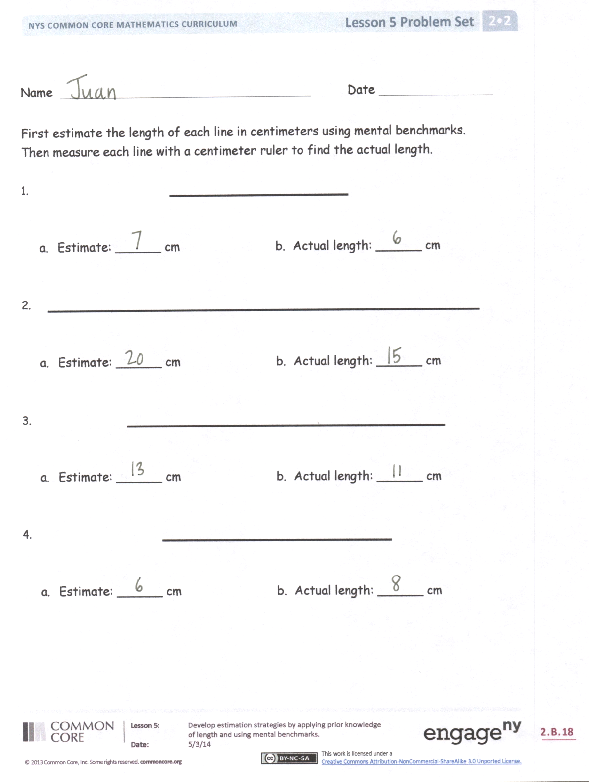
S: It looks like the board is a few meters long. I can fit more than one meter stick along the length of the board. I would say it is 2 meters long. To me, it’s longer than 2 meters, but shorter than 3 meters.
T: Let’s check our estimates. (Call on a volunteer to measure the board for the class.)
T: Now, look at this three-ring binder. What known measurement can we use to estimate the length?
MP.2
S: It looks about the same as my ruler, so 30 centimeters.
T: So, let’s check and see if it is 30 centimeters.
S: (Volunteer measures the three-ring binder.)
T: It is. Now that we know this is 30 centimeters, what other lengths can we estimate with this information?
S: The length of my science book. The length of the paper that goes inside the binder.
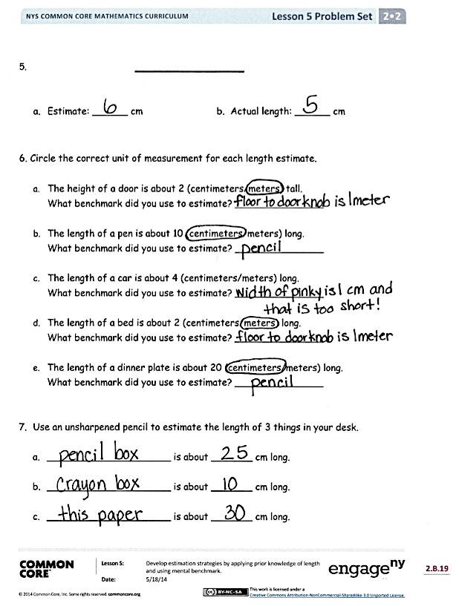
T: All these measurements we use to estimate length are called mental benchmarks. The pencil is 20 centimeters. Your pinky is 1 centimeter. The three-ring binder is 30 centimeters. And, the length from the doorknob to the floor is 1 meter. You can use these benchmarks at any time by picturing them in your head to estimate the length of an object. Now, use your mental benchmarks to estimate length on your Problem Set. Check your estimates by measuring.
Problem Set (10 minutes)
Students should do their personal best to complete the Problem Set within the allotted 10 minutes. For some classes, it may be appropriate to modify the assignment by specifying which problems they work on first. Some problems do not specify a method for solving. Students should solve these problems using the RDW approach used for Application Problems.

Student Debrief (10 minutes)
Lesson Objective: Develop estimation strategies by applying prior knowledge of length and using mental benchmarks.
The Student Debrief is intended to invite reflection and active processing of the total lesson experience.
Invite students to review their solutions for the Problem Set. They should check work by comparing answers with a partner before going over answers as a class. Look for misconceptions or misunderstandings that can be addressed in the Debrief. Guide students in a conversation to debrief the Problem Set and process the lesson.
You may choose to use any combination of the questions below to lead the discussion.
- Turn to your partner and compare your answers to Problems 1–5 in your Problem Set. Why is it possible to have different estimates? How can we check to see if our estimates are accurate?
- How many mental benchmarks can you name? (Draw students’ attention to Problem 6 on their Problem Set. Chart student responses for future reference.)
- How do mental benchmarks help us? When is a good time to use them?

NOTES ON
MULTIPLE MEANS
OF ACTION
AND EXPRESSION:
Provide sufficient wait time to allow students to process the connection between mental benchmarks and length of objects. Point to or hold visuals while speaking.
Ask students to explain how and why they chose a specific mental benchmark when estimating length.

- (Return to the Application Problem.) Look at Problem 6(c) on your Problem Set. We said that the length of a car is about 4 meters. How can we use this information to estimate the amount of rope Jenna and Bobby will need to build their ladder?
Exit Ticket (3 minutes)
After the Student Debrief, instruct students to complete the Exit Ticket. A review of their work will help you assess the students’ understanding of the concepts that were presented in the lesson today and plan more effectively for future lessons. You may read the questions aloud to the students.

Name Date

First, estimate the length of each line in centimeters using mental benchmarks.
Then, measure each line with a centimeter ruler to find the actual length.

- ______________

- Estimate: ______ cm b. Actual length: ______ cm

- __________________________________

- Estimate: ______ cm b. Actual length: ______ cm

- _________________________

- Estimate: ______ cm b. Actual length: ______ cm

- __________________

- Estimate: ______ cm b. Actual length: ______ cm

- ___________

- Estimate: ______ cm b. Actual length: ______ cm

- Circle the correct unit of measurement for each length estimate.

- The height of a door is about 2 (centimeters/meters) tall.
What benchmark did you use to estimate? _______________

- The length of a pen is about 10 (centimeters/meters) long.
What benchmark did you use to estimate? _______________

- The length of a car is about 4 (centimeters/meters) long.
What benchmark did you use to estimate? _______________

- The length of a bed is about 2 (centimeters/meters) long.
What benchmark did you use to estimate? _______________

- The length of a dinner plate is about 20 (centimeters/meters) long.
What benchmark did you use to estimate? _______________

- Use an unsharpened pencil to estimate the length of 3 things in your desk.

  - _____________________ is about _______ cm long.

  - _____________________ is about _______ cm long.

  - _____________________ is about _______ cm long.

Name Date

- Circle the most reasonable estimate for each object.
  - Length of a push pin 1 cm or 1 m
  - Length of a classroom door 100 cm or 2 m
  - Length of a pair of student scissors 17 cm or 42 cm

- Estimate the length of your desk. (Remember, the width of your pinky is about 1 cm.)
My desk is about _____ cm long.

- How does knowing that an unsharpened pencil is about 20 cm long help you estimate the length of your arm from your elbow to your wrist?
__________________________________________________________

__________________________________________________________

Name Date

- Name five things in your home that you would measure in meters.
Estimate their length.
*Remember, the length from a doorknob to the floor is about 1 meter.

Item | Estimated Length

- Choose the best length estimate for each object.

- Whiteboard 3 m or 45 cm

- Banana 14 cm or 30 cm

- DVD 25 cm or 17 cm

- Pen 16 cm or 1 m

- Swimming pool 50m or 150 cm
- The width of your pinky finger is about 1 cm.
Measure the length of the lines using your pinky finger. Write your estimate.

  - Line A _______________________

Line A is about _____ cm long.

  - Line B ____

Line B is about _____ cm long.

  - Line C _________________________________________________________

Line C is about _____ cm long.

  - Line D __________________________________

Line D is about _____ cm long.

  - Line E _______________

Line E is about _____ cm long.

