Lesson 1  
Objective: Connect measurement with physical units by using multiple copies of the same physical unit to measure.

Suggested Lesson Structure

 Fluency Practice (12 minutes)

 Application Problem (8 minutes)

 Concept Development (30 minutes)

 Student Debrief (10 minutes)

**Total Time (60 minutes)**

Fluency Practice (12 minutes)

* Happy Counting 20–40 **2.NBT.2** (2 minutes)
* Two More **2.OA.2** (1 minute)
* Sprint: Before, Between, After **2.NBT.2** (9 minutes)

Happy Counting 20–40 (2 minutes)

Note: Counting helps students prepare for counting centimeter cubes in the lesson.

T: Let’s count by ones, starting at 20. Ready? (Rhythmically point up until a change is desired. Show a closed hand, then point down. Continue, mixing it up.)

S: 20, 21, 22, 23. (Switch direction.) 22, 21, 20. (Switch direction.) 21, 22, 23, 24, 25. (Switch direction.) 24, 23, 22, 21, 20. (Switch direction.) 21, 22, 23, 24, 25, 26, 27, 28, 29, 30. (Switch direction.) 29, 28, 27. (Switch direction.) 28, 29, 30, 31, 32. (Switch direction.) 31, 30, 29, 28. (Switch direction.) 29, 30, 31, 32, 33, 34. (Switch direction.) 33, 32, 31, 30, 29. (Switch direction.) 30, 31, 32, 33, 34, 35, 36, 37, 38, 39, 40.

T: Excellent! Try it for 30 seconds with your partner starting at 28. Partner A, you are the teacher today.

Two More (1 minute)

Note: Students practice adding two more to make a ten, which builds fluency when crossing a ten.

T: For every number I say, you will say the number that is 2 more. If I say 2, you would say 4.   
Ready? 3.

S: 5.

Continue with the following possible sequences: 6, 8, 9, 18, 38, 58, 78, 79, 19, 29, and 39.

Sprint: Before, Between, After (9 minutes)

|  |  |
| --- | --- |
|  | NOTES ON  MULTIPLE MEANS  OF ENGAGEMENT: |

Some students may struggle to comprehend the transitive property. Divide the problem into small workable chunks so students can read and draw one step at a time.

For example:

T: Billy’s carrot sticks are longer than Emma’s.

S: (Draw 2 carrot sticks and label them.)

T: Mariana’s carrot sticks are longer than Billy’s.

S: (Draw a third carrot stick and label it, etc.)

Materials: (S) Before, Between, After Sprint

Note: Students identify the missing number in a pattern to build fluency counting up and back.

Application Problem (8 minutes)

At the lunch table, Mariana, Billy, and Emma are eating carrot sticks. Billy’s carrot sticks are longer than Emma’s, and Mariana’s carrot sticks are longer than Billy’s. If Mariana’s carrot sticks are 12 centimeters long, is it possible that Emma’s carrot sticks are 7 centimeters long? Draw a picture and use words to explain your thinking.

Extension: What is one possible length for Billy’s carrot sticks?

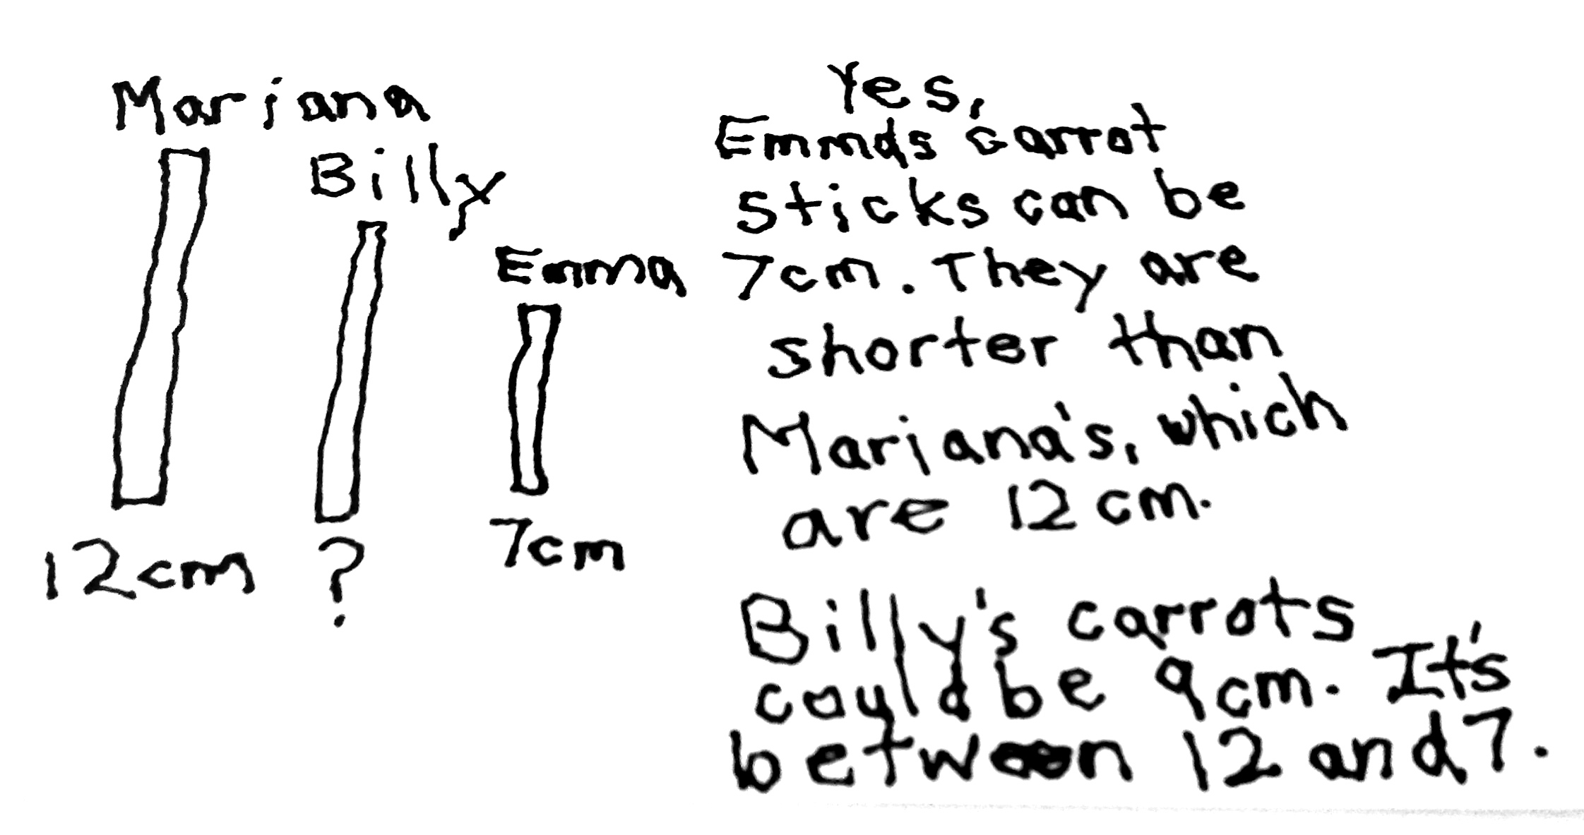

Note: In Grade 1, students spent time comparing the lengths of two objects indirectly by using a third object (**1.MD.1**). In this problem, students practice working with the transitive property using comparative language. While the teacher circulates and provides support, students use personal white boards to draw a picture and compare with a partner before participating in a whole class discussion. The teacher may wish to segue into today’s lesson by asking students if they could measure the carrot sticks with a small paper clip.

Concept Development (30 minutes)

**MP.3**

Materials: (T) 2–3 crayons of varying lengths (S) Per pair: baggie with 30 or more centimeter cubes, baggie of used crayons; 2 pencil boxes

T: (Call students to sit in a circle on the carpet.) I was looking at my pencil box this morning, and I was very curious about how long it might be. I also have this handful of centimeter cubes and I thought I might be able to measure the length of my pencil box with these cubes. Does anyone have an idea about how I might do that?

S: You could put the cubes in a line along the pencil box and count how many!

T: Does anyone want to guess, or **estimate**, about how many centimeter cubes long it will be?

S: (Make estimates.)

T: Let’s see how many centimeter cubes we can line up along the length of the pencil box. (Place cubes along the length of the first pencil box with random spaces in between each cube.)

T: OK. Should I go ahead and count my cubes now?

S: No!

|  |  |
| --- | --- |
|  | NOTES ON  MULTIPLE MEANS  OF REPRESENTATION: |

Post conversation starters during think–pair–share while measuring with cubes:

* Your solution is different from mine because….
* Your error was….
* My strategy was to….

These sentence starters will also be useful in the Student Debrief.

T: Why not?

S: You need to put the cubes right next to each other. 🡪 You need to start measuring at the beginning of the pencil box.

T: You are right! There should be no gaps between the cubes. Also, we need to begin measuring where the object begins. That’s called the **endpoint**.

T: Come show me how you would place the cubes to measure this second pencil box. (Student volunteer lays the cubes along the length of the second pencil box starting at the beginning with no spaces between each cube. Demonstrate in center of circle so students can see alignment.)

T: Let’s count the cubes my way and your way. (Count the cubes chorally with the students, and write both measurements on the board.)

T: Turn to your neighbor and tell them why there is a difference between my number of cubes and your number of cubes.

S: You had fewer cubes because there were some empty spaces. 🡪 If you push all the cubes together, you have a lot of extra space not measured. 🡪 You didn’t start at the endpoint.

T: Let’s look at a set of used crayons. Each crayon will be a different length, and some may not be an exact measurement.

T: (Hold up a crayon with a measurement that will be rounded up.)

T: Notice that this crayon is almost 8 centimeter cubes long. It is more than 7 and one-half cubes but not quite 8. I can say this crayon is about 8 centimeter cubes long.

T: (Hold up a crayon with a measurement that will be rounded down.)

T: Notice that this crayon is close to 6 centimeter cubes long. It is just a little bit longer than 6 cubes and not half way to 7 cubes. How long would you say this crayon is?

S: About 6 centimeter cubes.

T: Yes, and we can simply say the crayon is about 6 centimeters.

T: You will now work with a partner to measure a set of used crayons. As you measure, be sure to use the word *about* to describe a measurement that is not exact. Turn to your neighbor and estimate how many centimeter cubes you think you will need for each crayon in the baggie. (Alternative items to measure are scissors, each other’s pencils, and erasers.)

S: (Share estimates with their partner, and then begin measuring their crayons.)

T: Let’s practice some more measuring on our Problem Set.

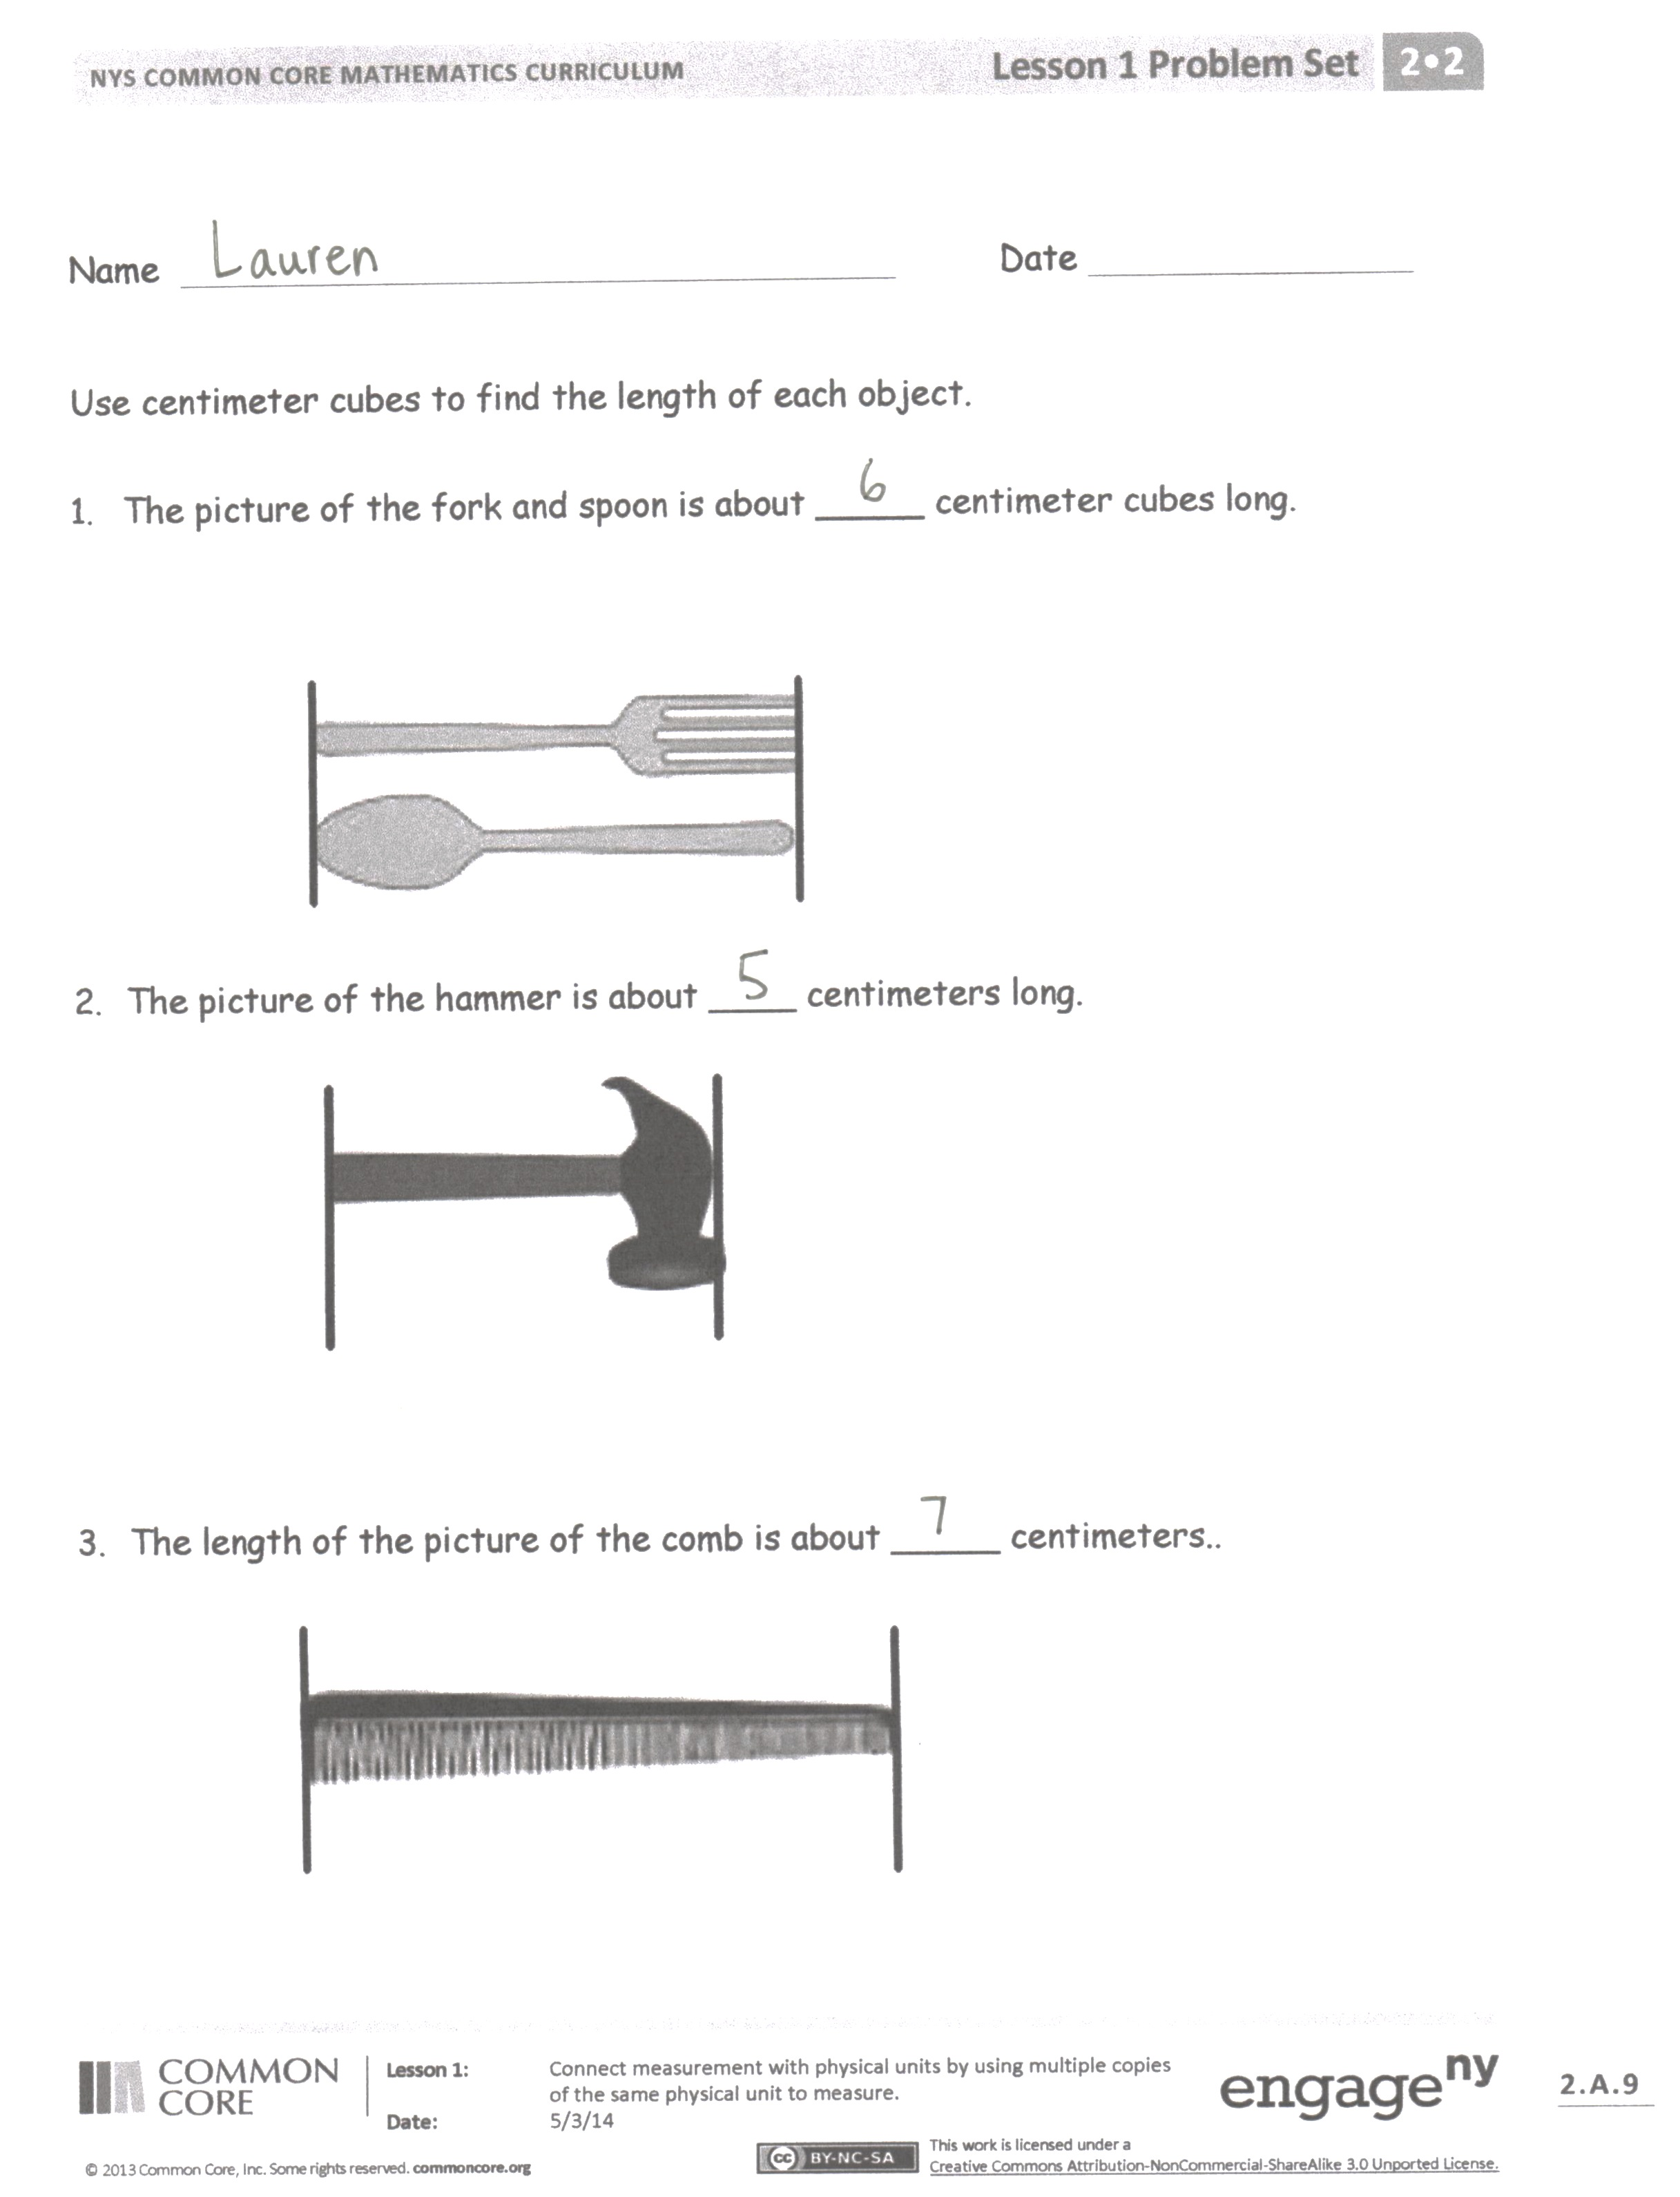Problem Set (10 minutes)

Students should do their personal best to complete the Problem Set within the allotted 10 minutes. Some problems do not specify a method for solving. This is an intentional reduction of scaffolding that invokes MP.5, Use Appropriate Tools Strategically. Students should solve these problems using the RDW approach used for Application Problems.

For some classes, it may be appropriate to modify the assignment by specifying which problems students should work on first. With this option, let the careful sequencing of the Problem Set guide your selections so that problems continue to be scaffolded. Balance word problems with other problem types to ensure a range of practice. Assign incomplete problems for homework or at another time during the day.

Student Debrief (10 minutes)

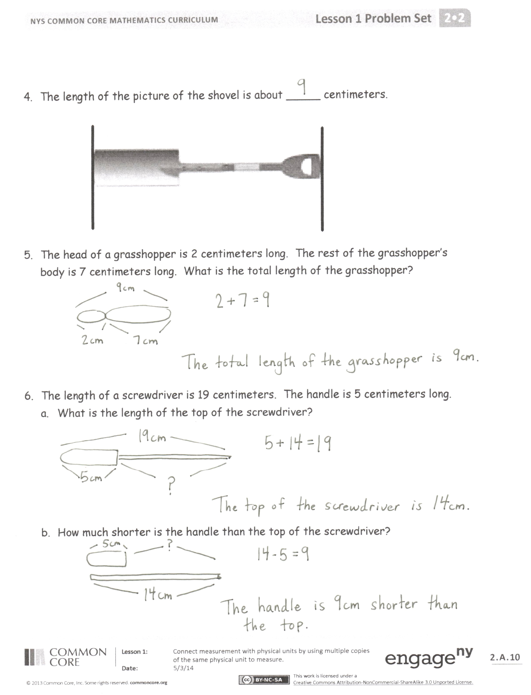**Lesson Objective**: Connect measurement with physical units by using multiple copies of the same physical unit to measure.

The Student Debrief is intended to invite reflection and active processing of the total lesson experience.

Invite students to review their solutions for the Problem Set. They should check work by comparing answers with a partner before going over answers as a class. Look for misconceptions or misunderstandings that can be addressed in the Debrief. Guide students in a conversation to debrief the Problem Set and process the lesson.

You may choose to use any combination of the questions below to lead the discussion.

* Turn to your partner and compare your answers to Problems 1–4. Explain what you had to do to measure correctly.

**MP.3**

* Did anyone find, when sharing your work, that you had a different measurement than your? (Students will share that they may have not lined up the object with the edge of the first centimetercube, or that they left spaces between cubes. This is an excellent opportunity to discuss **endpoint**.)
* How did your drawings help you to answer Problems 5 and 6? What new (or significant) vocabulary did we use today to talk about measurement? (Length, **estimate**, and longer.)
* What did you learn about how to measure with centimeter cubes? Could you have measured with a pocketful of coins?

Exit Ticket (3 minutes)

After the Student Debrief, instruct students to complete the Exit Ticket. A review of their work will help you assess the students’ understanding of the concepts that were presented in the lesson today and plan more effectively for future lessons. You may read the questions aloud to the students.

Note: Discuss Homework Problems 3 and 4 during the next day’s lesson to point out that students should not count the extra cubes.





Name Date

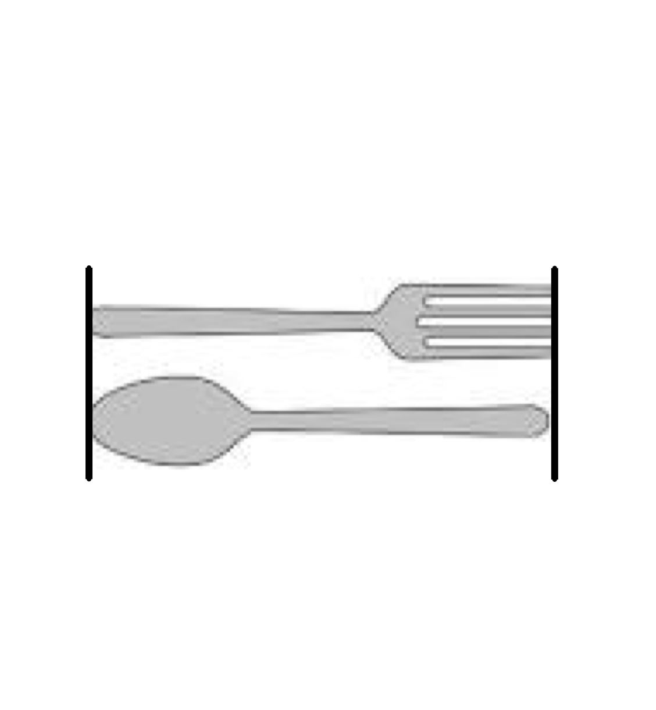Use centimeter cubes to find the length of each object.

1. The picture of the fork and spoon is about _____ centimeter cubes long.
2. The picture of the hammer is about ____ centimeters long.

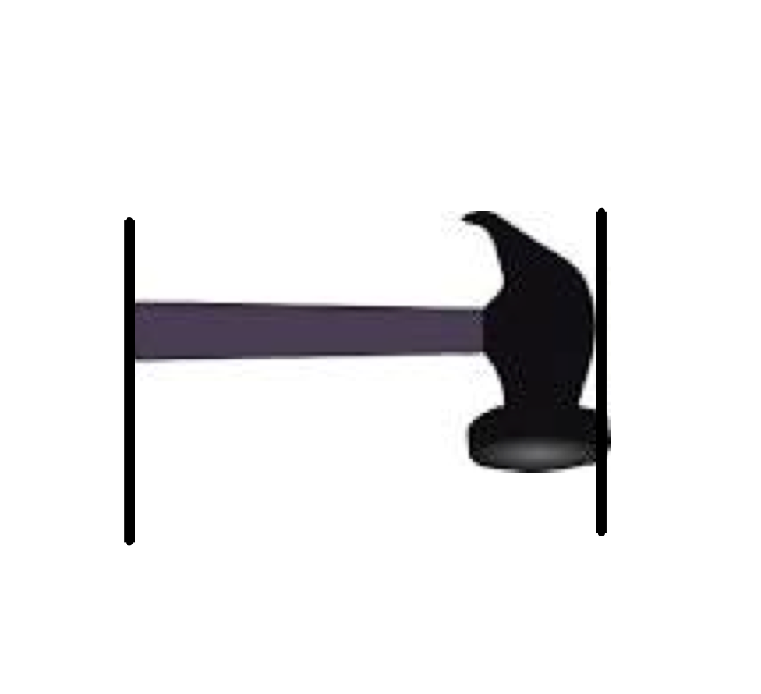

1. The length of the picture of the comb is about _____ centimeters..

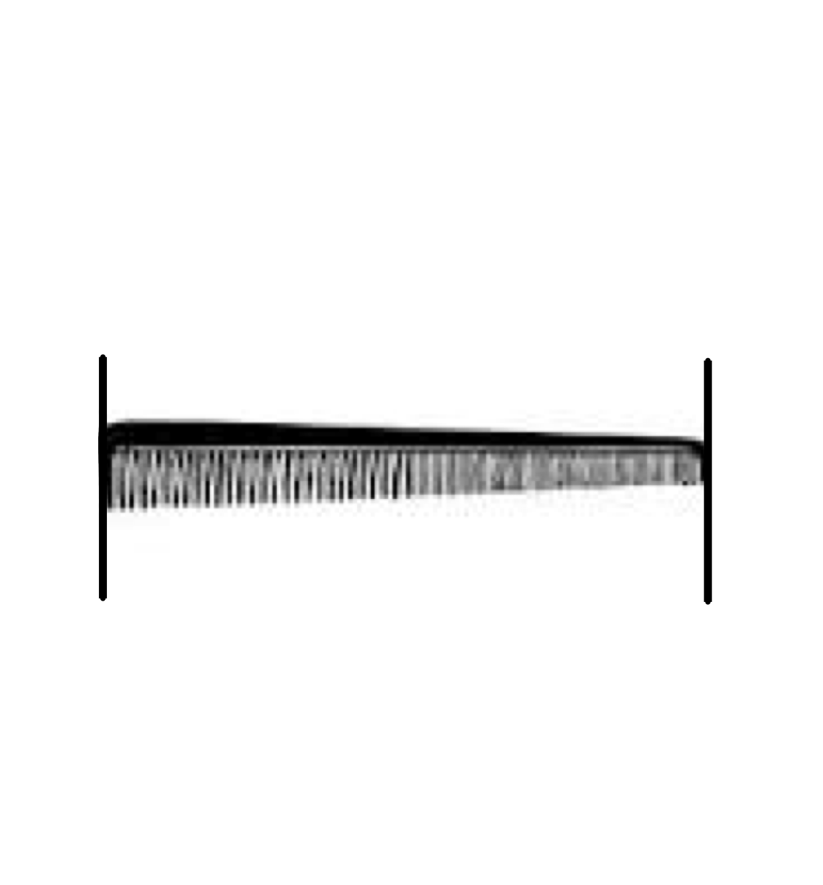

1. The length of the picture of the shovel is about _____ centimeters.

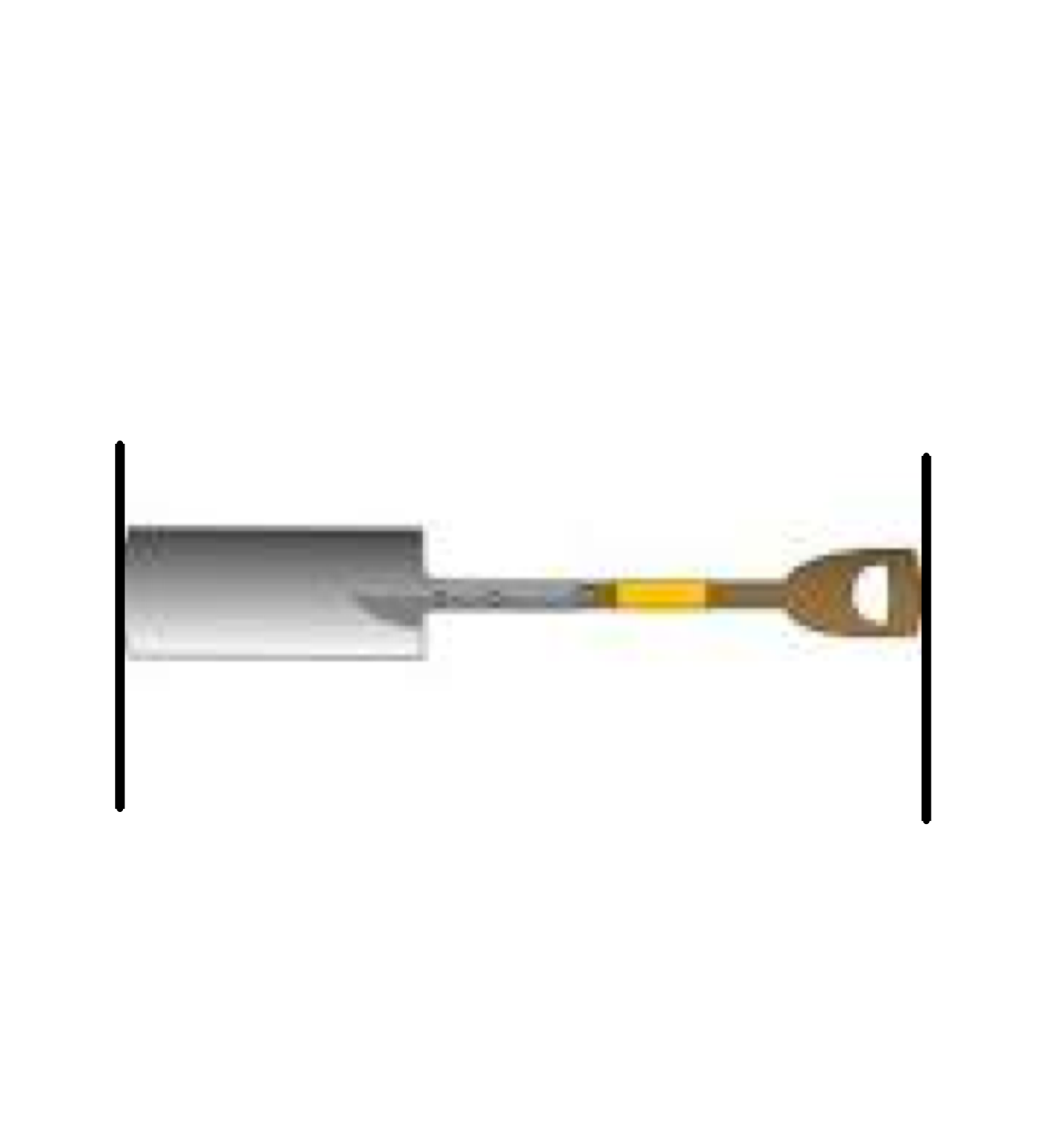

1. The head of a grasshopper is 2 centimeters long. The rest of the grasshopper’s body is 7 centimeters long. What is the total length of the grasshopper?
2. The length of a screwdriver is 19 centimeters. The handle is 5 centimeters long.
3. What is the length of the top of the screwdriver?
4. How much shorter is the handle than the top of the screwdriver?

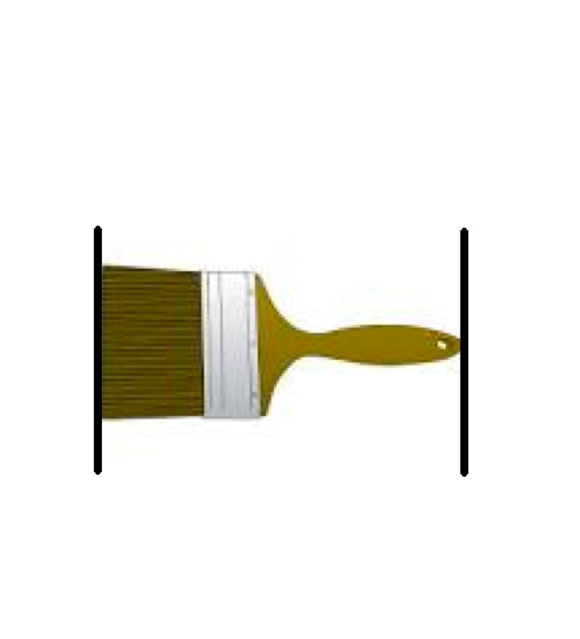Name Date

Sara lined up her centimeter cubes to find the length of the picture of the paintbrush.

Sarah thinks the picture of the paintbrush is 5 centimeter cubes long.



Is her answer correct? Explain why or why not.

__________________________________________________________

__________________________________________________________

Name Date

Count each centimeter cube to find the length of each object.



1.  The crayon is ______ centimeter cubes long.

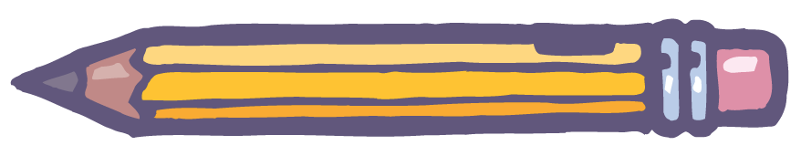



2. The pencil is ______ centimeters long.



3. The clothespin is ________ centimeters long.

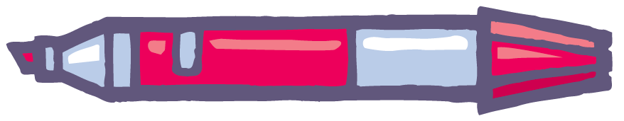



4.

The length of the marker is _______ centimeters.

1. Richard has 43 centimeter cubes. Henry has 36 centimeter cubes. What is the length of their cubes altogether?
2. The length of Marisa’s loaf of bread is 56 centimeters. She cut off of 32 centimeters of bread. What is the length of what she has left?
3. The length of Jimmy’s math book is 17 centimeter cubes. His reading book is 12 centimeter cubes longer. What is the length of his reading book?