Lesson 8

Objective: Decompose to subtract from a ten when subtracting within 100 and apply to one-step word problems.

Suggested Lesson Structure

 Fluency Practice (15 minutes)

 Concept Development (30 minutes)

 Application Problem (5 minutes)

 Student Debrief (10 minutes)

**Total Time (60 minutes)**

Fluency Practice (15 minutes)

|  |  |
| --- | --- |
|  | NOTES ON  MULTIPLE MEANS OF ENGAGEMENT: |
| Adjust the lesson times as needed. Consider omitting the Sprint in order to have sufficient time for the Concept Development portion. Or, complete the first half of the Concept Development, subtracting from multiples of ten, and save the balance of the lesson for inclusion in fluency activities throughout the rest of the year. | |

* Sprint: Make a Ten **2.OA.2**  (9 minutes)
* Take from 20 **2.OA.2** (3 minutes)
* Subtract 1 from Multiples of 10 **2.OA.2** (3 minutes)

Sprint: Make a Ten (9 minutes)

Materials: (S) Make a Ten Sprint

Note: Students should develop automaticity to fluently make a ten when adding.

Take from 20 (3 minutes)

Materials: (S) Personal white boards

Note: Students use personal white boards to see the connection between taking from ten and taking from a multiple of ten. As students show comprehension of the skill, practice orally without the personal boards.

T: I say 3, you say 7, to take the number I say from 10. Write the number sentence and wait for my signal to show it.

T: 8.

S: 2. (Write number sentence.)

T: Show your personal boards.

S: (Show 10 – 8 = 2.)

Continue with the following possible sequence: 4, 5, and 9.

T: This time instead of taking from 10, let’s take from 20. Ready? 1.

S: 19. (Write number sentence.)

T: Show your personal board.

S: (Show 20 – 1 = 19.)

Continue with the following possible sequence: 3, 2, 5, 0, 6, 8, 7, and 9.

|  |  |
| --- | --- |
|  | NOTES ON  MULTIPLE MEANS OF REPRESENTATION: |
| Coupled with Say Ten counting, these representations help students to understand the unit changes occurring at the tens. Connect Say Ten language with models such as the 100-bead Rekenrek. | |

Subtract 1 from Multiples of 10 (3 minutes)

Materials: (T) Drawings on the board should be sufficient. Cover rows and reveal them as the numbers grow.

Note: This fluency sequence assures that students can change from 30 to 29, 40 to 39. In Say Ten counting, the count goes from “3 tens” to “2 tens 9,” or “4 tens” to “3 tens 9.” Continue through 100 – 1. Consider doing the problems in order at first and then jumble the sequence.

**10 – 1 = 9**

**20 – 1 = 19**

**“2 tens – 1 is 1 ten 9.”**

**30 – 1 = 29**

**“3 tens – 1 is 2 tens 9.”**

Concept Development (30 minutes)

Materials: (T) Two-sided counters, ten-frame cards showing 10 (Lesson 3 Template)   
(S) Personal white boards

Part 1: Subtract single-digit numbers from multiples of 10 through 100.

T: Present 10 counters (as shown below).

T: 10 – 3 is…?

S: 7.

T: (Lay down a ten-frame card.) 10 + 7 is…?

S: 17.

T: 20 – 3 is…?

S: 17.

**10 – 3 = 7**

**20 – 3 = 17**

**30 – 3 = 27**

T: 10 + 10 – 3 is…?

S: 17.

T: (Lay down a ten-frame card.) 20 + 7 is…?

S: 27.

T: 30 – 3 is…?

S: 27.

T: 20 + 10 – 3 is…?

S: 27.

T: Explain to your partner how 10 – 3 helps us to solve   
30 – 3. Use the model to help you.

S: They’re the same, but 30 has 2 more tens. 🡪 10 is inside 30 so you take from the ten. 🡪 It’s the same as 20 + 10 – 3.

Following the work with manipulatives, model how to draw the number bond in order to solve the problems. Take the 3 from the ten.

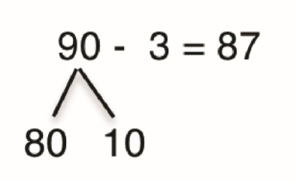Give the students a variety of problems from simple to complex. Use this possible sequence: 20 – 1, 20 – 5, 30 – 6, 40 – 6, 50 – 4, 60 – 3, 70 – 2, 80 – 8, 100 – 8. Conclude with a brief discussion about the helpfulness of the structure.

T: 90 – 3 = 87. Discuss with your partner how 10 – 3 helps to solve 90 – 3. Use a drawing or materials that will help you to explain clearly.

T: 60 – 8 can be solved using the same way of thinking. Can you write and solve other problems that can be solved this way, too?

Part 2: Subtract single-digit numbers from multiples of 10 with some ones.

Note: Students continue to take from the 10 to subtract, with the added complexity of adding some ones back in. This enables students to see the pattern and gain a deeper understanding of how the structure of 10 can be used to make problem solving easier. When students count back to execute this process, it is very hard to see the simplicity of the pattern.

T: Present 11 counters (as shown below).

T: 10 – 5 (pause and point) + 1 is…?

S: 6.

T: 11 – 5 is…?

S: 6.

T: (Lay down a ten-frame card.) 20 – 5 is…?

S: 15.

T: 20 – 5 + 1 is…?

**11 – 5 = 6**

**21 – 5 =16**

**31 – 5 = 26**

**41 – 5 = 36**

S: 16.

T: 21 – 5 is…?

S: 16.

T: (Lay down a ten-frame card.) 30 – 5 is…?

S: 25.

T: 30 – 5 + 1 is…?

S: 26.

T: 31 – 5 is…?

S: 26.

T: Explain to your partner how 10 – 5 helps us to solve 21 – 5. Use the model to help you.

S: I can break 21 into 11 and 10 and then I just take 5 from 10, and add 11 to the answer. 🡪 I know 10 – 5 is 5, so 20 – 5 is 15, then 21 – 5 is 16.

Part 3: Practice on personal white boards.

Note: Allow time for students to work on their personal boards, with manipulatives as needed, so that they practice many problems. As students demonstrate proficiency, allow them to work on the Problem Set.

T: 91 – 5 = 86. Show your partner how you know that is true. Use your words, number bonds, and models to prove it. How might you solve 23 – 9 using the same process?

Problem Set (10 minutes)

Students should do their personal best to complete the Problem Set within the allotted 10 minutes. For some classes, it may be appropriate to modify the assignment by specifying which problems they work on first. Some problems do not specify a method for solving. Students should solve these problems using the RDW approach used for Application Problems.

G2-M1-TC-L8 sketchApplication Problem (5 minutes)

Kayla has 21 stickers. She gives Sergio 7 stickers. How many stickers does she have left?

T: Let’s read the problem together.

T: What is the problem asking you to find?

S: How many stickers Kayla has left.

T: Are we given the total and one part, or do we know both parts?

S: The total and one part.

T: What is the total?

S: 21.

T: What is the part?

S: 7.

T: Talk with your partner: What can you draw that will help you see the information in the problem?

S: I can draw circles like on the ten-frame cards. 🡪 I can draw a number bond.

T: (Give students a minute to make their drawings on their personal boards.)

T: How can I find the difference?

S: Subtract!

T: Can I use the strategy we learned today to solve?

S: Yes! Subtract from the ten.

T: (Circulate as students solve and show their work. Choose one or two pieces of student work to share with the class. Ask the students to share the strategies they used to solve.)

Note: This Application Problem is an extension of the Concept Development wherein students decompose to subtract from a ten. While the vignette guides students to use the strategy of subtracting from the ten using ten frames and number bonds, accept all work that students can rationally explain.

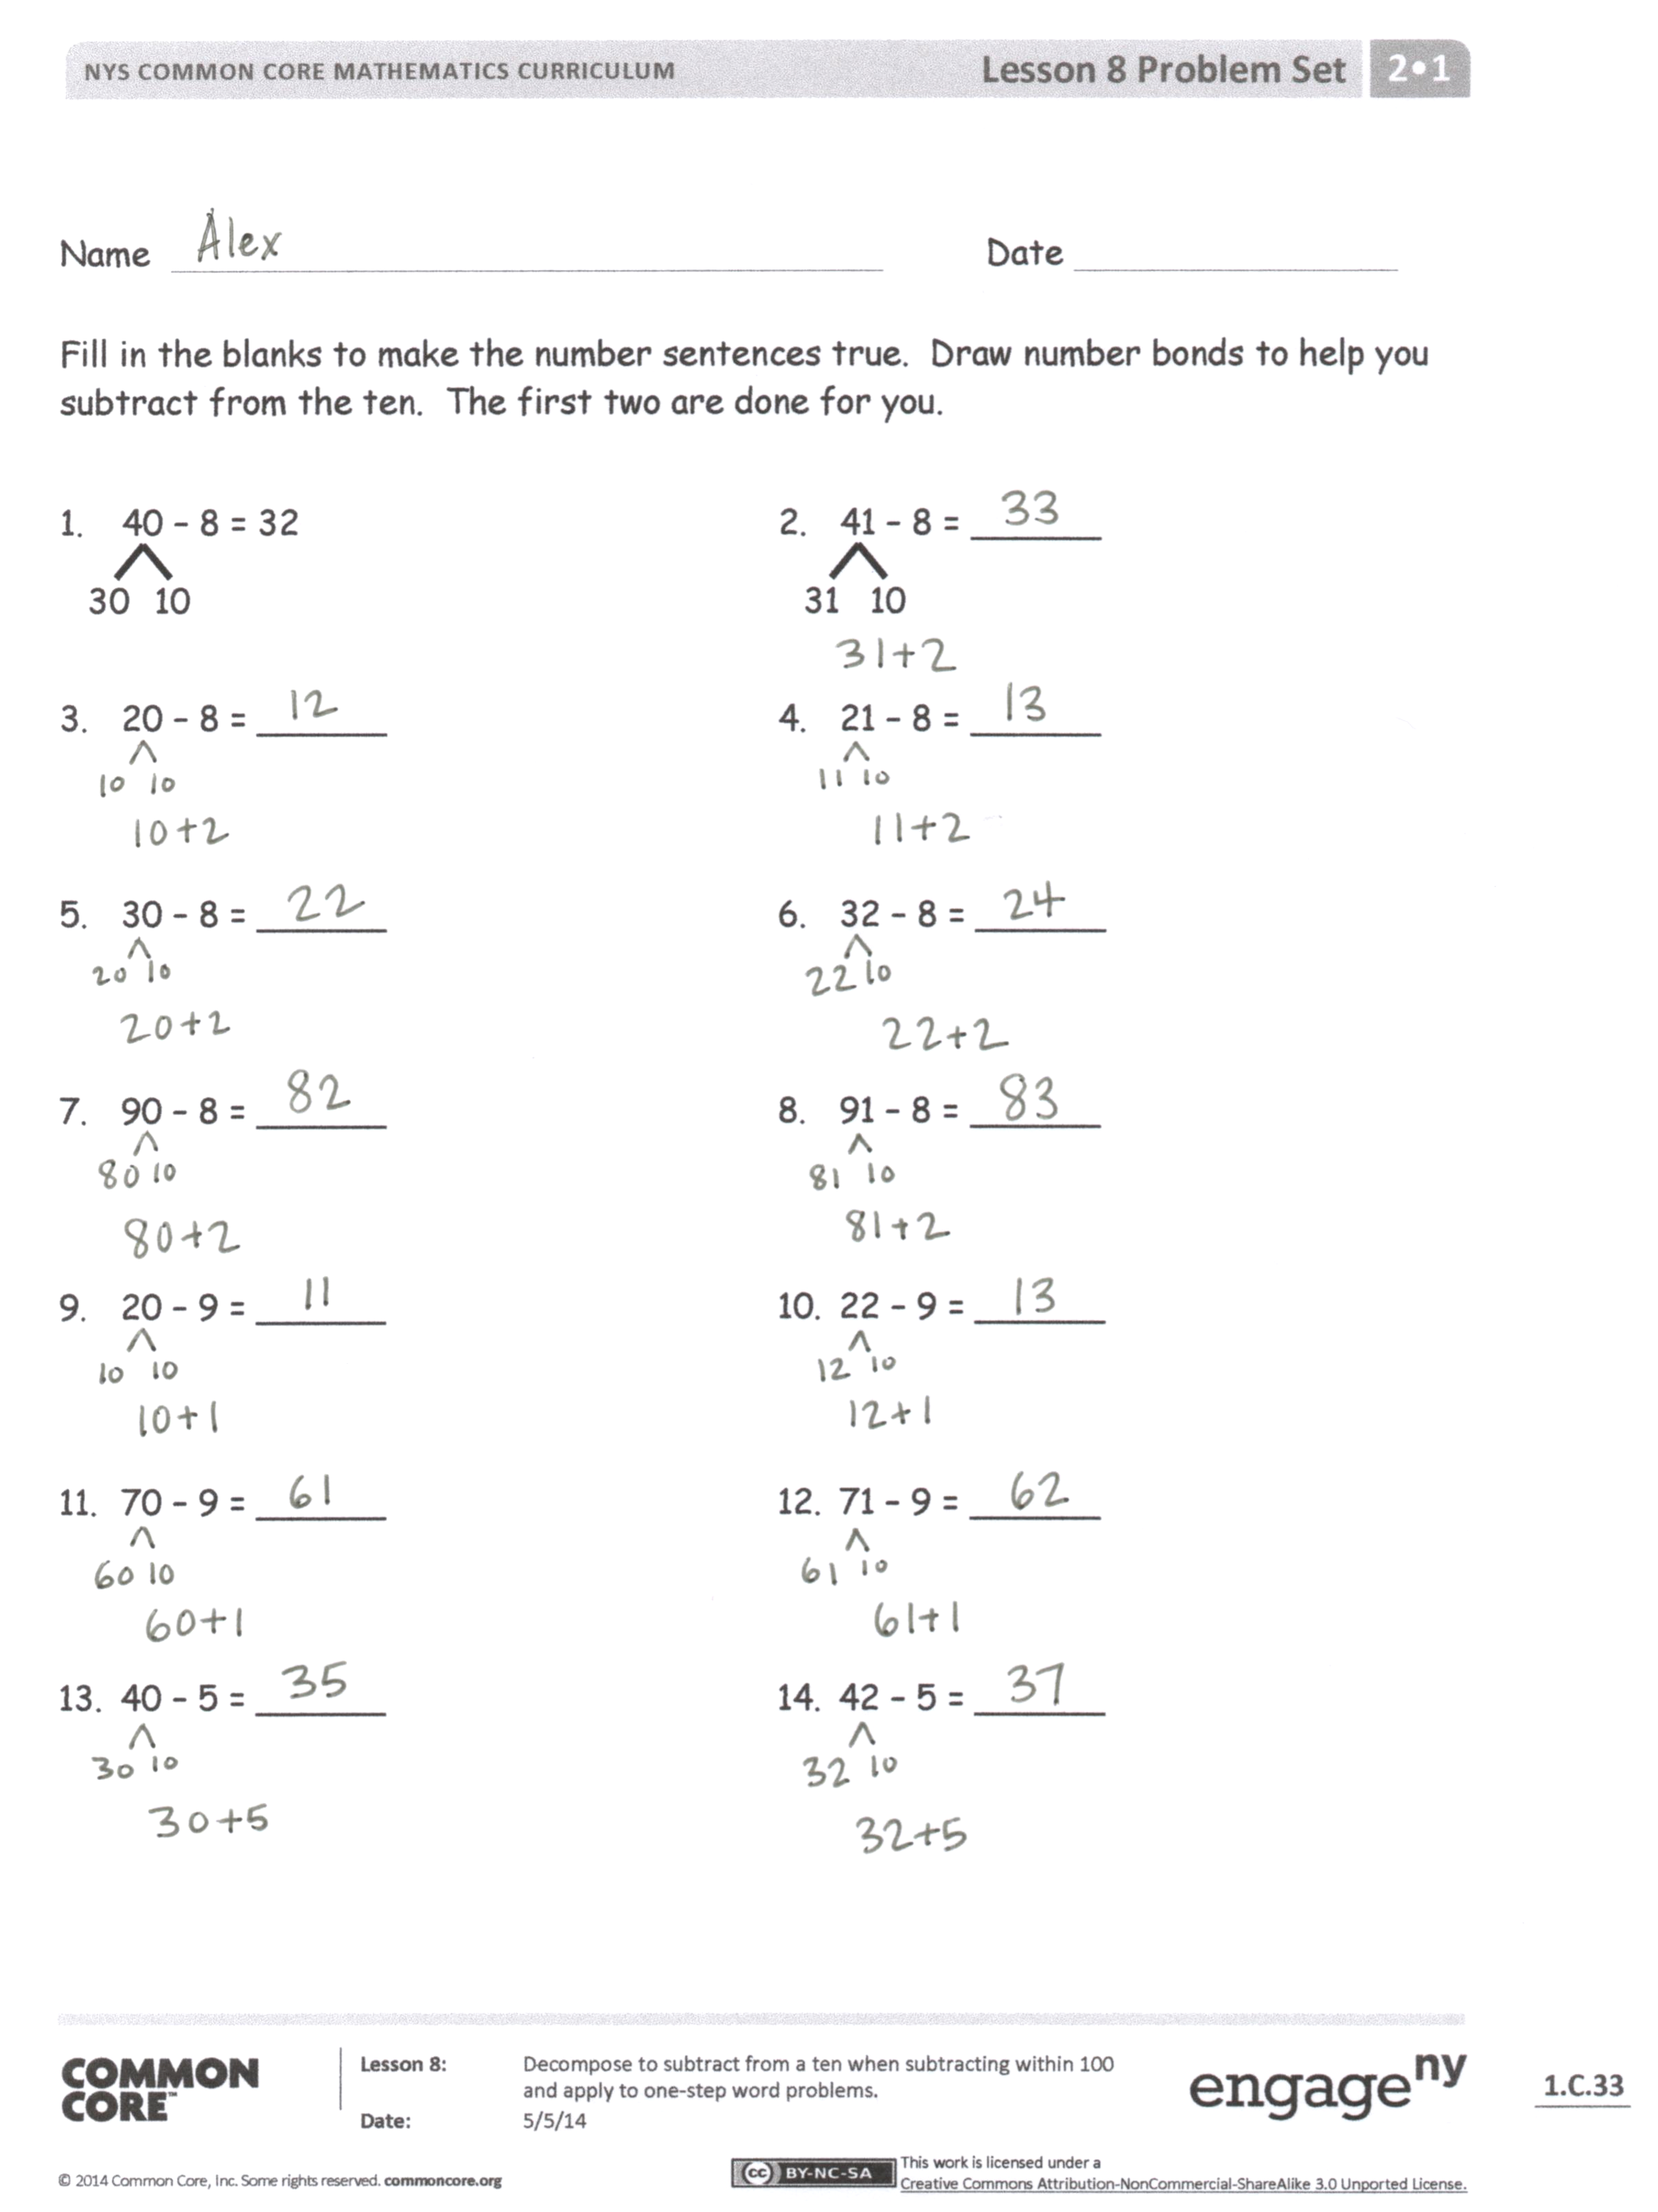Student Debrief (10 minutes)

**Lesson Objective:** Decompose to subtract from a ten when subtracting within 100 and apply to one-step word problems.

The Student Debrief is intended to invite reflection and active processing of the total lesson experience.

Invite students to review their solutions for the Problem Set. They should check work by comparing answers with a partner before going over answers as a class. Look for misconceptions or misunderstandings that can be addressed in the Debrief. Guide students in a conversation to debrief the Problem Set and process the lesson.

You may choose to use any combination of the questions below to lead the discussion.

* In the Problem Set, how does 20 – 8 help you solve 21 – 8?
* How does 21 – 8 help solve 32 – 8?

**MP.7**

* How did the basic fact 10 – 8 = 2 help you solve 21 – 8 and 32 – 8?
* How do number bonds help you solve subtraction problems?
* What was the focus of our lesson today?

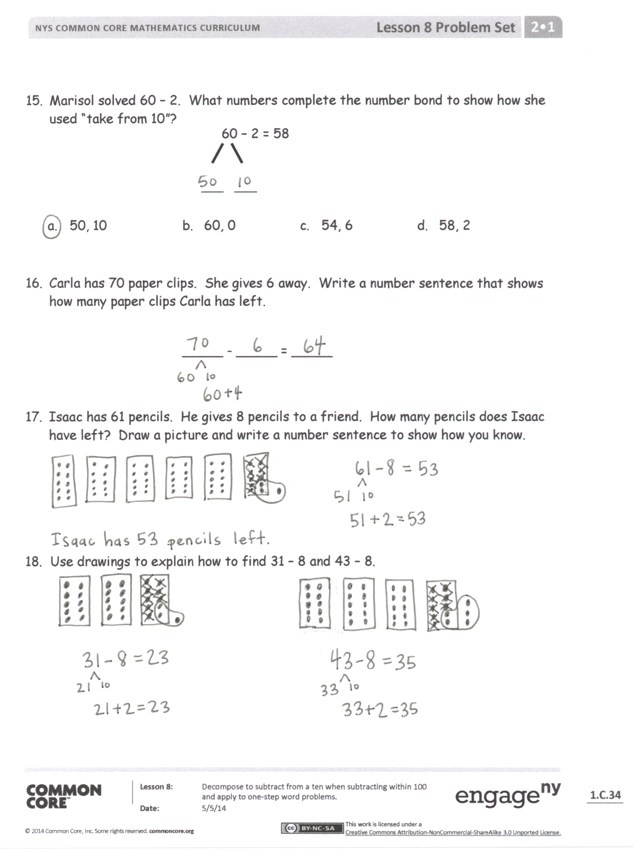Exit Ticket (3 minutes)

After the Student Debrief, instruct students to complete the Exit Ticket. A review of their work will help you assess the students’ understanding of the concepts that were presented in the lesson today and plan more effectively for future lessons. You may read the questions aloud to the students.

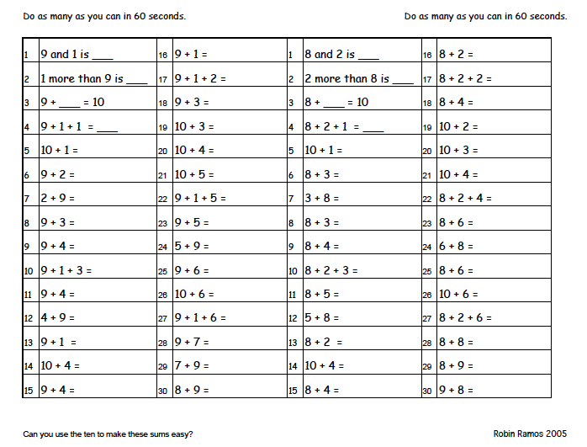

Name Date

Fill in the blanks to make the number sentences true. Draw number bonds to help you subtract from the ten. The first two are done for you.

|  |  |
| --- | --- |
| 1. 40 – 8 = 32   30  10 | 1. 41 – 8 = ______   31  10 |
| 1. 20 – 8 = ______ | 1. 21 – 8 = ______ |
| 1. 30 – 8 = ______ | 1. 32 – 8 = ______ |
| 1. 90 – 8 = ______ | 1. 91 – 8 = ______ |
| 1. 20 – 9 = ______ | 1. 22 – 9 = ______ |
| 1. 70 – 9 = ______ | 1. 71 – 9 = ______ |
| 1. 40 – 5 = ______ | 1. 42 – 5 = ______ |

15. Marisol solved 60 – 2. What numbers complete the number bond to show how she used “take from 10”?

60 – 2 = 58

___ ___

a. 50, 10 b. 60, 0 c. 54, 6 d. 58, 2

16. Carla has 70 paper clips. She gives 6 away. Write a number sentence that shows how many paper clips Carla has left.

_____ - _____ = _____

17. Isaac has 61 pencils. He gives 8 pencils to a friend. How many pencils does Isaac have left? Draw a picture and write a number sentence to show how you know.

18. Use drawings to explain how to find 31 – 8 and 43 – 8.

Name Date

Fill in the blanks to make the number sentences true. Draw number bonds to help you subtract from the ten.

1. 20 – 8 = _______ 2. 60 – 5 = ______

3. 21 – 8 = ______ 4. 62 – 5 = ______

Name Date

Fill in the blanks to make the number sentences true. Draw number bonds to help you subtract from the ten. The first two are done for you.

|  |  |
| --- | --- |
| 1. 40 – 8 = 32   30  10 | 1. 41 – 8 = ______   31  10 |
| 1. 10 – 3 = ______ | 1. 11 – 3 = ______ |
| 1. 20 – 5 = ______ | 1. 21 – 5 = ______ |
| 1. 50 – 7 = ______ | 1. 52 – 7 = ______ |
| 1. 70 – 8 = ______ | 1. 71 – 8 = ______ |
| 1. 40 – 8 = ______ | 1. 42 – 8 = ______ |
| 1. 60 – 7 = ______ | 1. 61 – 7 = ______ |
| 1. 80 – 9 = ______ | 1. 82 – 9 = ______ |

17. Mary solved 40 – 6. Which numbers complete the bond to show how she used “take from 10”?

40 – 6 = 34

___ ___

a. 3, 3 b. 40, 10 c. 30, 6 d. 30, 10

18. Anne finds 41 leaves. She drops 3. Write a number sentence that shows how many leaves are left.

______ – ______ = ______

19. Dane has 22 cans. His mother took 5 cans. How many cans does Dane have left? Draw a picture and write a number sentence to show how you know.