Lesson 7

Objective: Add within 100 using properties of addition to make a ten.

Suggested Lesson Structure

 Fluency Practice (15 minutes)

 Concept Development (27 minutes)

 Application Problem (8 minutes)

 Student Debrief (10 minutes)

**Total Time (60 minutes)**

Fluency Practice (15 minutes)

* Break Apart by Tens and Ones **2.NBT.1** (3 minutes)
* Take from 20 **2.OA.2** (5 minutes)
* Up to the Next Ten with Number Sentences **2.NBT.5** (5 minutes)
* Two More **2.OA.2** (2 minutes)

Break Apart by Tens and Ones (3 minutes)

Note: Students need to build an understanding of place value relationships. In time, challenge students by asking, “6 ones 3 tens” with students correctly replying “36.”

T: If I say 42, you say 4 tens 2 ones.

T: If I say 4 tens 2 ones, you say 42.

T: 4 tens 2 ones.

S: 42.

T: 56.

S: 5 tens 6 ones.

T: 7 tens 3 ones.

S: 73.

Continue with the following possible sequence: 67, 54, 49, 71, and 88.

Take from 20 (5 minutes)

Materials: (S) Personal white boards

Note: Students use personal white boards to see the connection between taking from ten and taking from a multiple of ten.

T: I say 2, you say 8, to take the number I say from 10. Then, write the number sentence and wait for my signal to show it.

T: 6.

S: 4. (Write number sentence.)

T: Show your board.

S: (Show 10 – 6 = 4.)

Continue with the following possible sequence: 7, 9, and 5.

T: This time instead of taking from 10, let’s take from 20. Ready?

T: 1.

S: 19. (Write number sentence.)

T: Show your board.

S: (Show 20 – 1 = 19.)

Continue with the following possible sequence: 5, 6, 8, and 3.

Up to the Next Ten with Number Sentences (5 minutes)

Note: Students remember the importance of their make ten facts with larger numbers. By saying *up* it indicates an addition sentence.

|  |  |
| --- | --- |
|  | NOTES ON  MULTIPLE MEANS OF ACTION AND EXPRESSION: |
| During Fluency Practice, provide a variety of ways for students to respond: oral, choral, student personal white boards for number sentences, concrete models (e.g., fingers, Rekenrek), or pictorial models (e.g., ten-frame). Vary choral response with written response on student boards to support English language learners. Model how the use of the ten-frame can help students answer problems such as *57 up*. | |

T: If I say, “18 up,” you say “2.”

T: If I say, “Give me the number sentence,” you say,   
“18 + 2 = 20.” Ready?

T: 7 up.

S: 3.

T: Give me the number sentence.

S: 7 + 3 = 10.

T: 17 up.

S: 3.

T: Give me the number sentence.

S: 17 + 3 = 20.

Continue with the following possible sequence: 57 up, 97 up, 6 up, 4 up, 26 up, 24 up, 54 up, 74 up, 1 up, 9 up, 31 up, 61 up, and 81 up.

Two More (2 minutes)

Note: Students are eased into crossing multiples of ten by asking for just 2 more.

T: For every number I say, you will say what number is 2 more. If I say 2, you say 4. Ready? 3.

S: 5.

Continue with the following possible sequence: 6, 9, 8, 18, 38, 58, 78, 9, 19, 39, 59, and 79.

Concept Development (27 minutes)

Materials: (T) Ten-frame cards showing 10 (Lesson 3 Template), two-sided counters (S) Personal white board

Note: This lesson focuses on addition of two-digit and one-digit numbers crossing multiples of 10   
(e.g., 38 + 4, 47 + 6, 78 + 5, 5 + 78).

**7 + 5 = 12**

T: (Present 12 counters as shown at right.)

T: 7 + 3 (pause and point) + 2 is…?

S: 12.

T: 7 + 5 is…?

S: 12.

**17 + 5 = 22**

T: (Lay down a ten-frame card.) 17 + 3 (pause) + 2 is…?

S: 22.

T: 17 + 5 is…?

S: 22.

T: 5 + 17 is…?

S: 22.

**27 + 5 = 32**

T: (Lay down a ten-frame card.) 27 + 3 (pause) + 2 is…?

S: 32.

T: 27 + 5 is…? Let’s read them the Say Ten way.

S: 7 + 5 = 1 ten 2. 1 ten 7 + 5 = 2 tens 2, 2 tens 7 + 5 = 3 tens 2.

T: What basic fact was used in all three problems?

S: 7 + 5 = 12.

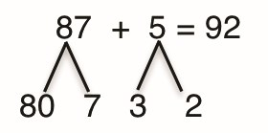T: On your personal white boards, work with me to solve 87 + 5 without materials. First, bond 87 as 80 and 7.

S: (Write the bond.)

T: How did we bond 5 to make a ten (point to the materials)?

S: 3 and 2.

T: Excellent. 7 needs 3 to make ten. Show me that second bond.

S: (Write the bond.)

T: We end up with 80 + 7 + 3 + 2. The answer is…?

S: 92.

T: Talk to your partner about how you know.

S: 7 + 3 is 10, so it’s 80 + 10 + 2, 92. 🡪 I know 7 + 5 is 12, so 80 + 12 is 92. 🡪 I counted on, 80, 90, 92.

T: Try using the same strategy to solve 18 + 6 on your personal white board. Share if you get stuck.

Note: As students work, provide new problems as needed, varying the basic fact and increasing the number of tens for some students (e.g., 15 + 6, 45 + 6, 5 + 76, 4 + 87) while giving the same basic fact and staying under 5 tens for others who need more practice at a simpler level (e.g., 19 + 3, 29 + 3, 39 + 3). It is wise to use the personal white board rather than pencil and paper at times as students are advancing into more challenging territory. Work can quickly be erased and corrected, making error correction easy and more conducive to perseverance.

Problem Set (10 minutes)

Students should do their personal best to complete the Problem Set within the allotted 10 minutes. For some classes, it may be appropriate to modify the assignment by specifying which problems they work on first. Some problems do not specify a method for solving. Students should solve these problems using the RDW approach used for Application Problems.

Application Problem (8 minutes)

One box fits exactly 10 cans. On Monday, Maria packed (18, 78) (see Multiple Means Note) cans into boxes, making sure to fill a box before beginning a new one. On Tuesday she added 6 more cans.

|  |  |
| --- | --- |
|  | NOTES ON  MULTIPLE MEANS OF ENGAGEMENT: |
| “(18,78)” is an invitation to choose numbers that are appropriate for diﬀerent learners. Students may lack wisdom in their choice of numbers. Better to initially guide them towards the right choice for the skill set, with the understanding that we are coaching them towards becoming wiser choosers.  Extension problems are always accommodations for early finishers and advanced learners. | |

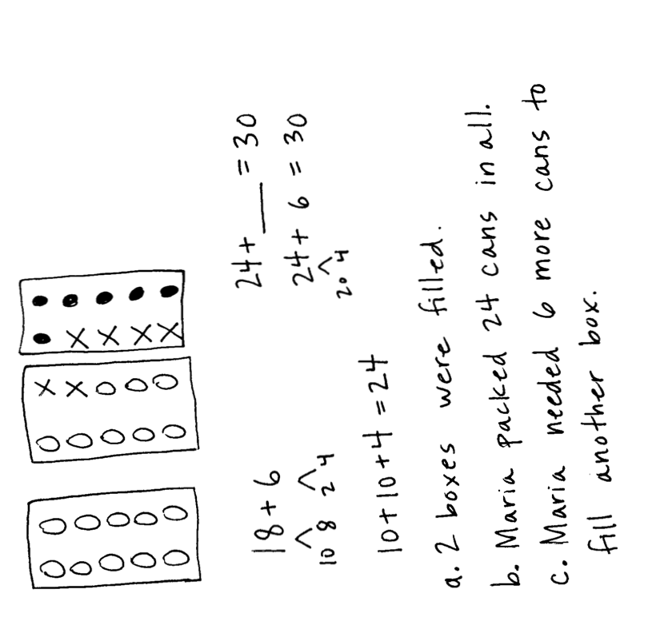

1. How many boxes were completely filled then?
2. How many cans did Maria pack in all?
3. Extension: How many more cans did Maria need to fill another box?

Note: In this problem, students apply the strategy they learned in today’s lesson, using basic facts to bond and make a ten when crossing multiples of ten. Students who are able to work without support may choose to solve for the larger number, 78, while the teacher guides others using the smaller number, 18.

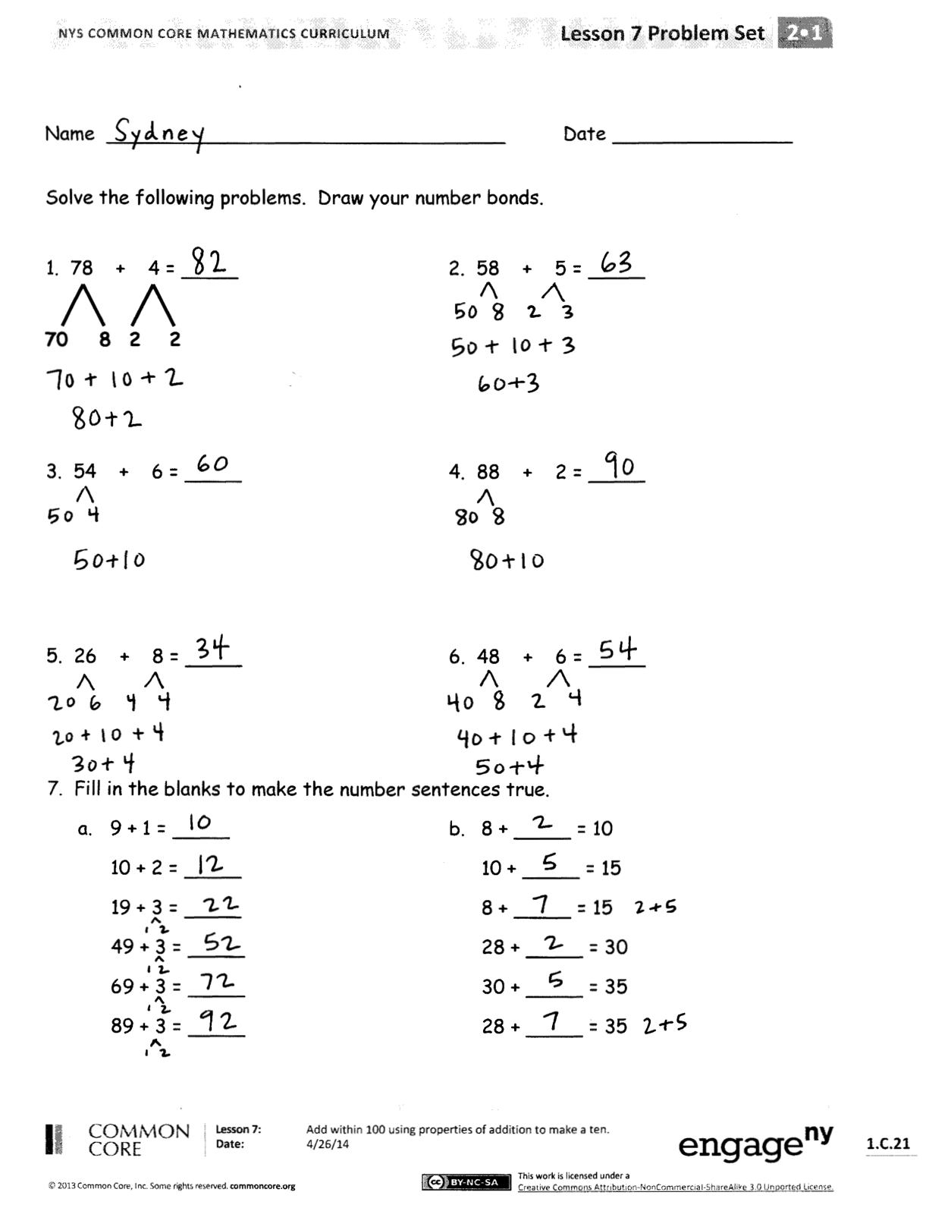Student Debrief (10 minutes)

**Lesson Objective:** Add within 100 using properties of addition to make a ten.

The Student Debrief is intended to invite reflection and active processing of the total lesson experience.

Invite students to review their solutions for the Problem Set. They should check work by comparing answers with a partner before going over answers as a class. Look for misconceptions or misunderstandings that can be addressed in the Debrief. Guide students in a conversation to debrief the Problem Set and process the lesson.

You may choose to use any combination of the questions below to lead the discussion.

* How does knowing 8 + 2 make 10 help you solve 78 + 4?
* Look at Problems 1 and 2. What is the relationship between 78 + 4 and 58 + 5?
* 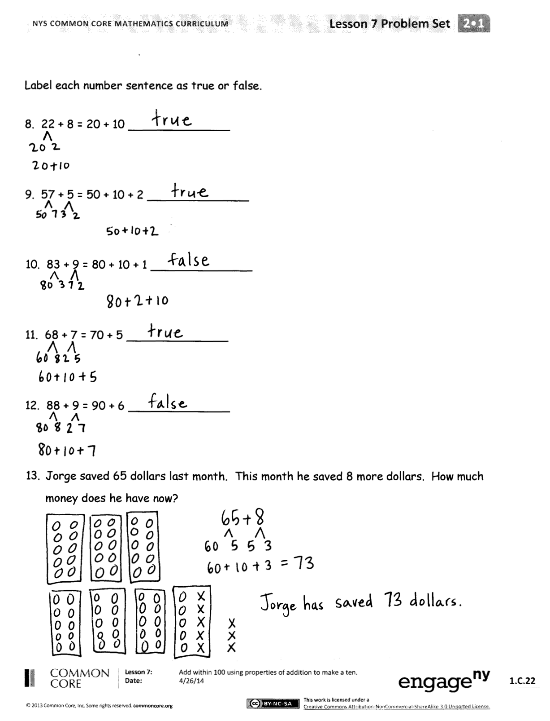How did the basic fact 6 + 8 help you solve Problems 4 and 5?
* How does a ten-frame model help us with learning to complete a 10 to add numbers to 100?
* Think about our story problem with the cans and the way that we solved problems with the ten-frame model. Partner B, explain to Partner A how the problems are the same.

Exit Ticket (3 minutes)

After the Student Debrief, instruct students to complete the Exit Ticket. A review of their work will help you assess the students’ understanding of the concepts that were presented in the lesson today and plan more effectively for future lessons. You may read the questions aloud to the students.

Name Date

Solve the following problems. Draw your number bonds.

1. 78 + 4 = 2. 58 + 5 =

**70**

**8**

**2**

**2**

3. 54 + 6 = 4. 88 + 2 =

5. 26 + 8 = 6. 48 + 6 =

7. Fill in the blanks to make the number sentences true.

a. 9 + 1 = b. 8 + = 10

10 + 2 = 10 + = 15

19 + 3 = 8 + = 15

49 + 3 = 28 + = 30

69 + 3 = 30 + = 35

89 + 3 = 28 + = 35

Label each number sentence as true or false.

8. 22 + 8 = 20 + 10

9. 57 + 5 = 50 + 10 + 2

10. 83 + 9 = 80 + 10 + 1

11. 68 + 7 = 70 + 5

12. 88 + 9 = 90 + 6

13. Jorge saved 65 dollars last month. This month he saved 8 more dollars. How much money does he have now?

Name Date

Solve the following problems. Draw your number bonds.

1. 28 + 4 = 2. 39 + 4 =

3. 27 + 9 = 4. 38 + 9 =

Name Date

Solve the following problems. Draw your number bonds.

1. 78 + 4 = _______ 2. 58 + 5 = _______

**70**

**8**

**2**

**2**

3. 36 + 6 = _______ 4. 26 + 7 = _______

5. 23 + 9 = _______ 6. 44 + 9 = _______

7. 47 + 8 = _______ 8. 68 + 8 = _______

9. 89 + 8 = _______ 10. 77 + 9 = _______

Label each number sentence as true or false.

11. 38 + 2 = 30 + 10

12. 57 + 5 = 50 + 10 + 2

13. 83 + 9 = 80 + 10 + 1

14. 64 + 7 = 70 + 1

15. 89 + 9 = 90 + 7

16. Anthony found 48 coins last month. This month he found 7 more coins. How many coins does he have now?