Lesson 6

Objective: Add and subtract within multiples of ten based on understanding place value and basic facts.

Suggested Lesson Structure

 Fluency Practice (20 minutes)

 Concept Development (30 minutes)

 Student Debrief (10 minutes)

**Total Time (60 minutes)**

Fluency Practice (20 minutes)

|  |  |
| --- | --- |
|  | NOTES ON  MULTIPLE MEANS OF ACTION AND EXPRESSION: |
| During Fluency Practice, students recall and build upon their prior knowledge of place value and basic facts from Grade 1. Design math centers that include concrete representations for students (e.g., Rekenrek, ten-frames, linking cubes). Suggestions for centers ideas include the following:   * Rekenrek: Make ten, add/subtract across ten, build numbers 11–20, etc. * Ten-frames: Roll dice and build the number, ten-frame flash (add or take away 1), two more/less, double it, etc. * Linking cubes: Build a tower with two colors that shows a given total, build towers to 10 and relate quantities with number sentences, and build partner towers and tell how many more or less. | |

* Say Ten Counting from 26 to 58 **2.NBT.1** (2 minutes)
* Take from 20 **2.OA.2** (4 minutes)
* Basic Facts Are Tools **2.OA.2** (5 minutes)
* Sprint: Adding Ones to Ones **2.OA.2** (9 minutes)

Say Ten Counting from 26 to 58 (2 minutes)

Materials: (T) Hide Zero cards (Lesson 2 Template 1), Rekenrek

Note: Students need a clear understanding of the structure of ten to be able to add and subtract within multiples of 10.

T: (Show 22 with Hide Zero cards.) What is 2 more than 20, the regular way?

S: 22.

T: (Pull cards apart to show 20 + 2.) What is the Say Ten way to say 22?

S: 2 tens 2.

T: (Show 23.) What is the Say Ten way for 23?

S: 2 tens 3.

T: (Pull cards apart to show 20 + 3.) That’s right!

T: Let’s count the Say Ten way starting from 26 on the Rekenrek. As I move the beads, count aloud. What is the Say Ten way for 26?

T: (Show 26 with beads pulled to the left on the Rekenrek.)

S: 2 tens 6.

S: 2 tens 7, 2 tens 8, 2 tens 9, 3 tens, 3 tens 1, 3 tens 2.

Continue counting to 5 tens 8.

Take from 20 (4 minutes)

Materials: (S) Personal white boards

Note: The lesson relies on a student’s ability to make ten and apply it to multiples of 10. This exercise will give students familiarity with the skill prior to the Concept Development.

T: Take the number I say from 10. I say 1, you say 9. Then write the number sentence and wait for my signal to show it.

T: 7.

S: 3. (Write number sentence.)

T: Show your personal white boards.

S: (Show 10 – 7 = 3.)

Continue with the following possible sequence: 8, 6, and 9.

T: This time instead of taking from 10, let’s take from 20. Ready? 1.

S: 19. (Write number sentence.)

T: Show your personal white board.

S: (Show 20 – 1 = 19.)

Continue with the following possible sequence: 3, 2, 5, 0, 6, 8, 7, and 9.

Basic Facts Are Tools (5 minutes)

Materials: (T) Rekenrek

Note: This activity prepares students for the day’s Concept Development by emphasizing the presence of the basic fact. The Rekenrek provides visual support, enabling students to see the structure of ten. For example, 8 + 3 is seen as 8 + 2 + 1.

T: Our basic fact, or tool, is 8 + 2. 8 + 2 is…?

S: 10.

T: 8 + 3 is…? (Show the numbers on the Rekenrek each time.)

S: 10 + 1.

T: 8 + 7 is…?

S: 10 + 5. (Continue with the following possible sequence: 9 + 5, 9 + 4, and 9 + 8.)

T: Our new basic fact, or tool, is 10 – 8. 10 – 8 is…?

S: 2.

T: 12 – 8 is…? (Show the numbers on the Rekenrek each time.)

S: 2 + 2.

T: 15 – 8 is…?

S: 2 + 5. (Continue with the following possible sequence: 12 – 9 and 15 – 9.)

Sprint: Adding Ones to Ones (9 minutes)

Materials: (S) Adding Ones to Ones Sprint

Note: The Sprint applies prior knowledge of adding basic facts to larger numbers.

Concept Development (30 minutes)

Materials: (T) Two-sided counters, 3 ten-frame cards for the number 10, set of ten-frame cards (Lesson 3 Template), linking cubes

Part 1: Add and subtract within a unit of 10 (e.g., 73 + 2, 75 – 2).

Note: Simple basic facts such as 3 + 2 and 5 – 2 are helpful in solving problems with larger numbers. Use the Say Ten way (e.g., 13 is 1 ten 3, 26 is 2 tens 6) to emphasize the presence of the basic fact.

T: (Show two-sided counters.) 3 + 2 is…?

**3 + 2 = 5**

**5 – 2 = 3**

S: 5.

T: 5 – 2 is?

S: 3.

T: (Lay down a ten-frame card.) 1 ten 3 + 2 is?

**13 + 2 = 15**

**15 – 2 = 13**

S: 1 ten 5.

T: 13 + 2 is?

S: 15.

T: 1 ten 5 – 2 is?

S: 1 ten 3.

**23 + 2 = 25**

**25 – 2 = 23**

T: 15 – 2 is?

S: 13.

T: (Lay down another ten-frame card.) 2 tens 3 + 2 is?

S: 2 tens 5.

T: 23 + 2 is?

**33 + 2 = 35**

**35 – 2 = 33**



S: 25.

T: Partner A, talk to your partner about how 3 + 2 helps

you solve 23 + 2.

S: It’s easy because you just add the ones, so 20 + 5 =25. 🡪 I just think 2 tens 3 + 2 is 2 tens 5.

T: 2 tens 5 – 2 is…?

S: 2 tens 3.

T: 25 – 2 is…?

S: 23.

T: Partner B, talk to your partner about how 5 – 2 helps you solve 25 – 2.

S: The answer to the basic fact doesn’t change so 5 – 2 = 3 then add 20. 🡪 2 tens 5 – 2 is 2 tens 3.

T: (Lay down another ten-frame card.) 3 tens 3 + 2 is…?

S: 3 tens 5.

Part 2: Look for and make use of structure.

T: (Pass out the Problem Set.)

|  |  |
| --- | --- |
|  | NOTES ON  MULTIPLE MEANS OF REPRESENTATION: |
| In a healthy classroom culture, students may disagree with one another as they share their work. Disagreement encourages scrutiny and is an opportunity for students to learn and justify their choices. During partner talk, encourage students to justify arguments. Model and post good conversation starters: “I disagree because …” “Your solution is different from mine because . . .” “My error was …” “Your answer does not make sense to me because …” These starters should spark conversations within student partnerships. | |

T: Complete Problems 1 and 2.

S: (Work.)

T: With your partner, look at the problems with 2 + 4 and 6 – 4.

**MP.7**

T: Partner A, read your problems aloud to Partner B the Say Ten way. Then switch.

T: Listen closely to your words. Do you hear a pattern?

S: Yes!

T: What pattern do you hear when you add?

S: All the answers have 6 ones. 🡪 It’s the same basic fact 2 + 4.

**MP.7**

T: What pattern do you hear when you subtract?

S: All the answers have 2 ones. 🡪 It’s the same basic fact 6 – 4.

T: Explain to your partner what is different about your problems, both in addition and subtraction.

S: The first number is different. → The ten is different. → The number of tens is different but the ones stay the same.

2 + 4 = ____ 6 – 4 = ____

12 + 4 = ____ 36 – 4 = ____

**/\ /\**

**10 2 30 6**

22 + 4 = ____ 56 – 4 =

**/\ /\**

**20 2 50 6**

T: The basic fact you heard is the same, but the number of tens changes.

T: Make bonds in Problems 1 and 2 to break apart the ones from the number of tens. (Shown right.)

S: (Work.)

T: How does 6 – 4 help you solve 56 – 4? Talk to your partner.

S: The number of tens doesn’t change. 🡪 You just have to know the basic fact. 🡪 5 tens 6 – 4 is 5 tens 2.

T: (Allow students time to share.) Let me hear you subtract without the basic fact by counting down. Ready?

S: 55, 54, 53, 52.

Have students share with a partner about which strategy is easier to use, counting down or using the basic fact 6 – 4.

T: Think of the different numbers of tens as towers of linking cubes of different sizes. No matter what size the tower is, the 2 + 4 doesn’t change. (Model this concept pictorially or concretely with linking cubes or blocks.)

T: It’s helpful to look for structure and patterns to make math easier. Here’s a structure (refer to the linking cube tower). The basic fact (refer to the model of 2 + 4) helps create a number pattern when we repeatedly use it.

Part 3: Look for and make use of structure to complete a unit of 10 (e.g., 37 + 3, 87 + 3, 83 + 7).

Note: As you move through the problems modeled below, be sure to record the number sentences sequentially for reflection at the end.

**7 + 3 = 10**

T: Present 10 counters (as shown to the right). 7 + 3 is…?

S: 10.

T: (Lay down a ten-frame card.) Give the expression that is the same as 10 + 7 + 3.

S: 10 + 10.

T: 1 ten 7 + 3 is…?

S: 2 tens.

**17 + 3 = 20**

T: 17 + 3 is…? Give the addition sentence.

S: 17 + 3 = 20.

T: (Lay down a ten-frame card.) Give the expression that is the same as 20 + 7 + 3.

S: 20 + 10.

T: 2 tens 7 + 3 is…?

**27 + 3 = 30**

S: 3 tens.

T: 27 + 3 is…? Give the addition sentence.

S: 27 + 3 = 30.

T: (Lay down a ten-frame card.) 30 + 7 + 3 is the same as…?

S: 30 + 10.

**37 + 3 = 40**

T: 3 tens 7 + 3 is…?

S: 4 tens.

T: 37 + 3 is…? Give the addition sentence.

S: 37 + 3 = 40.

T: Let’s read each number sentence the Say Ten way.

S: 7 + 3 = 1 ten; 1 ten 7 + 3 = 2 tens; 2 tens 7 + 3 = 3 tens; 3 tens 7 + 3 = 4 tens.

T: What basic fact creates the pattern?

S: 7 + 3. 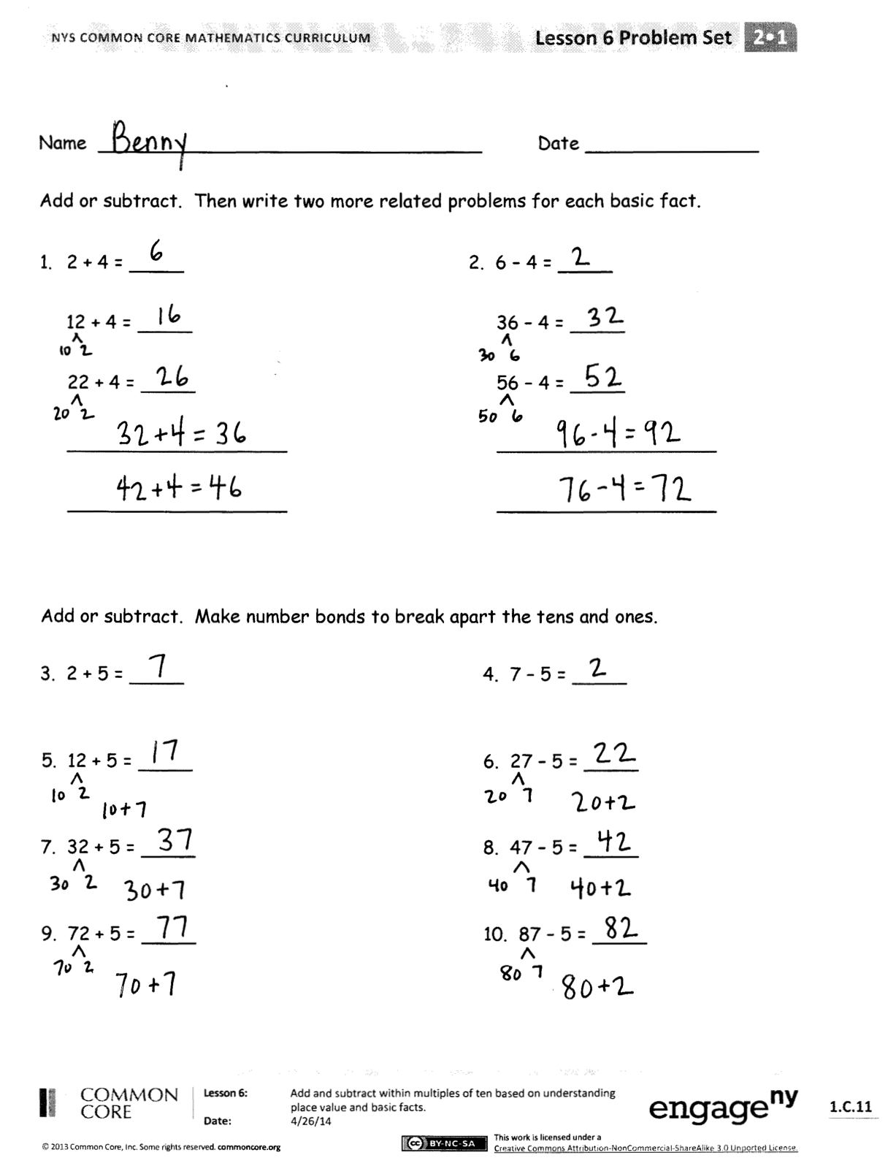

T: (Join 7 linking cubes with 3 cubes.) What new structure did we make?

S: 10.

As students demonstrate proficiency allow them to complete the Problem Set.

Problem Set (10 minutes)

Students should do their personal best to complete the Problem Set within the allotted 10 minutes. For some classes, it may be appropriate to modify the assignment by specifying which problems they work on first. Some problems do not specify a method for solving. Students should solve these problems using the RDW approach used for Application Problems.

Student Debrief (10 minutes)

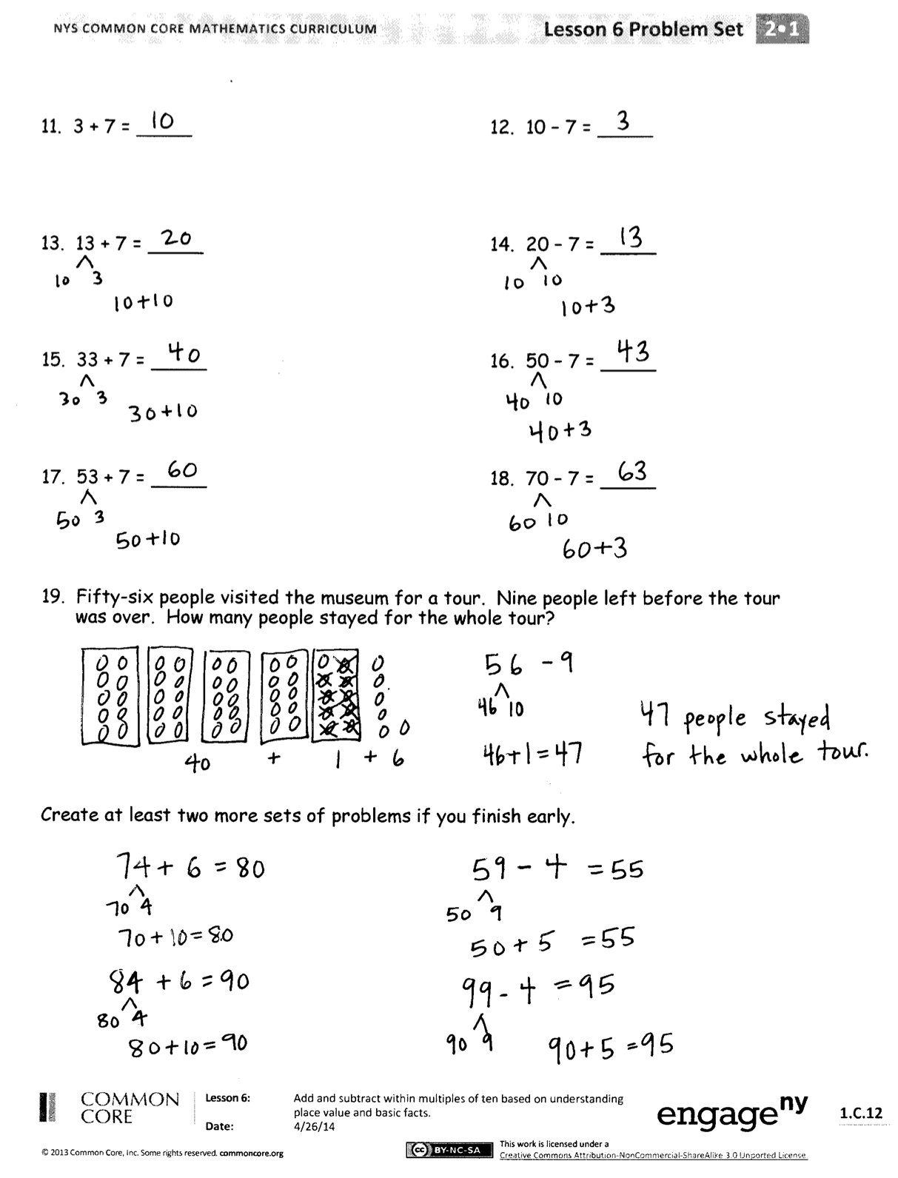**Lesson Objective:** Add and subtract within multiples of ten based on understanding place value and basic facts.

The Student Debrief is intended to invite reflection and active processing of the total lesson experience.

Invite students to review their solutions for the Problem Set. They should check work by comparing answers with a partner before going over answers as a class. Look for misconceptions or misunderstandings that can be addressed in the Debrief. Guide students in a conversation to debrief the Problem Set and process the lesson.

You may choose to use any combination of the questions below to lead the discussion.

* Look at Problem 1 of the Problem Set. How does knowing 2 + 4 help you solve 12 + 4?
* How does solving the first column help you solve the second column?
* Talk to your partner about what you think our lesson’s goal was today.
* How do structures or patterns help make math easier?

Exit Ticket (3 minutes)

After the Student Debrief, instruct students to complete the Exit Ticket. A review of their work will help you assess the students’ understanding of the concepts that were presented in the lesson today and plan more effectively for future lessons. You may read the questions aloud to the students.



Name Date

Add or subtract. Then write two more related problems for each basic fact.

1. 2 + 4 = 2. 6 – 4 =

12 + 4 = 36 – 4 =

22 + 4 = 56 – 4 =

Add or subtract. Make number bonds to break apart the tens and ones.

3. 2 + 5 = 4. 7 – 5 =

5. 12 + 5 = 6. 27 – 5 =

7. 32 + 5 = 8. 47 – 5 =

9. 72 + 5 = 10. 87 – 5 =

11. 3 + 7 = 12. 10 – 7 =

13. 13 + 7 = 14. 20 – 7 =

15. 33 + 7 = 16. 50 – 7 =

17. 53 + 7 = 18. 70 – 7 =

1. Fifty-six people visited the museum for a tour. Nine people left before the tour was over. How many people stayed for the whole tour?

Create at least two more sets of problems if you finish early.

Name Date

Solve the problems. In the space provided, write a related problem for each of the basic facts.

|  |  |  |
| --- | --- | --- |
| 1. 4 + 2 = | 1. 6 – 4 = | 1. 1 + 9 = |
| 24 + 2 = | 36 – 4 = | 11 + 9 = |
| 84 + 2 = | 76 – 4 = | 61 + 9 = |
|  |  |  |
| ______________ | ______________ | ______________ |

Name Date

Add or subtract. Then write two more related problems for each basic fact.

1. 6 + 2 = 2. 8 – 6 =

16 + 2 = 28 – 6 =

26 + 2 = 38 – 6 =

3. 4 + 3 = 4. 7 – 3 =

44 + 3 = 57 – 3 =

74 + 3 = 77 – 3 =

5. 5 + 2 = 6. 7 – 2 =

35 + 2 = 57 – 2 =

75 + 2 = 67 – 2 =

Solve the following problems. Show your number bonds. Draw if that will help you.

7. 20 – 6 = 8. 30 – 5 =

9. 49 – 6 = 10. 69 – 6 =

1. Seventy-nine people attended the concert. Six people had to leave at the break. How many people were still at the concert after the break?