Lesson 5
Objective: Decompose to subtract from a ten when subtracting within 20 and apply to one-step word problems.

Suggested Lesson Structure
 Fluency Practice (7 minutes)
 Concept Development (33 minutes)
 Application Problem (10 minutes)
 Student Debrief (10 minutes)
Total Time (60 minutes)
Fluency Practice (7 minutes)
- Take from Ten 2.OA.2 (3 minutes)
- Take from the Ones 2.OA.2 (4 minutes)
Take from Ten (3 minutes)
Note: This activity builds fluency when subtracting from ten when the subtrahend is greater than the ones digit.

NOTES ON
MULTIPLE MEANS OF ENGAGEMENT:
Provide students with a 20-bead Rekenrek so that they can see numbers to 10 as a number line on one row or a ten-frame (5 beads on two rows). Connect numbers to concrete experiences by encouraging English language learners to show their answers with their fingers.

T: When I say 1, you say 9. 10 – 1 = 9. Ready? 2.
S: 8.
T: What’s the number sentence?
S: 10 – 2 = 8.
Continue with the following sequence: 7, 4, 9, 0, 5, and 8.
Take from the Ones (4 minutes)
Note: As students realize that at times they have enough ones to subtract, they then become aware that sometimes they do not and must take from the ten.
T: Let’s take from the ones. 5 – 3 = .
S: 2.
T: 15 – 3 = .
S: 12.
Continue with the following possible sequence: 6 – 2; 16 – 2; 8 – 4; 18 – 4; 4 – 2; 14 – 2; 7 – 5; 17 – 5;
9 – 6; 19 – 6; 7 – 3; 17 – 3; 8 – 5; 18 – 5; 9 – 5; 19 – 5; 9 – 2; and 19 – 2.
Concept Development (33 minutes)
Materials: (T) Two-sided counters (S) Personal white board, ten-strip (Lesson 4 Template), bag of two-sided counters, a subtracting strip (this is simply a white strip of paper, pictured in the photograph in Part 2)
Note: Two-sided counters can be any available objects that allow students to see two distinct parts (e.g., linking cubes in two different colors, spray painted beans, two-color counters).
Part 1: Solve problems with a common subtrahend (e.g., 11 – 8, 12 – 8, 13 – 8, etc.)
T: (Present ten counters, eight of one color, two of another as shown at right.)
T: How many counters are here (signaling the 10 arranged as 2 fives)?
10 – 8 = 2
S: 10.
T: If I subtract the red counters, what is left?
S: 2.
T: What subtraction sentence takes away 8?
S: 10 – 8 = 2.
T: (Place one counter next to the ten as shown at right.) How many counters are here?
S: 11.
11 – 8 = 3
/\
10 1

10 – 8 = 2
2 + 1 = 3
11 – 8 = 3

T: Let’s subtract 8 again.
T: How many counters are left (point to the 2 and 1)?
S: 3.
T: What addition sentence puts these two sets together?
S: 2 + 1 = 3.
T: So, 11 – 8 = 2 + 1?
S: Yes.
T: What subtraction sentence have we modeled?
S: 11 – 8 = 3.
T: (Place another counter next to the ten as shown at right.) How many counters are here?
S: 12.
12 – 8 = 4
/\
10 2

10 – 8 = 2
2 + 2 = 4
12 – 8 = 4

T: What subtraction sentence takes away 8?
S: 12 – 8 = 4.
T: What addition sentence puts the remaining sets together?
S: 2 + 2 = 4.
T: So, 12 – 8 = 2 + 2?
S: Yes.
T: Explain 11 – 8 = 2 + 1 and 12 – 8 = 2 + 2 to your partner. Use the models to help you.
Part 2: Determine whether to subtract from the ten or the ones.
T: Watch as I model the number 14 with a ten-strip and ones counters. (Show a ten-strip and a column of 4 to its right.)
T: For 14 – 3, do I have enough ones to subtract 3 from the ones?
S: Yes.
T: Subtract 3 from 4. (Cover 3 counters with subtracting strip as pictured below.) 14 – 3 is…?
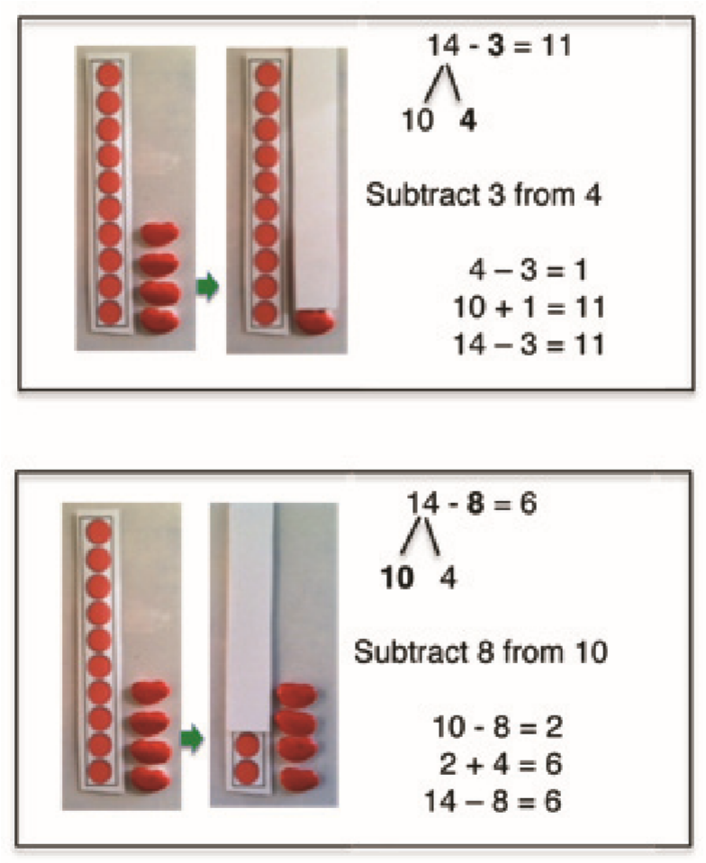
S: 11.
T: Use addition to put together the two parts that are left.
S: 10 + 1 = 11.
T: (Show the number 14 again.) For 14 – 8, do we have enough ones to subtract 8 from the ones?
S: No.
T: Subtract 8 from the ten. (Cover 8 of the ten-strip with subtracting strip as pictured to the right.) 14 – 8 is…?
S: 6.
T: Use addition to put together the two parts that are left.
S: 2 + 4 = 6.
T: For 14 – 3, we subtracted from the ones. For 14 – 8, we subtracted from the…?
S: Ten.
T: Show me the number 13 with your ten-strip and ones counters.
S: (Show a ten-strip and a column of 3 to its right.)
T: 13 – 8. Use your subtraction strip to subtract from either the ten or the ones.
T: What’s the complete number sentence?
S: 13 – 8 = 5.
T: Did you subtract from the ten or the ones?
S: The ten.
T: Let’s do another. 15 – 2.
S: (Show 10 and 5, and then cover 2 of the 5 ones.)
T: What’s the complete number sentence?
S: 15 – 2 = 13.
Quickly continue with other examples alternating between taking from the ones and taking 8 from the ten and asking them from which they subtracted, the ten or the ones. Using personal white boards, students record solutions with number bonds. If they still need the models, allow them to continue working with a ten-strip and counters.
T: Talk to your partner. How does 10 – 8 help you to solve 12 – 8?
T: How would 10 – 9 help you to solve 13 – 9?
Part 3: Extension
Note: Just as in the previous lessons, the goal is for students to achieve fluency over time by recognizing connections and developing mental strategies that support their mastery of standard 2.OA.2. In addition to subtracting from 10 with a common minuend and subtracting from 10 with a common difference, it is also imperative that students have significant amounts of mixed practice as the year progresses.
The problems below are modeled for use in fluency activities throughout the year as students develop fluency with sums and differences to 20, with an emphasis on using 10. If there is time within today’s lesson, consider advancing to these problems.

NOTES ON
PACING:
The work thus far takes the entire 26 minutes. Part 2 and Part 3 problems are modeled for use in fluency activities throughout the year as students develop fluency with sums and differences to 20, with an emphasis on using 10. If there is time within the day’s lesson, consider advancing to Part 3 problems.
There are clearly other strategies for subtracting from the teens such as counting back and adding on. However, the take from ten strategy develops the important skill of breaking apart a unit relevant to work with place value, measurement, units, and fractions.

Subtract from 10 with a common minuend.
11 – 2; 11 – 3; 11 – 4; 11 – 5; 11 – 6; 11 – 7; 11 – 8; 11 – 9.
12 – 3; 12 – 4; 12 – 5; 12 – 6; 12 – 7; 12 – 8; 12 – 9.
13 – 4; 13 – 5; 13 – 6; 13 – 7; 13 – 8; 13 – 9.
14 – 5; 14 – 6; 14 – 7; 14 – 8; 14 – 9.
15 – 6; 15 – 7; 15 – 8; 15 – 9.
16 – 7; 16 – 8; 16 – 9.
17 – 8; 17 – 9.
18 – 9.
Subtract from 10 with a common difference. Over time, present students with opportunities to realize that when subtracting from 12, for example, we always are adding back the 2 ones.
11 – 2; 12 – 3; 13 – 4; 14 – 5; 15 – 6; 16 – 7; 17 – 8; 18 – 9.
11 – 3; 12 – 4; 13 – 5; 14 – 6; 15 – 7; 16 – 8; 17 – 9.
11 – 4; 12 – 5; 13 – 6; 14 – 7; 15 – 8; 16 – 9.
11 – 5; 12 – 6; 13 – 7; 14 – 8; 15 – 9.
11 – 6; 12 – 7; 13 – 8; 14 – 9.
Problem Set (10 minutes)
Students should do their personal best to complete the Problem Set within the allotted 10 minutes. For some classes, it may be appropriate to modify the assignment by specifying which problems they work on first. Some problems do not specify a method for solving. Students should solve these problems using the RDW approach used for Application Problems.
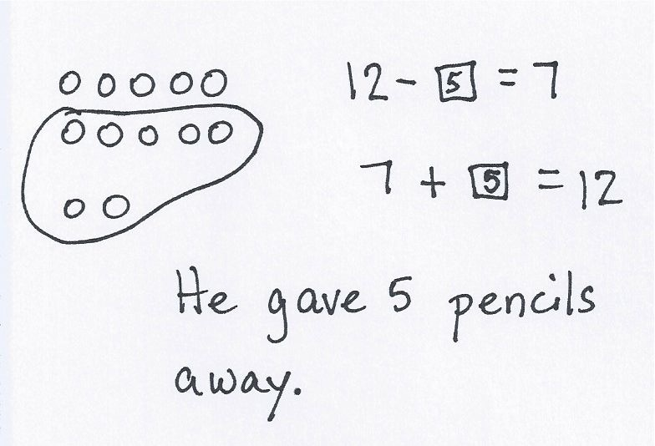
Application Problem (10 minutes)
Problem 1
Pencils come 12 to a package. Shane gives some pencils to his friends. Now he has 7 left. How many pencils did he give away?
Problem 2
Sylvia has a dime and three pennies. A friend asked her for 8 cents.
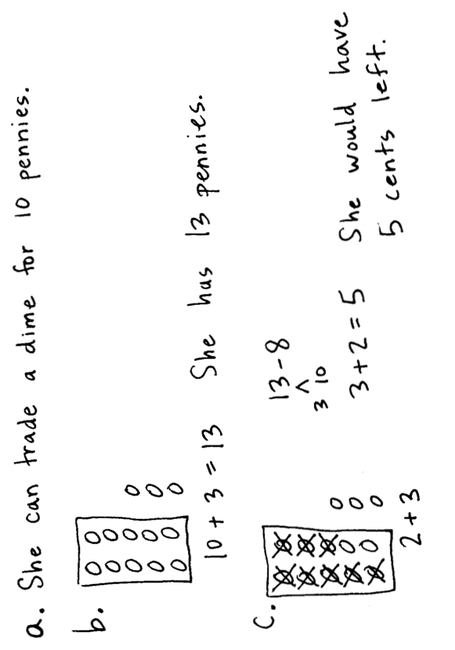
- What can Sylvia do to be able to give her friend 8 cents?
- How many pennies does Sylvia have after she trades her dime?
c. How much money would she have left after giving away 8 cents?
Note: Today’s problems provide practice decomposing to subtract from a ten. Some students may simply know the answer, so it is important to establish the purpose of the Application Problem of each lesson. It is the time to focus on understanding the situation presented in the problem and representing that situation with a drawing and an equation. It is also the time for students to share their representations and their ways of thinking, which can help more students access problem-solving strategies. Below is a sample dialogue to guide students through Problem 2.
S: (Read chorally.)
T: (Model one dime and three pennies.) What is the value of the money?
MP.1
S: 13.
T: 13 what? Remember to always state the unit.
S: 13 cents.
T: Talk to your partner about how Sylvia can give her friend 8 cents.
S: She can’t. → Yeah, she can, she has 13 cents and 13 is more than 8. → We can switch a dime for ten pennies. → Oh, yeah, then there are enough pennies to give 8.
Circulate, listen, and provide advancing questions to move students forward. At times, speak very quietly, and at other times, speak loudly enough so that the whole class has access to the hint.
T: As I moved around the room, I heard lots of students suggesting that Sylvia could trade her dime for ten pennies. Thumbs up if this was your idea.
T: (Model the exchange, laying pennies out in a ten-frame format.) Look at the model. To give her friend 8 cents, should Sylvia take the money from the ten pennies or from the three pennies?
S: The ten.
T: (Cover the 10.) Can I take 8 from 3?
S: No.
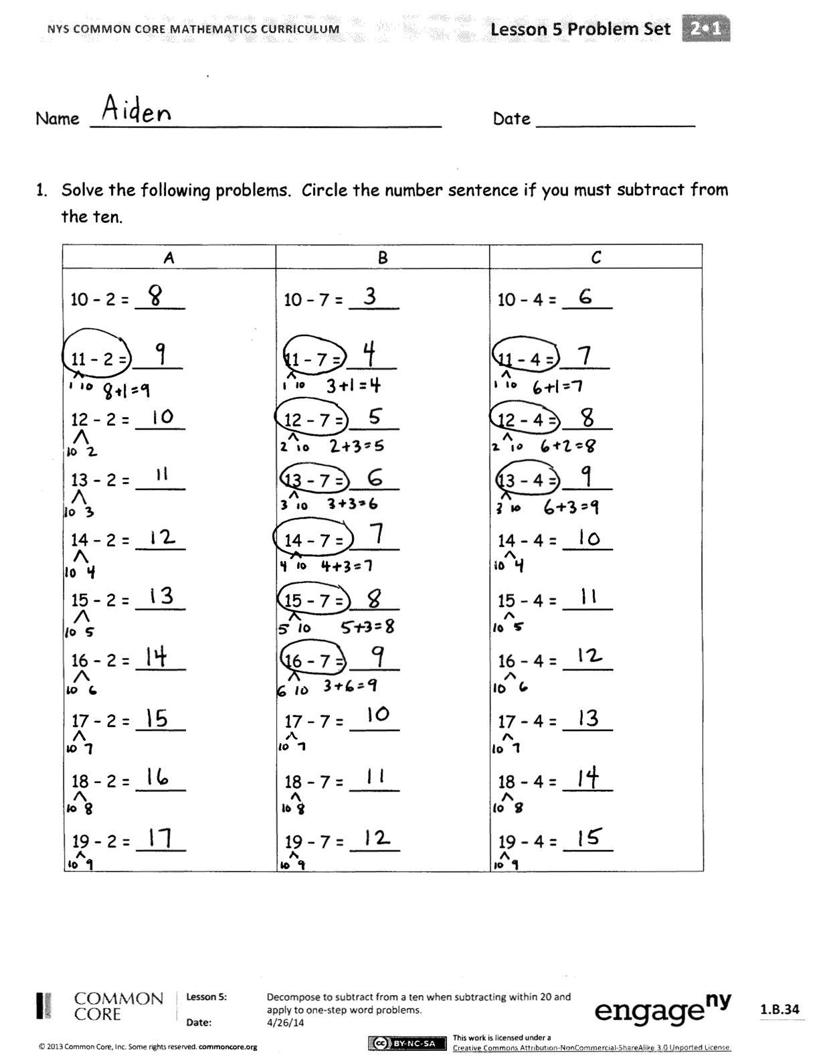
T: (Cover the 3.) Can I take 8 from 10?
S: Yes.
T: Yes, because you have enough.
T: Imagine Sylvia gives her friend the eight pennies. Turn and talk to your partner about how many pennies are left. Tell me how many.
S: 5.
T: (Take the eight pennies away from ten.) How many were left from the dime?
MP.1
S: 2.
T: How many were left from the extra pennies? (Isolate the set with your hands.)
S: 3.
T: What addition sentence combines these?
S: 2 + 3 = 5.
T: (Write the number sentence 13 – 8 = 2 + 3.) Turn and talk to your partner about what each number means in this number sentence.
Student Debrief (10 minutes)

NOTES ON
MULTIPLE MEANS OF REPRESENTATION:
Since the Problem Set does not include the pictorial or concrete, invite tactile learners to use their beans and subtraction strips to model the problems.
The goal in both making a 10 and taking from 10 is for students to master mental math. An important bridge is visualization. Have them use a ten-frame card, but flip it over so they cannot see the units. Allow students to peek if they must, but encourage them to visualize the quantity next time.

Lesson Objective: Decompose to subtract from a ten when subtracting within 20 and apply to one-step word problems.
The Student Debrief is intended to invite reflection and active processing of the total lesson experience.
Invite students to review their solutions for the Problem Set. They should check work by comparing answers with a partner before going over answers as a class. Look for misconceptions or misunderstandings that can be addressed in the Debrief. Guide students in a conversation to debrief the Problem Set and process the lesson.
You may choose to use any combination of the questions below to lead the discussion.
- Let’s look at Problem 1 column A on the Problem Set. How does knowing 10 – 2 help you solve the rest of the problems?
- What is the relationship of the problems in Column B?
- What basic fact helps you solve the problems in Column B? Column C?
- In Problem 2, where did the 2 come from in 11 – 8 = 2 + _____?
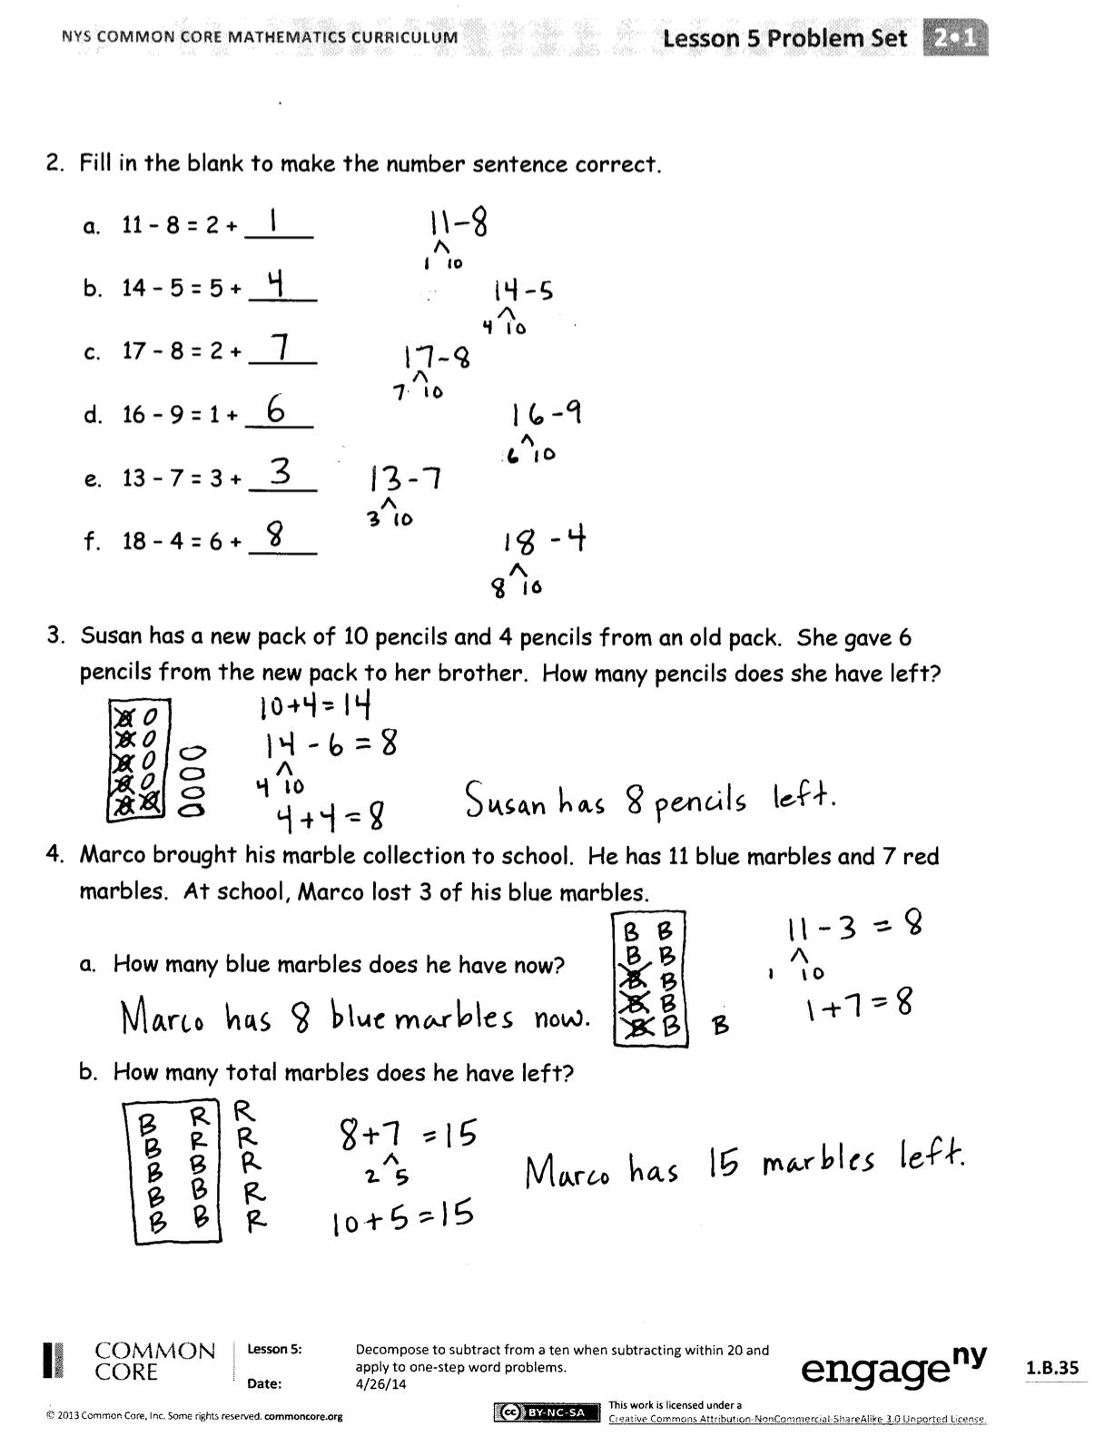
Exit Ticket (3 minutes)
After the Student Debrief, instruct students to complete the Exit Ticket. A review of their work will help you assess the students’ understanding of the concepts that were presented in the lesson today and plan more effectively for future lessons. You may read the questions aloud to the student.
Name Date

- Solve the following problems. Circle the number sentence if you must subtract
from the ten.
A | B | C
10 – 2 = | 10 – 7 = | 10 – 4 =
11 – 2 = | 11 – 7 = | 11 – 4 =
12 – 2 = | 12 – 7 = | 12 – 4 =
13 – 2 = | 13 – 7 = | 13 – 4 =
14 – 2 = | 14 – 7 = | 14 – 4 =
15 – 2 = | 15 – 7 = | 15 – 4 =
16 – 2 = | 16 – 7 = | 16 – 4 =
17 – 2 = | 17 – 7 = | 17 – 4 =
18 – 2 = | 18 – 7 = | 18 – 4 =
19 – 2 = | 19 – 7 = | 19 – 4 =

- Fill in the blank to make the number sentence correct.

- 11 – 8 = 2 +
- 14 – 5 = 5 +
- 17 – 8 = 2 +
- 16 – 9 = 1 +
- 13 – 7 = 3 +
- 18 – 4 = 6 +

- Susan has a new pack of 10 pencils and 4 pencils from an old pack. She gave 6 pencils from the new pack to her brother. How many pencils does she have left?

- Marco brought his marble collection to school. He has 11 blue marbles and 7 red marbles. At school, Marco lost 3 of his blue marbles.

  - How many blue marbles does he have now?

  - How many total marbles does he have left?

Name Date

Complete each set.

1. 15 – 9 2. 14 – 6
/\ /\
__ __ __ __

10 – 9 = 10 – 6 =
1 + 5 = 4 + 4 =
15 – 9 = 14 – 6 =

3. 11 – 8 4. 12 – 7
/\ /\
__ __ __ __

10 – = 10 – =
+ 1 = + 2 =
11 – 8 = 12 – 7 =

Name Date

- Solve the following problems. Circle the number sentence if you must subtract
from the ten.
A | B | C
10 – 3 = | 10 – 5 = | 10 – 6 =
11 – 3 = | 11 – 5 = | 11 – 6 =
12 – 3 = | 12 – 5 = | 12 – 6 =
13 – 3 = | 13 – 5 = | 13 – 6 =
14 – 3 = | 14 – 5 = | 14 – 6 =
15 – 3 = | 15 – 5 = | 15 – 6 =
16 – 3 = | 16 – 5 = | 16 – 6 =
17 – 3 = | 17 – 5 = | 17 – 6 =
18 – 3 = | 18 – 5 = | 18 – 6 =
19 – 3 = | 19 – 5 = | 19 – 6 =

- Fill in the blank to make the number sentence correct.

- 14 – 8 = 2 +
- 15 – 6 = 4 +
- 18 – 9 = 1 +
- 16 – 7 = 3 +
- 11 – 5 = 5 +
- 13 – 4 = 6 +

- Mrs. Jones collects 12 eggs from her chickens in the morning. Mr. Jones collects 5 more eggs in the evening. They used 8 eggs for dinner. How many eggs are left?

- Eleven pink roses and 7 red roses are growing in Mrs. Thompson’s garden. She wants to give 9 of the pink roses to her neighbor. How many roses will she have left?

